**Optimizing Campus Mobility with a focus on Sustainability: A Graph Theory Approach to Intra-Campus Transportation Networks**

Quinn Nelson, Donald Steffensmeier, Sachin Pawaskar

Department of Computer Science

University of Nebraska at Omaha

Omaha, NE 68182

[qnelson@unomaha.edu](mailto:qnelson@unomaha.edu) | [djsteffy@unomaha.edu](mailto:djsteffy@unomaha.edu) | [spawaskar@unomaha.edu](mailto:spawaskar@unomaha.edu)

**Abstract**

The idea of public transportation is supported by most in theory but often heavily criticized by users when put into application. There are common tensions that are related to public transportation, as described by frequent users: unreliable, too crowded, and slow. The University of Nebraska-Omaha (UNO) is a growing metropolitan institution that uses a shuttle system to transport students among their three campuses daily. As of 2015, the current total student enrollment is approximately 16,000; UNO plans to enroll 20,000 students by 2020.  The expected student growth is also reflected by the current construction of new buildings and expansion of UNO’s campus. Like most metropolitan universities, space and parking on a college campus is a limited resource, and UNO’s shuttle transportation system plays a vital role in ensuring student mobility between campuses. With growing pressure from the UNO community to improve kinesis there is a need to optimize intra-campus transportation in an environmentally sustainable manner. To alleviate the tensions involved with the UNO shuttle system, we have created an algorithm to model shuttle routes using graph theory. Once modeled, our program chooses an optimized route based on various conditions: time, volume of students anticipated to use the shuttle, and fuel cost. The algorithm created can be used to optimize transportation routes, alleviate user tension, and decrease the carbon footprint of transportation networks. Our project thus charts the future by improving student transportation methods and people movement between urban campuses in an environmentally friendly and efficient way.

**Keywords**: Graph Theory, Metropolitan Universities, Transportation Networks, Environmental Sustainability, Urban Planning

**1. Introduction**

The University of Nebraska-Omaha (UNO) is a growing metropolitan university. The UNO campus stretches across three major streets in Omaha: Dodge, Pacific, and Center. This distance is roughly 2 miles wide. According to UNO 2013 Factbook, the UNO campus has a weekday population of over 17,702 making the university larger than the population of La Vista, NE (17,562) [1].

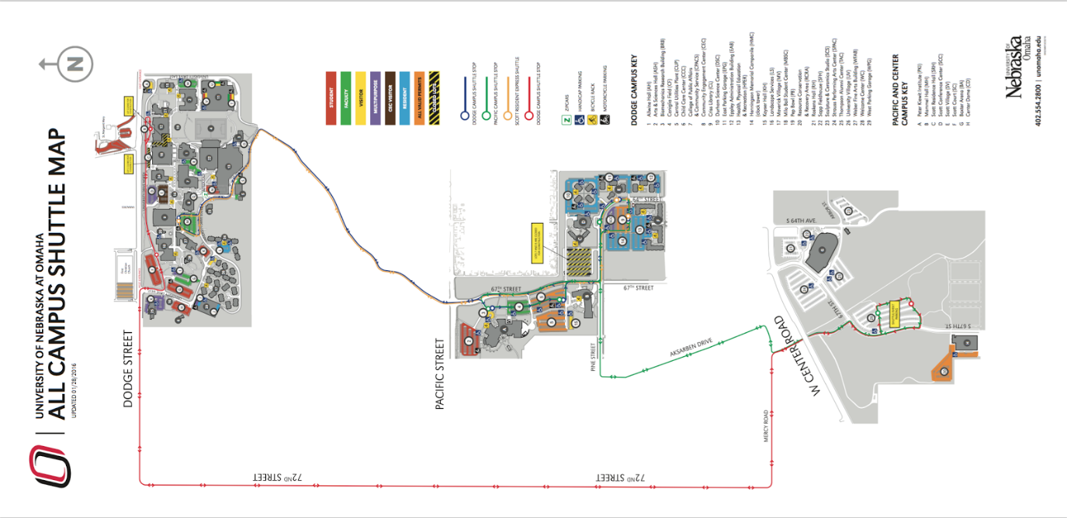Each school day, students need to be able to move among the three campuses for classes, meals, parking, etc. The growth of UNO’s students, accompanied by the expansion of the UNO campus creates a situation where campus mobility can be a serious problem.

Figure 1: UNO Campus Shuttle Routes

The major way UNO student’s move between campuses is the UNO Shuttle system. The shuttle system currently moves between all three campuses with three different routes, as shown in the following diagram.

Figure 2 UNO 2013 Parking Ratios

The growth of UNO’s student enrollment and campus expansion puts pressure on UNO to improve the UNO shuttle system to adequately transport students between campuses. This research project focuses on creating an algorithm that represents the UNO shuttle system in a graph theory approach, while finding an optimized shuttle route for the UNO transportation network.

The improvements needed to be made to the UNO shuttle system is not limited to an optimized route. More specifically, the UNO shuttle system needs to be improved while keeping environmental sustainability in mind. With all aspects in mind, our algorithm will optimize the UNO shuttle system based on time, volume of students anticipated to use the shuttle, and fuel cost.

**2. Basic Terminology and Problem Definition**

As previously described, UNO is a metropolitan campus surrounded by businesses, parks, and residential developments. The interoperability of UNO’s campus mobility is highly dependent on the subsequent traffic from various high volume areas (i.e. Aksarben, Elmwood Park, Pacific Street). Such campus mobility is critical to the livelihood of UNO’s students, faculty, and visitors. A major component of campus mobility is parking. A large demographic of UNO’s students are commuters to campus: meaning they drive to campus on a daily basis for classes, meetings, studying, etc. The parking options available at UNO are fairly competitive on a national scale against other metropolitan colleges. The image below depicts this relationship.

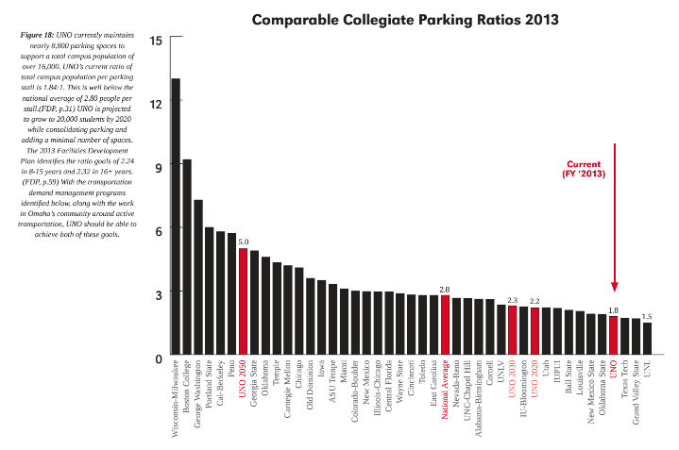

Although the parking ratio at UNO is fairly low when compared nationally to other colleges, this does not solve the campus mobility issues at UNO. It is one thing if students are able to find a parking spot on one of UNO’s three campuses, and it is another point to be able to efficiently move between campuses in a timely manner during the day. UNO has recognized this issue and has implemented a shuttle system that operates three routes connecting the three campuses. Until recent years, the shuttle system has been the victim to serious criticism from a wide demographic of UNO students, faculty, and visitors. With UNO’s current state - growing and developing buildings, attracting new students - in pursuit of becoming a premier nationally recognized undergraduate university, there is a need to explore options to improve UNO’s campus mobility. This research project aims to improve campus mobility by optimizing the UNO shuttle system.

A common goal for newly proposed resolutions to outdated systems is to account for a number of important variables that make a new system attractive to implement. One important variable to focus on for this system is sustainability. Sustainability is most often defined in terms of meeting “the needs of the present without compromising the ability of future generations to meet their own needs” [2].

It is with this definition that our project gains credibility and importance. A shuttle system that currently runs on diesel operated buses presents a situation where advances in sustainability can be made. If there are ways to limit the amount of fuel burned, decrease the carbon-footprint, and increase the sustainability of the UNO shuttle system - then a proposed change satisfying these requirements would be widely accepted.

To provide more momentum for our project, UNO has specifically detailed their commitment to improving the shuttle system in a sustainable manner. For example, in the UNO Sustainability Master Plan, their top six priorities are detailed. One of the six priorities relate to the improvement of the shuttle system: “Adjust campus shuttle contract to favor cleaner burning fuels to improve campus air quality and image.” This specific commitment to enhance the sustainability of UNO’s shuttle system is profound and well-received. From an administrative level, UNO has acknowledged the importance of a sustainable shuttle system - providing relevance and support for various efforts reflecting UNO’s priorities.

In previous years, UNO has demonstrated their commitment to resolving mobility issues with the transportation system in a sustainable manner. For example, UNO has proposed various strategies to address sustainable improvement. Two strategies share significance with this research project. UNO aims to “rightsize the fleet” by “identifying unused vehicle resources for reallocation or downsizing without impacting employee mobility” [1]. In addition, UNO strategized “fleet GPS tracking” by “using GPS systems to track vehicle operations and use this feedback to improve route efficiencies and fleet management” (UNO Sustainability Master Plan 49). Both strategies are supported by the conclusions this research project aims to demonstrate.

There are several terms that will be used throughout the remainder of the project. It is essential to understand these in order to understand the overarching concepts that are used in the solution to the stated problem. In the field of computer science and graph theory, the two primary definitions are those of a node and an edge. A node is simply a data point on a larger network. These networks can consist of hundreds or even thousands of nodes, but for the current purposes, will not exceed more than a few that gives an adequate solution to the problem. An edge is simply an association between two nodes that can be visualized as a connecting line, and computed as a two element subset of the nodes that it respectfully connects.

The term graph, as it is used currently, is referring to the network of nodes that is connected by edges, and representing, in this case, the UNO shuttle system. This system can be altered, as has been done to accommodate a fluctuating number of students. When another node is added to the graph along with its corresponding edges to accompany it, the graph is said to be augmented, or added to.

Mathematically, there is a need to represent the edge data that is present outside of a graphical form. This is especially important when creating software representations for simulation. This is done using an adjacency matrix. This is a |V| x |V| two-dimensional array of length and depth equal to the number of nodes, or vertices represented as ‘V’, that are present in the corresponding graph. In the current implementation, the row represents the starting node, and the column represents the ending node. The value at this location in the array is the edge value that can be mapped on the corresponding graph.

The corresponding graph is better and more aptly defined as the adjacency graph, to match the matrix. This is the representational graph that is created by mapping the entirety of the adjacency matrix using the edge values between nodes with (in this case) directed paths [3].

**3. Motivation**

It is said that those who have the power and the knowledge to make a positive change and impact in the world, have the responsibility to do so. This can be directly applied to the current situation, in which the right people need to be utilized the correct way. While transportation falls at the feet of administration for guidance and organization, the task of optimizing is much better suited to the computer science and engineering departments. These departments deal with problems and systems very similar to this, and the concepts that are taught can be directly applied to the stated problem.

Not only this, but being at a college, those that are making the system better are also the users of it. This makes for a direct benefit for those putting in the work, as well as their constituents. It is one of the primary purposes of the engineering and the computer sciences fields to make continued positive contributions to society as a whole. This can be seen hand has been outlined in several organizational ethics codes in the field, including the respective ethics codes for both IEEE and ACM [4] [5].

**4. Proposed Solution**

There are several ways to approach the problem at hand. A standard method that is most commonly used currently is to base the supply simply on observations made. This forms a try and try again approach which eventually works, until the variables change. Another method is to take data at various points and of various factors on the route, then base the supply off of those, possibly with a formulated algorithm based on the data. The approach we chose is based on Graph Theory and uses a software implementation to autonomously take in collected or simulated data and make recommendations based on it.

Make arrays (dist, parent, shortest path...)

Initialize arrays

Loop through all nodes

Set each node to false in shortest path

Set each node distance to infinity

Set dist of first node to 0 and parent to -1

Loop through all instances

Set min dist var to infinity and index -1

Loop through all nodes

Find min dist and index of next not in path

Add index to shortest path set

Loop through neighbors

Update shortest dist to each

Set parent of each

The graph theory approach was chosen for two reasons. First, it is scalable to a high degree, which in the event of extreme data set or matrix size, the problem can be handled with the implementation. Secondly, the solution can be implemented in a generic sense in the coding, so that different matrices can be handled with the same solution. This makes for a “one size fits all” solution that can be run as-is for all use cases.

The code itself is written in Java, and is based around the standard implementation of Dijkstra’s famous shortest-path algorithm. This algorithm finds the shortest path, lowest cost, and least effort through a set of given nodes in a graph. Using this, we are able to read in a set of nodes in a graph and determine which path is the best based on a variety of factors that can be distinguished between. A pseudocode overview can be found below [Figure 2], as well as the supporting code that was needed to support the core algorithm.

First, we create separate arrays to hold the values of the shortest distances from the starting node, the parent node to each node in the loop, and a boolean (true or false) to discriminate whether each node is in the overall shortest path from the starting node to the ending node. The starting and ending nodes are passed in to Dijkstra's method from the external source, in this case a simple txt file, through some other pre-processing structures. Initialization consists of looping through each of the positions in the boolean array and setting them to false, and looping through each position in the distance array while setting it to an arbitrarily high value (in this case, Java’s Integer.MAX_VALUE was used). The distance of the source node was then set to zero, and the parent of the first node was set to -1. This is the starting point for the algorithm.

The algorithm then goes into the main processing loop, where it first finds the node of minimum distance, that is not yet in the shortest path. This is done with a secondary looping structure and common comparisons to make the discovery. After the acquisition of this node, it is added to the shortest path boolean (true), and the index is stored. Another loop is then run through of each of the other nodes to update them relative to the current discovery. This is done by comparing the distances of each of the other nodes relative to the discovered (marked) node, and then setting the distance relative if it is closer than the original distance, which in the beginning, will be INT_MAX. Lastly, if this comparison passes and the distance is reset, then the parent of the neighbor node will be set to the currently marked node. This loop then continues to pass through the same number of times as nodes in the array.

Figure 4: Input graph matrix and variables

Figure : Pseudo Code for proposed algorithm

8:39, true, false, true, true

verts=5

startPT=0, endPT=4

0, 11.58, 0, 11.58, 0

0, 0, 1.72, 0, 0

0, 0, 0, 0, 2.58

0, 0, 0, 0, 2.72

12.68, 0, 0, 0, 0

In order to be able to leverage the algorithm for use, other structures had to also be defined. The nodes were structured in a matrix in which each row instantiated a node, and its connections to other nodes were described by the locations of the values within the row as shown in [Figure 4]. Since there are other variables that need to be referenced, these were each brought into the computing algorithm as well within the same file, in an organized file structure. This will be discussed more in the simulation structures section.

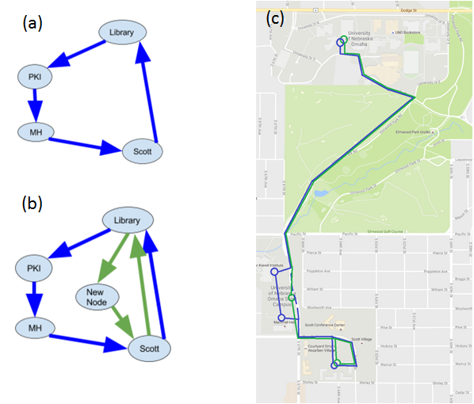[Figure 5a] shows the nodes of the dodge-pacific shuttle routes. Library = Criss Library, PKI = Peter Kiewit Institute, MH = Mammel Hall, Scott = Joint Scott Village and Scott Court bus stop. The blue path represents the current shuttle route. The red path represents the proposed new route with the augmented node.

Figure 5: (a) Initial Shuttle Routes (b) Augmented Graph (c) Implemented Shuttle Routes

This figure is the basis for our algorithm and modelling project. We used graph theory to model the nodes in a 5 by 5 array. The values in the array represent the time taken to get from node to node. In our program node 0 is Library, node 1 is PKI, node 2 is MH, node 3 is Scott, and node 4 is New Node.

[Figure 5c] shows the basis for [Figure 5a]. It is the current implementation of the campus shuttle system. The blue route shows the daily routes that the shuttles take between the Dodge and Pacific Campuses though the park, and the green route is the proposed change.

The time values were generated using a random number system. We wrote a Java program to generate test files were the array values were populated based on time observations by Molly Pavlik. The random variance between nodes is shown in the table below [Table 1].

Table 1: Edge time variances

|  |  |  |
| --- | --- | --- |
| Start Node | End Node | Time Variance |
| Library | PKI | 4-8 mins |
| PKI | MH | 0.5-2 mins |
| MH | Scott | 0.5-2.5 mins |
| Scott | Library | 4-8 mins |
| Library | New Node | 4-8 mins |
| New Node | Scott | 0.5-2 mins |

In addition to the random value generator for our program, we designed various penalties to more accurately produce a true reflection of the shuttle system.

The penalties include time additions for hazardous weather conditions, traffic in Elmwood Park, and general rush hour traffic. The weather penalty is determined by a random number generator where approximately 1 out of every 12 days experiences some type of bad weather. The traffic in Elmwood Park penalty is determined by time - if the shuttle is running between 8 and 9 am. Furthermore, the general traffic penalty is determined by time as well - if the shuttle is running between 8 and 9am, 12 and 1pm, and 4 and 5pm.

**Figure 9: Flowchart of Data Input and Output through Test File Generator, Custom Algorithm Processor, and Results Interpretation**

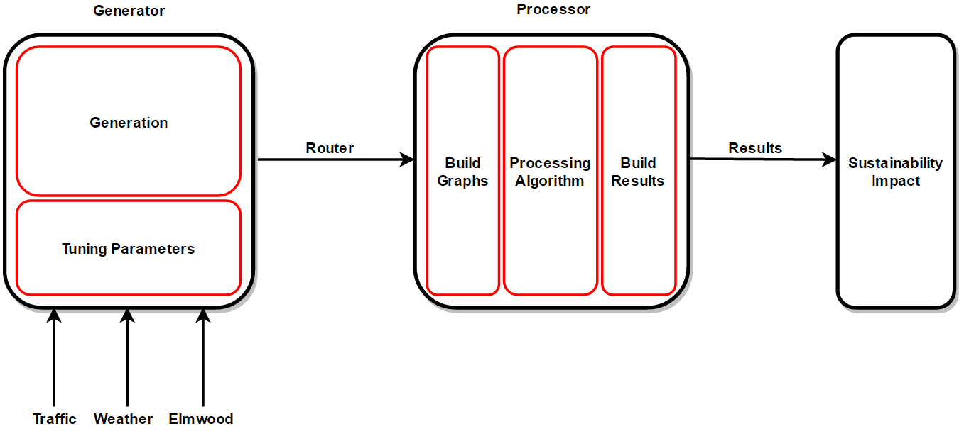Our modelling system produced 257 shuttle records per day - which simulate a full run. Each shuttle record has a various number of values: test case number, time stamp, penalties (weather, Elmwood, and traffic) Dijkstra’s choice, non-augmented route length (minutes), and augmented route length (minutes). 257 shuttle runs per day is an accurate model of an average day for the UNO shuttles running on the blue route between Dodge campus and Pacific campus. In our program, shuttle runs are generated based on a frequency. From 6:30am - 6pm, a shuttle record is generated every 3 minutes. From 6pm - 10:30pm, a shuttle record is generated every 10 minutes. The application of a frequency based modelling system adequately represents an average day for UNO shuttles. In addition, the application of penalties determined by weather, traffic, and delays in Elmwood park add to the rigor of our modelling system.

**5. Implementation and Results**

From our model of 257 shuttle runs per day, we generated 5 sets of shuttle runs to model a regular school week. With a total of 1285 total shuttle runs per week, we were able to generate graphs that demonstrate the differences between the current shuttle route, and our proposed route.

[Figure 6] shows counts of each route chosen by Dijkstra’s algorithm in our graph theory model. In total, our algorithm chose the augmented graph 1057 out of 1285 times, resulting in an 90% choice rate compared to 228 out of 1280 choices for the current route, a mere 10% choice rate as shown in [Figure 7]. [Figure 8] demonstrates a comparison of round trip travel times for each of the 1285 individual runs.  As demonstrated in the figure, the augmented route is consistently shown as the better option in terms of time when compared to the 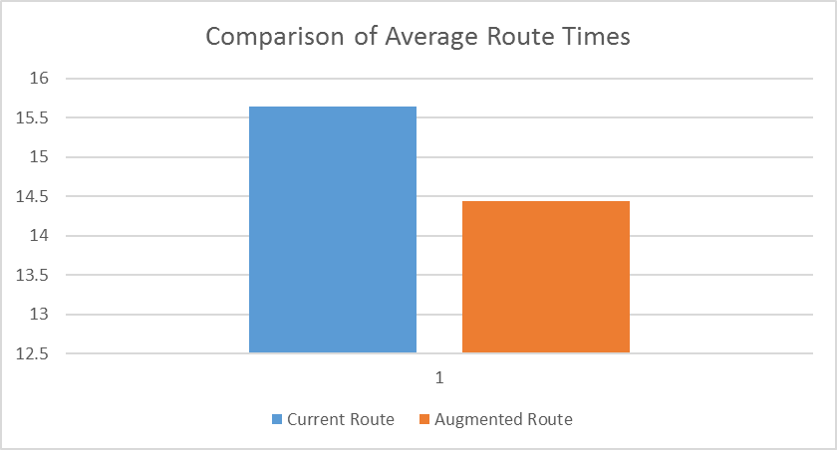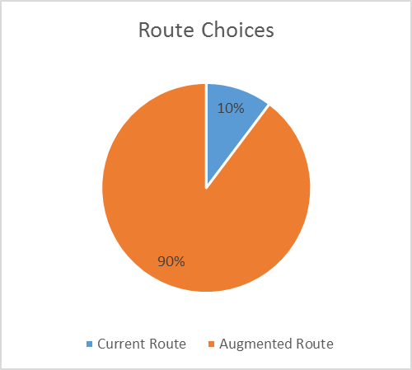current route. Moreover, through a 5 day average, our model depicts an average savings of 1.20 minutes per shuttle run. This can be translated to a savings of 308.4 minutes per day, and 1542 minutes per week.

Figure 6: Route Choices

Figure : Comparison of Average Route Times

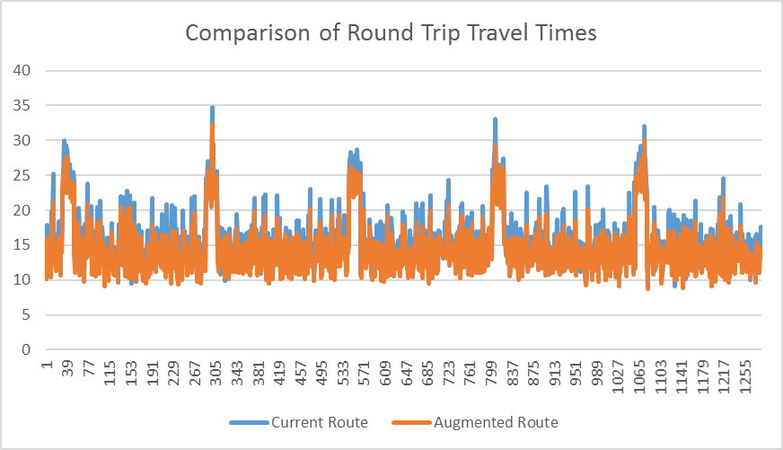This then leads into the greater discussion that involves the monetary and sustainability debates that encompass the shuttle situation as a whole. With 2 semesters that each run 17 weeks long within a typical university fiscal year, this savings can then be extended to a total of 52,428 minutes (or 873.8 hours) over the duration. In addition to this, the shuttle system runs at about half rate during the summer sessions. This then adds another 10,794 minutes, or 179.9 hours. The university (the case in point) currently outsources its shuttle services to external companies. Let’s project that each shuttle costs the university 38 dollars per hour of operation. At this rate, the recommended new shuttle node would save an average of 40,040.6 dollars per year. This is the tip of the iceberg.

Figure Comparison of Round Trip Travel Times

It is currently non-representable numerically, but the recommended new node would also allow each individual shuttle to run more efficiently and more effectively through its route. This then allows each shuttle to move more students per hour of operation. By doing this, the university can essentially run fewer shuttles at a time, thus alleviating the funding needed to keep all running at once. For example, if just 20% of the shuttles were not needed due to increases in route and transportation efficiency because of a nodal change, the university would save another 8008.12 dollars every year, bringing the total up to 48048.72 dollars.

On the side of sustainability, this can have an impact on CO emissions as well. Over the course of a year, it can be estimated that the entire shuttle fleet is operating at 25 mph for 75% of the time, and sitting idle for the other 25% of the time. To operate the shuttle at 25 mph for a period of 750.77 extra hours requires 1,681,724.80 grams of CO. To let the fleet sit idle for the other 25% of the time requires and extra 259,264.18 grams of CO. Obviously these numbers are extremely large and it would be a great service to both our civilization and our planet to reduce and optimize them, not just for our university, but for all around the US and abroad [6].

This is simply for one route. The university has three separate shuttle routes, which could, if optimized, potentially triple the results.

**6. Conclusions**

The UNO shuttle system is a vital component to campus mobility and interoperability on a daily basis. It is with this importance that the UNO shuttle system needs to be optimized to its utmost efficient capabilities. Each day, roughly 16,000 people have the opportunity to depend on the UNO shuttle system for effective mobility between campuses. In the 2017-2018 academic year, UNO will experience an influx of approximately 450 additional residential students on Pacific campus, as well as a multi-level parking structure with a capacity to hold approximately 1200 vehicles on 67th and Pacific. In total, the 2017-2018 academic year can introduce an influx of students, teachers, and faculty which will depend on the shuttle system of optimized travel and mobility each and every day.

Our graph theory model of the UNO shuttle system has produced a sound model that demonstrates areas where the system can be improved and optimized for future users. This project compares the current blue shuttle route to an augmented route proposed in this project. The augmented route contains a new node between PKI and Mammel Hall on 67th street. The implementation of this new node in our augmented graph is shown in our modelling system to save an average of 1.2 minutes per shuttle run. Which translates to a savings of 308.4 minutes per day, and 1542 minutes per week - based on 257 shuttle runs per day. Overall, the augmented route with a new node in the graph alleviate tensions associated with the shuttles being too slow - and does this in a sustainable manner. In the long run, a savings like this can pay off substantially in terms of fuel consumption, cost, and CO2 emissions.

With this in mind, our research project has demonstrated an increase in campus mobility and interoperability by decreasing the time it takes for a shuttle to complete its route. This improvement will alleviate many tensions surrounding the UNO shuttle system. In addition, the augmented graph will prepare the shuttle system to for an increase in demand for the 2017-2018 academic year, while taking the initiating steps leading to a more sustainable transportation system.

**7. References**

|  |  |
| --- | --- |
| [1] | Verdis Group, "UNO Sustainability Master Plan," November 2014. [Online]. Available: http://www.unomaha.edu/news/docs/UNO-Sustainability-Master-Plan.pdf. |
| [2] | J. Bartle, C. Decker, G. Englemann, J. Fiene, J. H. Kamm and P. Landow, "Campus Priorities: Charting a Clear Vision for 2020," February 2012. [Online]. Available: http://www.unomaha.edu/engagement/docs/2012-campus-priorities-2020.pdf. |
| [3] | T. H. Cormen, C. E. Leiserson and R. L. Rivest, Introduction to Algorithms, New York: NcGraw-Hill Book Company, 1994. |
| [4] | I. o. E. a. E. Engineers, "IEEE Code of Ethics," 18 October 2016. [Online]. Available: http://www.ieee.org/about/corporate/governance/p7-8.html. |
| [5] | A. f. C. Machinery, "ACM Code of Ethics and Professional Conduct," 18 October 2016. [Online]. Available: https://www.acm.org/about-acm/acm-code-of-ethics-and-professional-conduct. |
| [6] | Environmental Protection Agency, "Average In-Use Emissions from Urban Buses and School Buses," October 2008. [Online]. Available: https://www3.epa.gov/otaq/consumer/420f08026.pdf. |
| [7] | A. Gibbons, Algorithmic Graph Theory, New York: Press Syndicate, 1985. |
| [8] | University of Nebraska Omaha, "2016-2017 Campus Shuttle Map," 2 August 2016. [Online]. Available: http://www.unomaha.edu/business-and-finance/support-services/_documents/shuttle-map-2015-16.pdf. |
| [9] | H. D. Paul Deitel, Java: How To Program, Eighth Edition (Late Objects Version), Upper Saddle River, New Jersey: Pearson, 2010. |
| [10] | M. A. Weiss, Data Structures and Algorithm Analysis in Java (Third Edition), Upper Saddle River, New Jersey: Pearson, 2012. |