1. Immigration Literature Review
   1. Definitions on the types of Immigration
   2. Immigration Policy—General Policy
      1. European Policy (historical & today) – Wouter
      2. American Policy (historical & today) -- Brandy
      3. Asylum seeking policy (historical & today) – Kim & Harwinder
   3. Factors of Immigration
      1. Economic Factors – Hitesh, Daniel, Ranga
         1. Economic reasons for Human Migration
         2. Economic Impacts of Human Migration
      2. Environment Factors -- (Are we still including this?) - Brandy
         1. Drought
         2. Agricultural (Farming and fishing)
      3. Political Environment
         1. (War, forced immigration) - Brandy
2. Analysis & Methodology
   1. Volume of Immigrants (where they are coming from and where they’re going) - Brandy & Wouter
      1. Who is taking the most immigrants in Europe (total & relative) – Wouter
      2. Who is immigrating to the US - Brandy
      3. Where are the majority of the immigrants coming from – Brandy & Wouter
      4. What is the volume of illegal immigration (internationally, or is it specific to the US) -- Brandy
      5. What are the volumes of asylum seekers and refugees? Kim/Harwinder (please include sub points)
   2. Economic Growth - Hitesh, Ranga, Daniel
      1. How are the economics affected by immigration
3. Discussion
   1. Findings/recommendations
   2. Data gaps
   3. Future research

## 1. Literature Review

>> All

## 1.1 Definitions on the types of Immigration

Immigration is the process of moving from one country to another to live permanently. Migration, a broader term, is the process of moving with the intention of settling permanently or temporarily [14]. Migration delineates into several categories, internal and international and then forced or voluntary. Internal migration occurs when one individual (or family), moves to another area within a country’s borders. International migration is the movement from one country to another. Furthermore, migration may be voluntary or forced. Voluntary migration occurs when an individual (family) seeks better economic opportunities and housing [14]. Forced migration occurs when individuals (families) are expelled due to war or political conflict [14]. Often, these migrants are transported as slaves or prisoners [14]. However, refugees fleeing war, famine and natural disasters are intermediary between voluntary and forced migration.

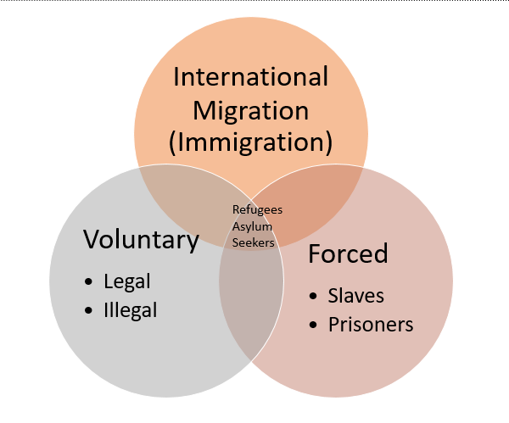

The focus of this research is to understand international immigration policy and how it affects voluntary and forced international migration, the factors leading to migration and the impact of migration on the destination countries.

## 1.2 Immigration Policy—General Policy

>> Brandy

Immigration policy is the legislative and administrative policies, court decisions and regulations that shape a country’s immigration system [16]. Immigration policy is the architecture that impacts the demographics, culture, economy, and politics of a country. Immigration policy has two primary objectives, 1) immigration control/regulation and 2) Immigration policy.

First, Immigration control is the rules and processes that determine the admission of foreign citizens into a country. Immigration control focuses on the selection of permanent immigrants, temporary migrant workers and refugees and restricts illegal immigration and the ethnic origin of the migrants. It covers the “who”, “what type” of migrant and “where does he/she come from” questions.

On the other hand, Immigration policy defines the conditions, or the “when” and “why”, provided for resident immigrants. The immigrant policies refer to the working/housing conditions, welfare provisions and educational opportunities [16]. It is an interdisciplinary subject that spans across political science/politics theories, international relations, sociology and psychology. An article by Meyer [16] delineates the strengths and weakness of six approaches to immigration policy including Marxism (and neo-Marxism), realism, liberalism, “national identity”, domestic policies (partisan and interest group politics), and institutionalism [16]. After evaluating each of these approaches in detail, Meyer [16] found a collaborative approach to using these ideals. For example, policies using realism to understand refugee policy and global power relationships. Marxism to understand migrant workers and illegal immigration, neoliberalism on EU policies (and refugee crises), and institutionalism on policies regarding refugees and migrant workers.

## 1.2.1 European Policy (historical & today)

>> Wouter

In 2013, Finotelli and Sciortino discuss the current state of European visa policies and immigration control. From the 1980s onwards, European governments have attempted to enforce a restrictive immigration and asylum strategy, as a result of illegal migration. This has led to Europe being referred to as ‘Fortress Europe’ by various researchers. Nevertheless, in 2013 it was estimated that European countries hosted up to 3.8 million irregular immigrants (immigrants who did not possess the required authorization). In addition, it was estimated that several million irregular immigrants acquired legal status through special programs, after they had illegally entered the European Union. At the same time, it was reported that almost three out of four immigrants in the Italian amnesty program had entered the country legally.

As the European Union consists of many different countries, not only the number of incoming immigrants varies, but so does that attitude towards immigrants. In 2008, Meuleman and Reeskens divided the member states of the EU into three classes, based on how tolerant the population of each country is towards immigration. The first class included the 9 most tolerant countries (*U.K., Portugal, Spain, Italy, the Netherlands, Belgium, Norway, Sweden* and *Finland*), followed by the second class (*France, Germany, Switzerland, Luxembourg* and *Ireland*) and the third class (*Greece, Denmark, Austria, Czech Republic, Hungary, Slovakia, Poland, Lithuania, Latvia* and *Estonia*). It should be noted that some countries have a longer history of immigration than others, which could explain the differences. Moreover, it shows that although the EU tries to harmonize immigration policies, populations of different countries have different opinions.

However, there is also another aspect that has an effect on immigration in Europe. The Schengen Agreement was signed by European leaders in 1985, and allows citizens of 26 member states to enter, live and even work in countries within the Schengen Area without any restrictions (Davis & Gift, 2014). This has created a unified European market, in which border control could be eliminated and both goods and people can be moved freely. Altogether, this unified market has reduced bureaucracy and increased collaboration between member states. However, allowing goods and people to move around member states can also have an effect on immigration. For example, a visitor on a visa entering Spain could continue to other member states, even though an additional visa would have officially been required to do so. At the same time, when Greece became a member state it did not lead to a migration of its lower-class population to wealthier member states (Guild & Bigo, 2017).

## 1.2.2 American Policy (historical & today)

>> Brandy

U.S. Immigration law is complex. The Immigration and Naturalization Act (INA) is the law governing U.S. Immigration Policy. It limits an annual limit of 675,000 permanent immigrants, with exceptions for close family members [17]. Lawful residency allows for foreign born immigratns to work lawfully and permanently within the United States. They are eligible for nearly all jobs and can remain within the United States even if unemployed.

Immigration to the United States follows four basic principles: 1) reunification of families, 2) admitting skilled laborers 3) refugee protection and 4) promoting diversity.

Family based immigration allows the admission of immediate relatives of an United States Citizen or family preferences [17]. Immediate relatives are considered spouses, unmarried minor children (under 21 years of age), and parents [17]. A limited number of visas are available for “family preferences” including adult children (married and unmarried), spouses of a legal resident. Note that under both types of admission, the prospective immigrants must meet eligibility criteria, age and financial requirements.

For employment-based immigration, visas are provided for immigrants with valuable skills to come to the United states both permanently or temporarily. Temporary employment-based visas are utilized for limited periods and there are about 20 types of temporary work visas [17]. Permanent employment visas are limited per year and divided into five categories including “extraordinary ability, professional (advanced degrees), skilled lavor for non-temporary/seasonable positions, special immigrants including religious workers former U.S. government employees, and individuals investing money in job-creating enterprises that will employ at U.S. fulltime workers [17].

Per-Country ceilings limits no group of permanent immigrants from a single country can exceed 7% of the total number of people immigrating to the United States in a single year [17]. This is a limit to prevent any immigrant group from dominating immigration patterns to the U.S. [17].

Finally, refugees are admitted based on their inability to return home because of “founded fear of prosecution” [17]. Prosecution is defined by particular social group, political view, religion, national origin. Refugees apply to the United States from a transition country. Admission is dependent on degree of risk, membership to groups of particular interest to the United States, and whether they have family members currently in the United States [17].

Asylum is similar to refugee status however that the individual is already in the United States and are seeking protection for the same grounds that other refugees may have. They apply at port of entry seeking admission or within the year of arriving in the United States. At this time, no limit is set to the number of individuals granted asylum in a given year [17]. Refugees and Asylum policies are discussed in further detail in the next section as this is pertaining to just the United States.

The Diversity Visa Program enacted by the Immigration Act of 1990 is dedicated for immigrants from countries with low rates of immigration to the United States [17]. To be eligible, an immigrant must have a high-school education and within the last five years, dedicated two years as a professional or professional in training. Spouses and minor unmarried children may also enter as dependents [17]. A random computer-generated algorithm chooses individuals evenly distributed among six geographic regions with low rates of immigration from countries with less than 50,000 immigrants within the last five years. While this program randomly selects individuals, it benefits Africans and Eastern Europeans the most [17].

## 1.2.3 Asylum seeking policy (historical & today)

>> Kim

**American Asylum Seeking Policy**

From past 30 years, developed nations have been struggling with the rise in asylum seekers. Every day more people around the world are now forcibly displaced from their homes. According to the UN High Commissioner for Refugees and Global Trend Report, 2.9 million people became refugees in 2014 [22]. Asylum Remedy is an essential part of Human Rights. Asylum has been one of the increasing sources for immigration [21]. *Who is Eligible and where can you apply?*

**"Any alien who is physically present in the United States or who arrives in the United States (whether or not at a designated port of arrival ...), irrespective of such alien's status, may apply for asylum ..."**

The quote mentioned above is from Immigration and Nationality Act. [23]

The concept of asylum — of providing a safe haven to people fleeing oppression -- was formally recognized by the international community at the United Nations in 1951.

Before becoming a refugee, an individual undergoes the asylum-seeking process to have his or her claim be evaluated. Hence, becoming an asylum seeker is the initial step into becoming a refugee. After Refugee Act of 1980 was effective in United States, the amount of asylum applications filed with Immigration and Naturalization Service increased rapid with 85,866 in 1997 followed by 128,190 cases filed in 1996 [30]. Asylum seeker often arrive at US border or already step foot on US soil can apply for asylum due to fear of persecution from origin countries.

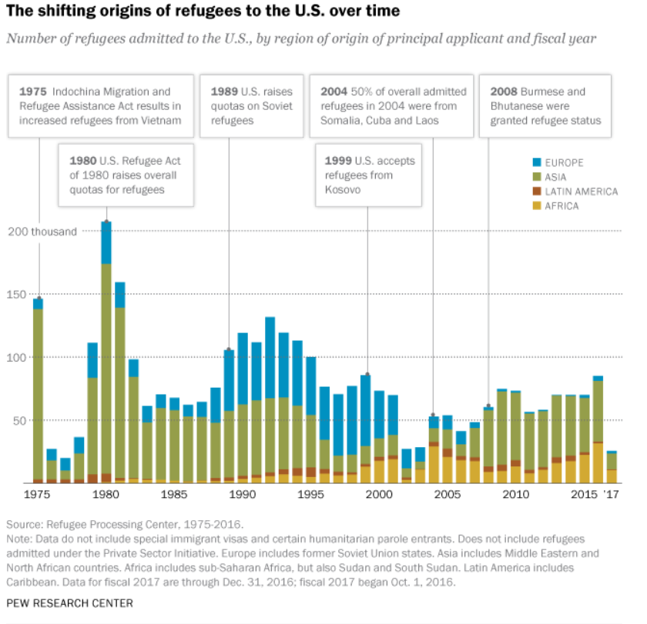

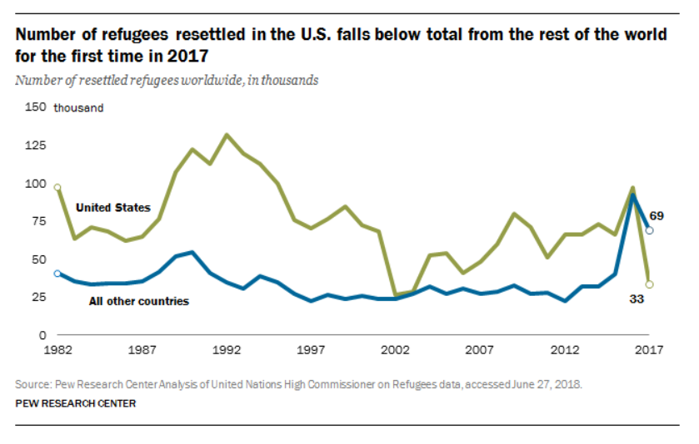

European Asylum-Seeking Policy (Harwinder)

## 1.3 Factors of Immigration

## 1.3.1 Economic Factors

>> Hitesh, Daniel, Ranga

As of 2015, there are approximately 244 million immigrants around the world, with majority of them living in developed countries. Approximately 19% of these immigrants live in the US alone. Immigration numbers have almost doubled in the last 50 years. Research shows that the shift of population from one location to other impacts not only the Economy of the country where people immigrate to, but also to the country where people emigrate from.

Throughout history large groups of people have immigrated from one part of the world to another. There are many different complex reasons behind these immigrations such as economic hardships, social or cultural pressures, political or military oppressions etc. However, in this literature review only the economic factors are discussed in detail. Furthermore, the impact on the economics of the sending and receiving countries, from these immigrations, is also discussed in detail.

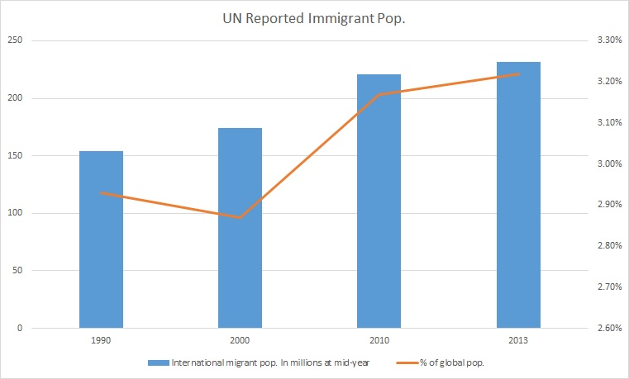

Source: <http://www.un.org/en/development/desa/population/migration/data/estimates2/estimates15.asp>

## 1.3.1.1 Economic reasons for Human Migration

>> Hitesh, Daniel, Ranga

The economic reasons, for immigration, are usually fueled by people’s desire to seek an improved quality of life. The lack of employment, entrepreneurial and or educational opportunities are usually the economic factors that motivate people to take the risk of migrating to a different place. In most cases people that migrate are the ones that come under the category of low-income citizens and most of the immigrations are done from developing countries to developed countries. This is pretty evident, considering the fact that in order to achieve an improved standard of living, it is essential to move to a place which has better economic conditions.

According to the net migration data of the world bank, in 2017, the top 5 countries with the maximum number of net emigrants were India, Bangladesh, China, Syrian Arab Republic & Pakistan. China being on the list is evident considering it’s the most populated country in the world. India, Bangladesh and Pakistan are the most populated countries of the South Asian region and each one of them is categorized as a ‘developing’ country. The lack of resources and overpopulation, in these countries, are the prime reasons for their significant net migration numbers. Syria has the maximum net migration of a single year, in 2012, which was primarily due to the fact that the country has been in civil war since 2011.

According to the same aforementioned database, top 5 countries with the maximum number of net immigrants in 2017 were United States, Germany, Turkey, Canada and the United Kingdom. Each of these countries are categorized as ‘developed countries with the United States, Germany and the UK being amongst the most powerful and economically dominant countries of the world. Canada adopts relatively open immigration policies due to the fact that it occupies a significantly large area with proportionally very little native population hence inviting immigrants to enlarge its workforce. Turkey receives most of its economic migrants from nearby developing countries, towards its Asian side, such as Armenia, Moldova, Georgia, Iran, Azerbaijan and other countries from Central Asia.

## 1.3.1.2 Economic Impact of Human Migration

>> Hitesh, Daniel, Ranga

## Positive Impact

Majority of the research indicates that immigration has a positive economic impact on both the sending and receiving countries. According to a research paper written by Ana Maria Iregui, “Studies show that the elimination of barriers to migration would have profound effects on world GDP, with estimates of gains ranging between 67 and 147 percent.” According to the Centre for Global Development, opening all borders could add $78 trillion to the world GDP.

Some research also suggests that the reduction in native employment due to automation can be offset by immigration considering the influx of immigrants increases the overall demand, consequently pushing the natives out of low-skilled manual labor into better paying occupations.

As far as fiscal impact is concerned, studies show that immigration has a very minimal effect although the effects tend to be positive. According to a 2007 literature review by the Congressional Budget Office, "Over the past two decades, most efforts to estimate the fiscal impact of immigration in the United States have concluded that, in aggregate and over the long term, tax revenues of all types generated by immigrants—both legal and unauthorized—exceed the cost of the services they use."

Immigrants has also been linked to higher achievements in education, greater invention and immigration, specifically in the United States. Many startup companies, in the United States, worth billions of dollars are either founded by immigrants or employee immigrant workers in highly ranked positions. Recent statistics have shown that foreign born students account for more than 50% of the total PhD student population in American Universities.

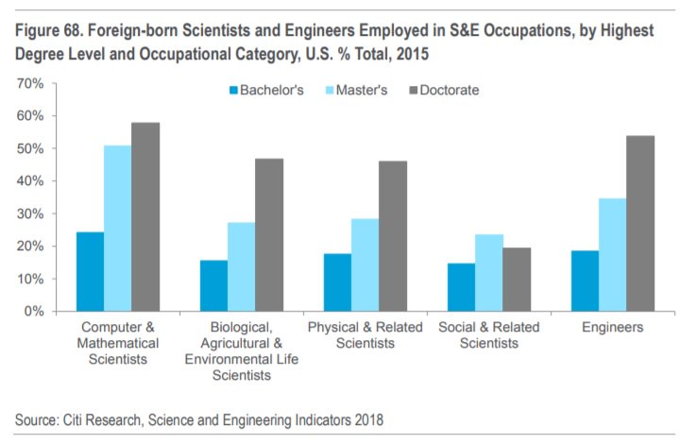

Source: <http://www.aei.org/publication/how-immigration-boosts-american-economic-growth-and-innovation/>

Research also shows that the sending economics of the sending countries also benefit from immigration. The primary reason for this is remittance which is the money these immigrants transfer back to their less developed countries from what they earn in the developed countries. “For many developing nations, remittances received make up a significant portion of their economies often receiving over 10% of their GDP in remittances each year.”

## Negative Impact

There are arguments against the economic benefits of immigration. The primary argument is with respect to the fact that an immigrant worker is willing to work for an income lower than what a native low skilled worker would demand because the immigrants expected standards of living are lower than that of the native. This forces the native low skilled workers out of jobs. This also results in greater income inequality in the native population.

A key factor to identify is the immigration of people with no documentation or in other words illegal immigrants. These immigrants work outside the native country’s economic system and usually get paid in cash from employers. This exchange of money has to be done ‘under the table’ and does not get taxed. This not only encourages employees to underpay the illegal immigrants and not employ legal native employees, but it also forces the illegal immigrants to remain below the poverty line hence increasing the rate of crime and consequently leaving a negative impact on the economy.

Another argument against immigration is related to asylum seekers. When immigrants apply for an asylum, they are usually given working privileges and welfare benefits right away. After their case is reviewed the authorities decide whether the applicants are eligible and if not, they get deported back to their native countries. This process can take up to years due to the backlog of a very high number of applicants, as is the case in the US. “In March 2018, there was a backlog of 690,000 deportation cases under review”. This allows anyone in the world to apply for asylum by making up false oppressive cases and benefitting from the welfare system for long periods of time.

## 1.3.3 Environment Factors -- (Are we still including this?)

>> Brandy

Migration is a normal part of the development process. Unmanaged and unexpected climate migration intensifies problems such as deterioration of ecosystems, slowing economic development, disruption of human and political rights, and increase in internal conflicts (24, 25). The international community observes that the current mitigation of climate change may not be enough to prevent significant harm (26).

The degradation of the environment and increase in natural disasters are key drivers for migration and displacement (27). Several factors determine success of emigration as an adaption strategy to the adverse effects of global warming. Factors that increase migration due to climate change include quality and quantity of economic, social, and geographical resources available, the vulnerability of the place of origin and the political/economic situation of the destination country (27).

In a study in 2018 by Rigaud, de Sherbinin, Jones, Bergmann et al projected more than 143 million internal migrants by 2050 across sub-Sahara Africa, South Asia, and Latin America due to environmental changes (28). The volume of potential migrants indicates that migration and displacement are critical issues within the context of climate change that requires international attention (27).

Environmental drivers of migrations in poor regions where agriculture is a dominant economic driving force increasingly focuses on evaluating the impact of climate change. Without significant adaptation measure, regions home to poor and food insecure populations will suffer negative impacts when productions of crops decline drastically. Furthermore, natural disasters such as volcanic eruptions, typhoons, hurricanes, landslides, and earthquakes will continue to increase displacement and affect migration in countries with poor infrastructure to support the effects of those phenomena (27).

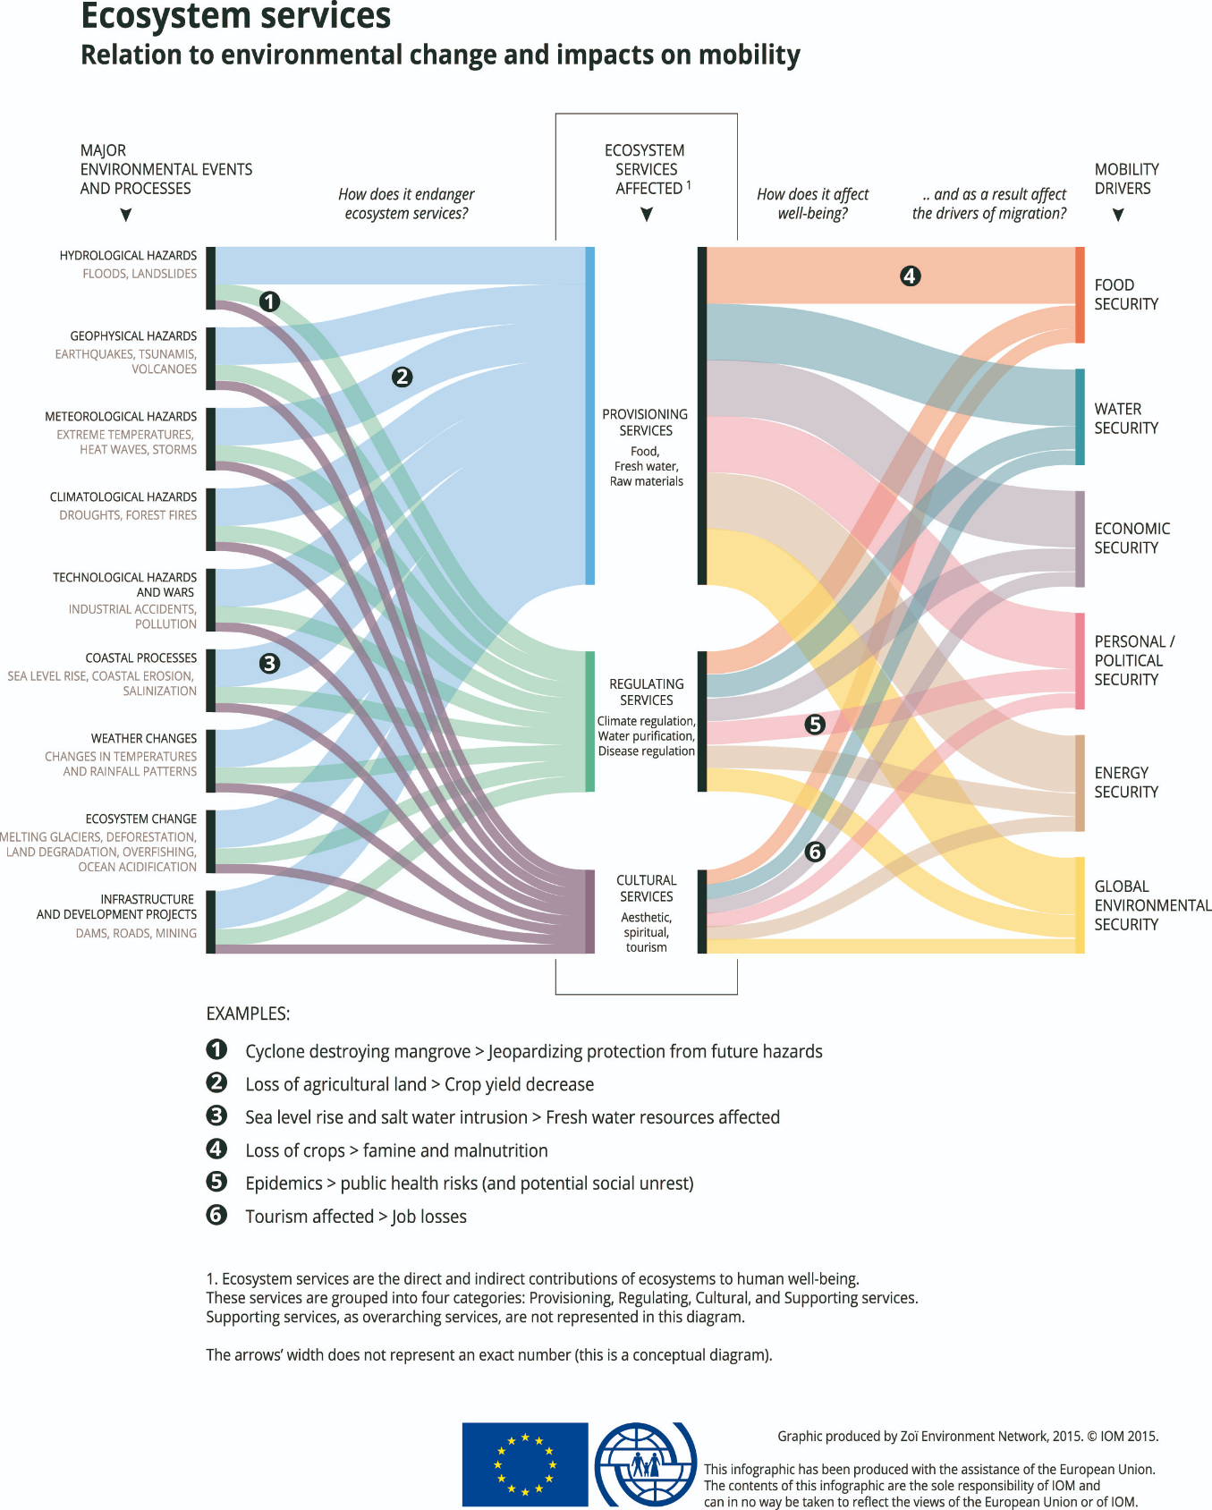

## (<https://environmentalmigration.iom.int/infographics>)

## 1.3.3.1 Agricultural (Farming and fishing)

Climate change affects food production in low latitude countries, the higher temperatures affect the crop yield as well as water scarcity. Water scarcity affects both the crop yield but also livestock production and fisheries (28). Productivity declines increase poverty and food insecurity (28). Research by Feng, Krueger and Oppenheimer (2010) examined the link between climate productivity changes in agriculture and out-migration with Mexico (to the United States). They found a linear correlation between crop yields and emigration and predicted an increase in migration to the United States (thus inferring similar behaviors to other migrate-receiving countries).

As the world population continues to grow, the demand for food and water exacerbates the competition for these resources prompting migration for some individuals and families. Within the context of famine and drought, food security and migration have a direct relationship because the people are forced for migrate to escape hunger (28), however the migration is frequently temporary. Migration is often a strategy used by farmer to cope with income uncertainty as well as food insecurity. Poorer rural households tend to send one or more family members to urban areas to work in non-agriculture sectors to reduce the risk of hunger and extreme poverty (28). Furthermore, the evidence suggests that households with members that are anxious about food security, often decide that an adult should migrate in search of employment to support the family better (28).

Additionally, adequate humanitarian assistance is a consideration for internal migratants (individuals migrating within the country and those that are refugees to the country) (28). Support for these communities brings social benefits in stabilization of these economies, protecting families and providing opportunities for economic development (28 ).

## 1.3.4 Political Environment

## 1.3.4.1 (War, forced immigration) -- isn’t this

>> Brandy

# 2. Analysis & Methodology

>> All

Hypotheses and research questions

What are the factors leading to the current immigration crises and what are the recommendations to improve the situation for immigrants internationally?

1. First, we need to see the volume of immigrants, where are they coming from and where are they going?
2. How does illegal immigration fit into the international immigration crises?
3. What portion of immigrants are asylum seekers and refugees?
4. How are economies being affected by immigration? Is there a positive direct relationship between immigration flow and the host countries economy/living standards (I.e. GDP per capita and per person employed?) Is there a positive direct relationship to labor market performance (I.e. defined through employment rate and wage levels)? What is the economic effect of education on attracting migrants?

## 2.1 Volume of Immigrants (where they are coming from and where they’re going)

>> Brandy & Wouter

## 2.1.1 Who is taking most immigrants in Europe (total & relative)

>> Wouter

Figure 1 shows the distribution of immigrants in Europe in the year 2017. Since the percentage of immigrants with an ‘unknown’ origin is very low, the administration of immigration in Europe appears to be accurate. It can also be observed that Germany takes the largest number of immigrants by far, and that the first five countries (Germany, United Kingdom, Spain, Italy and France) together take the very vast majority of all immigrants in Europe. However, it should also be noted that that these countries are some of the largest countries on the continent, both in terms of area size and population.

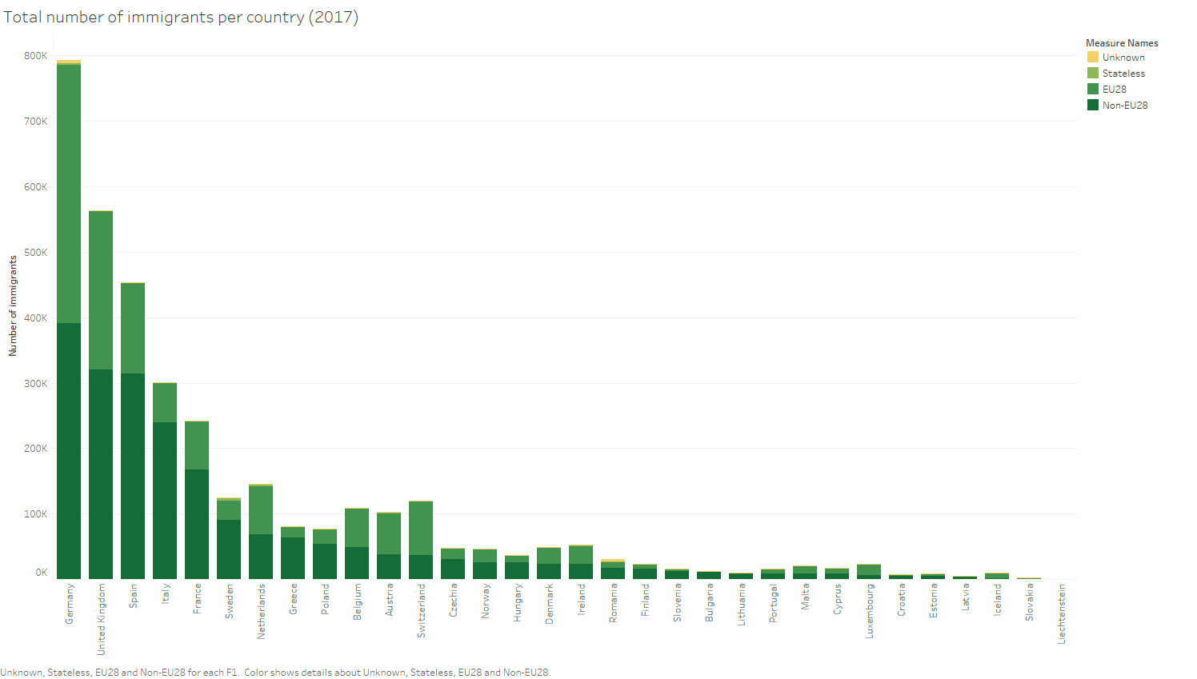Figure 1: Total number of immigrants per European country (2017).

Therefore, it is more interesting to compare the number of non-EU28 immigrants for each country to its own population and observe the relative distribution of immigrants in Europe. Figure 2 shows the immigrants per 1000 inhabitants of each European country. Here, some of the smallest countries appear to take the highest number of immigrants when compared to their own population. In Figure 2, Spain, Germany and the United Kingdom rank average, with Italy and France ranking below average.

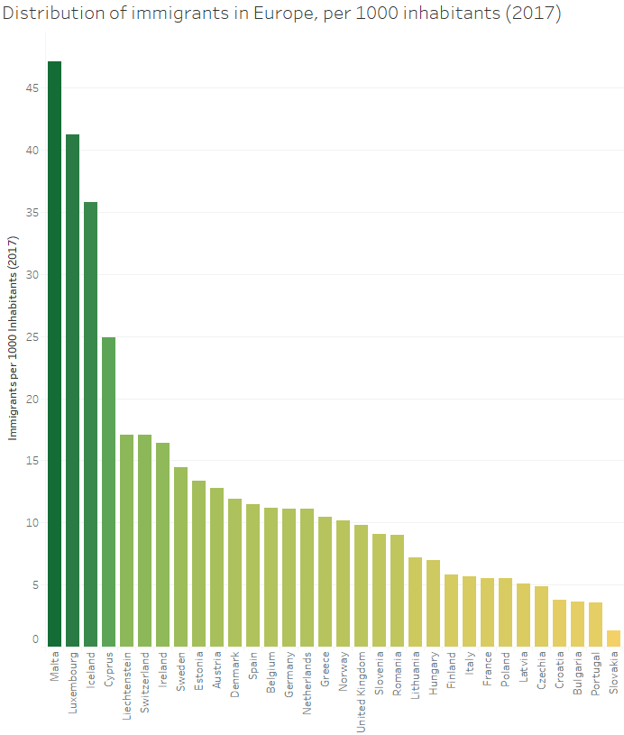

Figure 2: Distribution of immigrants in Europe, per 1000 inhabitants (2017)

>> Compare number of immigrants to country’s GDP.

## 2.1.2 Who is immigrating to the US

>> Brandy

## 2.1.3 Where are the majority of the immigrants coming from

>> Brandy & Wouter

## 2.1.4 What is the volume of illegal immigration (internationally, or is it specific to the US)

>> Brandy

## 2.1.5 What are the volumes of asylum seekers and refugees?

>> Kim & Harwinder

(please include sub points)

## 2.2 Economic Growth

>> Hitesh, Ranga, Daniel

## 2.2.1 How are the economics affected by immigration

# 3. Discussion

>> All

## 3.1 Findings/recommendations

>> All

## 3.2 Data gaps

>> All

## 3.3 Future research

>> All

## 3.4 Conclusion

>> All

# 4. References

(APA)

1. [1] Davis, D., & Gift, T. (2014). The positive effects of the Schengen agreement on European trade. *The World Economy, 37*(11), 1541-1557.
2. [2] Finotelli, C., & Sciortino, G. (2013). Through the gates of the fortress: European visa policies and the limits of immigration control. *Perspectives on European Politics and Society, 14*(1), 80-101.
3. [3] Guild, E., & Bigo, D. (2017). Policing at a distance: Schengen visa policies. In Controlling Frontiers (pp. 233-263). Routledge.
4. [4] Meuleman, B., & Reeskens, T. (2008). The relation between integration policy and majority attitudes toward immigration. An empirical test across European countries. Dag van de Sociologie, Leuven.
5. <http://www.globalissues.org/article/537/immigration>
6. [https://en.wikipedia.org/wiki/Human_migration#cite_note-40](https://en.wikipedia.org/wiki/Human_migration)
7. <https://ideas.repec.org/p/unu/wpaper/dp2003-27.html>
8. <https://data.worldbank.org/indicator/sm.pop.netm?end=2017&start=1962&view=chart&year_high_desc=false>
9. <https://en.wikipedia.org/wiki/Immigration_to_Turkey>
10. <https://www.cbo.gov/sites/default/files/110th-congress-2007-2008/reports/12-6-immigration.pdf>
11. <http://www.aei.org/publication/how-immigration-boosts-american-economic-growth-and-innovation/>
12. <http://www.migrationpolicy.org/article/understanding-importance-remittances>
13. <https://www.thebalance.com/how-immigration-impacts-the-economy-4125413>
14. Britannica, T. E. (2016, July 27). Human migration. Retrieved March 12, 2019, from <https://www.britannica.com/topic/human-migration>
15. Meyers, E. (2000). Theories of International Immigration Policy — A Comparative Analysis. *International Migration Review*, *34*(4), 1245–1282. <https://doi.org/10.1177/019791830003400407>
16. Migration Policy. (2019). Migration Policy. Retrieved March 12, 2019 from <https://www.migrationpolicy.org/topics/immigration-policy-law>
17. Neli Demireva; *Immigration Policy and the Shaping of U.S. Culture: Becoming America.* By Roger White, *Migration Studies*, , mnz007, <https://doi.org/10.1093/migration/mnz007>
18. <https://www.americanimmigrationcouncil.org/research/how-united-states-immigration-system-works>
19. <https://www.researchgate.net/publication/323895041_Migrants'_Role_in_Enhancing_the_Economic_Development_of_Host_Countries_Empirical_Evidence_from_Europe>
20. S
21. SCHUCK, P. (1990). The Great Immigration Debate. Retrieved from <https://prospect.org/article/great-immigration-debate>
22. Newland, K. (2015, July 22). Beyond Asylum: Adapting the Global Protection System to Better Meet Escalating Needs. Retrieved from <https://www.migrationpolicy.org/events/beyond-asylum-adapting-global-protection-system-better-meet-escalating-needs>
23. Dooling, S. (2018, December 3). What Is Asylum? Who Is Eligible? Why Do Recent Changes Matter? Retrieved from <https://www.wbur.org/news/2018/12/03/asylum-explainer>
24. Gleditsch NP, Nordas R, Salehyan I (2007) Climate Change and Conflict: The Migration Link (International Peace Academy, New York)
25. Feng, S., Krueger, A., Oppenheimer, M. (2010) Linkages among climate change, crop yields and Mexico-US cross-border migration. (PNAS). <https://www.pnas.org/content/pnas/107/32/14257.full.pdf>
26. Sujatha Byravan & Sudhir Chella Rajan (2006) Providing new homes for climate change exiles, , 6:2, 247-252 To link to this article: <https://doi.org/10.1080/14693062.2006.9685599>
27. Rigaud, K.K., de Sherbinin, A., Jones, B., Bergmann, J., Clement, V., Ober, K., Schewe, J., Adamo, S., McCusker, B., Heuser, S., & Midgley, A. 2018. Groundswell: Preparing for Internal Climate Migration. Washington, DC, The World Bank.
28. Warner, K., & Afifi, T. 2014. Where the rain falls: Evidence from 8 countries on how vulnerable households use migration to manage the risk of rainfall variability and food insecurity. Climate and Development, 6:1:1–17
29. *Asylees, Fiscal Year 1997* (Vol. 3, Rep.). (1999).