**…………………………………………….**

**Software Requirements Specification** for **LogicMaster.**

Version 1.0

Prepared by:

1. Divyansh Naithani
2. Sachin Rawat
3. Shivam Kulshrestha
4. Baljeet Thakur
5. Anmol Tyagi.

**July 2020**

**………………………………………………………………**

**-----------Table of content---------**

**1. Introduction**  
 1.1 Purpose  
 1.2 Document Convention  
 1.3 Intended Audience and Reading Suggestions  
 1.4 Product Scope  
 1.5 References

**2. Overall Description** 2.1 Product Perspective  
 2.2 Product Functions  
 2.3 User Classes and Characteristics  
 2.4 Operating Environment  
 2.5 Design and Implementation Constraints  
 2.6 User Documentation

**3. External Interface Requirements**  
 3.1 User Interfaces  
 3.2 Hardware Interfaces

**4. System Features**  
 4.1 Data Table  
 4.2 Servlets  
 4.3 JSP

4.4 Entity

**5. Other Non-functional Requirements**  
 5.1 Performance Requirements  
 5.2 Safety Requirements   
 5.3 Security Requirements   
 5.4 Software Quality Attributes

**\*\*\*\*\*\*\*\*\*\*\*\*\*\*\*\*\*\*\*\*\*\*\*\*\*\*\*\*\*\*\*\*\*\*\*\*\*\*\*\*\*\*\*\*\*\*\*\*\*\*\*\*\*\*\*\*\*\*\*\*\*\*\*\*\*\*\*\*\*\*\*\*\*\*\*\*\*\*\*\*\*\***

1. **Introduction**
   1. **Purpose.**

The purpose of this document is to present a detailed description of the web application LogicMaster. It will explain the purpose and features of the software, the interfaces of the software, what the software will do and the constraints under which it must operate. This document is intended for users of the software and also potential developers.

* 1. **Documentation Convention.**

This Document was created based on the IEEE template for System Requirement Specification Documents.

* 1. **Intended Audience and Reading Suggestions.**

• Typical Users, such as students, who want to use LogicMaster for learning technologies like Java, Hibernate, etc

• Advanced/Professional Users, such as engineers or researchers, who want to use LogicMaster to add to their skills by learning latest and trending technologies.

• Any user who wants to use LogicMaster to share queries and find solutions for one.

* 1. **Design and Implementation Constraints**

LogicMaster is developed in Java. It has been built on top of the Eclipse Platform. It uses a modular design where every feature is wrapped into a separate module and the modules depend on each other through well-written JSPs.

* 1. **User Documentation**

There is a quick start guide will be available on the github.

We will share the github link soon. Basic way to use the website will be available on the Home page of website.

**3. External Interface Requirements**

* 1. **User interfaces**

1.LogicMaster’s Welcome Screen

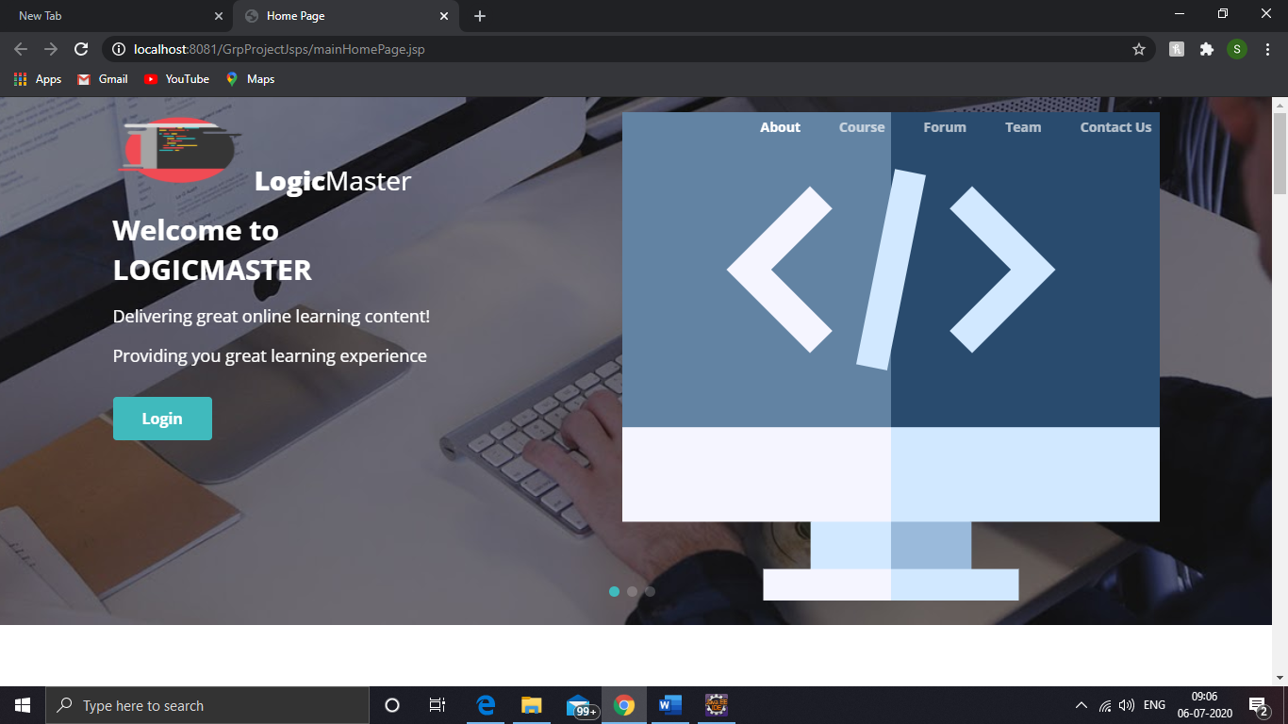

2.LogicMaster’s course screen

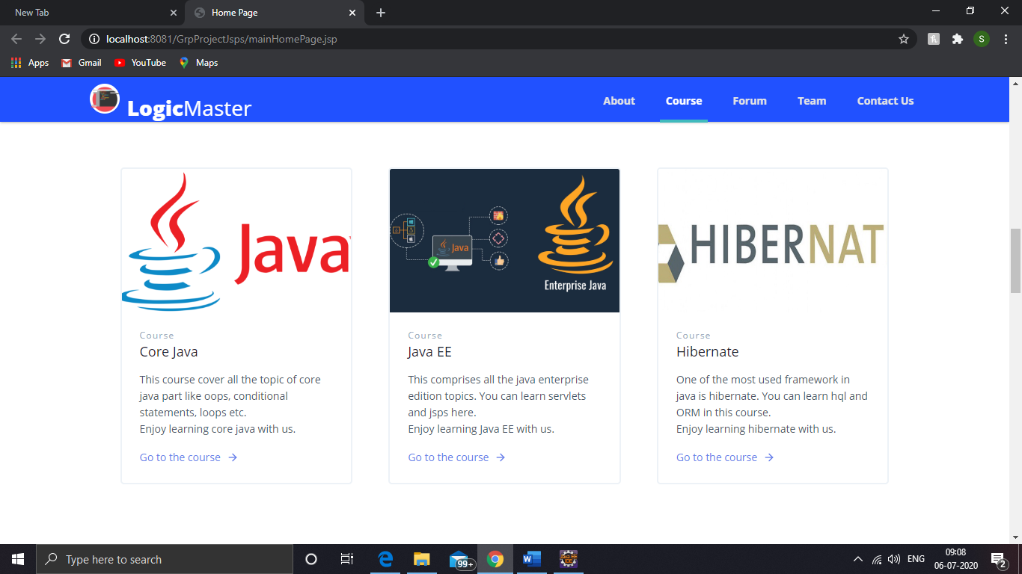

3.LogicMaster’s Forum screen

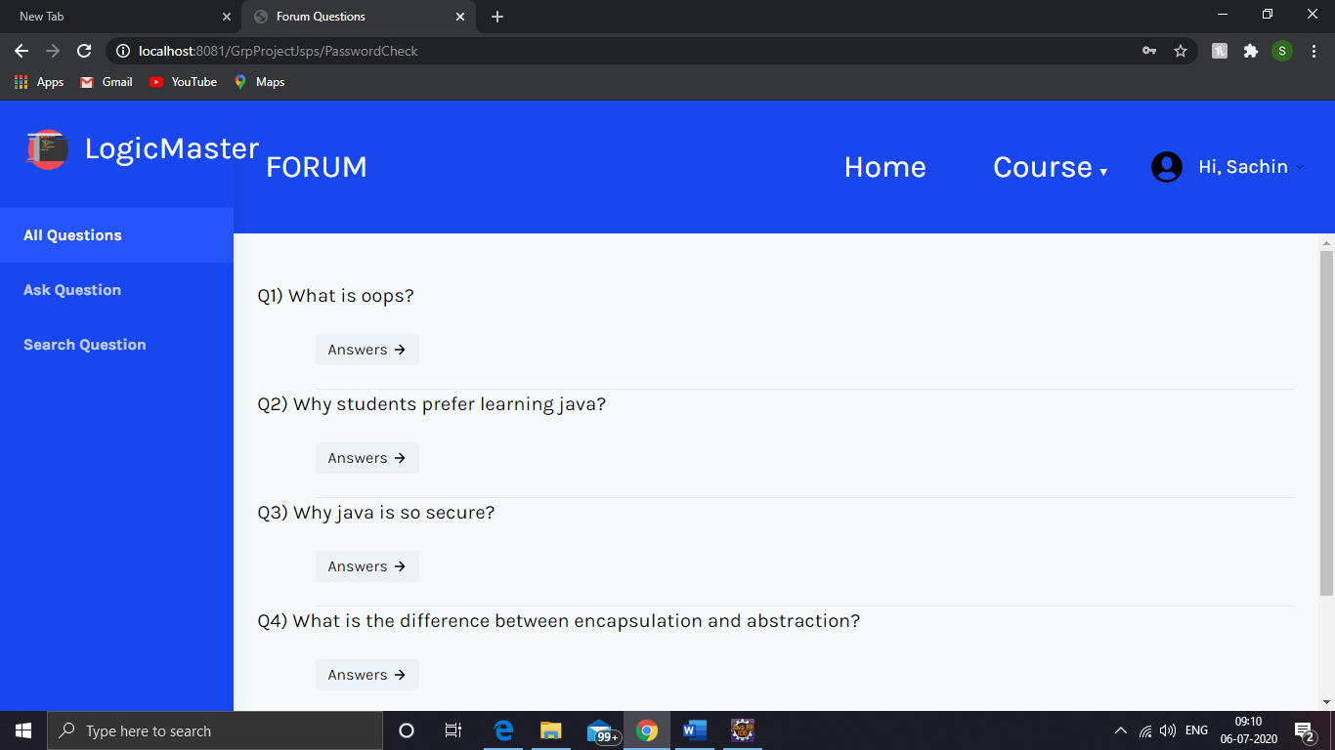

4.LogicMaster’s signin screen

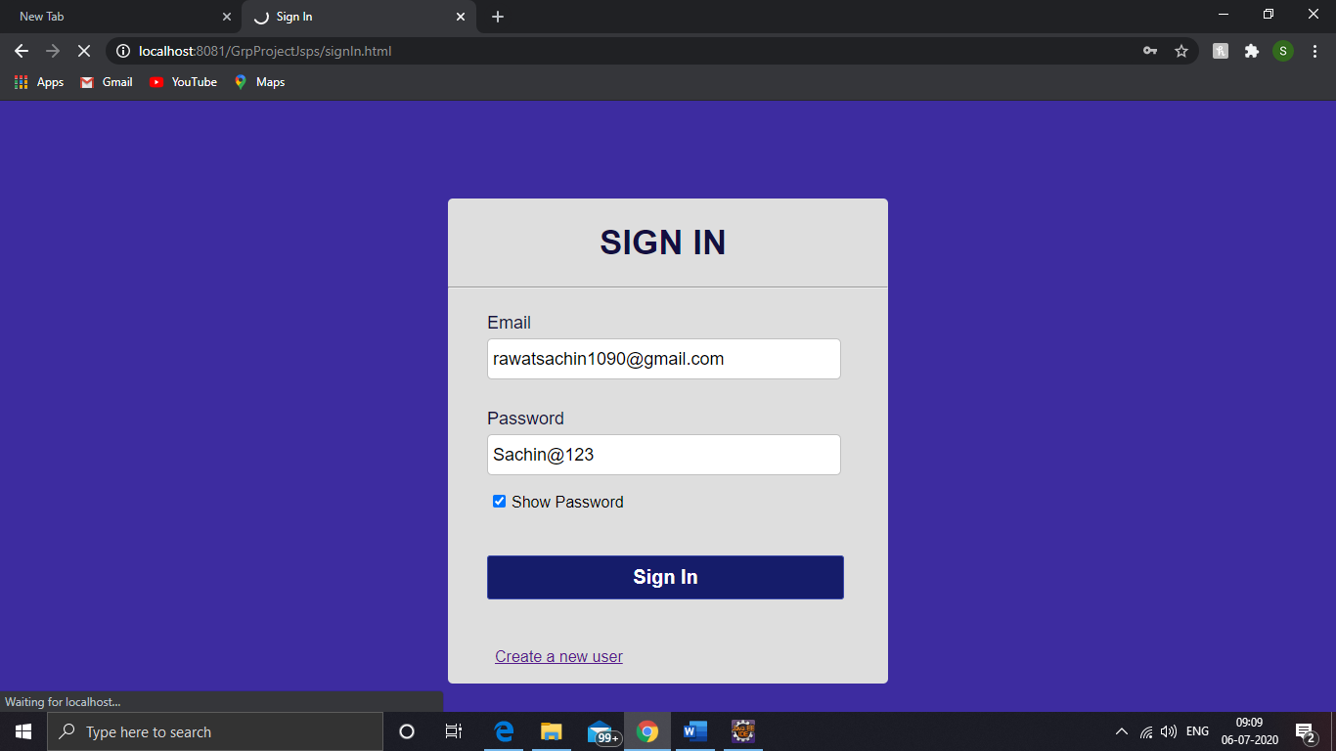

5.LogicMaster’s java course

