**OXFORD INTERNATIONAL PUBLIC SCHOOL**

ACADEMIC YEAR : 2022-23

**PROJECT REPORT ON**

**HOSPITAL MANAGEMENT**

ROLL NO : 1315

NAME : SACHIN SHARMA

CLASS : XII

SUBJECT : INFORMATICS PRACTICES

SUB CODE : 065

PROJECT GUIDE: Mr Naveen Nath PGT

**Oxford international public school**

SANGANER, JAIPUR

**CERTIFICATE**

This is to certify that Cadet **Sachin Sharma** Rollno **3015** has successfully completed the project Work entitlted SHOE BILLING SYSTEM (SBS) in the subject INFORMATICS PRACTICS (065) laid down in the regulations of CBSE for the purpose of Practical Examination in Class XII to be held in OXFORD INTERNATIONAL PUBLIC SCHOOL, JAIPUR on______________.

PGT INFORMATICS PRACTICES

Examiner:

Name: _______________

Signature:

**TABLE OF CONTENTS [ T O C ]**

SER DESCRIPTION PAGE NO

01 ACKNOWLEDGEMENT 04

02 INTRODUCTION 05

03 OBJECTIVES OF THE PROJECT 05

04 PROPOSED SYSTEM 06

05 SYSTEM DEVELOPMENT LIFE CYCLE (SDLC) 07

06 PHASES OF SYSTEM DEVELOPMENT LIFE CYCLE 08

07 SOURCE CODE 11

08 OUTPUT 19

09 HARDWARE AND SOFTWARE REQUIREMENTS 34

10 BIBLIOGRAPHY 34

**S**

**ACKNOWLEDGEMENT**

Apart from the efforts of me, the success of any project depends largely on the encouragement and guidelines of many others. I take this opportunity to express my gratitude to the people who have been instrumental in the successful completion of this project.

I express deep sense of gratitude to almighty God for giving me strength for the successful completion of the project.

I express my heartfelt gratitude to my parents for constant encouragement while carrying out this project.

I gratefully acknowledge the contribution of the individuals who contributed in bringing this project up to this level, who continues to look after me despite my flaws,

I express my deep sense of gratitude to the luminary The Principal, oxford international public school who has been continuously motivating and extending their helping hand to us.

I express my sincere thanks to the academician The Co-ordinator, oxford international public school, for constant encouragement and the guidance provided during this project

I am overwhelmed to express my thanks to The Administrative Officer for providing me an infrastructure and moral support while carrying out this project in the school.

My sincere thanks to Mr. Naveen Nath, Master In-charge, A guide, Mentor all the above a friend, who critically reviewed my project and helped in solving each and every problem, occurred during implementation of the project

The guidance and support received from all the members who contributed and who are contributing to this project, was vital for the success of the project. I am grateful for their constant support and help.

**PROJECT ON HOSPITAL MANAGEMENT (HM)**

**HOSPITAL**

A hospital is a health care institution providing patient treatment with specialized staff and equipment. Hospitals are usually funded by public sector by health organisations (for profit or non-profit), by health insurance companies, or by charities, including direct charitable donations. Hospitals have a range of departments (e.g., surgery, and urgent care etc).

**OBJECTIVES OF THE PROJECT**

A hospital management system is an information system that manages the aspects of a hospital. This may include the administrative, financial, and medical processing. It is an integrated end-to-end Hospital Management System that provides relevant information across the hospital to support effective decision making for patient care, hospital administration and critical financial accounting, in a seamless flow. This program can look after Inpatients, OPD patients, records, database treatments, status illness, billings etc. it also maintains their hospital info such as ward id, Doctor in Charge, Department administering etc. Now with a laboratory module to handle all lab operations...!!! Not only has this it also looked after doctor and staff records and payments. Now with advanced features like LAN connectivity, ICD10 disease database, Webcam support.

**PROPOSED SYSTEM**

Today one cannot afford to rely on the fallible human beings of be really wants to stand against today’s merciless competition where not to wise saying “to err is human” no longer valid, it’s outdated to rationalize your mistake. So, to keep pace with time, to bring about the best result without malfunctioning and greater efficiency so to replace the unending heaps of flies with a much sophisticated hard disk of the computer.

One has to use the data management software. Software has been an ascent in automation various organisations. Many software products working are now in markets, which have helped in making the organizations work easier and efficiently. Data management initially had to maintain a lot of ledgers and a lot of paperwork has to be done but now software production this organization has made their work faster and easier. Now only this software has to be loaded on the computer and work can be done.

This prevents a lot of time and money. The work becomes fully automated and any information regarding the organization can be obtained by clicking the button. Moreover, now it’s an age of computers of and automating such an organization gives the better look.

**SYSTEM DEVELOPMENT LIFE CYCLE (SDLC)**

The systems development life cycle is a project management technique that divides complex projects into smaller, more easily managed segments or phases. Segmenting projects allows managers to verify the successful completion of project phases before allocating resources to subsequent phases.

Software development projects typically include initiation, planning, design, development, testing, implementation, and maintenance phases. However, the phases may be divided differently depending on the organization involved.

For example, initial project activities might be designated as request, requirements-definition, and planning phases, or initiation, concept-development, and planning phases. End users of the system under development should be involved in reviewing the output of each phase to ensure the system is being built to deliver the needed functionality.

**PHASES OF SYSTEM DEVELOPMENT LIFE CYCLE**

**INITIATION PHASE**

The Initiation Phase begins when a business sponsor identifies a need or an opportunity.

The purpose of the Initiation Phase is to:

Identify and validate an opportunity to improve business accomplishments of the organization or a deficiency related to a business need.

Identify significant assumptions and constraints on solutions to that need.

Recommend the exploration of alternative concepts and methods to satisfy the need including questioning the need for technology, i.e., will a change in the business process offer a solution?

Assure executive business and executive technical sponsorship. The Sponsor designates a Project Manager and the business need is documented in a Concept Proposal. The Concept Proposal includes information about the business process and the relationship to the Agency/Organization.

Infrastructure and the Strategic Plan. A successful Concept Proposal results in a Project Management Charter which outlines the authority of the project manager to begin the project.

Careful oversight is required to ensure projects support strategic business objectives and resources are effectively implemented into an organization's enterprise architecture. The initiation phase begins when an opportunity to add, improve, or correct a system is identified and formally requested through the presentation of a business case. The business case should, at a minimum, describe a proposal’s purpose, identify expected benefits, and explain how the proposed system supports one of the organization’s business strategies. The business case should also identify alternative solutions and detail as many informational, functional, and network requirements as possible.

**SYSTEM CONCEPT DEVELOPMENT PHASE**

The System Concept Development Phase begins after a business need or opportunity is validated by the Agency/Organization Program Leadership and the Agency/Organization CIO.

The purpose of the System Concept Development Phase is to:

Determine the feasibility and appropriateness of the alternatives.

Identify system interfaces.

Identify basic functional and data requirements to satisfy the business need.

Establish system boundaries; identify goals, objectives, critical success factors, and performance measures.

Evaluate costs and benefits of alternative approaches to satisfy the basic functional requirements

Assess project risks

Identify and initiate risk mitigation actions, and Develop high-level technical architecture, process models, data models, and a concept of operations. This phase explores potential technical solutions within the context of the business need.

It may include several trade-off decisions such as the decision to use COTS software products as opposed to developing custom software or reusing software components, or the decision to use an incremental delivery versus a complete, onetime deployment.

Construction of executable prototypes is encouraged to evaluate technology to support the business process. The System Boundary Document serves as an important reference document to support the Information Technology Project Request (ITPR) process.

The ITPR must be approved by the State CIO before the project can move forward.

**PLANNING PHASE**

The planning phase is the most critical step in completing development, acquisition, and maintenance projects. Careful planning, particularly in the early stages of a project, is necessary to coordinate activities and manage project risks effectively. The depth and formality of project plans should be commensurate with the characteristics and risks of a given project. Project plans refine the information gathered during the initiation phase by further identifying the specific activities and resources required to complete a project.

A critical part of a project manager’s job is to coordinate discussions between user, audit, security, design, development, and network personnel to identify and document as many functional, security, and network requirements as possible. During this phase, a plan is developed that documents the approach to be used and includes a discussion of methods, tools, tasks, resources, project schedules, and user input. Personnel assignments, costs, project schedule, and target dates are established.

A Project Management Plan is created with components related to acquisition planning, configuration management planning, quality assurance planning, concept of operations, system security, verification and validation, and systems engineering management planning.

**REQUIREMENTS ANALYSIS PHASE**

This phase formally defines the detailed functional user requirements using high-level requirements identified in the Initiation, System Concept, and Planning phases. It also delineates the requirements in terms of data, system performance, security, and maintainability requirements for the system. The requirements are defined in this phase to a level of detail sufficient for systems design to proceed. They need to be measurable, testable, and relate to the business need or opportunity identified in the Initiation Phase. The requirements that will be used to determine acceptance of the system are captured in the Test and Evaluation Master Plan.

**The purposes of this phase are to:**

Further define and refine the functional and data requirements and document them in the Requirements Document,

Complete business process reengineering of the functions to be supported (i.e., verify what information drives the business process, what information is generated, who generates it, where does the information go, and who processes it),

Develop detailed data and process models (system inputs, outputs, and the process.

Develop the test and evaluation requirements that will be used to determine acceptable system performance.

**DESIGN PHASE**

The design phase involves converting the informational, functional, and network requirements identified during the initiation and planning phases into unified design specifications that developers use to script programs during the development phase. Program designs are constructed in various ways. Using a top-down approach, designers first identify and link major program components and interfaces, then expand design layouts as they identify and link smaller sub systems and connections. Using a bottom-up approach, designers first identify and link minor program components and interfaces, then expand design layouts as they identify and link larger systems and connections. Contemporary design techniques often use prototyping tools that build mock-up designs of items such as application screens, database layouts, and system architectures. End users, designers, developers, database managers, and network administrators should review and refine the prototyped designs in an iterative process until they agree on an acceptable design. Audit, security, and quality assurance personnel should be involved in the review and approval process. During this phase, the system is designed to satisfy the functional requirements identified in the previous phase. Since problems in the design phase could be very expensive to solve in the later stage of the software development, a variety of elements are considered in the design to mitigate risk. These include:

Identifying potential risks and defining mitigating design features.

Performing a security risk assessment.

Developing a conversion plan to migrate current data to the new system.

Determining the operating environment.

Defining major subsystems and their inputs and outputs.

Allocating processes to resources.

Preparing detailed logic specifications for each software module. The result is a draft System Design Document which captures the preliminary design for the system.

Everything requiring user input or approval is documented and reviewed by the user. Once these documents have been approved by the Agency CIO and Business Sponsor, the final System Design Document is created to serve as the Critical/Detailed Design for the system.

This document receives a rigorous review by Agency technical and functional representatives to ensure that it satisfies the business requirements. Concurrent with the development of the system design, the Agency Project Manager begins development of the Implementation Plan, Operations and Maintenance Manual, and the Training Plan.

**DEVELOPMENT PHASE**

The development phase involves converting design specifications into executable programs. Effective development standards include requirements that programmers and other project participants discuss design specifications before programming begins. The procedures help ensure programmers clearly understand program designs and functional requirements. Programmers use various techniques to develop computer programs. The large transaction oriented programs associated with financial institutions have traditionally been developed using procedural programming techniques. Procedural programming involves the line-by-line scripting of logical instructions that are combined to form a program.Effective completion of the previous stages is a key factor in the success of the Development phase. The Development phase consists of:

Translating the detailed requirements and design into system components.

Testing individual elements (units) for usability.

Preparing for integration and testing of the IT system.

INTEGRATION AND TEST PHASE

Subsystem integration, system, security, and user acceptance testing is conducted during the integration and test phase. The user, with those responsible for quality assurance, validates that the functional requirements, as defined in the functional requirements document, are satisfied by the developed or modified system. OIT Security staff assess the system security and issue a security certification and accreditation prior to installation/implementation.

Multiple levels of testing are performed, including:

Testing at the development facility by the contractor and possibly supported by end users

Testing as a deployed system with end users working together with contract personnel

Operational testing by the end user alone performing all functions. Requirements are traced throughout testing ,a final Independent Verification & Validation evaluation is performed and all documentation is re viewed and accepted prior to acceptance of the system.

IMPLEMENTATION PHASE

This phase is initiated after the system has been tested and accepted by the user. In this phase, the system is installed to support the intended business functions. System performance is compared to performance objectives established during the planning phase. Implementation includes user notification, user training, installation of hardware, installation of software onto production computers, and integration of the system into daily work processes. This phase continues until the system is operating in production in accordance with the defined use requirements.

OPERATIONS AND MAINTENANCE PHASE

The system operation is ongoing. The system is monitored for continued performance in accordance with user requirements and needed system modifications are incorporated. Operations continue as long as the system can be effectively adapted to respond to the organization’s needs. When modifications or changes are identified, the system may re enter the planning phase.

The purpose of this phase is to:

Operate, maintain, and enhance the system.

Certify that the system can process sensitive information.

Conduct periodic assessments of the system to ensure the functional requirements continue to be satisfied.

Determine when the system needs to be modernized, replaced, or retired.

**SOURCE CODE**

File Name: new.py

print('\t\t\t-------------->OXFORD HOSPITAL<----------------')

import pandas as pd

import matplotlib.pyplot as plt

b=int(input('1.Use Exiting Record\n2.Create Record\n->'))

def excel():

r=input('csv file Name\n->')

re=r+'.csv'

print('-----------------------------',re,'-----------------------------')

df=pd.read_csv(re)

print('---------------------------------------------------------------')

print(df)

def iexcel():

r=input('csv file Name to export\n->')

re=r+'.csv'

df.to_csv(re)

def sexcel():

df.to_csv('record.csv')

if b==1:

r=input('csv file Name\n->')

re=r+'.csv'

print('-----------------------------',re,'-----------------------------')

df=pd.read_csv(re)

print(df)

print('---------------------------------------------------------------')

while True:

print('1.Function\n2.Plot graph\n3.Add or Drop\n4.Search\n5.Change\n6.Exit')

i=int(input('ENTER NUMBER:'))

print('-------------------------------------------------------------------')

if i==1:

print('1.SLICING\n2.Head\n3.Tail\n4.Max\n5.Min\n6.Total\n7.Mode\n8.Average\n9.Count\n0.Exit')

s=int(input('Choose Function:'))

if s==1:

r=input('Start row:')

r1=input('Endrow:')

c=input('Start column:')

c1=input('End column:')

l=df.loc[r:r1,c:c1]

print('')

print(l)

print('---------------------------------------------------------------')

continue

if s==2:

h=int(input('No. Rows:'))

H=df.head(h)

print('')

print(H)

print('---------------------------------------------------------------')

continue

if s==3:

t=int(input('No. Rows:'))

T=df.tail(t)

print('')

print(T)

print('---------------------------------------------------------------')

continue

if s==4:

c=input('column:')

M=df[c]

x=M.max()

print('')

print(x)

print('---------------------------------------------------------------')

continue

if s==5:

c=input('column:')

Mi=df[c]

x=Mi.min()

print('')

print(x)

print('---------------------------------------------------------------')

continue

if s==6:

c=input('column:')

S=df[c]

x=S.sum()

print('')

print('Total=',x)

print('---------------------------------------------------------------')

continue

if s==7:

Mo=df.mode()

print('')

print(Mo)

print('---------------------------------------------------------------')

continue

if s==8:

print('Column Name:')

n=input('->')

t=df[n]

m=t.mean()

print(m)

print('---------------------------------------------------------------')

continue

if s==9:

f=df['ID']

a=f.count()

print('There are',a,'records')

continue

if s==0:

print('---------------------------------------------------------------')

continue

if i==2:

print(df)

print('---------------------------------------------------------------')

d=int(input('1.Bar\n2.line\n3.Exit\n->'))

if d==1:

print(df)

X=input('Column data for X axis\n->')

x=df[X]

Y=input('Column data for Y axis\n->')

y=df[Y]

c=input('Color:')

plt.plot(x,y,color=c)

plt.show()

if d==2:

X=input('Column data for X axis\n->')

x=df[X]

Y=input('Column data for Y axis\n->')

y=df[Y]

c=input('Color:')

plt.bar(x,y,color=c)

plt.show()

if d==3:

continue

else:

print('------------------------Wrong Entry--------------------------')

continue

if i==3:

print('1.Add\n2.Drop\n3.Exit')

r=int(input('->'))

if r==1:

print('Enter ID Number ')

g=int(input('->'))

print('Enter Name ')

h=input('->')

print('Enter Address ')

f=input('->')

print('Enter Disease ')

v=input('->')

print('Enter Room no. ')

k=int(input('->'))

print('Enter Number of days ')

j=int(input('->'))

print('Enter Amount ')

a=int(input('->'))

f=df['ID']

s=f.count()

S=s+1

df.loc[S]=[g,h,f,v,k,j,a]

print(df)

print('---------------------------------------------------------------')

continue

if r==2:

e=int(input('Sr.no-'))

f=df.drop(e,axis=0)

print(f)

print('---------------------------------------------------------------')

continue

if i==4:

s=input('By which column u want to Find\nID\nName\nAddress\nRoom\nNumber of Days\n->')

if s=='ID':

d=int(input('Enter Data\n->'))

e=df[s]

r=df.loc[e==d]

print('---------------------------------------------------------------')

print(r)

print('---------------------------------------------------------------')

continue

if s=='Room':

d=int(input('Enter Data\n->'))

e=df[s]

r=df.loc[e==d]

print('---------------------------------------------------------------')

print(r)

print('---------------------------------------------------------------')

continue

if s=='Number of Days':

d=int(input('Enter Data\n->'))

e=df[s]

r=df.loc[e==d]

print('---------------------------------------------------------------')

print(r)

print('---------------------------------------------------------------')

continue

if s=='Name'or'Address':

t=input('Enter Data\n->')

e=df[s]

r=df.loc[e==t]

print('---------------------------------------------------------------')

print(r)

print('---------------------------------------------------------------')

continue

else:

print('------------------wrong entry---------------')

continue

if i==5:

print(df)

print('---------------------------------------------------------------')

s=input('->By which column u want to Change<-\nID\nName\nAddress\nDisease\nRoom\nDays\nAmount \n->')

if s=='ID':

r=int(input('Sr.no\n->'))

t=int(input('Enter New Data\n->'))

df.loc[r,s]=t

sexcel()

print('-----------------------------------------------------')

print(df)

continue

if s=='Room':

r=int(input('Sr.no\n->'))

t=int(input('Enter New Data\n->'))

df.loc[r,'Room no.']=t

sexcel()

print('-----------------------------------------------------')

print(df)

continue

if s=='Days':

r=int(input('Sr.no\n->'))

t=int(input('Enter New Data\n->'))

df.loc[r,s]=t

sexcel()

print('-----------------------------------------------------')

print(df)

continue

if s=='Amount':

r=int(input('Sr.no\n->'))

t=int(input('Enter New Data\n->'))

df.loc[r,s]=t

sexcel()

continue

print('-----------------------------------------------------')

print(df)

if s=='Name'or'Address'or'Disease':

r=int(input('Sr.no\n->')

t=input('Enter New Data\n->')

df.loc[r,s]=t

sexcel()

print(df)

continue

if i==6:

exit()

else :

print('---------------------------wrong Entry-------------------------')

if b==0:

print('This project is created by Sachin')

if b==2:

print('Number of Data')

s=int(input('->'))

s=s+1

S=range(1,s)

df=pd.DataFrame({'ID':S,'Name':S,'Address':S,'Disease':S,'Room no.':S,'Days':S,'Amount':S},index=range(1,s))

o=int(input('Charges per day\n->'))

n=0

s=s-1

while n<s:

n=n+1

N=n-1

print('Enter ID Number for',n,'Person','\t')

g=int(input('->'))

df.iat[N,0]=g

print('Enter Name for',n,'\t')

h=input('->')

df.iat[N,1]=h

print('Enter Address of',h,'\t')

f=input('->')

df.iat[N,2]=f

print('Enter Disease of',h,'\t')

c=input('->')

df.iat[N,3]=c

print('Enter Room no. of',h,'\t')

k=int(input('->'))

df.iat[N,4]=k

print('Enter Number of days of',h,'\t')

j=int(input('->'))

df.iat[N,5]=j

df.iat[N,6]=j*o

print('---------------------------------------------------------------')

print(df)

print('---------------------------------------------------------------')

while True:

print('1.Function\n2.Export to Excel\n3.Import to Excel\n4.Plot graph\n5.Add or Drop\n6.Search\n7.Add Record to csv file\n8.Exit')

i=int(input('ENTER NUMBER:'))

if i==1:

print('1.SLICING\n2.Head\n3.Tail\n4.Max\n5.Min\n6.Total\n7.Mode\n8.Average\n9.Exit')

s=int(input('Choose Function:'))

if s==1:

r=input('row')

c=input('column')

l=df.loc[r:c]

print('')

print(l)

print('---------------------------------------------------------------')

if s==2:

h=int(input('No. Rows'))

H=df.head(h)

print('')

print(H)

print('---------------------------------------------------------------')

if s==3:

t=int(input('No. Rows'))

T=df.tail(t)

print('')

print(T)

print('---------------------------------------------------------------')

if s==4:

c=input('column')

M=df[c]

x=M.max()

print('')

print(x)

print('---------------------------------------------------------------')

if s==5:

c=input('column')

Mi=df.c

x=Mi.min()

print('')

print(x)

print('---------------------------------------------------------------')

if s==6:

c=input('column')

S=df[c]

x=S.sum()

print('')

print(x)

print('---------------------------------------------------------------')

if s==7:

Mo=df.mode()

print('')

print(Mo)

print('---------------------------------------------------------------')

if s==8:

print('Column name')

n=input('->')

t=df[n]

m=t.mean()

print(m)

print('---------------------------------------------------------------')

if s==9:

print('---------------------------------------------------------------')

continue

if i==2:

print('Export to csv')

iexcel()

print('Done')

print('---------------------------------------------------------------')

continue

if i==3:

print('Import from Excel')

excel()

print('---------------------------------------------------------------')

continue

if i==4:

d=int(input('1.Bar\n2.line\n3.Exit\n->'))

if d==1:

print(df)

X=input('Column data for X axis')

x=df[X]

Y=input('Column data for Y axis')

y=df[Y]

c=input('Color')

plt.plot(x,y,color=c)

plt.show()

if d==2:

X=input('Column data for X axis')

x=df[X]

Y=input('Column data for Y axis')

y=df[Y]

c=input('Color')

plt.bar(x,y,color=c)

plt.show()

if d==3:

continue

if i==5:

print('1.Add\n2.Drop\n3.Exit')

r=int(input('->'))

if r==1:

print('Enter ID Number ')

g=int(input('->'))

print('Enter Name ')

h=input('->')

print('Enter Address ')

f=input('->')

print('Enter Room no. ')

k=int(input('->'))

print('Enter Number of days ')

j=int(input('->'))

a=j*o

f=df['ID']

s=f.count()

S=s+1

df.loc[S]=[g,h,f,k,j,a]

print(df)

print('---------------------------------------------------------------')

continue

if r==2:

e=int(input('Sr.no-'))

f=df.drop(e,axis=0)

print(f)

print('---------------------------------------------------------------')

continue

if i==6:

s=input('By which column u want to Find\n1.ID\n2.Name\n3.Address\n4.Room\n5.Number of Days\n->')

if s=='ID':

d=int(input('Enter Data\n->'))

e=df[s]

r=df.loc[e==d]

print(r)

continue

if s=='Room':

d=int(input('Enter Data\n->'))

e=df[s]

r=df.loc[e==d]

print(r)

continue

if s=='Number of Days':

d=int(input('Enter Data\n->'))

e=df[s]

r=df.loc[e==d]

print(r)

continue

if s=='Name'or'Address':

t=input('Enter Data\n->')

e=df[s]

r=df.loc[e==t]

print(r)

continue

else:

print('---------------------------wrong Entry-------------------------')

if i==7:

e=input('Name of csv file\n->')

ex=e+'.csv'

csv=pd.read_csv(ex)

ap=csv.append(df,ignore_index=True)

print(ap)

ap.to_csv(ex)

print('----------------------Done---------------------')

continue

if i==8:

print('byeeeeee')

exit()

else:

print('---------------------------wrong Entry-------------------------')

continue

**OUTPUTS**

**Import csv file**

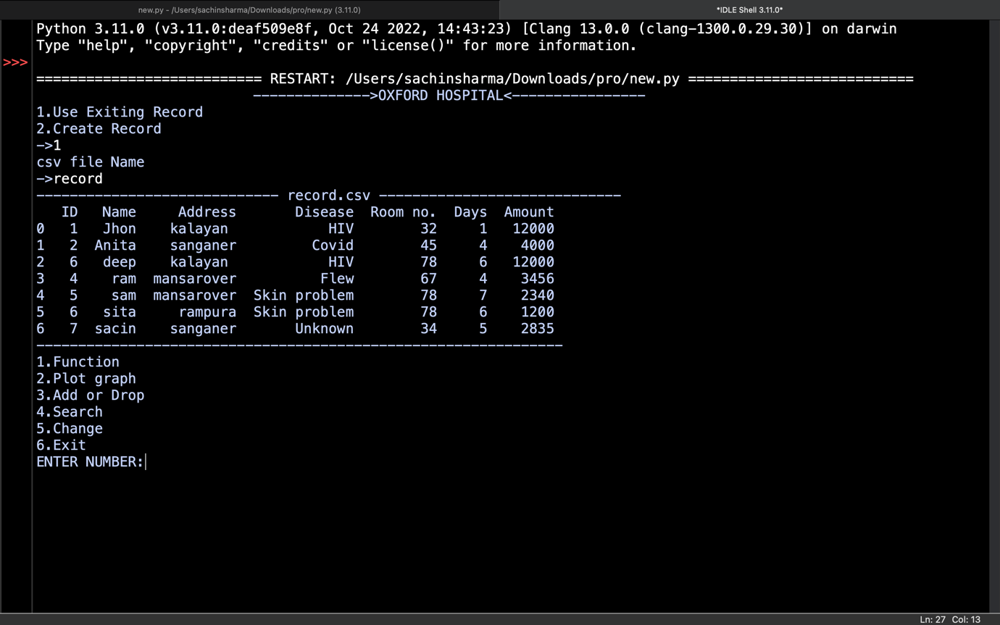

**SLICING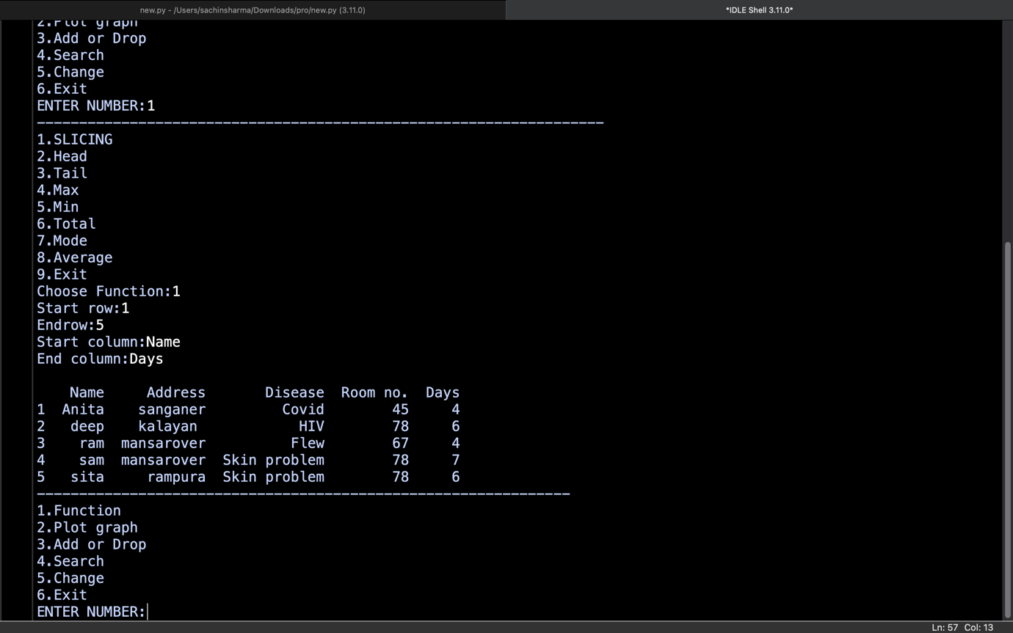HEAD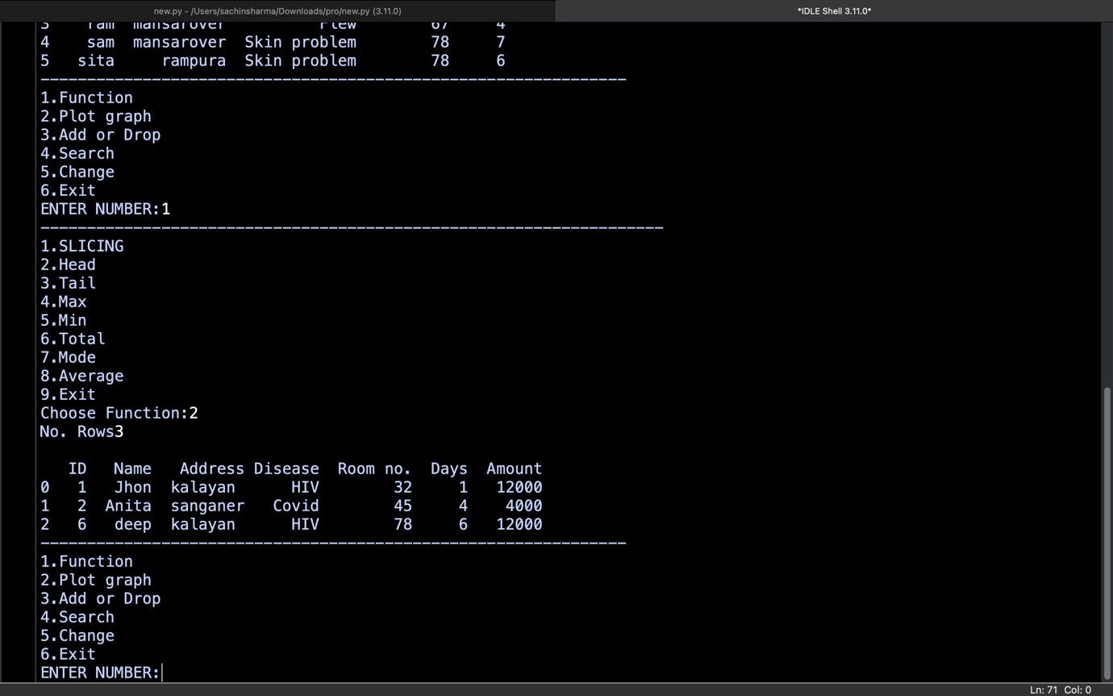TAIL**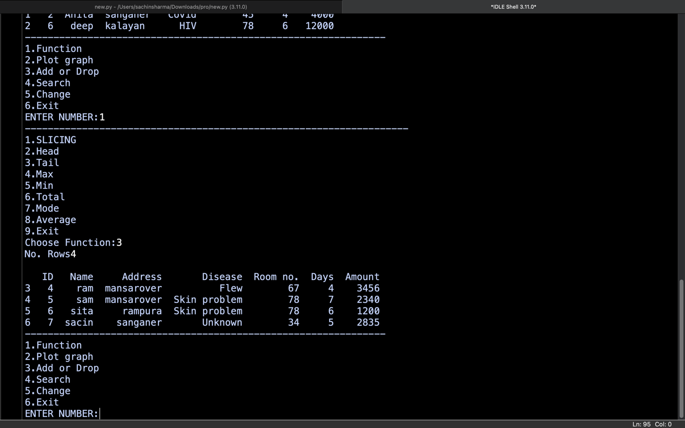

**MAX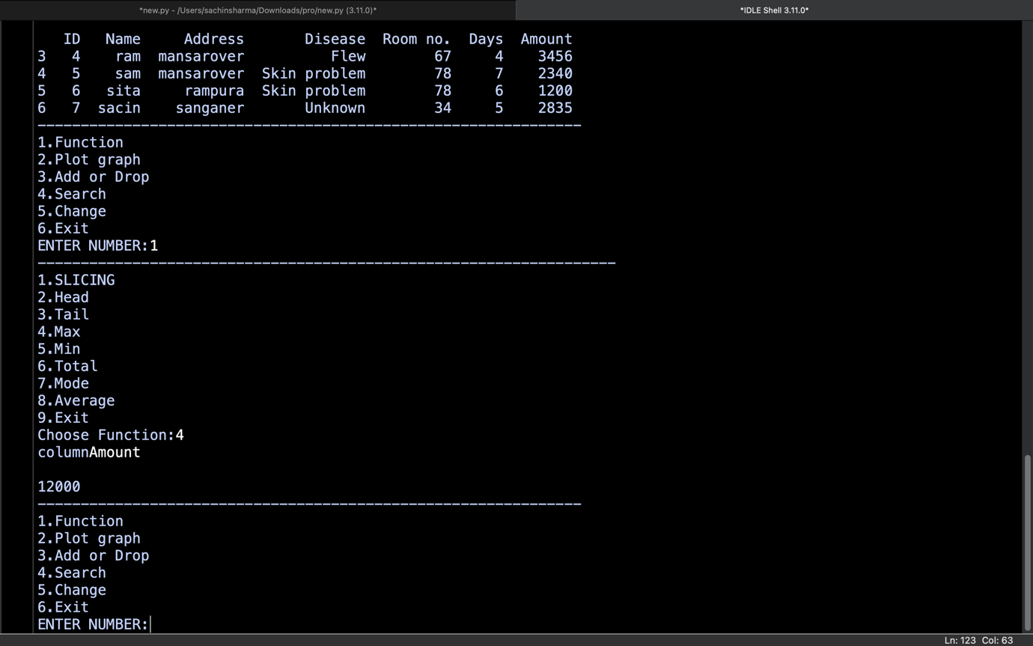TOTAL**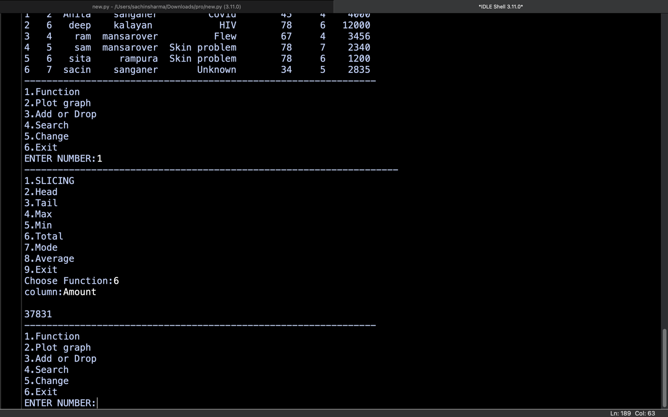

**MODE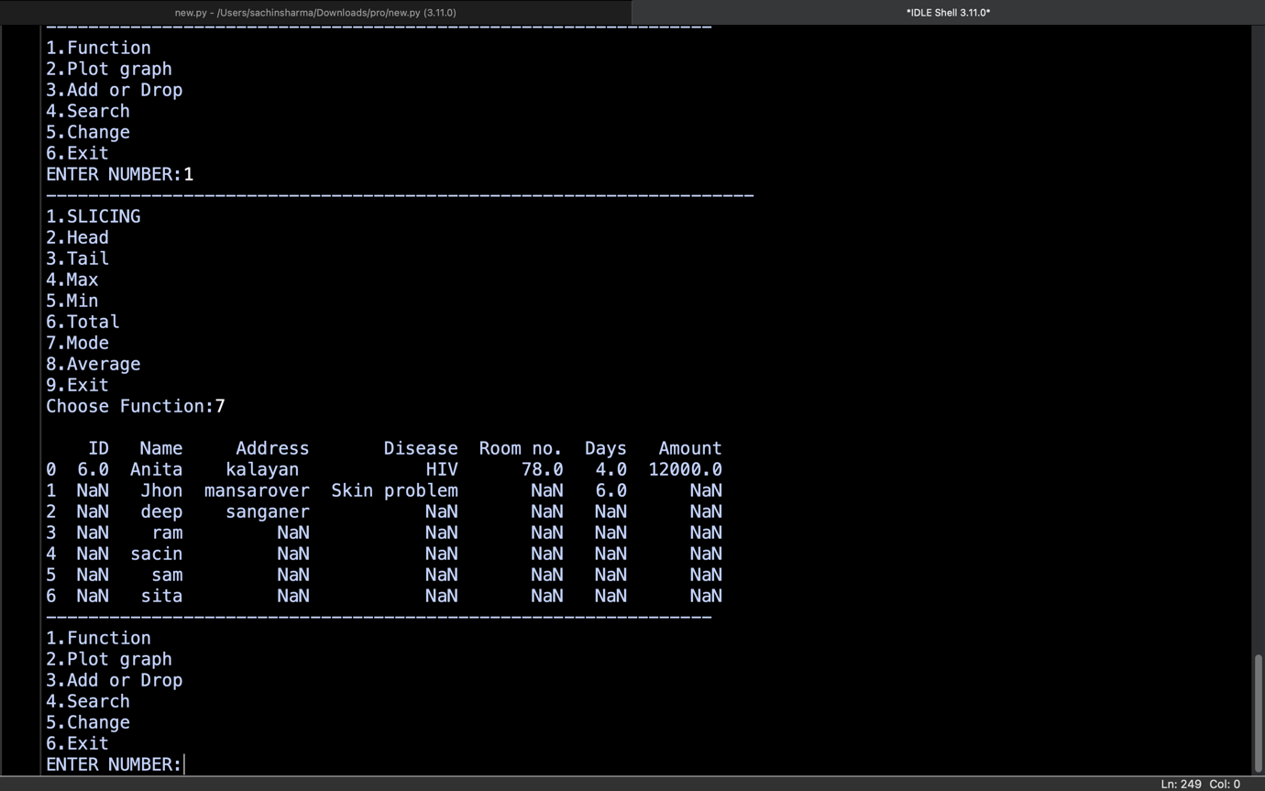AVERAGE**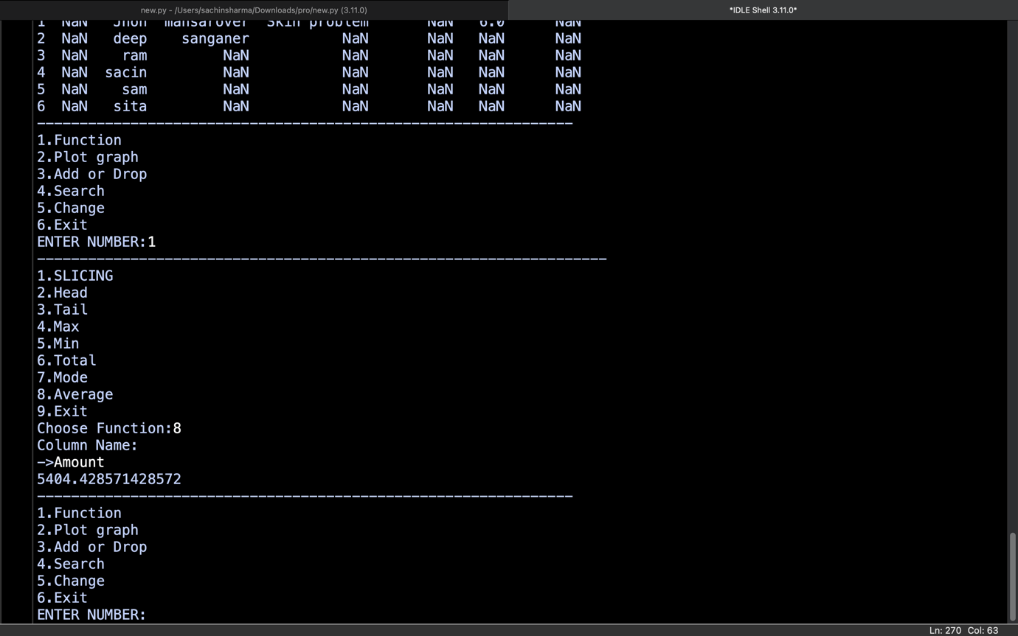

**BAR GRAPH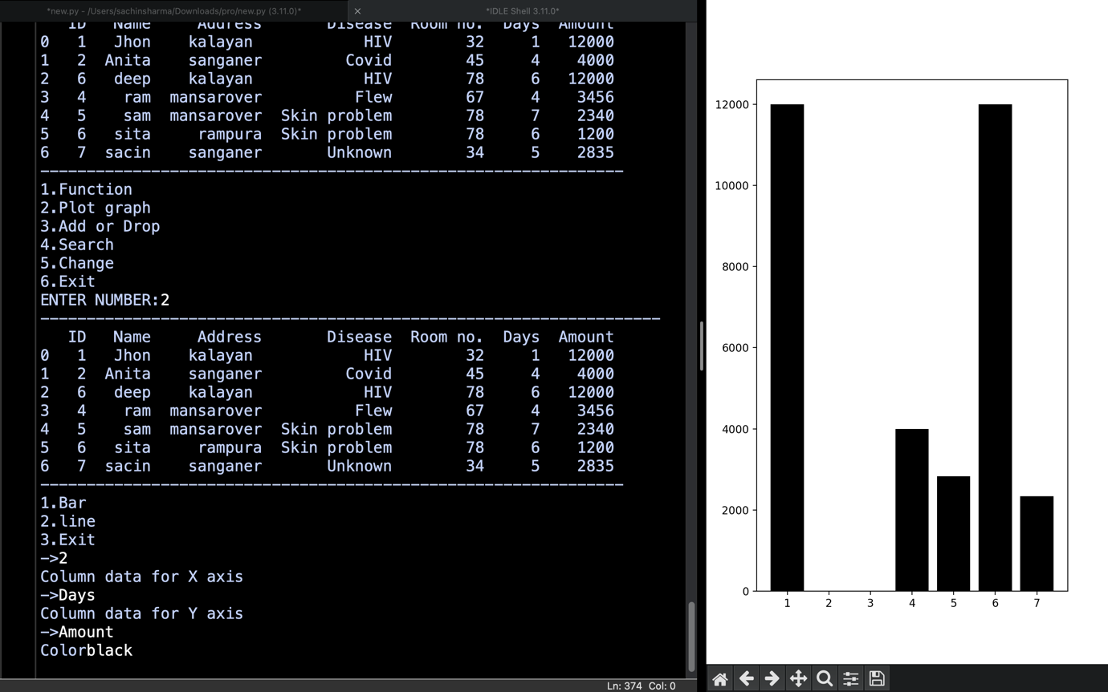ADD**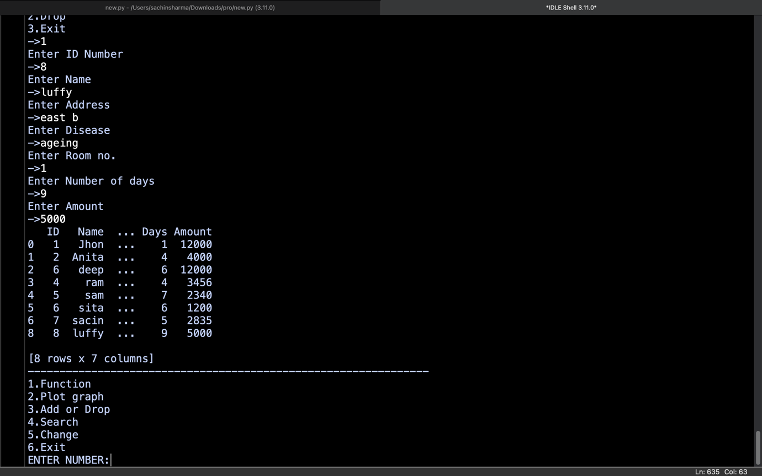

**DROP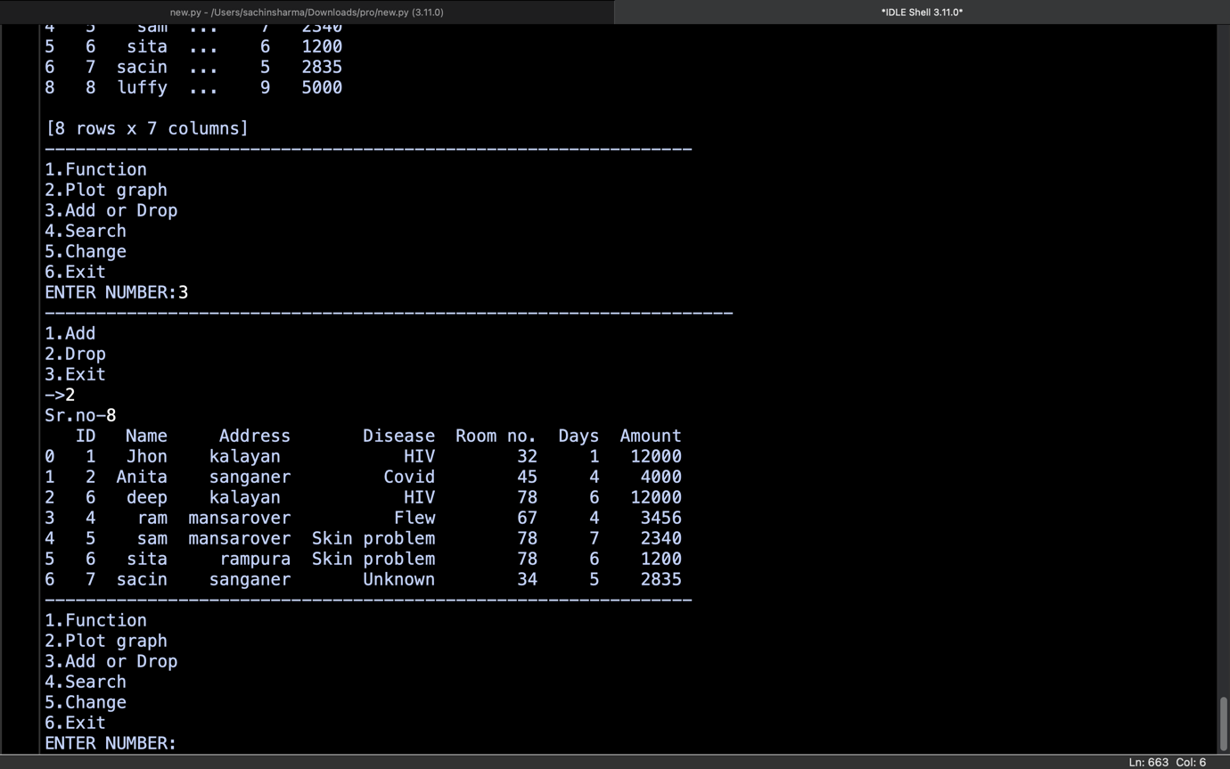SEARCH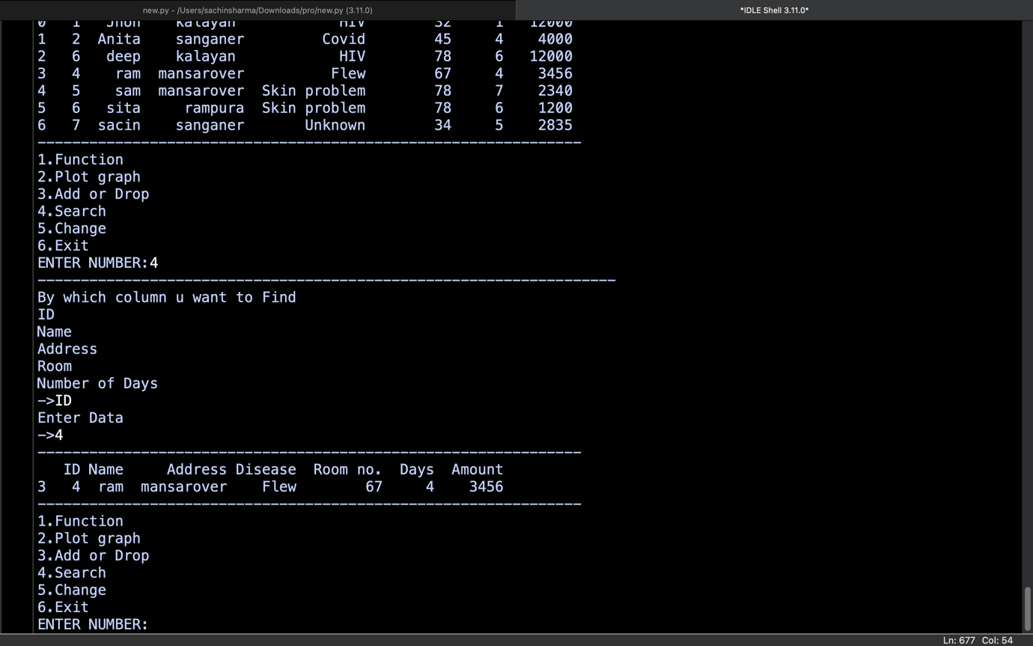CHANGE**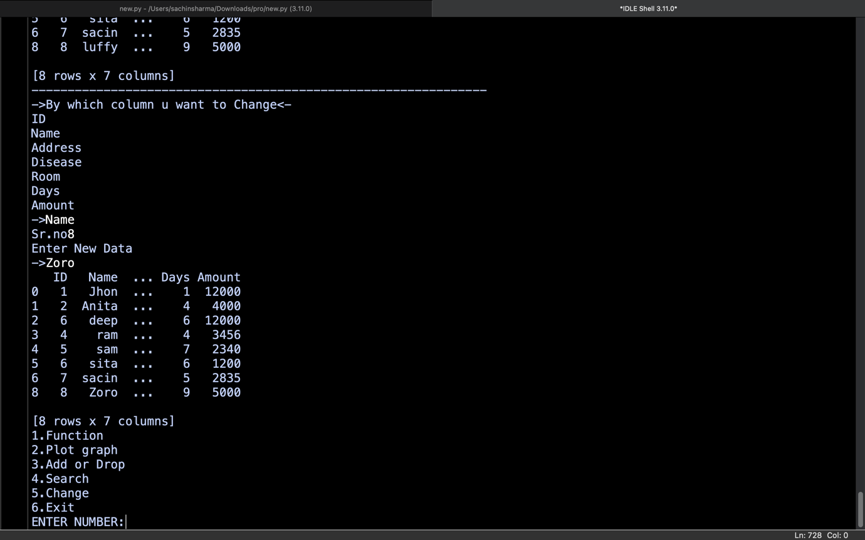

**AND MANY MORE**

**CODE COMPLETENESS EVALUATION**

White box testing methods can also be used to evaluate the completeness of a test suite that was created with black box testing methods. This allows the software team to examine parts of a system that are rarely tested and ensures that the most important function points have been tested.

**Two common forms of code coverage are:**

FunctionCoverage: Which reports on functions executed and

StatementCoverage: Which reports on the number of lines executed to complete the test.

They both return coverage metric, measured as a percentage

**HARDWARE AND SOFTWARE REQUIREMENTS**

1. OPERATING SYSTEM : WINDOWS /MAC OS/ LINUX
2. RAM : 512MB+
3. Hard disk : SATA 40 GB OR ABOVE

**SOFTWARE REQUIREMENTS:**

OS : WINDOWS /MAC OS/ LINUX

Python : 3

**BIBLIOGRAPHY**

Informatics Practices With Python - Class XII

By : Sumita Arora

A Project Report On

By :Sachin Sharma

**\*\*\***