Client want to get PDF or excel statement report downloaded for below filters.

Download Patient Register
To Date

From Date

Select Patient Source

PDF
DOWNLOAD
BACK

Patient Source : CD_DCD TYP =12

123.108.45.16,15143\\SQL2022
Sa
Creative
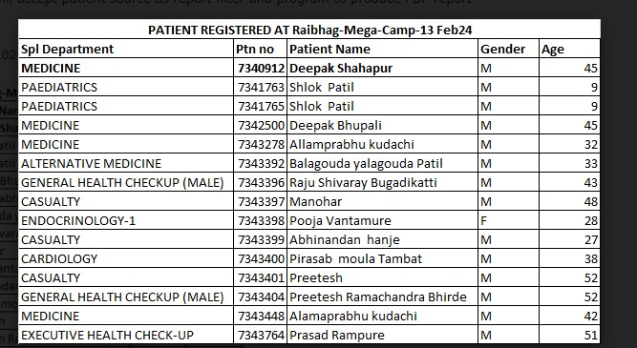

SELECT b.dcd, c.dcd ,a.ptnsrccd,*
FROM ptn_mst1 a
LEFT JOIN CD_DCD b on b.typ = 28 and b.cd = a.DocSpltyCd
LEFT JOIN CD_DCD c on c.typ = 13 and c.cd = a.ptnsrccd

where a.crt_dt > = '20 feb 2024'

