**A**

**Project Synopsis on**

**Eyeball controlled wheelchair with implementation of AI**

*By*

**Areen Rayees (1809732010)**

**Sachin Baghel (1809732021)**

*Submitted in partial fulfillment of the requirements of*

*the degree of*

**Bachelor of Technology**

*In*

**Electronics and Instrumentation Engineering**

*Submitted to*

# Guide Mrs. Priyanka



**Department of Electronics and Instrumentation Engineering**

**Galgotias College of Engineering and Technology, Greater Noida**



**Dr. A. P. J. Abdul Kalam Technical University, Lucknow**

**2021-22**

**CONTENTS**

* Abstract
* Introduction
* Literature Survey
* Explanation using block diagram
* Conclusion
* References

**ABSTRACT**

This document outlines a method for implementing an eye tracking device as a method of electrical wheelchair control with implementations of AI using open cv. Through the use of measured gaze points, it is possible to translate a desired movement into a physical one. This form of interface does not only provide a form of transportation for those with severe disability but also allow the user to get a sense of control back into their lives.

**BRIEF LITERATURE SURVEY**

A Wheelchair is basically designed and is mainly used when walking is troublesome or outlandish. A powered wheelchair is a mobility-aided device for persons with moderate/severe physical disabilities. Various kinds of control interfaces have been developed for wheelchair control: such as joystick or head control. These forms of interface may not be accessible or practical for all people. Through the use of an eye tracker, a different form of wheelchair control is possible. This paper presents the design, development, and medical impact of an eye controlled wheelchair.

Our proposed design for an eye controlled electric powered wheelchair has the same range of motion and ease of movement that a standard joystick powered wheelchair has but with the addition of several features. Sometimes natural reflexes cause unwanted movements of the chair hence , We propose notable ease of voice recognition and predefined routes using AI and ML technology.

**BLOCK DIAGRAM**

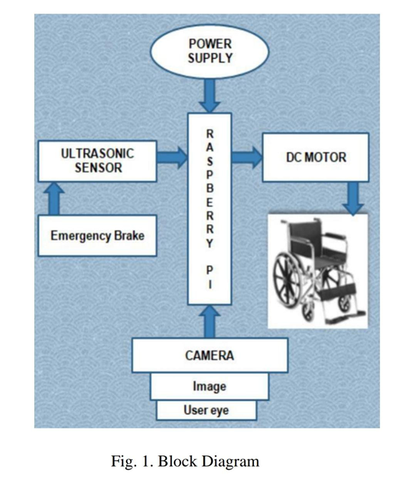

**HARDWARE SPECIFICATIONS**

* Eye Tracker
* DAQ ( Data Acquisition Unit)
* Pin Layout
* Control Module

**SOFTWARE SPECIFICATIONS**

* Programming Language: C++
* Programming Language: Python, Open cv

# CONCLUSION

Wheelchair control through the use of an eye tracker is possible and has been achieved. The design presented allows control of a wheelchair through a plethora of hardware and software components to create an effective system. This system included an eye tracker, a laptop, a DAQ, an inverter, a web cam and electric wheelchair. These pieces comprised the hardware. The software included LabVIEW programs and C++ scripts used to process the data and interact with the DAQ and eye tracker. While not a perfect system the wheelchair now stands able to be controlled solely through eye movement and thus help persons with moderate/severe physical disabilities.