ASSIGNMENT

MODULE 3 HTML

**1. Are the HTML tags and elements the same thing**?

-NO

**1.TAG**:

* HTML tags are like keyword
* HTML tags are used to hold the HTML element.
* HTML element holds the content.

**EX:**

* <table></table>
* <tr></tr>
* <td></td>
* <span></span>

. 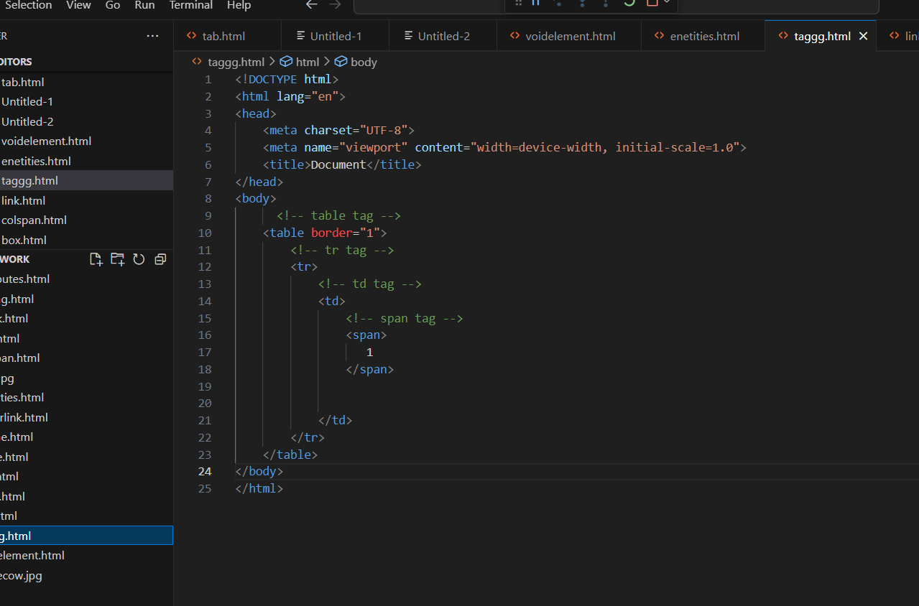

**Output:-**

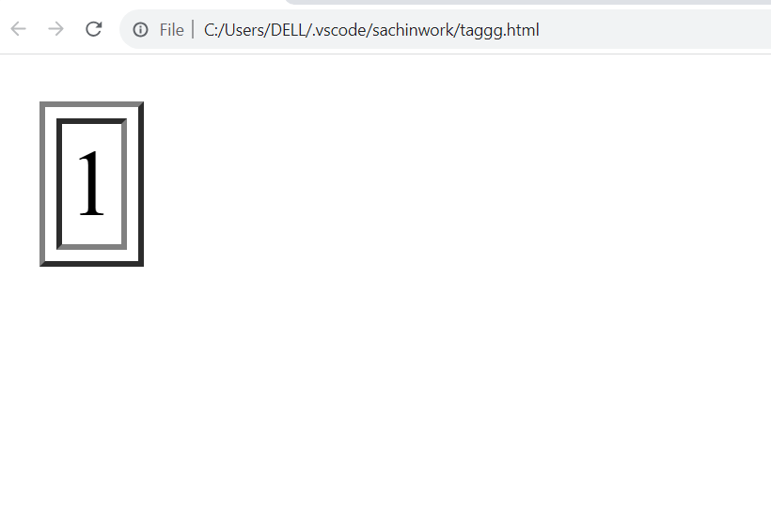

**2.Element**

The combination of the opening tag, content, and closing tag is referred to as an element.

**Ex:-**

In the following example,

<p> is the opening tag, Hello is the content, and </p> is the closing tag.

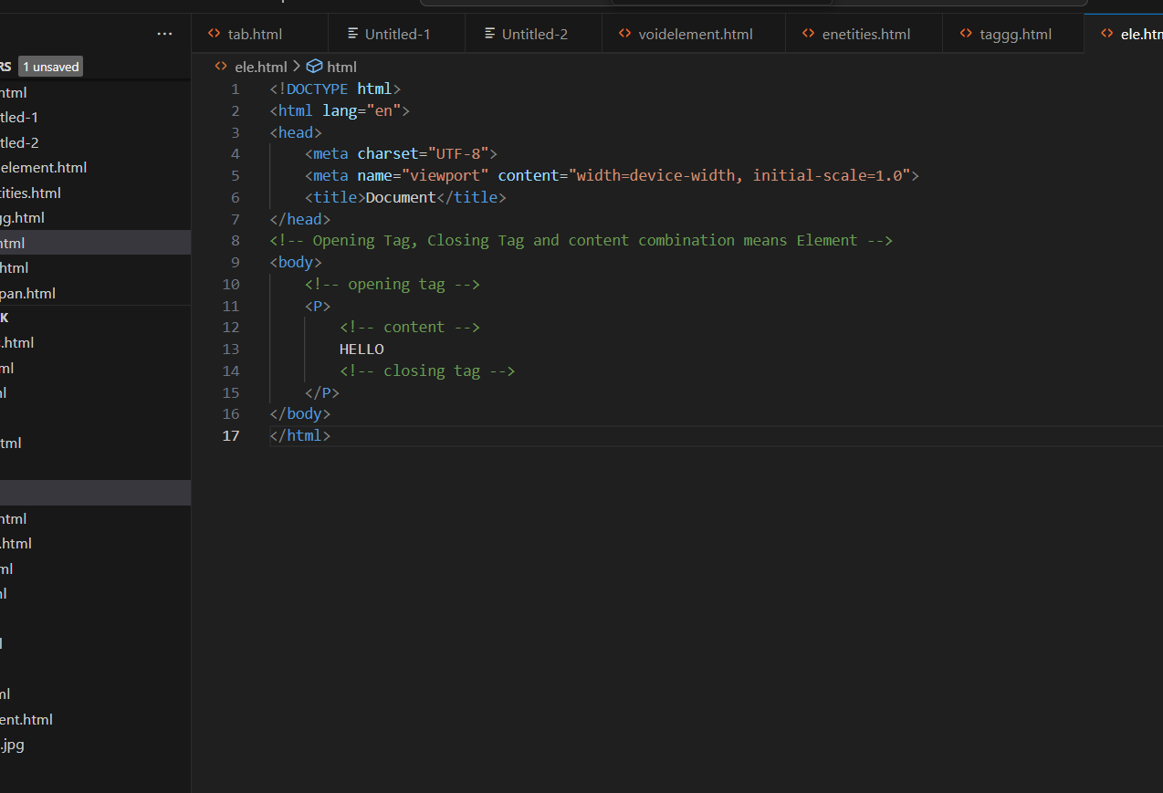

**Output:-**

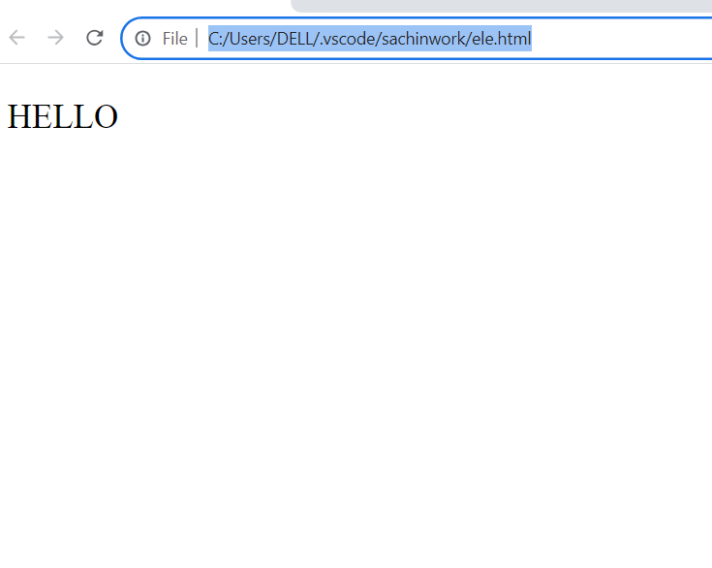

**2.What are tags and attribute in html.**

**1.TAG**:

* HTML tags are like keyword
* HTML tags are used to hold the HTML element.
* HTML element holds the content.

**EX:**

* **<table></table>**
* **<tr></tr>**
* **<td></td>**
* **<span></span>**
* **<form></form>**

EX:-



Output:-



**ATTRIBUTE:**

* This tag is decide to property and for giving information that ways content is very easy present.

EX:-

s


There Example in attribute in color And src is type attribute and #FF000(color code-Red), #0000 And Cow.jpg is value attribute

**Output:-**

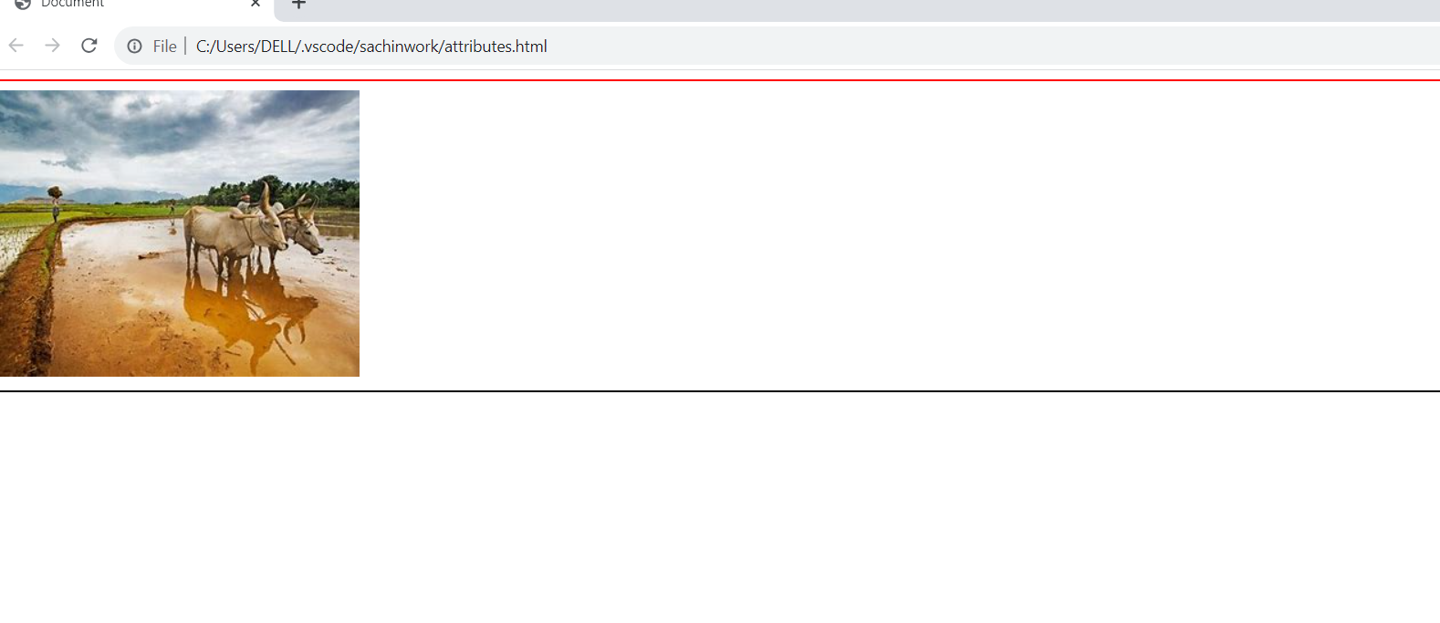

**3 What are void element in HTML with example.**

* Void element has required only opening tag.
* There in not required closing tag.

EX **:-**

**<img>**

**<br>**

**<hr>**

**<Area>**

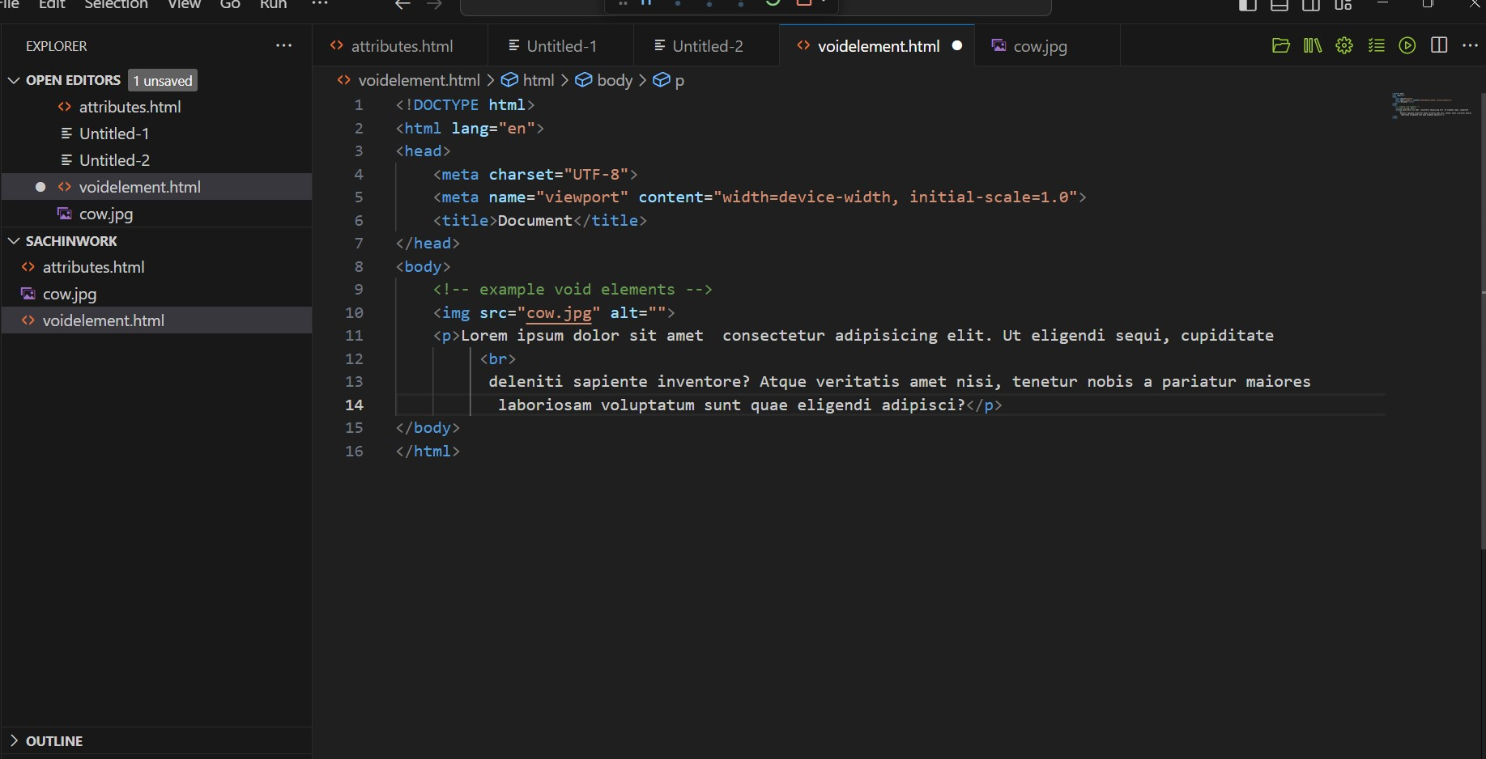**–––**

**Output:-**

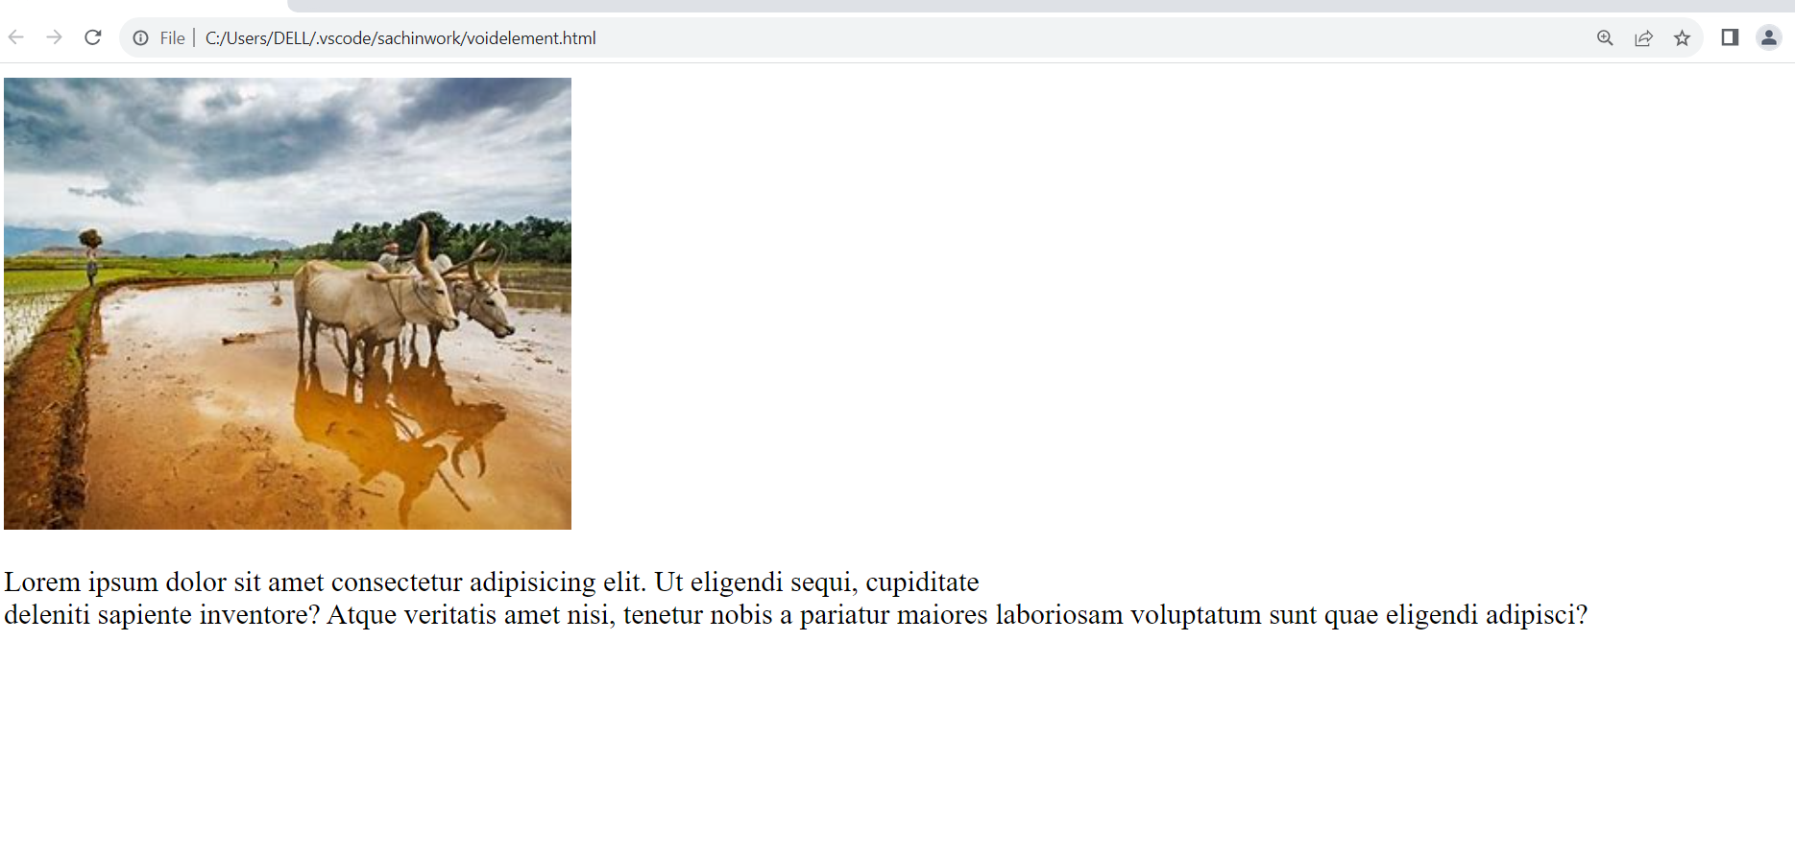

**4 What are HTML Entities ? with example.**

HTML ENTITIES:-

* HTML Entities are reserved characters that are used in html document.

EX:-

–––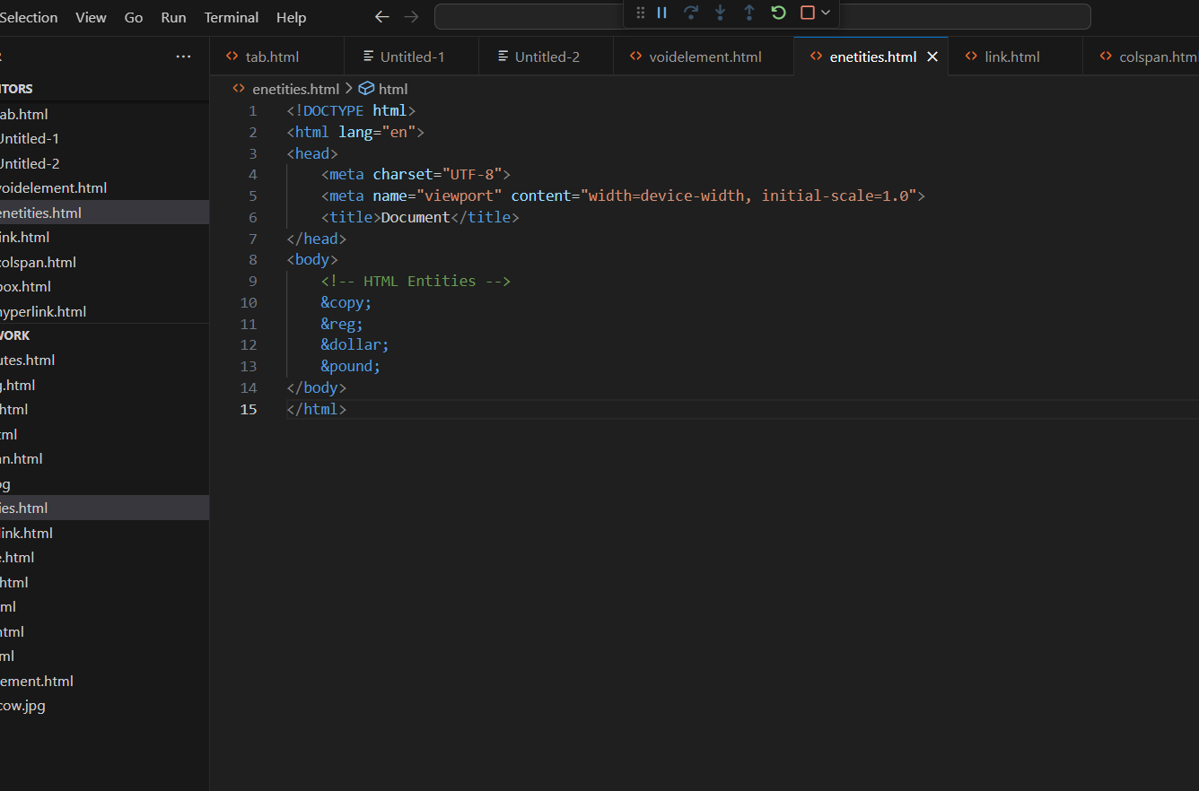––

Output:-

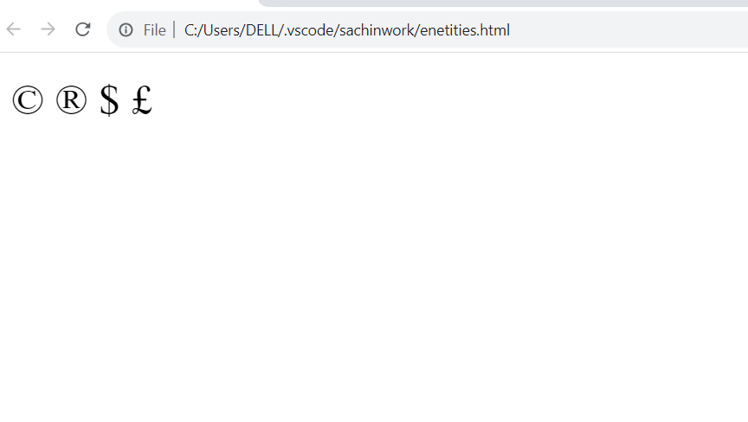

**5. what is the class attribute in html ? with Example.**

* The html class attribute is used to specify a class for an html element.

EX:-

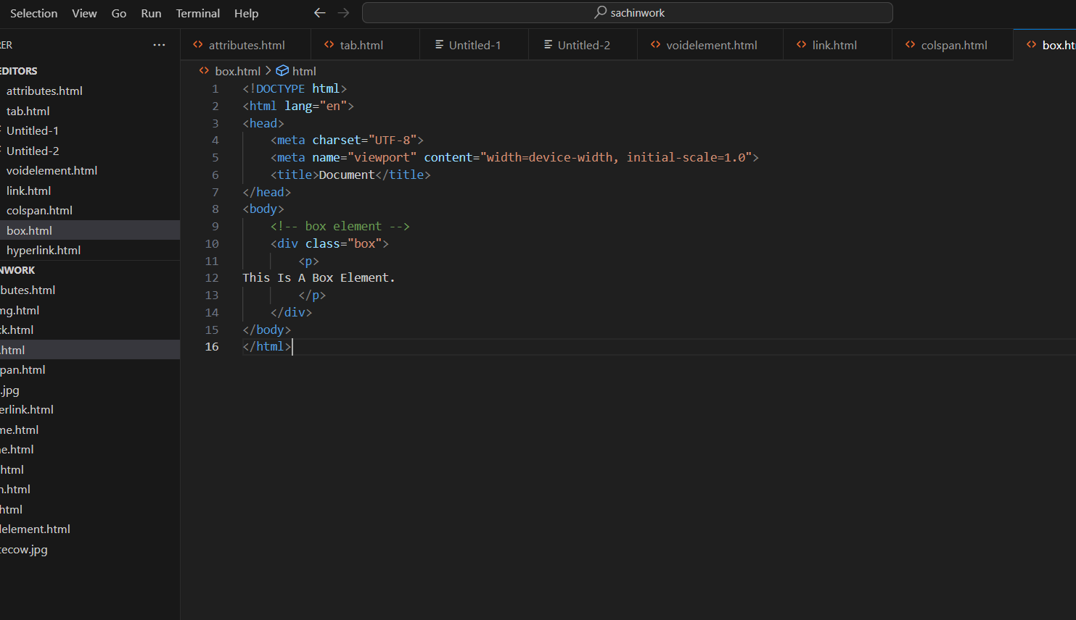

Output:-

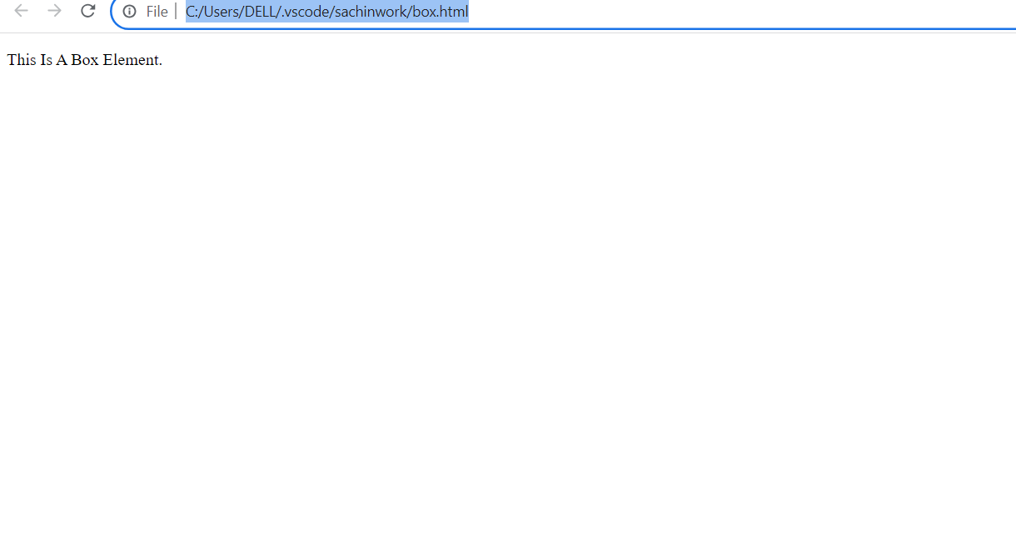

**6.What is the diffrence between the "id" attribute and the "class" attribute of HTML elements? with example.**

ID:-

* When create unique color and font in paragraph when you use id attribute HTML in one side.

EX:-

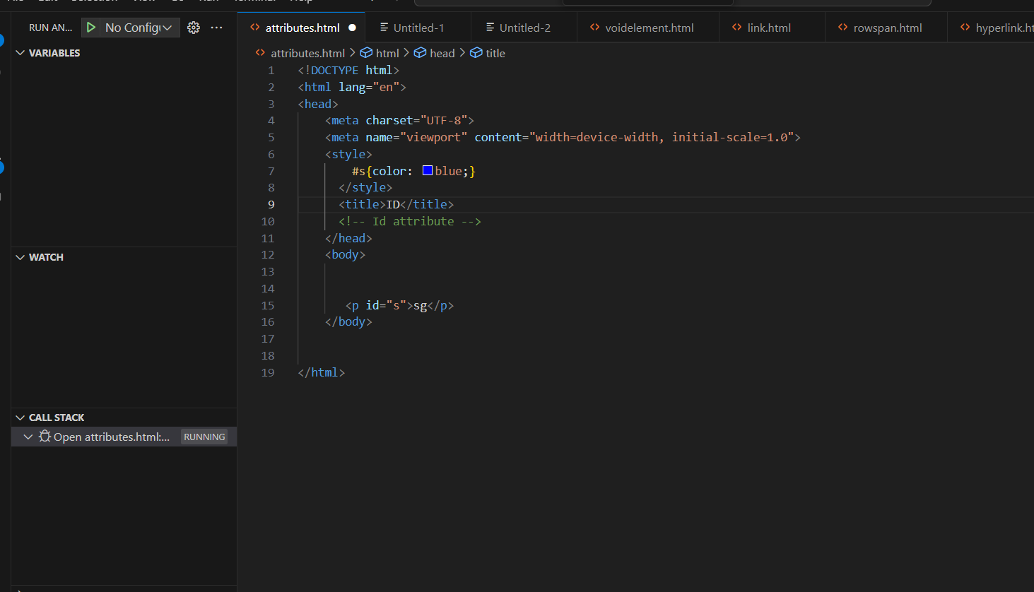

Output:-

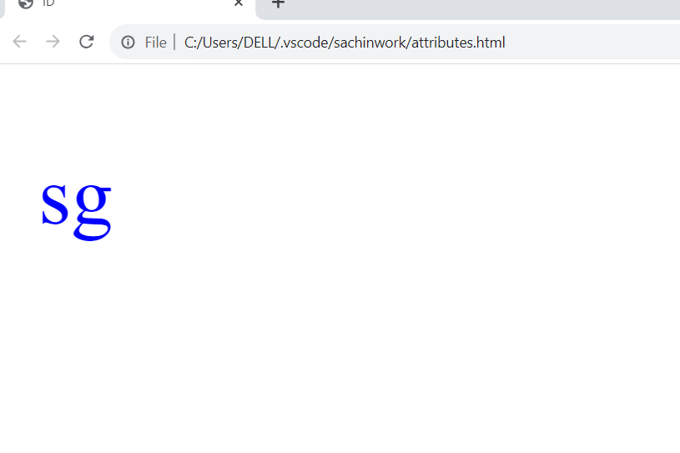

CLASS :-

* When create same color paragraph than use class attribute.

EX :-

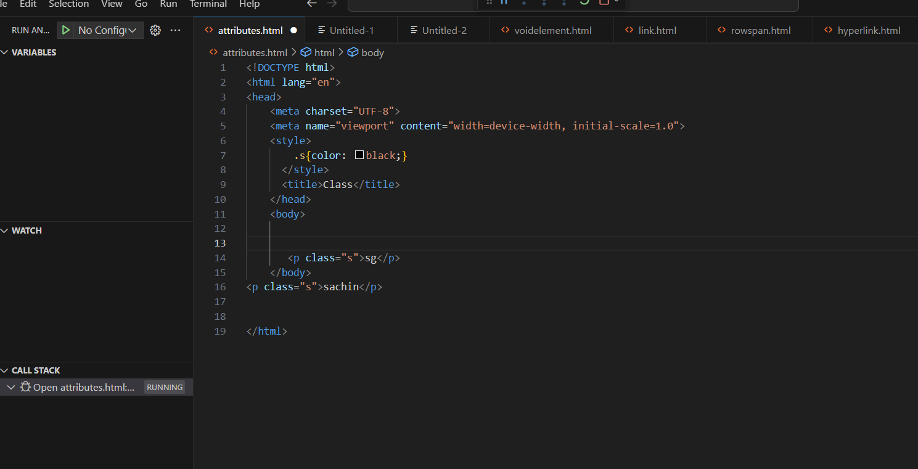



Output:-

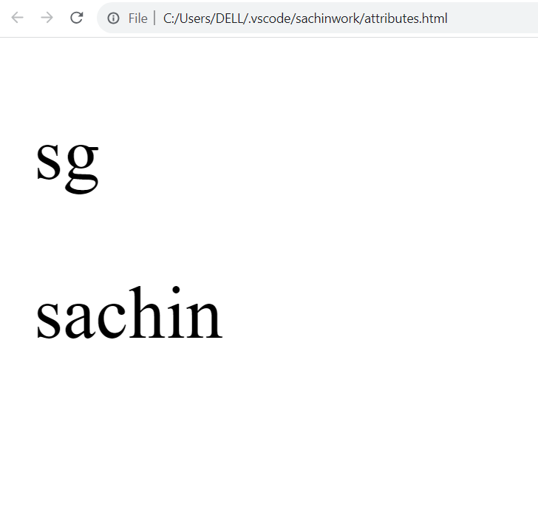

**7. What are the various formatting tags in html.**

* there are so many tags in html like.
* <b></b>
* <i></i>
* <u></u>

EX:-

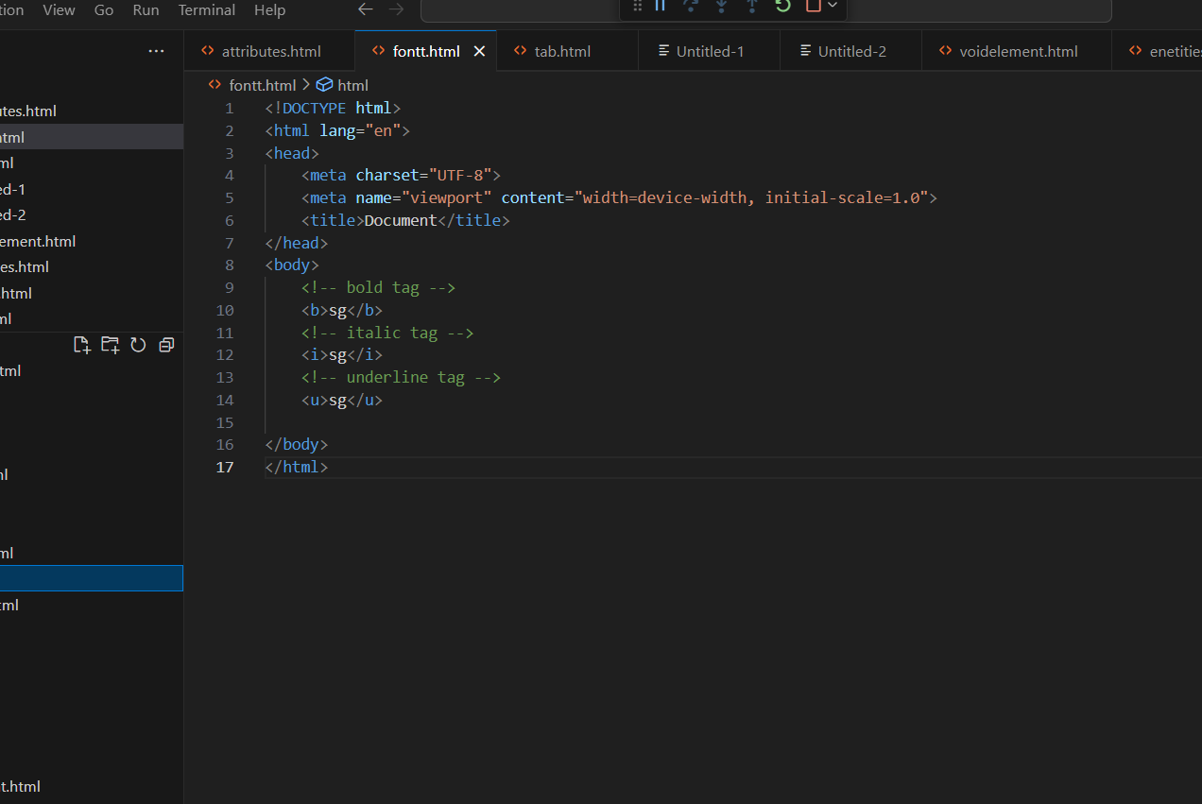

Output:-

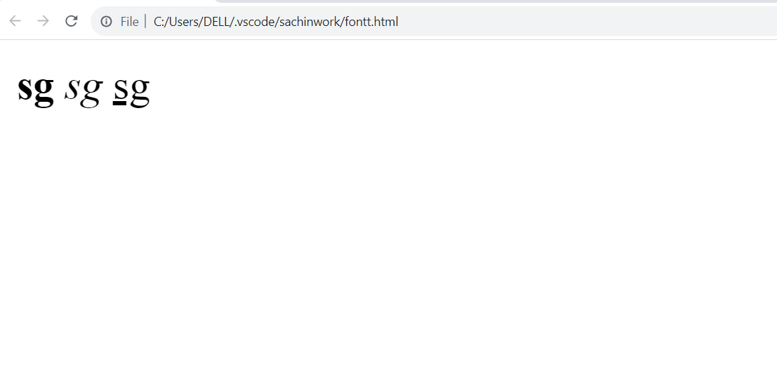

**8 . How is cell padding different from cell spacing ? with Example.**

CELL PADDING:- Cell padding for inner- cell (space).

EX:-

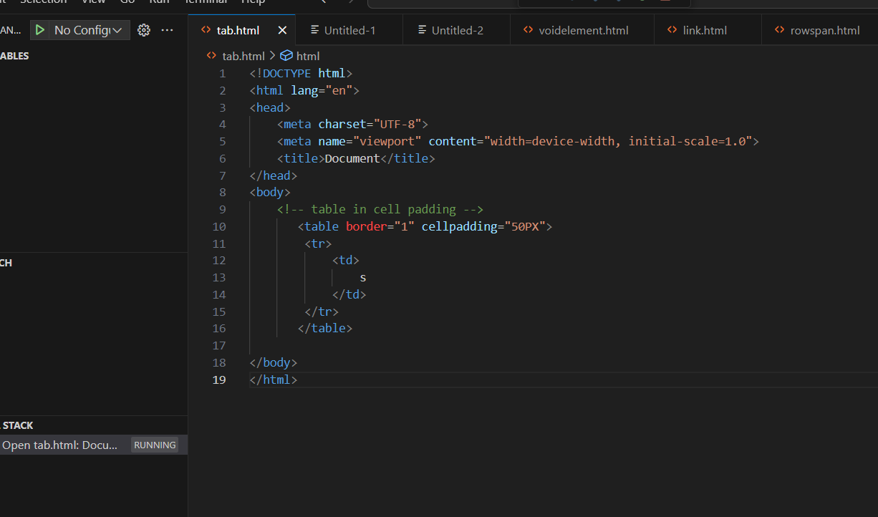

Output:-

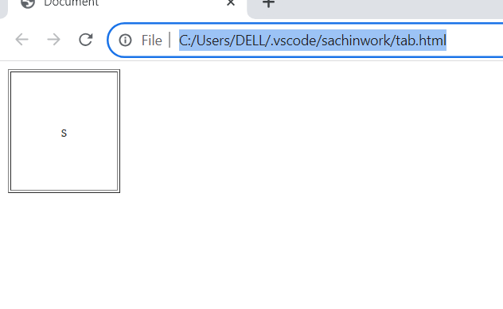

-CELL SPACING: cell spacing for out space.

EX:-

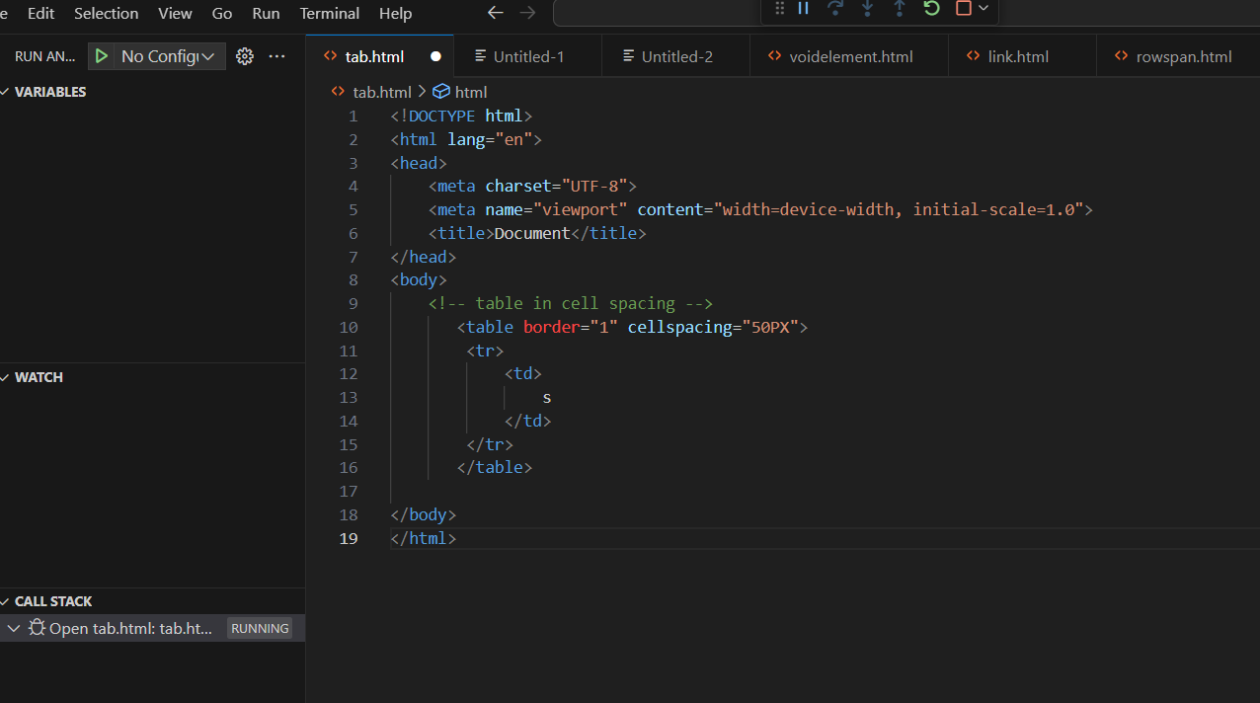

Output:-

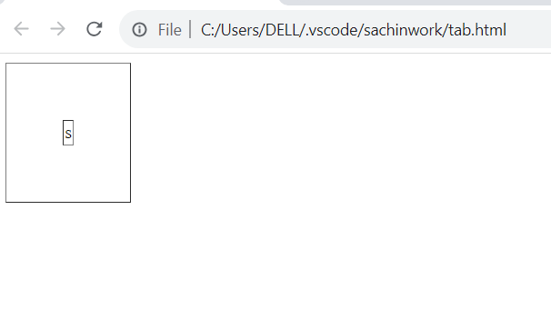

**9.How can we club two or more row or columns into a single row or colum in an HTML table ? With example**.

We use colspan and rowspsan attribute to merge cells in HTML .

EX:-

Output:-

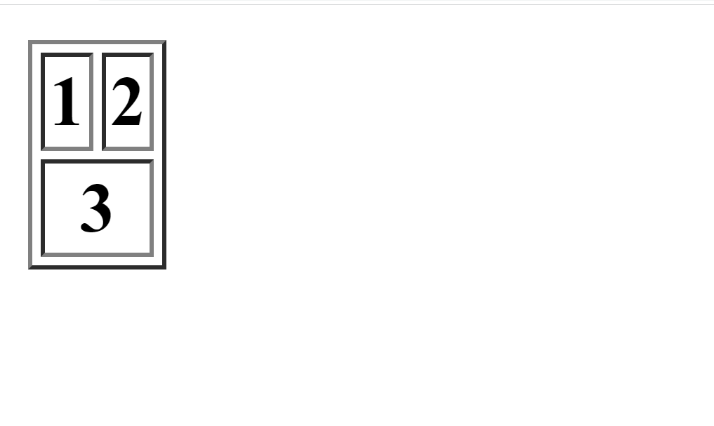

EX:-

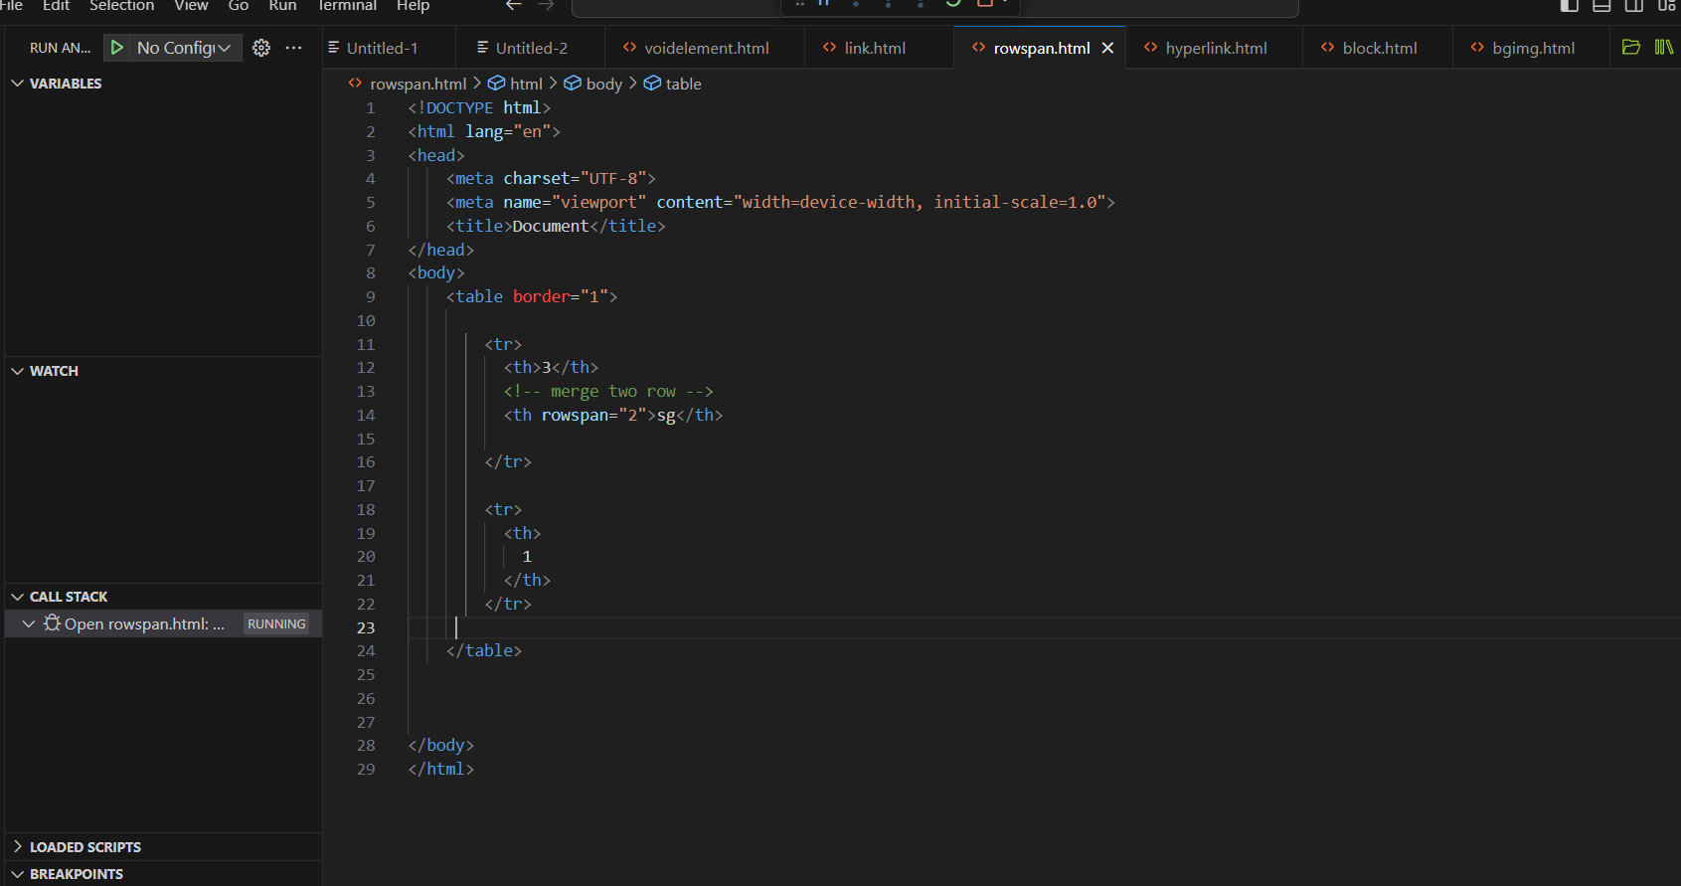

Output:-

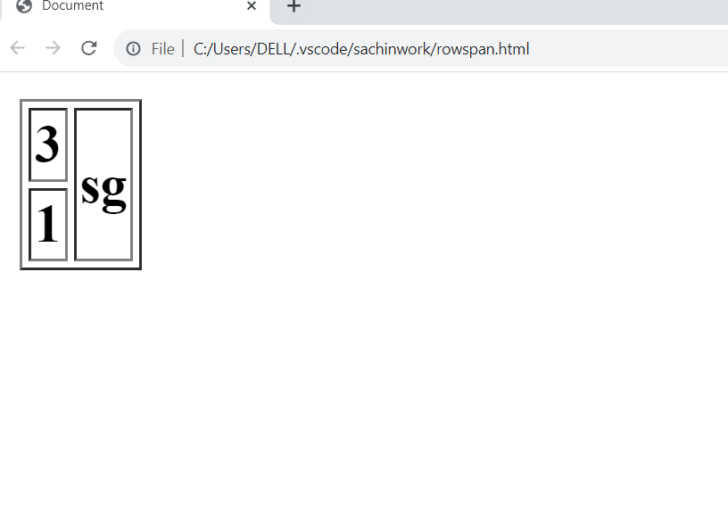

**10. What is the differtnce between a block- level element and an inline b element?**

-Block - level element: a block level element always starts on a new line and takes up the full with>

EX:-

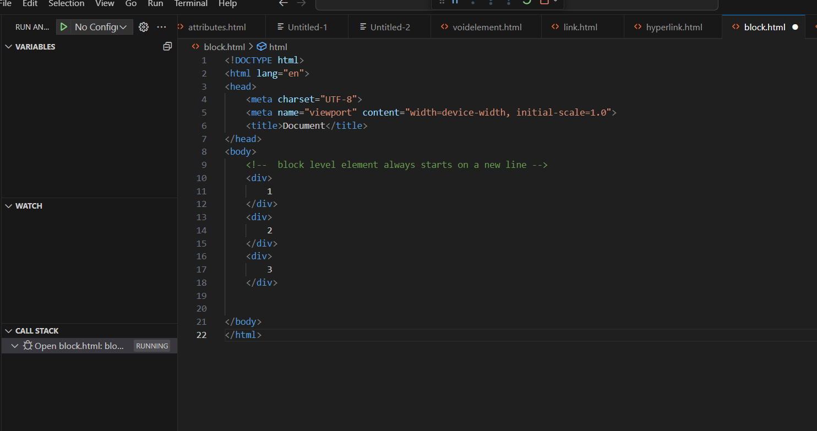

Output:-

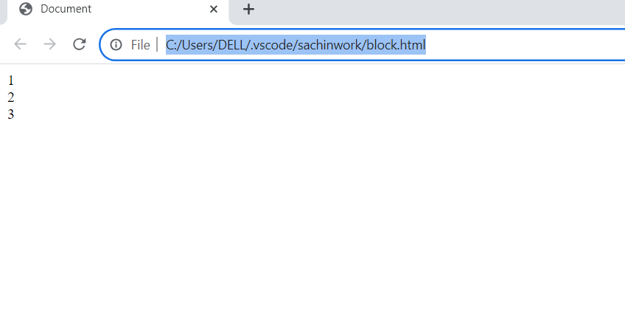

Inline element:-

inline element does not start on new line and only takes up much with as necessary

EX:-

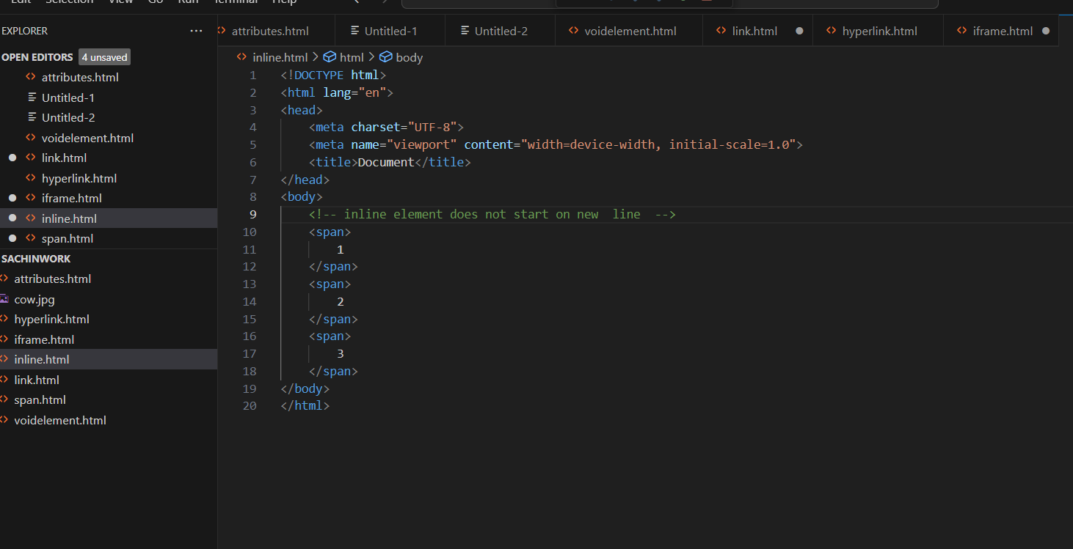

Output:-

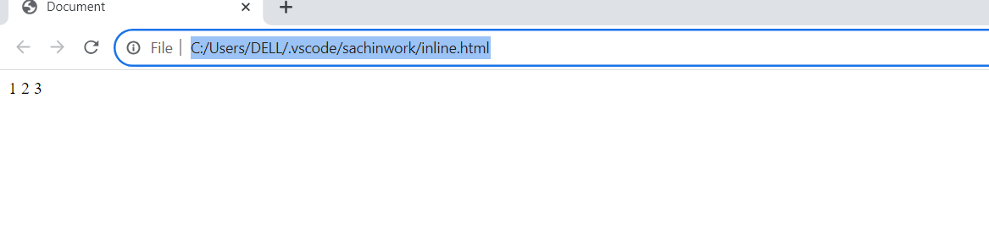

**11. How to create hyperlink in HTML ? with Example.**

Hyperlink:-

< a href =""> to creact hyper link.

EX:-

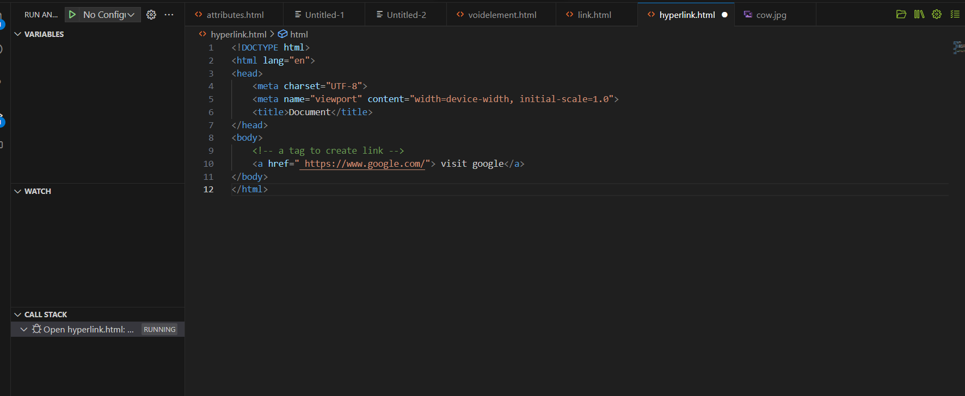

**Output:-**

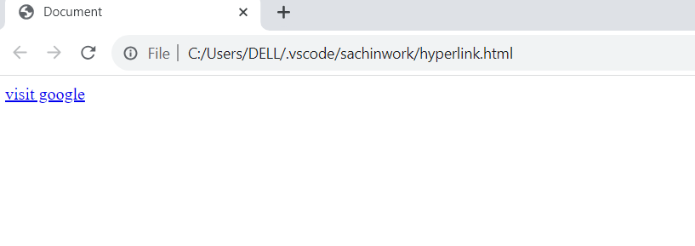

**12.What is the use to iframe tag.? with Example.**

Iframe:-

* An inline frame (iframe) is a HTML element that loads another HTML page within the document.
* it essentially puts another web page within the parent page.
* They are commonly used for advertisements, embedded videos. wed analytics and interactive contanct.

EX:-

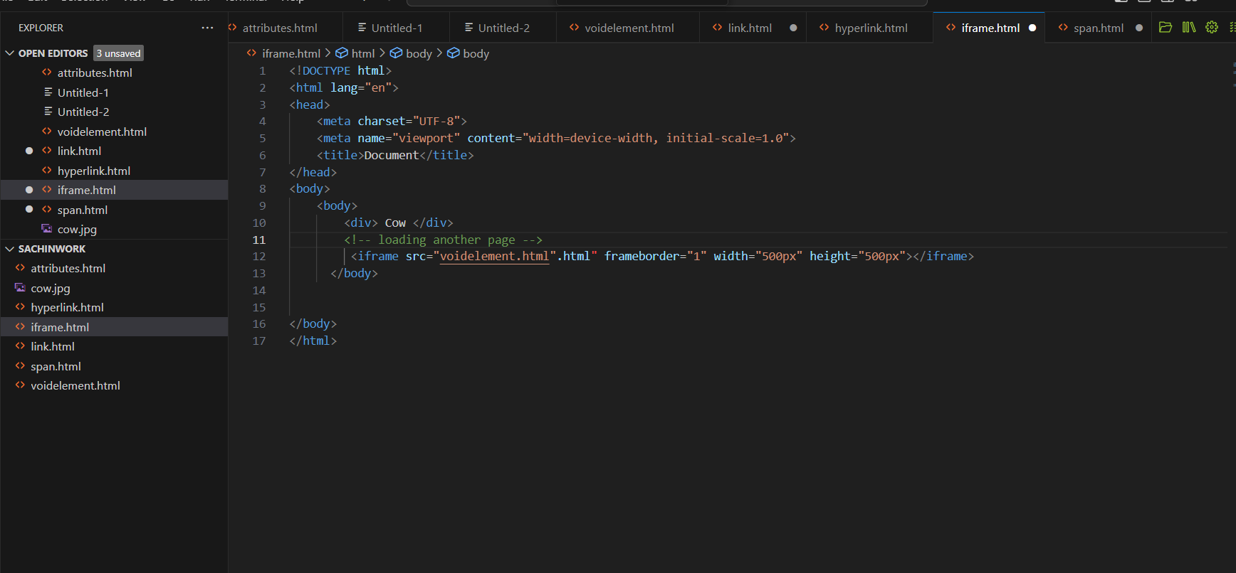

Output:-

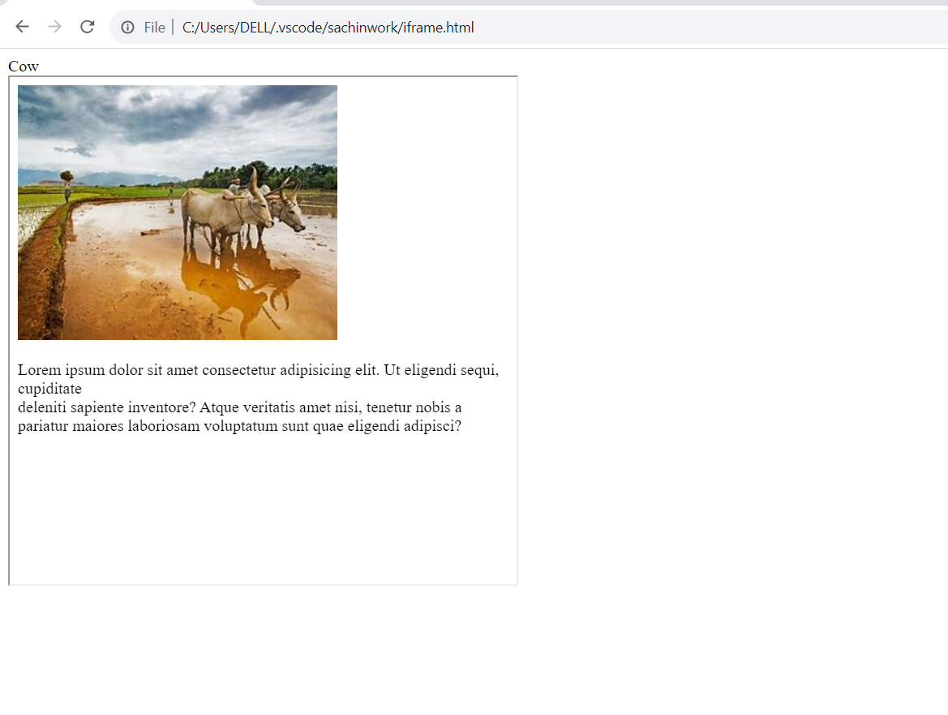

**13. what is tag use of a span tag? Explain with example?**

* + The <span> tag is an inline container used to mark up a part of a text , or a part of document.

Ex:-

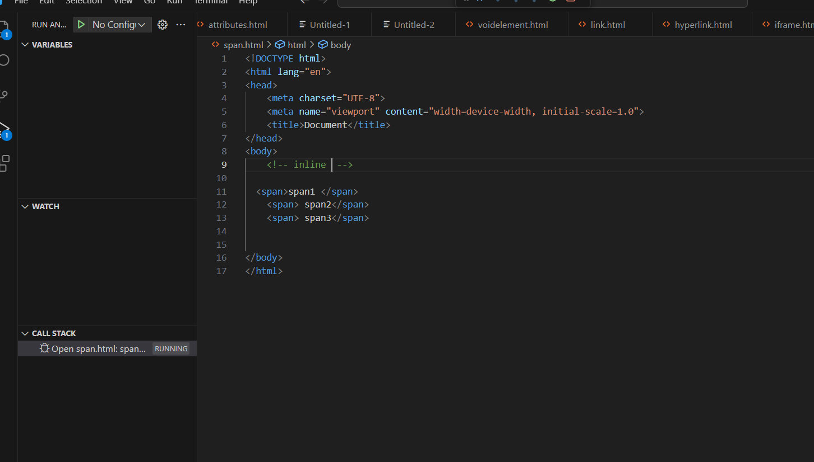

Output:-

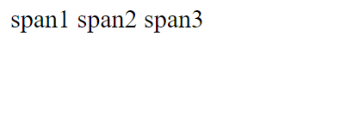

**14. How to insert a picture into a background image of a web page? With Example.**

* + The most common& simple way to add background image is using the back ground image attribute inside the<body>tag.

EX:-

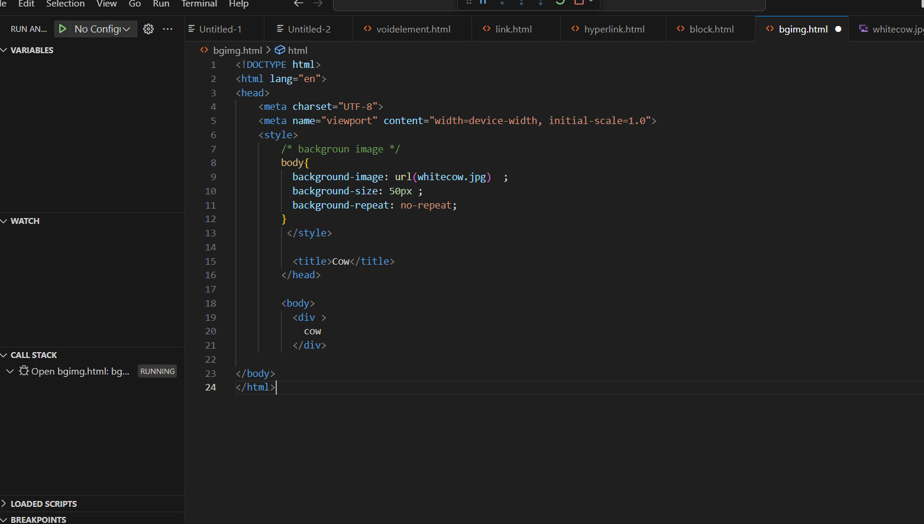

Output:-

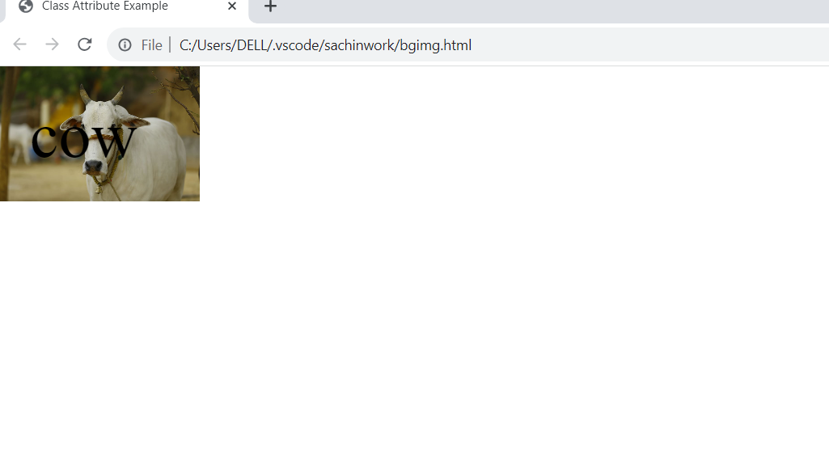

**15. How are actives links different from normal links?**

* Active Links: shows that the browser is in the process to load a new resource.
  + Normal links: A link (or hyperlink as it also called ) is created with a special <a> tag.

Ex:-

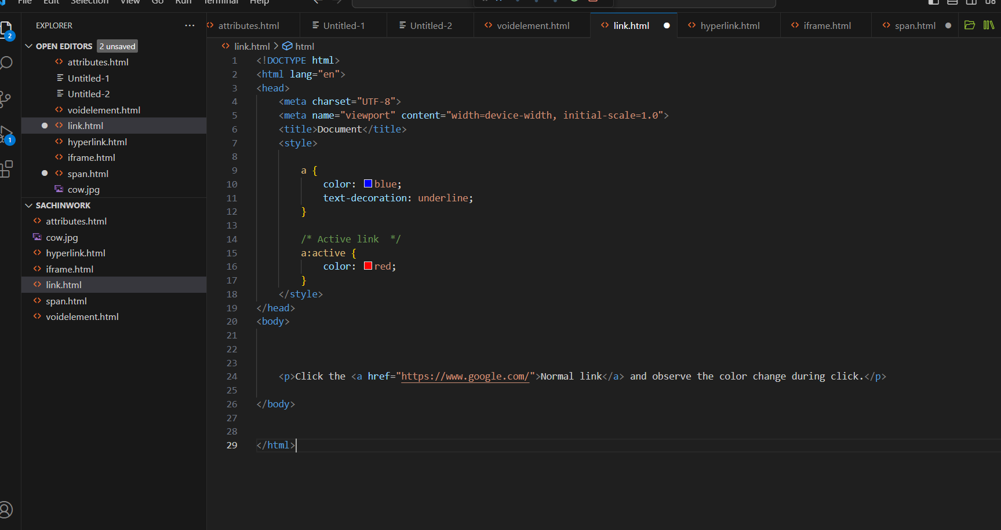

Output:-

