Title: Hybrid Neural-Sparse Retrieval-Augmented Generation for Trustworthy Pharmacovigilance Conversational Intelligence Name: Sachin kumar and Komal Kumari
University/Organization: Delhi Technological University, Delhi
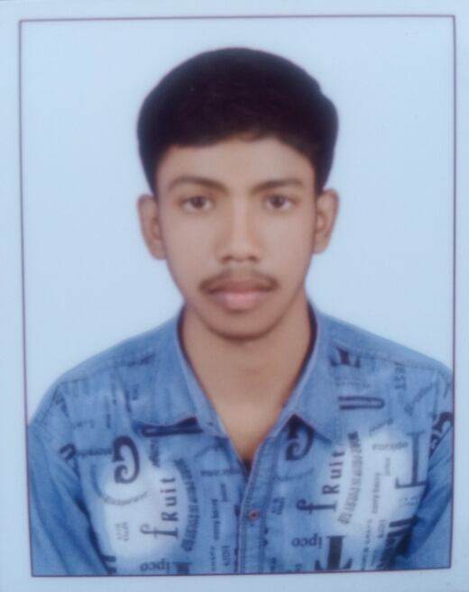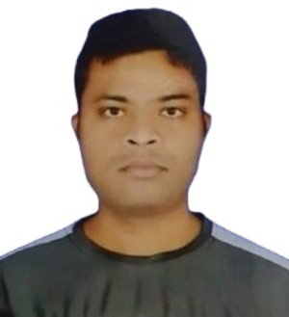
Photograph
Organization Logo

Subhadra Devi School of Nursing, Hajipur
Abstract:
The involvement of an analyst is indispensable to an ADR reporting system. The approach of consolidating the information contained in the narrative text of spontaneous reports, pharmacovigilance guidance documents, and biomedical literature is required and may, in many instances, take several hours for a single complex case. RAG can be seen as an anchored solution, in contrast to purely parametric inference via a language model. We are unaware of any comparison of the two approaches for a pharmacovigilance application with sparse, dense or hybrid retrieval architecture and neither method was evaluated on varying degrees of semantic relevance threshold. We report on 3 RAG systems with different complexities evaluated on a new corpus that contains 19,930 chunks and 100 test questions. We define Simple RAG by an FAISS flat index with BGE-large-en-v1.5 embeddings, Optimised RAG (with MiniLM for re-ranking,BM25 lexical search,RRFon hybrid search andMMP), and Turbo RAG by an IVFFlat ANN index (instead of a flat index), still using a hybrid search. Using a threshold=0.65 as defined in the work, TurboRAG shows Hit@5=1.000,NDCG@5=0.898,MRR=0.953,ROUGE-1=0.471 and similarity=0.872, although now the API call is the majority component in the total time taken.
Biography: Sachin Kumar is currently pursuing the M.Tech degree in Data Science from Delhi Technological University, Delhi, India. His research interests include artificial intelligence, pharmacovigilance, retrieval-augmented generation (RAG), machine learning, data science, and healthcare analytics.
Komal Kumari is pursing B.Sc. Nursing at Subhadra Devi School of Nursing, Hajipur, Bihar. Her interests lie in the fields of medical science and healthcare.

