**Steps To Be Followed** :-  
  
1. Folder Structure.  
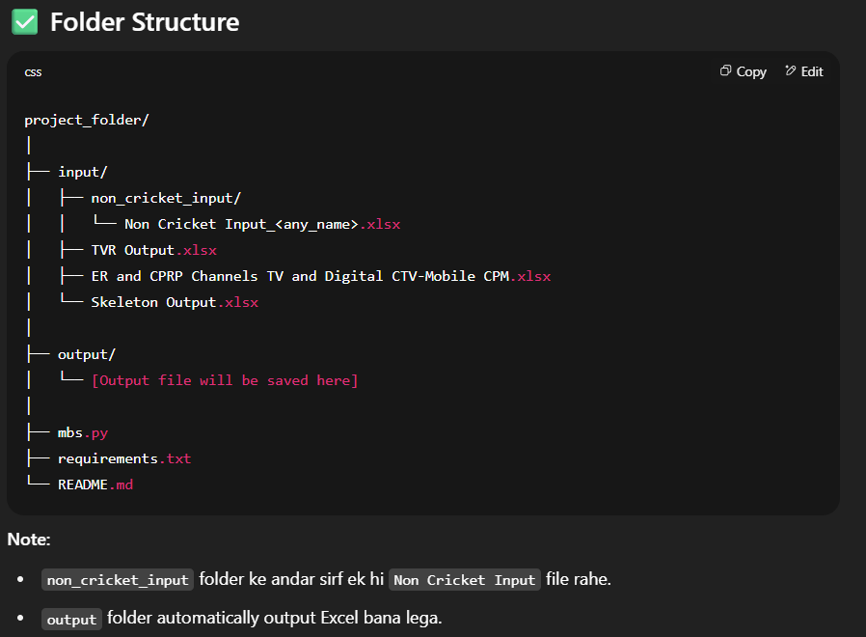

2. Open the project folder

- click on “*Open in terminal*”

3. type “code .” and press enter

- 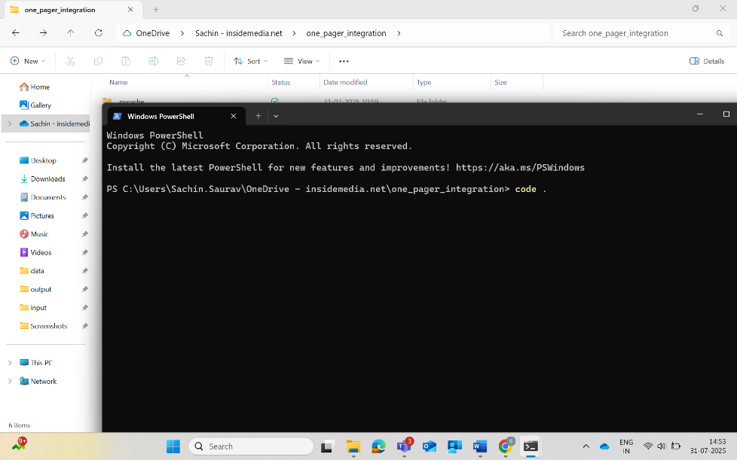

4. click on “…” on the menu bar

5. click on “Terminal” then click on “New Terminal”

6. Type “python mbs.py” and press *Enter*

*

7. If the Input File is in Correct Format (All the values are in right positions), then The Detailed package (Output File) will be generated and saved in the “output” folder.  
- 