# **SACHINI FERNANDO**

**Student Number: AC5296**

# **Synopsis**

I’m a 28-years-old student who is interested in new technologies and wants to become an expert in the IT field. That’s why I chose to study ICT at JAMK university and hope to enhance my skills and buildup my career throughout these studying period while getting the appropriate knowledge and experiences. In addition to the excellent education, Finland's natural beauty also won my heart. The individuals in our neighborhood are incredibly kind and helpful to one another. The best observation I've made during this small period in Finland is that.

Of course, education is not the only thing I do, my hobby is singing songs doing some handmade things etc. During my school time we won the first place from a singing competition where it was a group activity. So, mostly I like for teamwork where we can build the trust on the other person and respect their ideas.

Although, I’m a beginner at ICT I have a keen to learn every new thing and this is the best example for it; my web portfolio. I have made my own webpage and currently I have the skills on html code and CSS.

## This is the hierarchal structure of my web portfolio resume

Actually, this web portfolio is a one-page website, and here I mentioned the sections that I included in my web portfolio.

Main sections – Home / About me / Qualifications / Portfolio / Contact

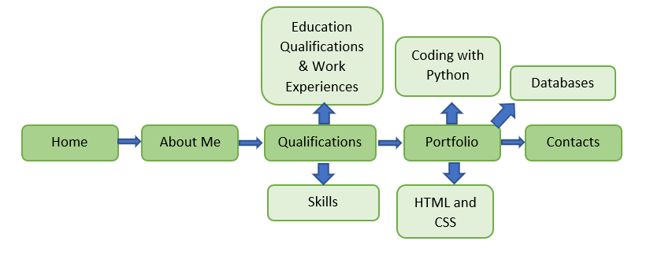

# **Audience**

Target audiences of my portfolio are Hiring managers at ICT organizations and I’m the developer of my website and I used Visual Studio Code for the development of my site. I used only HTML styles with CSS codes to modify my web portfolio and hope to add some more pictures and free materials later on.

# **Size**

Size of the file is 110KB, my file includes two images, html file and External CSS file

# **Layout Design**

My web portfolio is a one-page site and here I attached the page layout and the Wireframe. In the Menu bar I included my name in the left corner and the nav is in the right corner. Header includes a background picture and a text of my name. Next section includes ‘About Me’ and a paragraph of about me. Next section includes education qualifications and skills where the heading goes as ‘Qualifications’. In the portfolio section I included 3 boxes where it mentioned my works (Python, HTML & CSS, Databases). Lastly the contact section includes all the contact information of me and finally the footer has been added.

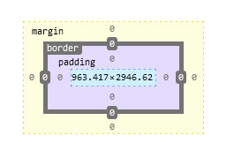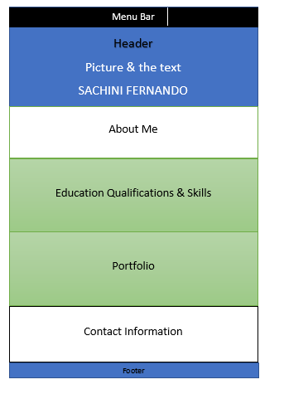

# **Results of testing**

There are no any differences in both chrome and Firefox.

No any errors in the validation.

# **Resources, how many hours**

General planning- for 2 days

Designing wireframe- 1days

Layout making- 25days

Adding the content – 5 days

Testing -7 days

So, all together approximately 320 hours I worked on this if I worked 7hours a day.

# **Self-evaluation**

First impression is really good as I think and I used 2 different font sizes and several icons in my web page. I used only 3 colors (black, white and yellow) which gives an impression rather than adding so many colors.

Clear menu bar is there for the navigation of my web site.

I added some comments to clarify the codes properly at the end of each section. This portfolio is responsive for mobile devices and laptop.

I’m 95% satisfied with my work as a beginner for this ICT field but when comparing to other’s work I would give 4 credits to my portfolio.

I hope to update my work during the next years to make it as perfect.

Thank you

# 