Level 01
When you start this war game you have to choose a tool to create a SSH session. I have chosen MobaXtrem.
After that first of all you have to create a SSH session to io.netgarage.org. Below is the command for creating a ssh connection. First password is given by them. The password is “level1”.
ssh level01@io.netgarage.org
As I have just now started the game I used ls command for get an idea. Then I saw files call readme and I opened the readme file. Inside the readme file, there were valuable details to achieve the targets of this wargame.

As in the readme they have mentioned that all the levels are in 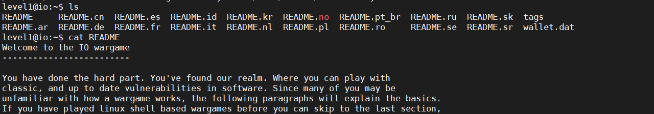levels directory. So I entered to that directory.
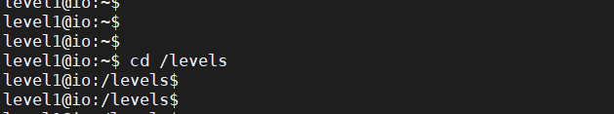

Just to get an idea of the directory I use the ls command.
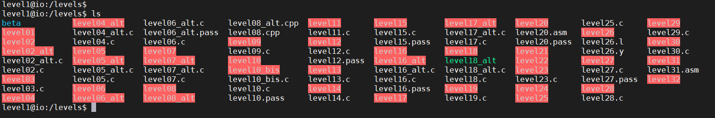
As there is a program called level01, I just run that program with just a random number.
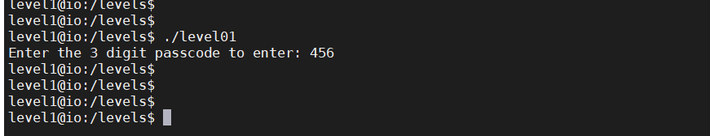
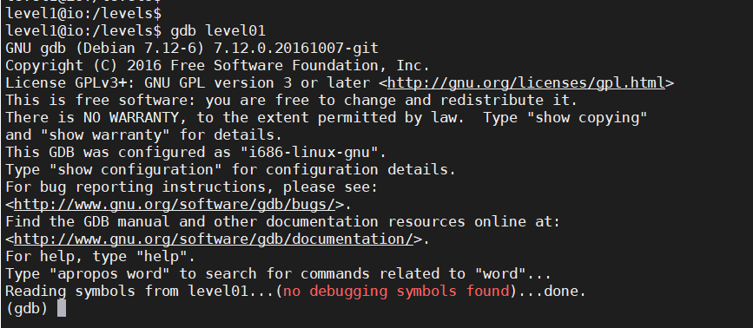After program finished running, there wasn’t any kind of details. Then I decided to use GDB debugger tool to investigate what is inside the program level01.

To get an idea about the program we have to disassemble the main method of the program using disas main as below.
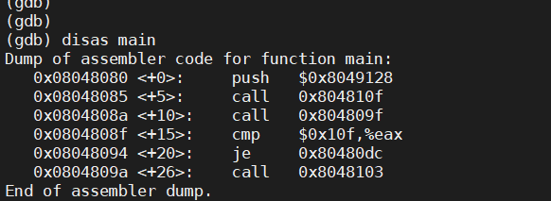

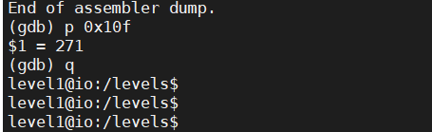As you can see in the above screenshot there is a cmp. That means comparison of this program is doing in that row with 0x10f. as 0x10f is starting with 0x we can guess that this may be a hexadecimal. So I tried to convert it to a decimal number as below.

Then try again running level01 program using 271 as the three digits passcode.
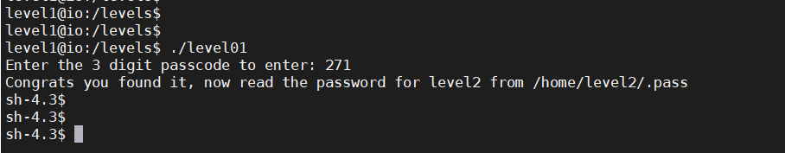
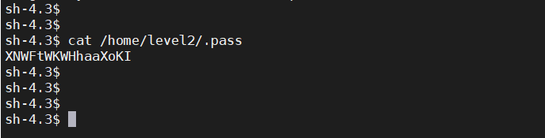With 271, the program worked and asked me to read home/level2/.pass. I read the file as below.

Wow!!! Finally I found the password.

