Level 02
First of all, we have to enter to level 02 by creating a ssh session with the password we have found in the level 01. The password for the level 02 is XNWFtWKWHhaaXoKI as below.
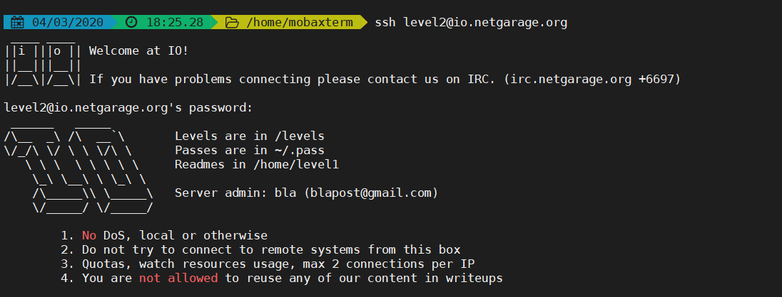
Then I entered to levels directory as the levels are in that directory. Then I ran ls command just to get an understanding. Then I execute the level02 program as shown in the below screenshot.
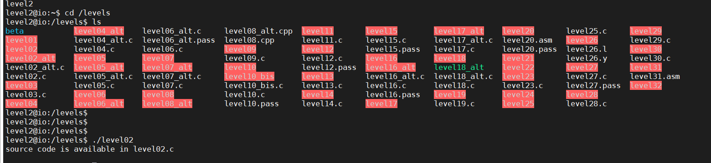
Then I looked into level02.c
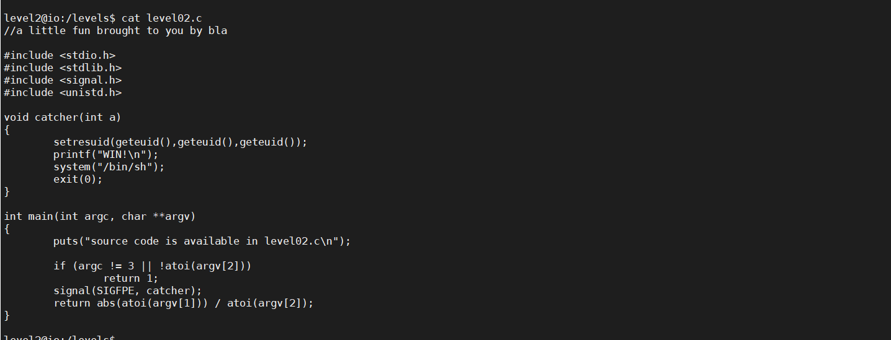
By studying the source code of level02.c I understood that I have enter to the main function and then the comparison in the if condition also has become true as I exit from the program after printing “Source code is available in level02.c”
The I understood that I may get permission for /home/level3/.pass if I make the if condition a false as the function catcher have been called by the main function after the if condition.
So I tried to make the if condition a false as below.
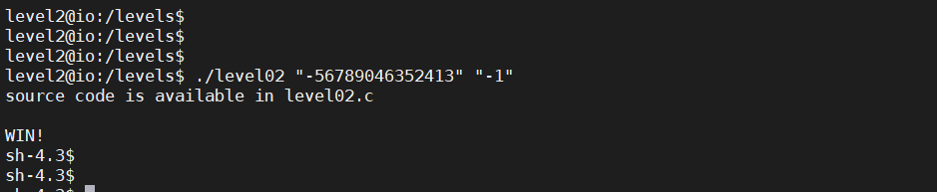
By that I entered to the catcher and I got the permission for /home/level3/.pass. Then I read the /home/level3/.pass file as below.
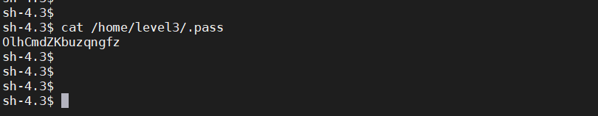
Wow!!! I found the password for the level 03.
Password - OlhCmdZKbuzqngfz

