PIZZA SALES SQL QUERIES

- KPI’s
1.Total Revenue
SELECT SUM(total_price) as Total_Revenue FROM PizzaSales
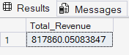

2.Average Order Value
SELECT SUM(total_price) /COUNT(DISTINCT order_id) AS Avg_Order_Value FROM PizzaSales
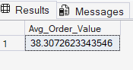

3.Total Pizza Sold
SELECT SUM(quantity) AS Total_Pizza_Sold FROM PizzaSales
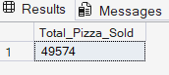

4.Total Orders
SELECT COUNT(DISTINCT order_id) AS Total_orders FROM PizzaSales
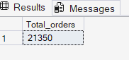
5.Average Pizzas Per Order
SELECT CAST(CAST(SUM(quantity) AS DECIMAL(10,2)) /
CAST(COUNT(DISTINCT order_id) AS DECIMAL(10,2)) AS DECIMAL (10,2)) Avg_Pizzas_Per_order FROM PizzaSales
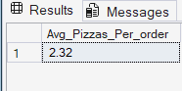

CHARTS REQUIREMENT
01.Daily Trend for Total Orders
SELECT DATENAME(DW,order_date) as order_day ,COUNT(DISTINCT order_id) AS Total_Order
FROM PizzaSales
GROUP BY DATENAME(DW,order_date)
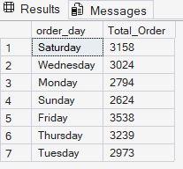
02.Monthly Trend For Total Orders
SELECT DATENAME(MONTH,order_date) AS Month_name , COUNT (DISTINCT order_id) AS Total_Orders
FROM PizzaSales
GROUP BY DATENAME(MONTH,order_date)
ORDER BY Total_Orders DESC
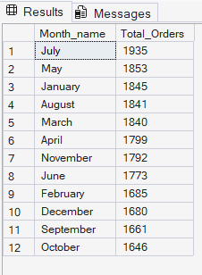

03.Percentage of Sales by Pizza Category
SELECT pizza_category ,SUM (total_price) AS Total_Sales,SUM(total_price)*100/(SELECT SUM(total_price) FROM PizzaSales) As Pecentage_Sales
from PizzaSales
WHERE MONTH(order_date)=1
GROUP BY pizza_category
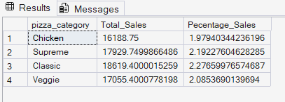

04.Percentage of Sales by Pizza Size
SELECT pizza_size ,CAST(SUM (total_price) AS DECIMAL(10,2)) AS Total_Sales,CAST(SUM(total_price)*100/(SELECT SUM(total_price ) FROM PizzaSales WHERE DATEPART(QUARTER,order_date)=1) AS DECIMAL(10,2)) As Pecentage_Sales
from PizzaSales
WHERE DATEPART(QUARTER,order_date)=1
GROUP BY pizza_size
ORDER BY Pecentage_Sales DESC
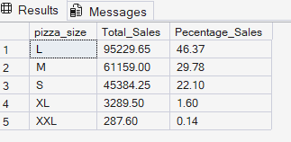

05.Top 5 Best Sellers by Revenue, Total Quantity and Total Orders
SELECT TOP 5 pizza_name,SUM(total_price) AS Total_Revenue FROM PizzaSales
GROUP BY pizza_name
ORDER BY Total_Revenue DESC
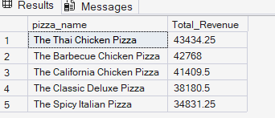
.

06.Bottom 5 Best Sellers by Revenue, Total Quantity and Total Orders
SELECT TOP 5 pizza_name,SUM(total_price) AS Total_Revenue FROM PizzaSales
GROUP BY pizza_name
ORDER BY Total_Revenue ASC
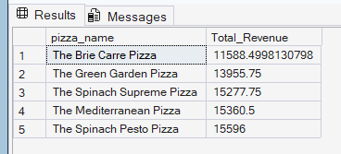

07.Total Pizzas Sold by Pizza Category
SELECT pizza_category,SUM(quantity) AS Total_Pizzas_Sold,
SUM(quantity) * 100.0 / (SELECT SUM(quantity) FROM PizzaSales
WHERE MONTH(order_date)=1)AS Percentage_Sold
FROM PizzaSales
WHERE MONTH(order_date)=1
GROUP BY pizza_category;
