# smallcase Program Question

## Question

1. Link to Question - <https://medium.com/@smallcaseHQ/522a47bcd37c>
2. Design - <http://nosmalltask.s3-website.ap-south-1.amazonaws.com/#artboard0>

## Technical stacks used

1. React
2. D3
3. HTML5
4. CSS3

## Completed Tasks

1. Listing the stocks with ‘prev’ and ‘next’ navigation
2. Portfolio – Adding and removing the stocks
3. Adding shares to a stock
4. Stock worth calculation
5. Portfolio graph implementation in D3 with tool-tip support
6. Added CSS styles, number-count and animation
7. Added filters to the available stocks
8. Support responsiveness
9. Tested in Mozilla Firefox and Google Chrome

## Source Code

GitHub - <https://github.com/Sachinmanoj/stock-portfolio>

## Steps to launch app from Source code

1. Clone or download the source code using above GitHub URL  
   Clone command - ‘*git clone* [*git@github.com:Sachinmanoj/stock-portfolio.git*](mailto:git@github.com:Sachinmanoj/stock-portfolio.git)’
2. Do ‘npm install’ in the parent directory
3. Run ‘npm start’ command to launch the application

## Steps to launch app from Build

1. Need to launch a server to serve files in Build directory
2. To launch server use python ([Link to Download](https://www.python.org/downloads/))
3. Launch server in the ‘Build’ folder using below command,

python -m SimpleHTTPServer 3000

1. Open below URL in browser

<http://localhost:3000>

## Screenshots (Google Chrome)

1. **Web page in 1920x989**

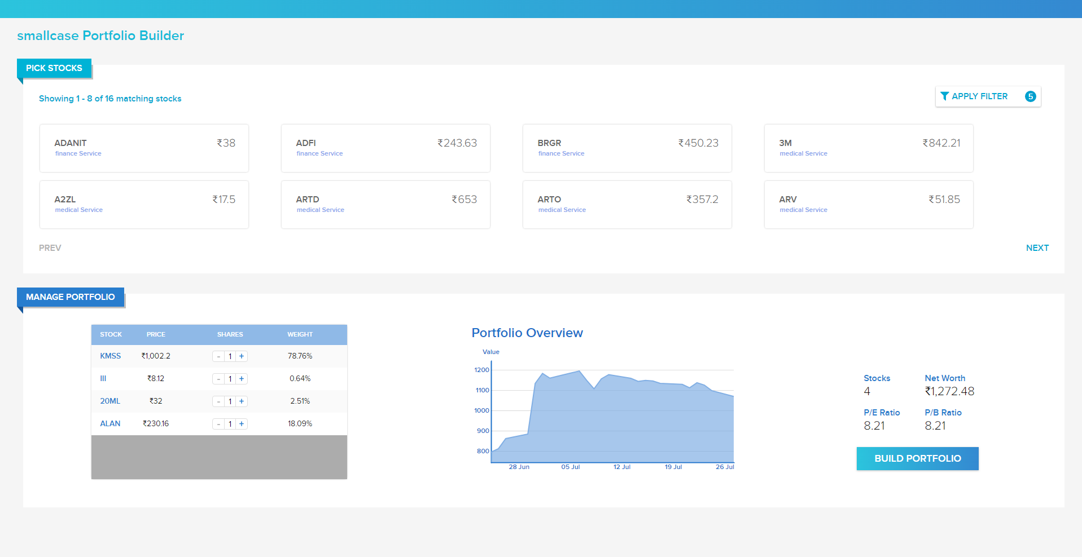

1. **Web page in 1150 x 950**

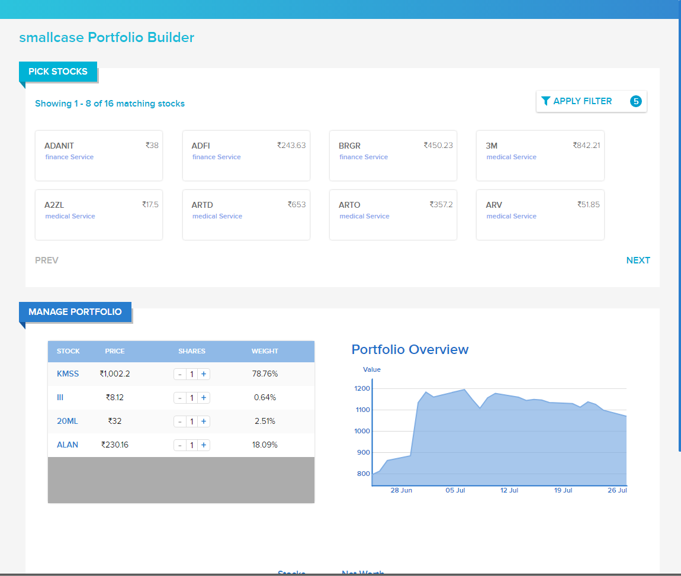

1. **Web page in 750 x 950**

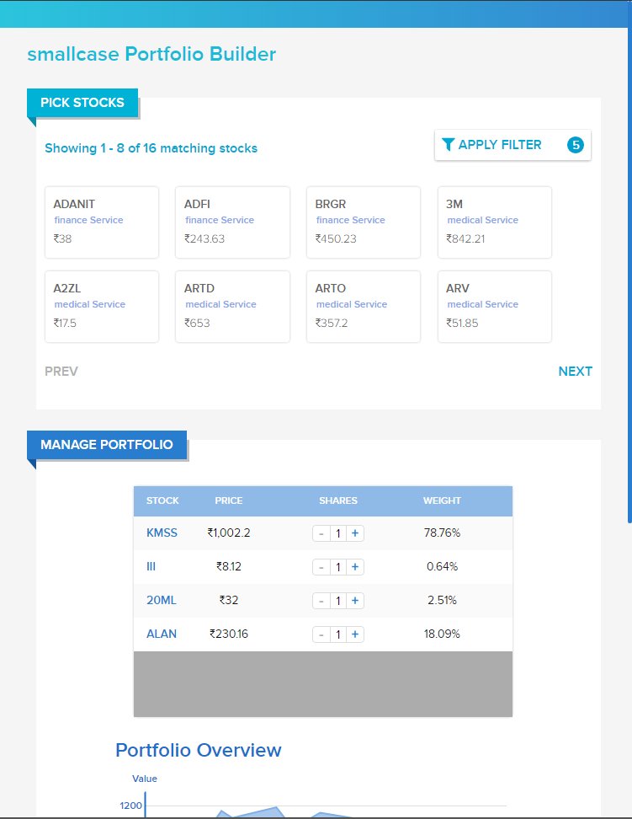

1. **Apply Filter control**

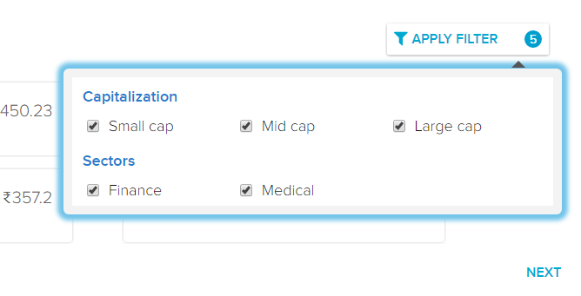

1. **Other screenshots**

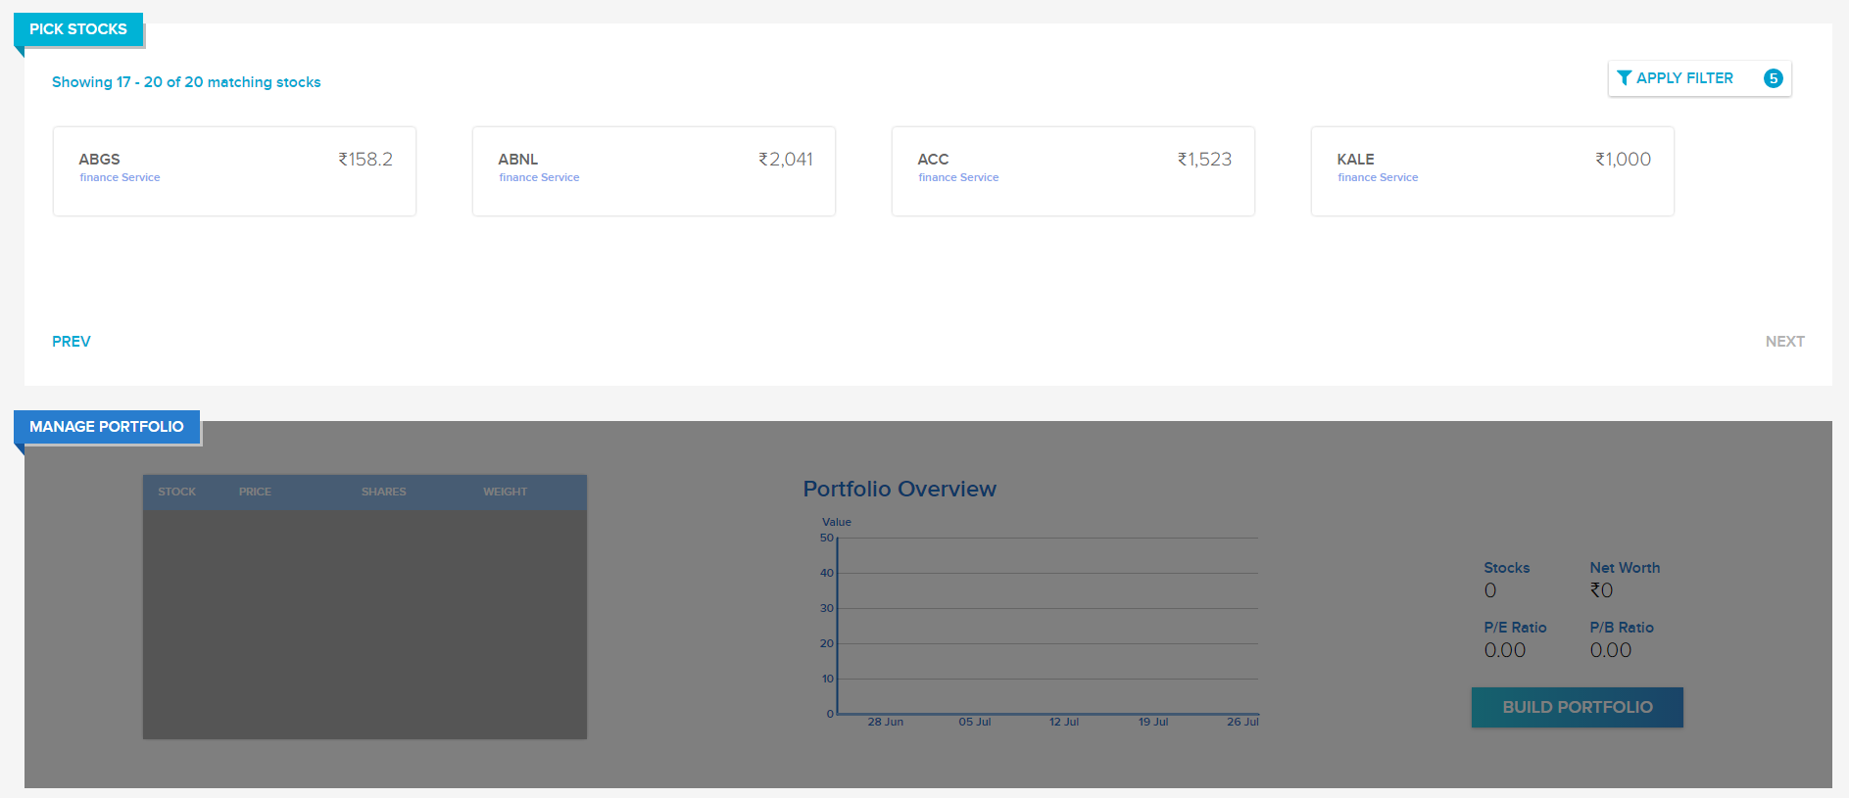

1. **Graph**

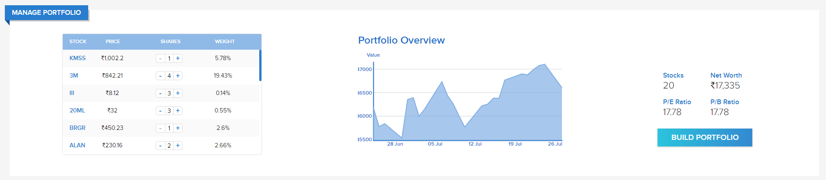

## Improvements can be done

1. Animations to Apply filter control
2. Better animations to Available stocks and Portfolio table
3. Zoom support to graph
4. Animation support to the “Manage Portfolio” overlay element

## Known issues

1. No responsiveness support for Apply filter control and popup dialog
2. Apply filter popup dialog is closed only by clicking the Apply filter button control
3. “Proxima-Nova” font is not working in Mozilla Firefox

## Patch work

1. Added “800px” as the minimum width for Mozilla Firefox browser, due to flex box and flex shrink issue

## Notes

1. Recommended to use Google Chrome