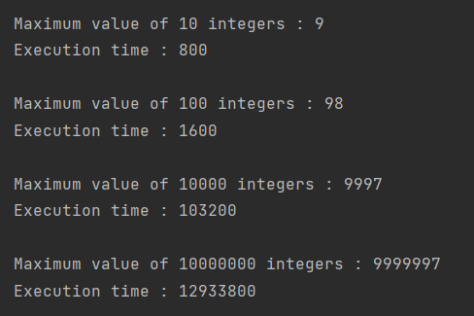**Output Example**

**Comparison of the Example**

|  |  |  |
| --- | --- | --- |
| Number of Elements | Maximum Value | Execution Time |
| 10 | 9 | 800 |
| 100 | 98 | 1600 |
| 10000 | 9997 | 103200 |
| 1000000 | 9999997 | 12933800 |

**Summary**

Execution time increase linearly with the number of elements.