What needs to be done:

1. Make these classes to form a basic file system:

file: everything in the file system has to be a file
plain_file: a plain file is a file that just has a name
directory: has its own name and a list of files

constructors such as _init__ methods need to be used to make the directory tree (file system) like the one below (directories in ovals, plain files in rectangles.

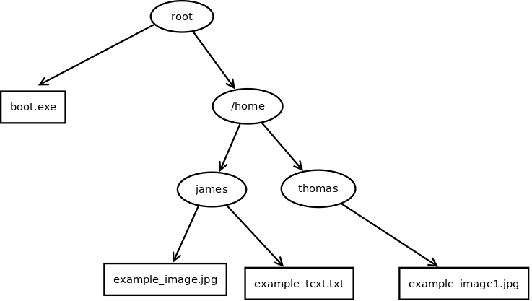

2. Some methods need to be added which recursively print the file system tree – I believe this may be by using ‘for each’. For this __stre__ methods need to be defined.

3. For each file, they must have an ‘owner’ attribute that be assigned, but if unassigned needs to be ‘default’. The method chown(new_owner) has to be implemented to allow the user to change the owner of the file or directory.

3.1 Make chown -r which recursively changes the owner to all files in the system, it needs to have an input, something like “Should these permissions be applied to all files in the system or just one? Enter ‘all’ or ‘one’?” .

4. The method ls() has to be implemented that recursively prints contents of a directory and all the content of all subdirectories using indentation to show how deep the file or directory is. It should show the owner of the file alongside it.

5. The class file_system needs to be added which allows the user to move around the file system like it was a UNIX file system. It needs to keep track of the working directory. It should look like
fs = file_system(root)

5.1 Make a method called pwd() that shows the current working directory and looks like:
fs.pwd()

5.2 Make ls() for the file_system so fs.ls prints the current directory.

5.3 Make cd() to move directories. But says “That doesn’t exist” if the directory isn’t there.

5.4 Make methods create_file(name) and mkdir(name) which work in the current directory. Allows user to indicate who owns the file or directory through input and pulls an error if the file or directory already exists.

5.5 Change the cd() method to allow the user to return to parent directories. It should look like
fs.cd(“..”)

5.6 Make method rm(name) that will allow the user to remove a file from the current directory or delete the current directory. If a directory is trying to be deleted but it has files in it is should show error (“The directory isn’t empty”).

5.7 Make a method called find(name) which finds a file and returns its path – it should look like
fs.find(“example_image.jpg”) however if the user has moved deeper into the directory using cd then it should only look in the current directory.

5.8 Make it so that files can be moved using ‘mv’ like in a UNIX system – it needs to look like
mv <current_path> <destination_path>.

