**Snaptrude Assignment**

**For this assignment, I have used Cucumber Framework.**

* Project Name 🡪 **SnapTrudeTask**

Inside this project, I have created 4 packages

* Modules
* PageObjects
* Runner
* Step_Definitions

Along with this, have also created **Feature** file using Gherkins language.

* Feature File🡪 **snaptrude.feature** this feature file contains all the scenarios.

The feature file contains 8 scenarios.

1. **Validlogin –** This is for Valid Email Subscription and Valid login credentials

2. **InValidlogin –** This is forInvalid Login credentials [Which contains 5 scenarios]

3. **InvalidEmailSubscription –** This is for Invalid Email ID for subscription

4. **ForgotPassword –** This is for Password Reset scenario

The Step_Defination package contains two classes

1. **SnapTrudeLoginSteps.java** class which contains the methods with an annotation above it which will be referring to feature file.

2. **Hooks.java** class which contains the method to Open and Close the browser

The PageObjects Package contains two classes

1. **SnapTrudeEmailSubscription.java** class which contains all the locators to find match the elements.

2. **BaseClass.java** class which is used to initialize the driver.

The Modules package contains one class

1. **SnapTrudeAction.java** class contains multiple methods which is used to perform the action on the particular element.

The Runner package contains one class

1. **SnapetrudeRunner.java** which is used to run the test.

**Test Cases**

**Objective 1: Verify that the user should be able to login to snaptrude website by entering valid login credentials.**

| **ID** | **Actions** | **Expected Result** |
| --- | --- | --- |
|  | Open browser🡪 enter “<http://www.snaptrude.com>”.  Type “ [Snaptrude@snaptrude.com](mailto:Snaptrude@snaptrude.com)" in the text box of ‘GetAnInvite’ button and click invite button | The Snaptrude website should be opened and the user should be able to enter the Email Id in the text box. One the invite button is clicked, “Thank you very much for Subscribing. We will email you the invite soon.” Message should be displayed. |
|  | Click on Login | Login pop up should be displayed |
|  | Enter [Snaptrude@snaptrude.com](mailto:Snaptrude@snaptrude.com) and test12345 in Email and password fields and click on sign in button | The user should be able to login and home page should be displayed. |

**Objective 2: Verify that the user should not be able to login to snaptrude website by entering Invalid login credentials.**

| **ID** | **Actions** | **Expected Result** |
| --- | --- | --- |
|  | Open browser🡪 enter “<http://www.snaptrude.com>”.  Type “ [Snaptrude@snaptrude.com](mailto:Snaptrude@snaptrude.com)" in the text box of ‘GetAnInvite’ button and click invite button | The Snaptrude website should be opened and the user should be able to enter the Email Id in the text box. One the invite button is clicked, “Thank you very much for Subscribing. We will email you the invite soon.” Message should be displayed. |
|  | Click on Login | Login pop up should be displayed |
|  | Enter ‘Sachinvr’ and ‘Welcome42’ and in Email and password fields and click on sign in button | The user should not be able to login and “Invalid Username or password” message should be displayed to the user. |
|  | Pass blank data in Email and password fields and click on sign in button | The user should not be able to login and “Invalid Username or password” message should be displayed to the user. |
|  | Enter ‘Sachinvr’ as Email ID and blank password field and click on sign in button | The user should not be able to login and “Invalid Username or password” message should be displayed to the user. |
|  | Enter ‘[Snaptrude@snaptrude.com](mailto:Snaptrude@snaptrude.com) in Email and blank password field and click on sign in button | The user should not be able to login and “Invalid Username or password” message should be displayed to the user. |
|  | Pass blank email ID and correct Password and click on sign in button | The user should not be able to login and “Invalid Username or password” message should be displayed to the user. |

**Objective 3: Verify the invalid email subscription in snaptrude website.**

| **ID** | **Actions** | **Expected Result** |
| --- | --- | --- |
|  | Open browser🡪 enter “<http://www.snaptrude.com>”.  Type “ abcd" in the text box of ‘GetAnInvite’ button and click invite button | One the invite button is clicked by entering data, “Please enter a valid email address.” Message should be displayed to the user. |

**Objective 4: Verify Forgot password functionality in Snaptrude website.**

| **ID** | **Actions** | **Expected Result** |
| --- | --- | --- |
|  | Open browser🡪 enter “<http://www.snaptrude.com>”.  Type “ [Snaptrude@snaptrude.com](mailto:Snaptrude@snaptrude.com)" in the text box of ‘GetAnInvite’ button and click invite button | The Snaptrude website should be opened and the user should be able to enter the Email Id in the text box. One the invite button is clicked, “Thank you very much for Subscribing. We will email you the invite soon.” Message should be displayed. |
|  | Click on Login | Login pop up should be displayed |
|  | Click on Forgot password | Password reset pop up should be displayed with a text box to type the Email ID. |
|  | Type the email ID and click on ‘Reset My Password’ button | Once the user clicks on ‘Reset My Password’ button, “Password Reset sent” message should be displayed. |

To run the Runner class, Open **SnapetrudeRunner.java 🡪** Right click🡪 Run as🡪1 JUnit Test.

Once the test is run, the **Report** will be generated in the below mentioned folder.

SnapTrudeTask\target\cucumber-html-report\**index.html**

**Screenshot of feature file.**

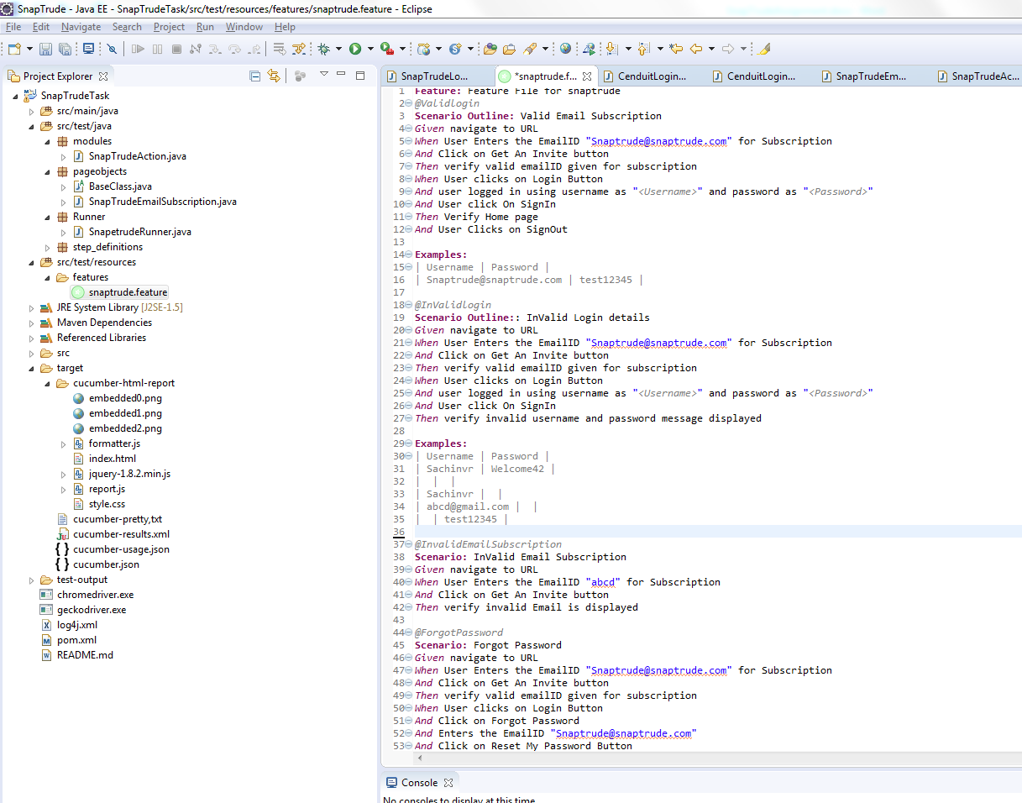

Output in the Console for Scenario 1. **ValidLogin**

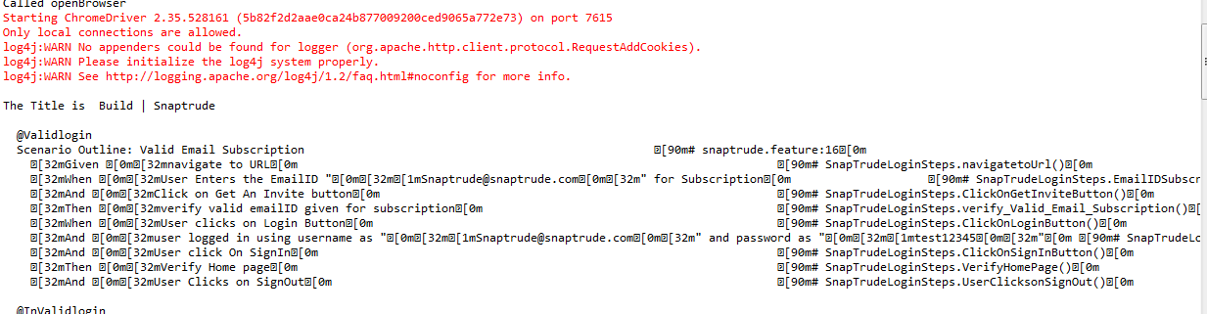

Output in the Console for Scenario [2 to 6] **InValidLogin**

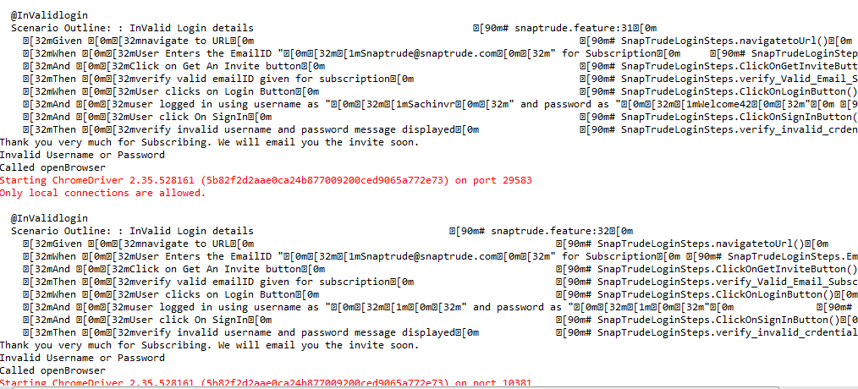

Output in the Console for Scenario 7. **InvalidEmailSubscription**

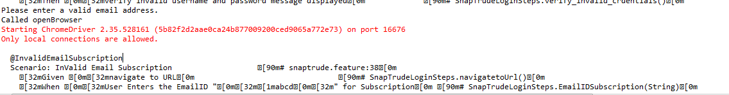

Output in the Console for Scenario 8. **InvalidEmailSubscription**

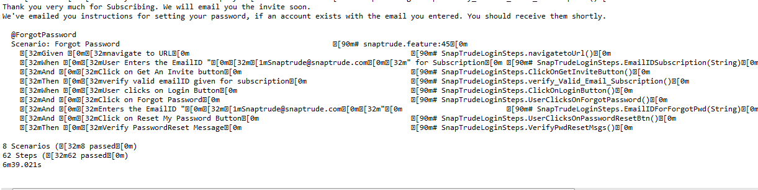

**Output in the Report for Scenario 1. ValidLogin**

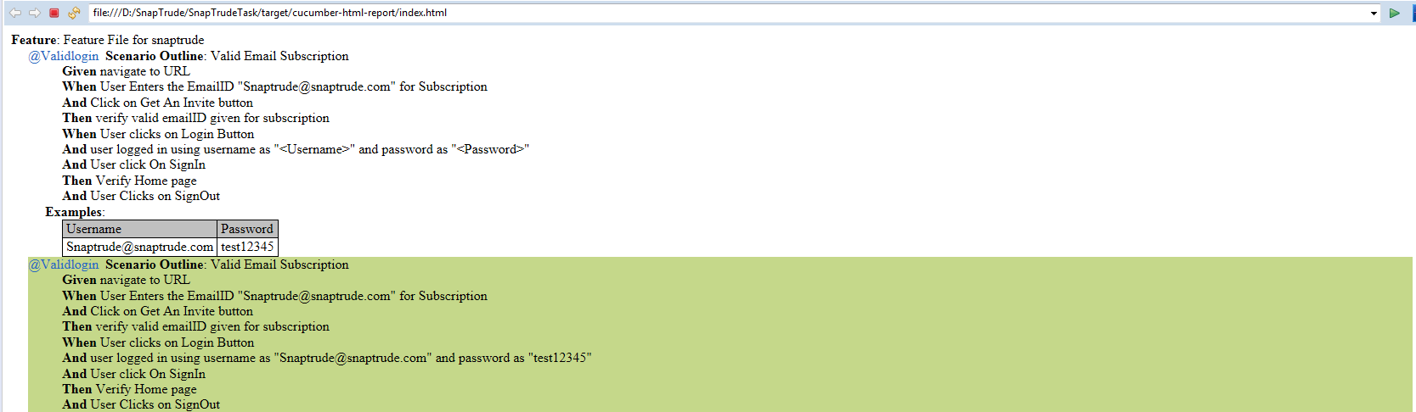

**Output in the Report for Scenario 2 to 6. InValidLogin**

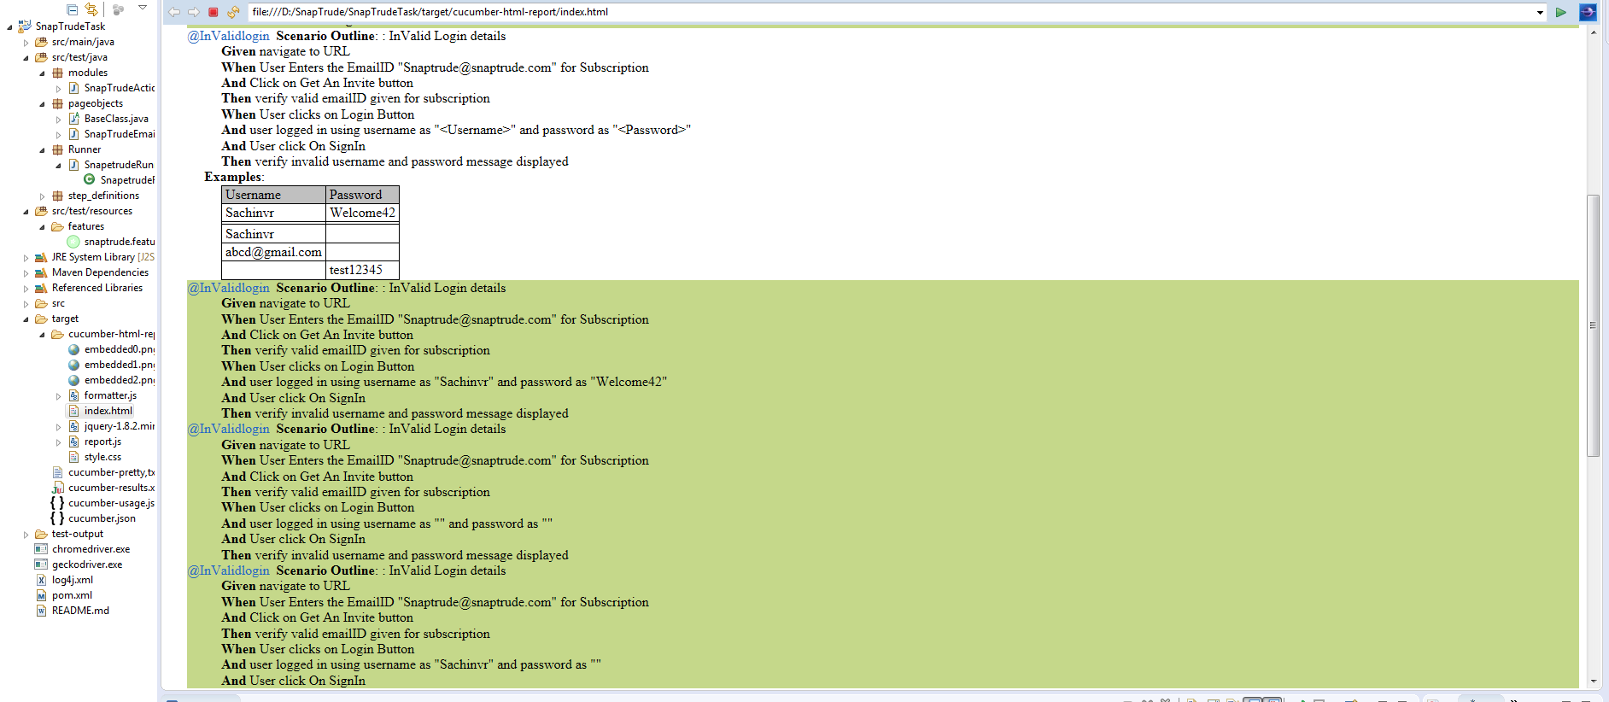

**Output in the Report for Scenario 7 and 8. InvalidEmailSubscription and ForgotPassword**

