Introduction

CellDepot is database management system integrated with management system, query searching and data visualization tools [1, 2] for scRNAseq datasets, which can be accessed by the link <http://celldepot.bxgenomics.com/>.This is a supplemental tutorial provides a detailed guide.

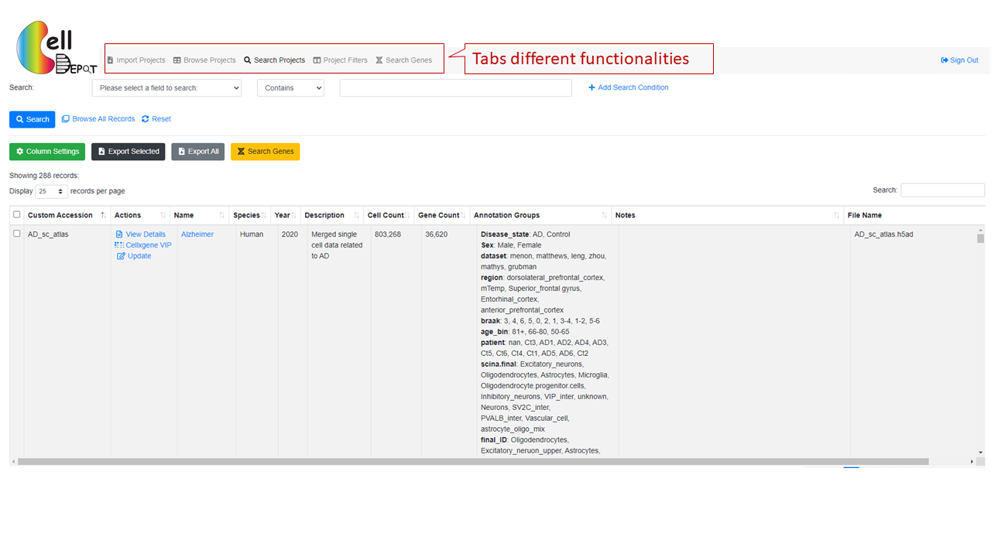The interface contains multiple tabs, corresponding to import and/or select objects in CellDepot scRNAseq database, that can be accessed on top panel of the webpage. Users can upload their own dataset or explore the existing datasets for visualization and analysis.

1. Upload projects

To upload new projects in CellDepot database, two files are required: 1) .h5ad files and 2) project information in csv format. Detailed formatting guidance can be found by ‘Download Example File’ hyperlink on webpage. In addition, two cellxgene VIP launch methods are provided: standard and preload in memory. Standard mode is for the first-time imported datasets, while preload in memory should be chosen when users update the meta information of datasets.

After the projects are submitted, CellxDepot will automatically analyze the datasets. To explore the detail of uploaded datasets, users can navigate to ‘browse projects’ page and then search the imported datasets by the customized accession number.

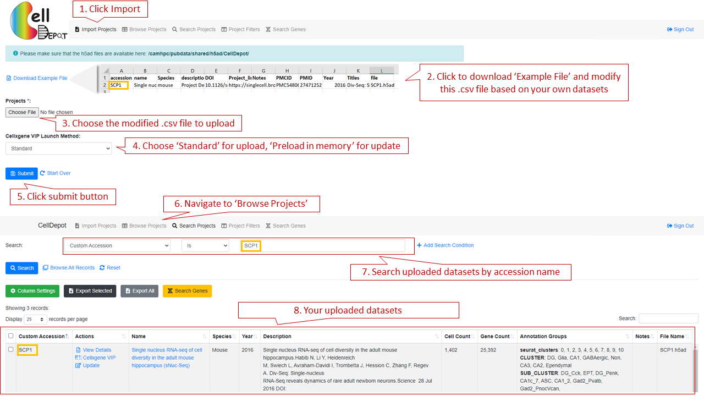

Figure S2. Workflow of how to import personal datasets.

1. Browse Projects
   1. Search Projects

This function allows the user to search any targeted interests, which also can be accessed through search projects on the top panel of the webpage. Users is allowed to select the projects by 17 attributes: annotation groups, cell count, cellxgene VIP launch method, Custom accession, description, DOI, file name, file size, gene count, name, notes, PMC ID, Publication Title, PubMed ID, Species, URL, Year. These 17 fields can also be (partially) displayed on the webpage through ‘column setting’ on the webpage. Users can also search projects by the keywords via the search function on the right of the webpage. In addition, by ‘column setting’, users can set up the customized layout of targeted projects; thereby exporting to csv format.

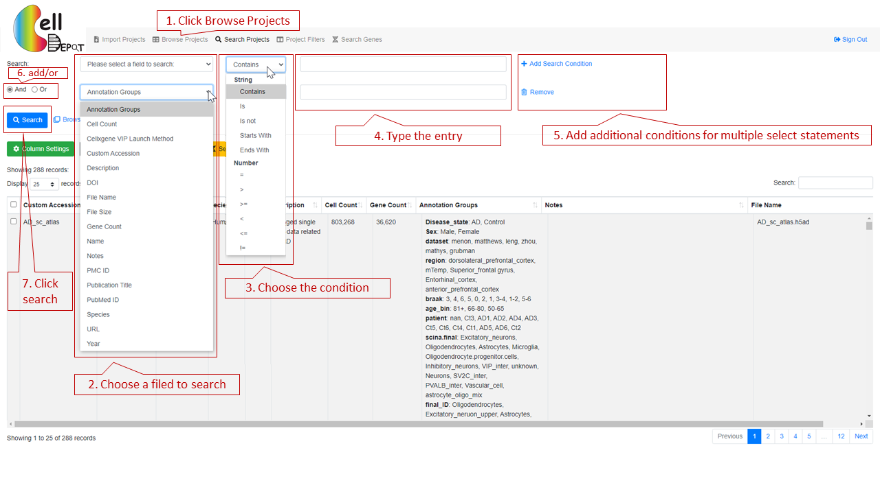

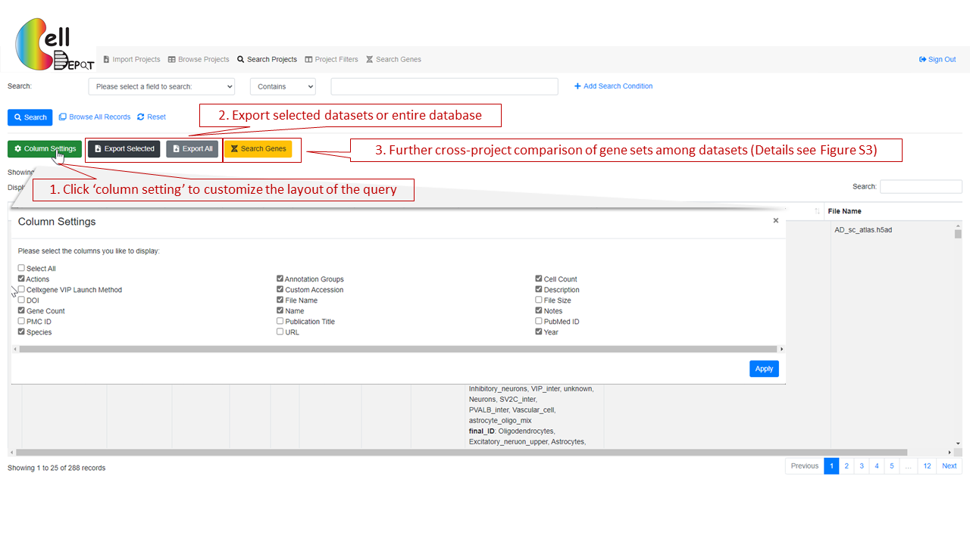

Figure S2. Workflow of how to search query on ‘Browse Projects’ page.

* + 1. Case study 1

Cross-project comparison of skeletal muscle marker genes PAX3, PAX7, PITX2, MYF5, MYF6, MYOD1, MYOG, NEB, MYH3 among the datasets whose species is human and cell type is myogenic.

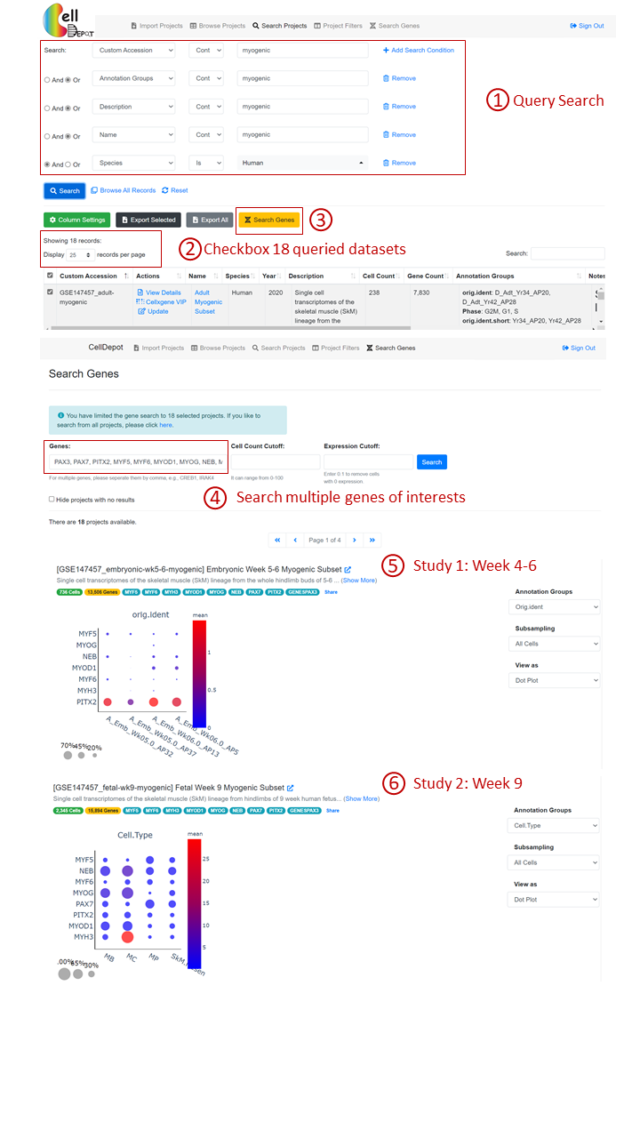

Figure S3. Workflow of how to conduct the cross-project comparison of gene sets among the selected datasets.

For each project, users can view the datasets information, visualize data analysis and conduct update through View Details, cellxgene VIP amd Update, separately.

* 1. Project Filters

This page provides the matched datasets by simply clicking the categories. It is a first-time user-friendly functionality as users may not be familiar with the content of the database. The advance search function is the same as that on the ‘Browse Projects’ page (Details see Figure S2).

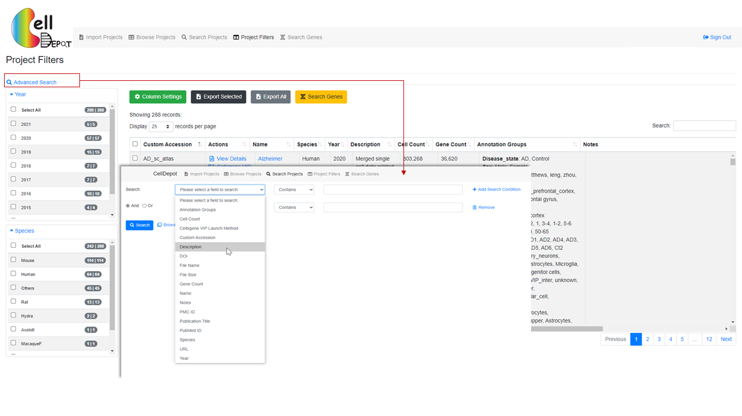

Figure S4. The layout of ‘Project Filters’ page.

3. Visualize the datasets

3.1 View Details

The datasets information consists of project summary and annotation groups. The project summary is provided by each user when uploading projects. The information of annotation groups is from uploaded .h5ad file.

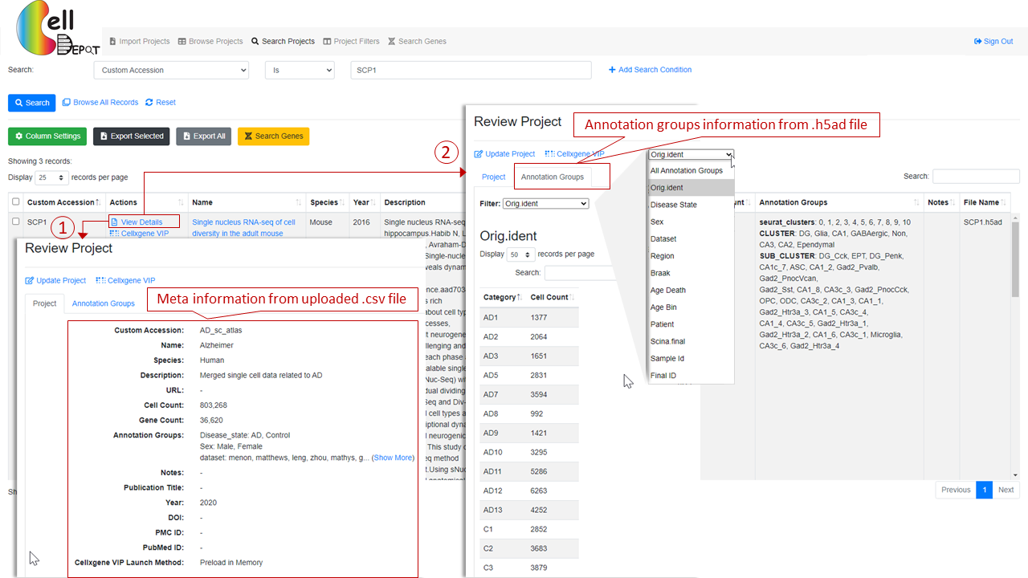

Figure S5. Visualization of details of datasets.

3.2 Update

Project summary information can be updated on ‘Browse Project’ page with ‘Preload in Memory’ cellxgene VIP launch method via click ‘Update’ hyperlink.

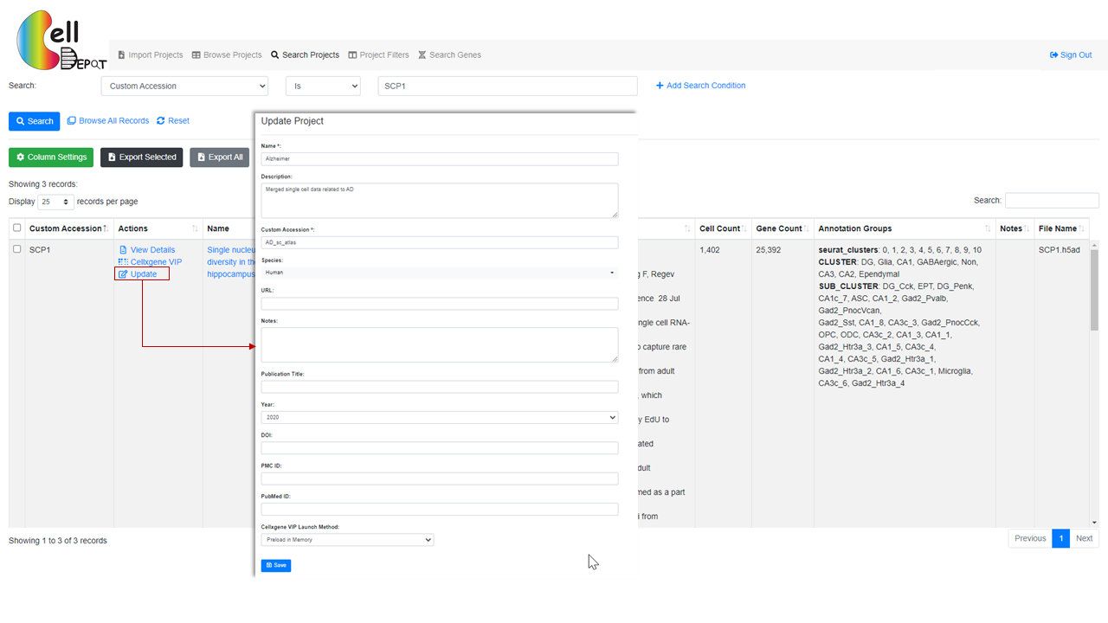Figure S5. Update project on ‘Browse Project’ page.

3.3 Data visualization and analysis

CellDepot is not only a database management system, but also a web portal to visualize the scRNAseq dataset. Here, we embed cellxgene and cellxgene VIP in CellDepot. By clicking ‘Cellxgene VIP’, data analysis results can be visualized. Detailed guides of cellxgene and cellxgene VIP, please go to [https://github.com/chanzuckerberg/cellxgene](https://github.com/chanzuckerberg/cellxgene%20) (cellxgene) and <https://github.com/interactivereport/cellxgene_VIP> (cellxgene_VIP).

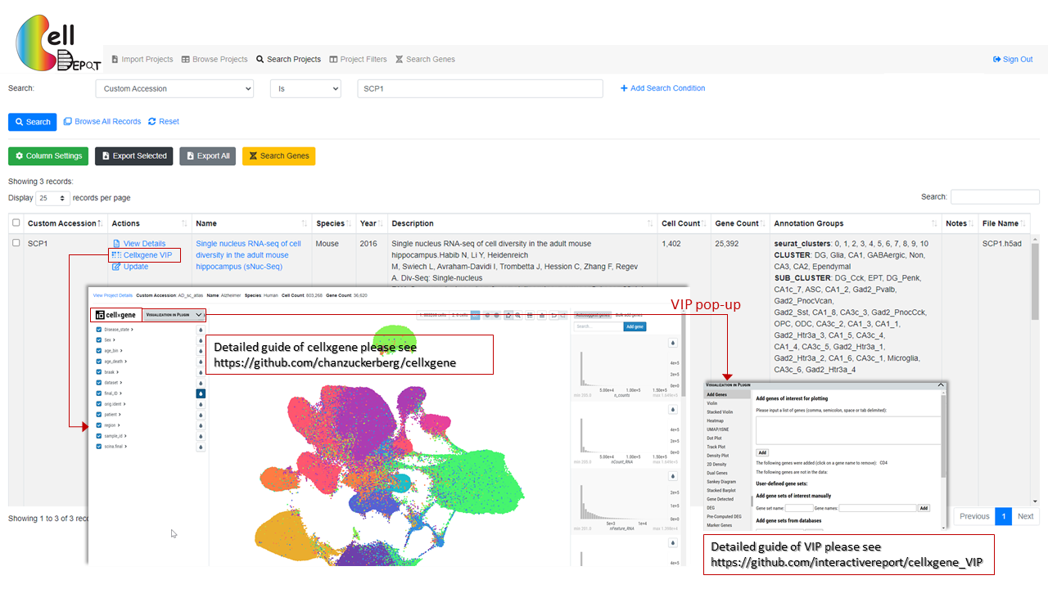

Figure S6. See visualization of selected datasets.

1. Search gene

This tab allows searching on targeted genes with cell count cutoff and expression cutoff. The search outcome provides users every project contains the targeted genes. Each project displays a link to project page and a figure plot if applicable. This plot can be either violin plot or dot plot shows the gene expression level in each annotation groups.

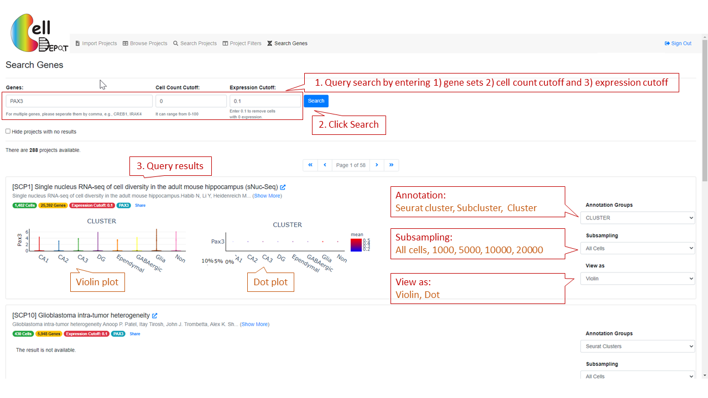

Figure S7. The layout of ‘Search Genes’

1. Cron job setting-up

[1] Li K, Ouyang Z, Lin D, Mingueneau M, Chen W, Sexton D, et al. cellxgene VIP unleashes full power of interactive visualization, plotting and analysis of scRNA-seq data in the scale of millions of cells. 2020:2020.08.28.270652.

[2] Megill C, Martin B, Weaver C, Bell S, Prins L, Badajoz S, et al. cellxgene: a performant, scalable exploration platform for high dimensional sparse matrices. 2021:2021.04.05.438318.