Capstone Life Villa Customisation Portal

A report submitted to

RAMAIAH INSTITUTE OF TECHNOLOGY

Bengaluru

INTERNSHIP (INT82)

as partial fulfillment of the requirement for

Bachelor of Engineering (B.E) in Information Science and Engineering

by

Sachit Reddy H ( USN- 1MS22IS113 )

under the guidance of

INDUSTRY GUIDE INTERNAL GUIDE
Rohit Rao JR Shruthi
Business Technology Manager Assistant Professor
Capstone Life Dept of ISE, RIT



DEPARTMENT OF INFORMATION SCIENCE AND ENGINEERING

RAMAIAH INSTITUTE OF TECHNOLOGY

June 2026

Department of Information Science and Engineering
Ramaiah Institute of Technology
Bengaluru – 54



CERTIFICATE

This is to certify that Internship Programme entitled “Capstone Life Villa Customisation Portal” is carried out by Sachit Reddy H [USN- 1MS22IS113], a bonafide student of Ramaiah Institute of Technology, Bangalore, in partial fulfillment for the award of Bachelor of Engineering in Information Science and Engineering of the Visvesvaraya Technological University, Belgaum, during the year 2025-2026. This work has been approved as it satisfies the academic requirements in respect to Internship Programme prescribed for the said degree.

(Internal Guide) (Head of the Department)
JR Shruthi Dr. Sumana M
Assistant Professor, Dept. of ISE, RIT Professor & Head, Dept. of ISE, RIT

ACKNOWLEDGEMENT

I would like to express my deepest gratitude to Dr. N V R Naidu, Principal of MSRIT. His vision and unwavering dedication to excellence have fostered an environment that actively encourages students like myself to pursue practical learning experiences beyond the classroom. Dr. Naidu's leadership has served as a constant source of inspiration throughout my academic journey.

My sincere appreciation extends to Dr. Sumana M, Head of the Department of Information Science and Engineering (ISE) and my internal internship guide JR Shruthi, whose unwavering support and guidance were instrumental in securing this real-world experience. Their encouragement and belief in my abilities played a crucial role in propelling me forward.

I am particularly grateful to Sumit Bhosle and Rohit Rao, my guides at Capstone Life, Bengaluru, for their invaluable mentorship. Their patience, unwavering support, and practical wisdom throughout this internship journey were truly appreciated. Sumit Bhosle and Rohit Rao's insights and constructive feedback significantly contributed to my learning and development.

A heartfelt thanks goes to my teammates at Capstone Life, Bengaluru. Their companionship and collaborative spirit throughout this journey have made it incredibly rewarding. Working alongside such a talented group who share a passion for the project has no doubt made this internship a truly memorable experience.

ABSTRACT

This report documents the design, development, and deployment of the Capstone Life Villa Customisation Portal, a full-stack web application developed as part of an internship with Capstone Life, a premium real estate developer working on the MSR Phase 3 luxury villa project in India. The portal addresses the limitations of a manual, catalogue-driven customisation process by providing an interactive digital platform through which villa buyers can browse and select upgrade options across eight categories — Space Customisations, Flooring Upgrades, Bathroom Upgrades (Sanitaryware and CP Fittings), VRF Cooling System, Smart Home Automation, Landscape Packages, Lift Interior Refinement, and Home Theatre.
The system is built on a React 19 and TypeScript frontend powered by Vite, a Python FastAPI backend with Motor for asynchronous MongoDB Atlas access, and JSON Web Token-based authentication with role-based access control. The application supports four user roles — Customer, Admin, CRM Admin, and Design Admin — each routed to role-specific dashboards. A structured quote lifecycle enables customers to submit selections, receive admin-priced quotations, and accept or request changes. A Drawing Register module tracks the distribution of architectural plans to individual villa customers.
The complete application was successfully deployed to Render (cloud platform-as-a-service) with MongoDB Atlas as the cloud database. All planned features were delivered and validated through functional testing, and the portal is in active use by the Capstone Life team and villa customers. Key technical achievements include a dynamic room-based navigation system for flooring and bathroom categories, a dual-notification system for admin and customer quote interactions, and a client-side Excel quotation generator. The project provided extensive practical exposure to full-stack development, REST API design, cloud deployment, and iterative software delivery.

INTERNSHIP COMPLETION CERTIFICATE
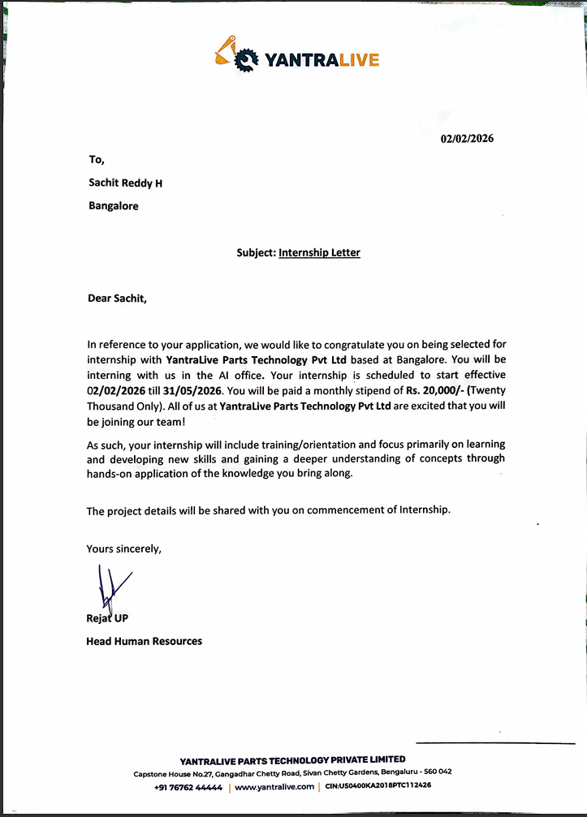
TABLE OF CONTENTS
- Introduction ….……………………………………………………….....5
1.1 About the Organization (Internship Work Place)…….………..5-6
1.2 Scope and Objectives……………...…………………………………6
- Methodology………………………………...……………………………7
- Implementation …………...……………………………………………10-11
- Results and Discussion…………...………………………………………15
- Conclusion …………...……………………………………………….....18

Chapter 1
INTRODUCTION
1.1 About the Organization (Internship Work Place)
Capstone Life is a premium real estate developer focused on delivering high-quality residential properties in India. The organisation's flagship MSR Phase 3 project is a signature development comprising luxury three-floor villas available in two architectural variants — Type 1 (East Facing) and Type 2 (West Facing). Each villa spans Ground, First, and Second floors and encompasses a wide array of interior and exterior upgrade options curated by the design and product teams.
The organisation's internal structure includes dedicated sales (CRM), design, and project management functions. The sales team manages customer relationships and quote interactions, the design team is responsible for architectural drawings and specifications, and the project management team oversees delivery timelines and construction milestones. This internship was conducted under the direct supervision of the digital infrastructure team at Capstone Life's Bengaluru office, which is responsible for building and maintaining the technology platforms supporting the MSR Phase 3 launch.
Prior to this project, the customisation selection process at Capstone Life was largely manual, relying on printed product catalogues, in-person meetings, and spreadsheet-based tracking. This approach was time-consuming for both the sales team and the customers, prone to miscommunication, and difficult to scale as the number of villa units grew. The Villa Customisation Portal was conceptualised to address these inefficiencies and provide a professional, digital-first experience for villa buyers.
1.2 Scope and Objectives
The primary objective of this project was to build a production-ready, role-based web portal that allows villa customers to browse and select customisation options across multiple product categories, and enables the Capstone Life team to manage these selections, generate quotations, and track drawing plans. The specific objectives were as follows:
1. To develop a customer-facing portal where villa buyers can log in securely, explore eight customisation categories, select standard or upgrade options, and submit those selections for quotation.
2. To implement an admin panel with three distinct roles — Admin, CRM Admin, and Design Admin — each with appropriate access controls and dashboards for managing customers, options, quotes, and villa drawings.
3. To design a structured quote workflow in which customers submit their selections, the admin team reviews and prices them at line-item level, and the customer can accept or request changes.
4. To build a Drawing Register module that tracks the upload status of standard and updated architectural plans for each villa unit.
5. To deploy the entire application to a cloud hosting platform (Render) with MongoDB Atlas as the database, making it accessible to real users during the pilot phase.
The scope of work covered the full software development lifecycle — from requirements gathering and system design through to coding, database setup, and cloud deployment. The eight customisation categories included: Space Customisations, Flooring Upgrades, Bathroom Upgrades (Sanitaryware and CP Fittings), VRF Cooling System, Smart Home Automation, Landscape Packages, Lift Interior Refinement, and Home Theatre.

Chapter 2
METHODOLOGY
2.1 Development Approach
An iterative, feature-driven development methodology was adopted for this project. Given that the requirements evolved continuously as the business team refined the customisation catalogue and the quote process, a rigid waterfall approach would have been unsuitable. Instead, the project was broken into vertical slices — each slice delivering end-to-end functionality for a specific feature area (authentication, category browsing, selections, quotes, admin management, drawing register) — and each slice was developed, reviewed, and refined before the next was begun. This approach ensured that working software was available for stakeholder feedback at each stage.
Weekly review sessions were conducted with the project supervisor to demonstrate progress, gather feedback, and reprioritise upcoming work. Issues and enhancements were tracked informally through a shared notes document, and the codebase was version-controlled using Git with a remote repository hosted on GitHub.
2.2 Technology Stack Selection
The technology choices were guided by three key criteria: suitability for a modern single-page web application, rapid development capability, and alignment with the hosting environment available.
Frontend: React 19 with TypeScript was selected for the customer and admin user interfaces. React's component model enabled the construction of reusable UI elements (category cards, option tiles, quote tables) while TypeScript provided static type safety that reduced runtime errors during development. Vite was used as the build tool for its fast hot-module replacement during development. React Router v7 managed client-side navigation across the landing page, customisation hub, category pages, and admin panels. Axios handled HTTP communication with the backend API. The Lucide React icon library provided consistent iconography, and xlsx-js-style enabled client-side generation of Excel quotation sheets.
Backend: Python with FastAPI was chosen for the REST API. FastAPI's automatic OpenAPI documentation (available at /docs) was particularly valuable during development, allowing the team to test endpoints interactively. Uvicorn served as the ASGI server. Pydantic v2 was used for request/response schema validation, ensuring data integrity at the API boundary. Async/await programming throughout the backend, powered by Motor (the async MongoDB driver for Python), allowed the server to handle concurrent requests efficiently.
Database: MongoDB Atlas (cloud-hosted) was selected as the data store. Its document-oriented model suited the variable structure of customisation options across categories. Indexes were created on frequently queried fields — email (unique), villa_number (unique), option_id (unique), customer_id — to optimise query performance.
Authentication: JSON Web Tokens (JWT) were implemented using the python-jose library. The system issues both short-lived access tokens (60 minutes) and longer-lived refresh tokens (7 days). Passwords are hashed using bcrypt via the passlib library. Role-based access control differentiates between customer, admin, crm_admin, and design_admin roles, with FastAPI dependency injection enforcing the correct role on each protected endpoint.
Deployment: Both the frontend and backend were deployed to Render, a cloud platform-as-a-service. The backend runs as a Python web service and the frontend as a static site with SPA rewrite rules. Environment variables (database URI, JWT secret, admin credentials) are managed through Render's dashboard, keeping secrets out of the codebase.
2.3 System Architecture
The application follows a three-tier architecture: a React Single-Page Application (SPA) in the browser, a FastAPI RESTful backend, and a MongoDB Atlas cloud database. The frontend communicates exclusively with the backend via HTTP API calls using Axios; there is no direct database access from the browser. The backend mounts static file directories (for option images and floor plans) and exposes them over HTTP. Cross-Origin Resource Sharing (CORS) middleware is configured on the backend to accept requests from the deployed frontend domain.
Role-based routing is enforced both on the frontend (navigating admin users to /admin, CRM users to /crm, design users to /design, and customers to /hub) and on the backend (FastAPI dependency functions require_admin, require_any_admin, and require_drawing_access guard sensitive endpoints). This dual enforcement ensures that even a technically sophisticated user cannot access data beyond their role by bypassing frontend navigation.
2.4 Database Design
The MongoDB database (capstone_portal) comprises seven collections. The users collection stores both customer and admin accounts, with a role field distinguishing between them. The villas collection tracks villa numbers, types, and assignment status. The categories collection defines the eight customisation categories. The customization_options collection holds all product options with rich embedded fields for images, pricing, room coverage, sub-sections, and villa-type applicability. The locations collection holds room-level location identifiers referenced by flooring and bathroom options. The customer_selections collection maintains a single document per customer with status tracking (in_progress, submitted, accepted).

Chapter 3
IMPLEMENTATION
3.1 Project Structure
The repository is organised into two top-level directories: backend and frontend. The backend directory contains the FastAPI application under the app sub-package, organised into routers (one per feature domain), schemas (Pydantic models for each entity), and core modules (security utilities and dependency injection). Static assets — floor plans and option product images — are served from the backend/static folder. The frontend directory contains the React/Vite application with source files under frontend/src, divided into pages (customer and admin views) and services (API client functions). Build output is placed in frontend/dist, which Render serves as the static site.
3.2 Authentication and Role-Based Access Control
The authentication system is built around JWT access and refresh tokens. When a user submits their credentials at the /auth/login endpoint, the backend verifies the email and bcrypt-hashed password, then issues an access token (valid for 60 minutes) and a refresh token (valid for 7 days). Admin sessions store tokens in sessionStorage while customer sessions use localStorage for persistent login. The /auth/refresh endpoint allows silent token renewal.
Role-based access is enforced through FastAPI dependency functions. get_current_user decodes the JWT and fetches the user document. require_admin ensures only admin users can access sensitive operations. require_any_admin permits admin, crm_admin, and design_admin roles for shared views. require_drawing_access allows design_admin and admin roles to view and upload drawing plans. Post-login routing directs each role to its appropriate entry point (/admin, /crm, /design, or /hub).
3.3 Customer-Facing Portal
The customer journey begins at the Landing Page, which displays the Capstone Life branding over a full-screen looping video banner of the villa. Once authenticated, the customer is routed to the Customisation Hub — a 3-by-3 grid of cards representing the eight customisation categories and a Floor Plan viewer.
For Flooring (CAT002) and Bathroom (CAT003), a room-based navigation flow is presented: the customer first selects a floor (Ground, First, or Second), then a specific room within that floor, and finally views the upgrade options for that room. For all other categories, all options are listed directly. Customers can view standard specifications, upgrade specifications, add-ons, and pricing. A selection panel records chosen options in real time, and a persistent cart icon shows the total count of selections.
The villa image gallery provides a room-by-room photographic tour, grouped by floor. The Floor Plan module displays architectural drawings uploaded by the design team, and floor plans are marked as 'viewed' via an API call the first time a customer opens them.
3.4 Selection and Quote Workflow
Selections are persisted server-side in the customer_selections collection. The upsert endpoint replaces any existing selection for the same option-location pair, ensuring the customer holds only one selection per upgrade slot per room. Customers can remove individual selections or clear all selections at any time before submission.
On submission, a quote request document is created (or updated) in quote_requests with a notification flag ('new' or 'updated'). The admin reviews the snapshot, assigns individual line-item prices, and sends the quote. Sending sets the status to 'quoted' and raises a customer-facing bell notification. The customer then accepts (permanently locking all selections) or requests changes (reopening selections and resetting the quote to pending). An admin unfreeze capability allows unlocking accepted quotes when required.
3.5 Admin Panel
The Admin Panel (at /admin) is divided into five sections: Dashboard, Customers, Quotes, Options, and Drawing Register. The Dashboard displays key metrics. The Customers section enables admin to create and update customer accounts (associating them with a specific villa) and view selection history. The Options section provides a searchable list of all customisation options with toggle, edit, and image-upload capabilities. The CRM Panel (/crm) provides a simplified view for crm_admin users limited to customer management and quote review. The Design Panel (/design) is restricted to drawing register access.
3.6 Drawing Register
The Drawing Register module tracks the distribution of architectural drawings to villa customers. Each villa entry can hold two plan types: a Standard Plan (original approved drawing) and an Updated Plan (revised drawing). Admin and design users upload plan files (images or PDFs) directly through the portal. The module tracks the uploader's name and upload timestamp, and displays plan status in a sortable table, replacing the previous manual distribution via email or physical printouts.

Chapter 4
RESULTS AND DISCUSSION
4.1 Features Delivered
By the conclusion of the internship, all planned features had been implemented and deployed to production on Render. The deliverables included: a secure JWT authentication system with role-based routing for four user types; a customer-facing customisation hub covering eight product categories with room-level navigation for flooring and bathroom upgrades; a selection management system with real-time server-side persistence; a full quote lifecycle from customer submission through admin pricing to customer acceptance or revision; an admin panel covering customer management, option management with image upload, and a comprehensive quote management interface; a drawing register module for architectural plan distribution; and a client-side Excel quotation generator.
The portal was successfully deployed with both frontend and backend live on Render, connected to a MongoDB Atlas cloud database. The system is accessible to real customers and the Capstone Life internal team, marking its transition from a development prototype to a live operational tool.
4.2 Technical Outcomes
The FastAPI backend exposes a well-structured REST API documented automatically at the /docs endpoint via Swagger UI, covering ten route groups: auth, villas, categories, options, selections, quotes, admin, interests, drawing register, and a health check. Database indexes on the seven collections ensure that the most frequent query patterns execute efficiently even as data volume grows.
The frontend SPA is bundled into a single optimised output by Vite, served from Render's CDN-backed infrastructure. The persistent background video on the customer hub is pre-fetched as a blob on application load and cached in a module-level variable to avoid re-fetching on navigation. An application-level ErrorBoundary component catches runtime errors and displays a developer-friendly diagnostic message, improving debuggability.
The room-based navigation for flooring and bathroom categories was a technically interesting implementation. The backend dynamically derives the list of available floors and rooms by querying distinct field values filtered by has_upgrade: true, ensuring that the navigation tree always reflects the live data rather than a hardcoded structure. This design allows the catalogue to be updated through the admin options panel without any code changes.

4.3 Challenges and Solutions
The first challenge was the complexity and variability of the customisation options data model. Different categories required entirely different data shapes — flooring options needed a rooms_covered array for packages, bathroom options needed separate sub-sections for sanitaryware and CP fittings, VRF options needed technical specification arrays, and Space Customisation options needed villa-facing-specific applicability flags. This was addressed by designing a single flexible OptionBase Pydantic schema with many Optional fields, combined with category-specific frontend rendering logic.
The second challenge was managing the quote notification state correctly. Admins see 'new' or 'updated' flags when customers submit, while customers see a bell notification when the admin sends a quote back. Ensuring that marking a quote as read cleared only the admin-facing flag (notification_type) while preserving the customer-facing flag (customer_notification) required careful state management across two separate fields in the quote document.
A third challenge involved data type inconsistencies in MongoDB, where some customer_id values had been stored as strings rather than ObjectIds during early testing. The solution implemented a fallback query that searched by both the ObjectId and its string representation, and a cleanup script was run to normalise the data. Deployment to Render also introduced a TLS certificate validation issue for MongoDB Atlas connections, which was temporarily resolved with the tlsAllowInvalidCertificates flag.
4.4 Testing and Validation
Functional testing was conducted manually throughout the development process using the FastAPI interactive documentation (/docs) to test API endpoints in isolation before frontend integration. End-to-end scenarios — including the complete customer journey from login to quote acceptance, and the admin workflow from customer creation to quote dispatch — were tested with representative data loaded through the seeding scripts. Database state was verified before and after each patching script run using MongoDB Atlas's web-based data explorer. No automated unit or integration test suite was implemented within the internship timeframe; this remains an area for future improvement.

Chapter 5
CONCLUSION
5.1 Summary of Achievements
This internship project resulted in the successful design, development, and deployment of the Capstone Life Villa Customisation Portal — a production-ready full-stack web application that digitises the villa customisation process for MSR Phase 3. The portal replaces a previously manual, catalogue-driven process with an interactive, role-differentiated digital platform serving customers, the sales (CRM) team, the design team, and administrators from a single integrated system.
The key achievements include: a secure JWT-based multi-role authentication system; a richly featured customer portal covering eight customisation categories with room-based navigation for two of them; a fully functional quote lifecycle from submission to acceptance; an admin panel with customer, option, and quote management capabilities; a drawing register for architectural plan distribution; and successful cloud deployment on Render with MongoDB Atlas.
5.2 Learning Outcomes
This internship provided extensive practical experience across the full web development stack. On the backend, working with FastAPI deepened understanding of asynchronous Python programming, dependency injection patterns, and RESTful API design. The use of Pydantic for data validation reinforced the value of schema-driven development in preventing data integrity issues. MongoDB's flexible document model was encountered first-hand, including its benefits (schema-less iteration) and its challenges (inconsistent field types requiring defensive queries).
On the frontend, the project strengthened proficiency in React with TypeScript, including hooks-based state management and the use of React Router for SPA navigation. The experience of handling complex, data-driven UI — such as the room-based navigation tree and the admin quote detail view with per-item pricing — developed skills in translating business workflows into intuitive user interfaces.
Beyond technical skills, the internship developed important professional competencies: communicating with a non-technical stakeholder to refine requirements, managing scope incrementally, and deploying and maintaining software in a live production environment. The iterative development approach taught the value of delivering working software early and adapting based on feedback.

