# ESP32 Wi-Fi Provisioning via BLE (Bluetooth Low Energy) – Arduino IDE

**Introduction:**

ESP32 Wi-Fi Provisioning via BLE (Bluetooth Low Energy) is a convenient method for connecting ESP32 microcontrollers to Wi-Fi networks. Instead of manually entering Wi-Fi credentials on the device by using code, this approach uses BLE to transfer the network details from a smartphone or BLE-enabled device to the ESP32. This method simplifies the setup process and especially useful for IoT applications and smart devices that need to connect to a Wi-Fi network quickly and efficiently.

**Overview:**

When I uploaded the code, esp32 received the Bluetooth from my phone and established the Bluetooth connectivity with the app. The app in my phone connects to esp32 using the Bluetooth (present in my phone) and informs that you can connect to the other Wi-Fi, which was fed by the app to esp32, and that SSID and password provided by the app were shown in the serial monitor.

**Code (by using dynamic random-access memory):**

(refer: https://github.com/Sachita2005/esp32_ble.git)

**Step by step procedure:**

1. Upload the code

1. You will get a QR code

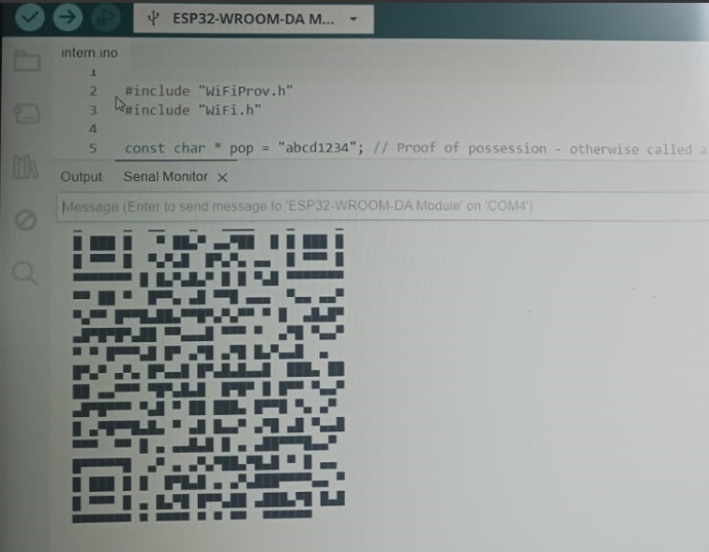

1. Scan it using the app => Give I don’t have QR code option=> Click the device=> Enter your ssid password and notice the serial monitor=> IP address will be shown in serial monitor.

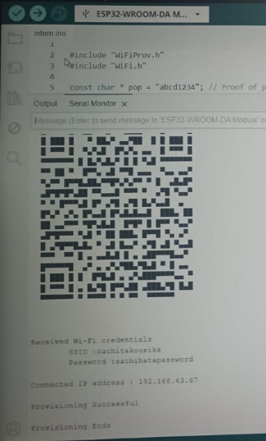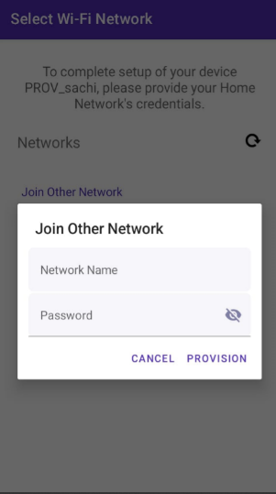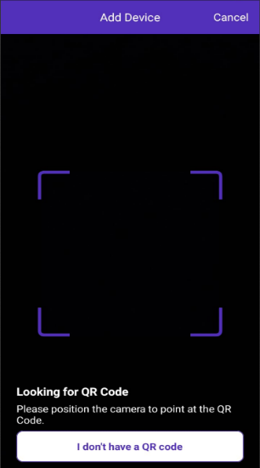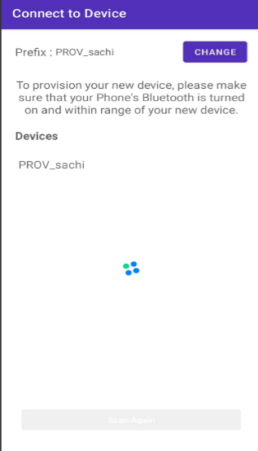

**Real-Time Application:**

Think of a smart device, like a Wi-Fi keyboard or smart home gadget. Instead of manually entering your Wi-Fi password on the device, you use your phone’s Bluetooth to send the Wi-Fi details directly. The device then connects to your Wi-Fi network on its own, making setup quick and hassle-free.

**Conclusion:**

Using Bluetooth to transfer Wi-Fi credentials simplifies the setup process for smart devices. This method allows devices to connect to your network seamlessly without needing manual input, enhancing convenience and streamlining the configuration experience.