Docker
- Spring boot provides maven wrapper along with spring. We need not to install maven locally in our system.
mvnw - maven wrapper for mac
mvnw.cmd - maven wrapper for windows
Developer creates the application --> builds it --> provides the jar to fellow devs.
devs open terminal on the jar location --> ./mvnw install for mac and /mvnw.cmd install for windows. This will build the project in their system --> now “target” folder is visible --> cd target --> java -jar employee-service-.0.0.1-SNAPSHOT.jar --> application starts running.

This will work if your system and your fellow devs system configuration/environment are exactly same.

- Docker commands:
docker ps:- to see all the running instances
docker ps -a : also shows exited processes
docker images : to see all the current images
docker run -it eclipse-temurin:25-alpine-3.22
docker build . -t employee-service:v1 : creates a docker image
docker run employee-service:v1 : run docker image
docker run -p 9090:8080 employee-service:v1 : port mapping, docker port 9090 is getting mapped to application’s 8080 port. Request to 9090 will be re-routed to 8080.
docker pull employee-service:v1
docker push employee-service:v1
docker kill <container-id>
docker rmi hello-world:latest
docker rm <container-id>
docker system prune : deletes all images from the system
docker logs container-id : to check logs
docker logs -f container-id : to check live logs
docker exec -it container-id sh : to enter a running container
docker stop container-id : to stop a running container
docker stats : monitor container resource usage like CPU, memory, network etc

- Containers close automatically when the application closes. The status of such images is “exited”.
Docker uses shared Kernel.
If we write docker run ubuntu, this will only download the userspace and not the entire OS.

Docker images are immutable in nature.
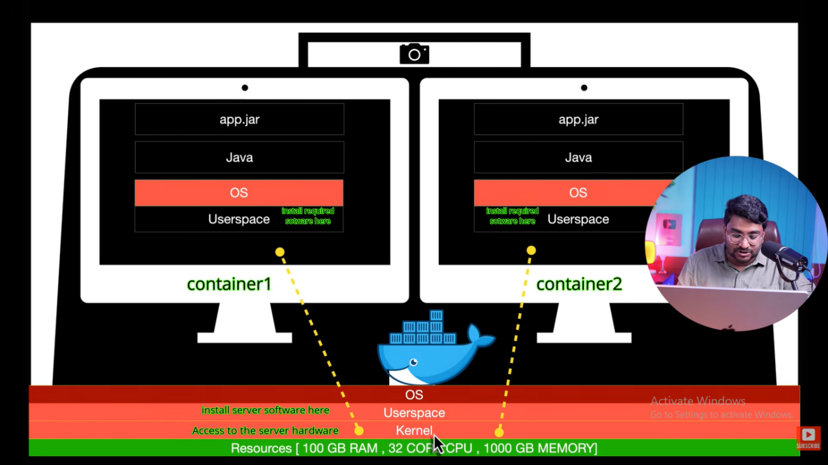

- Port Mapping
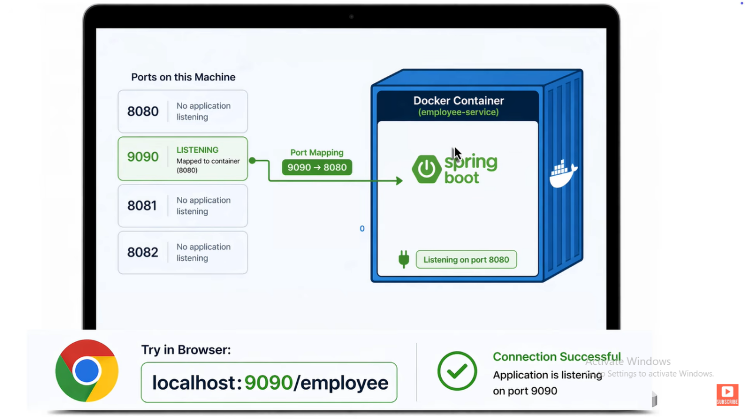

- Docker packages an application along with its dependencies into a container. Docker container is a running instance of an image.
Docker CLI
↓

Docker Daemon

↓

Images
Containers
Volumes
Networks

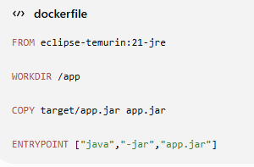

- How to dockerize a Spring Boot Application?
Ans.
Step 1
mvn clean package
Generates
target/app.jar
Step 2
Dockerfile
FROM eclipse-temurin:21-jre
WORKDIR /app
COPY target/app.jar app.jar
EXPOSE 8080
ENTRYPOINT ["java","-jar","app.jar"]
Step 3
docker build -t employee-service .
Step 4
docker run -p 8080:8080 employee-service

Why use Alpine images?
Ans. Instead of openjdk, use eclipse-temurin:21-jre-alpine
Benefits
- smaller
- faster pull
- lower attack surface
- Why use multi-stage build?
Ans. Image size is much smaller.

- Spring Boot application works locally but Docker container cannot connect to MySQL.
Answer:Common causes include:
- Using localhost instead of the database container/service name.
- Database isn't ready when the application starts.
- Wrong network configuration.
- Incorrect environment variables.
- Port confusion (container port vs host port).
- Container exits immediately after starting.
Ans. Possible reasons
- Main process crashed.
- Wrong ENTRYPOINT.
- Missing JAR file.
- Java version mismatch.
- Application startup exception.
- Docker image is 1.5GB. How do you reduce it?
Answer
- Multi-stage build
- Use JRE instead of JDK in runtime image
- Copy only required files
- Add a .dockerignore file to exclude target/ (when rebuilding), .git, IDE files, logs, etc.
- Choose a minimal base image after compatibility testing

Why shouldn't we keep secrets inside Docker images?
Ans. Because images can be shared and inspected. Secrets should be injected at runtime through environment variables, secret-management systems, or orchestration platforms.

Can two containers use same port?
Ans. Inside the containers, yes—they can both listen on port 8080.
On the host, you cannot map both to the same port simultaneously. For example:
Container A: 8080 -> Host 8080
Container B: 8080 -> Host 8081

