Kubernetes

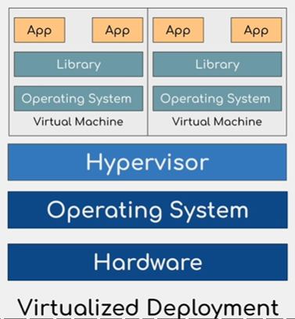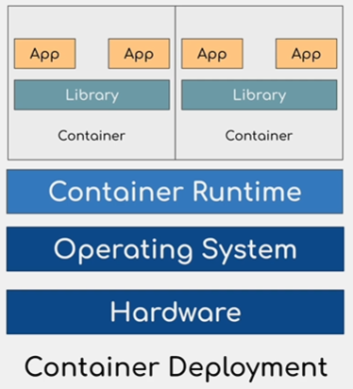

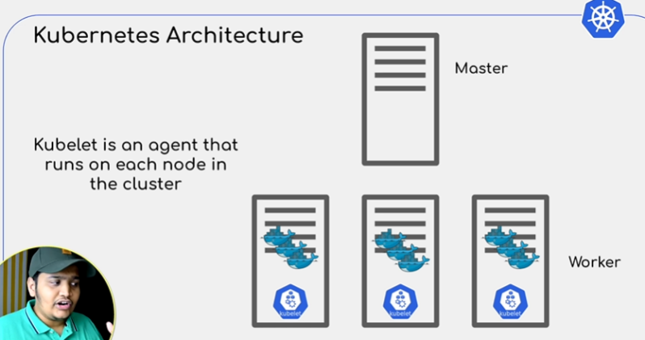

Master node has following components:
a. API - API server is the front end for the kubernetes control plane. It can be accessed through UI, API, or CLI.
- Controller manager - Keeps track of what is happening in the K8s cluster. It has four parts:- Node controller, Replication controller, Endpoints controller, Service account and Token controller.
- Scheduler - Manages pod placement.
- Etcd server - Consistent and highly-available key value store used as K8s backing store for all cluster data.

Worker node has the following components: Pods (with their IPs) + SVC
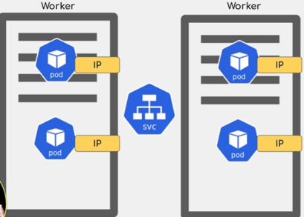

- Pod is the smallest unit that could be deployed in a cluster. Suppose we have one pod for the application, one for the DB. App pod went down, so its IP. New Pod comes up with a new IP, then how do these pods communicate with each other? Hence, every pod has SVC configured.
Ingress - Allows expernal systems to interact with the pods
config map - Handles all the configuration related to pods.
Secret - Stores all the secret in base64 encoded format.
Storage volume - To store local pod, config related data so that if pods restart, it has previous config info and pod info.

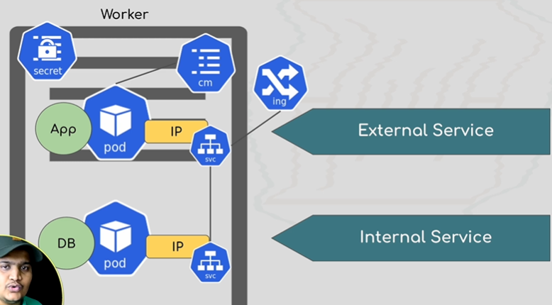

- Deployment- configs related to no of containers, disk, replicas, etc. Blue print of what all components we need to spin up the application.

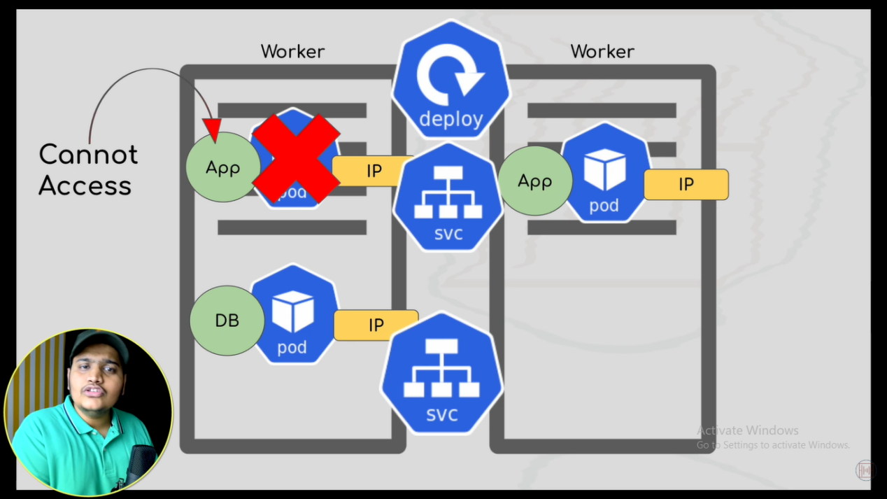

- Docker commands (minikube, for local development)

minikube start
minikube status

Kubectl get pods
Kubectl get deployment
Kubectl get services
Kubectl get namespaces
Kubectl delete all --all
Kubectl get all
Kubectl create deployment <deployment-name> --image=<image_name>
Kubectl describe deployment <deployment_name>
Kubectl get pods
Kubectl describe pod <pod_name>
Kubectl logs <pod_name>
Kubectl exec -it <pod_name> -- <command you want to run> :enter into a pod and execute something.
Kubectle edit deployment <deployment_name> : to edit document
Kubectl delete deployment

- Deploy.yaml
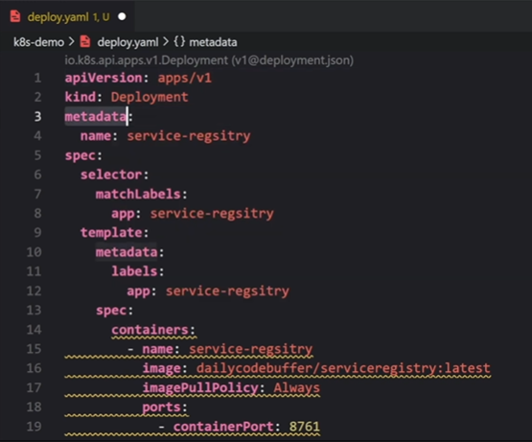

SVC.yaml
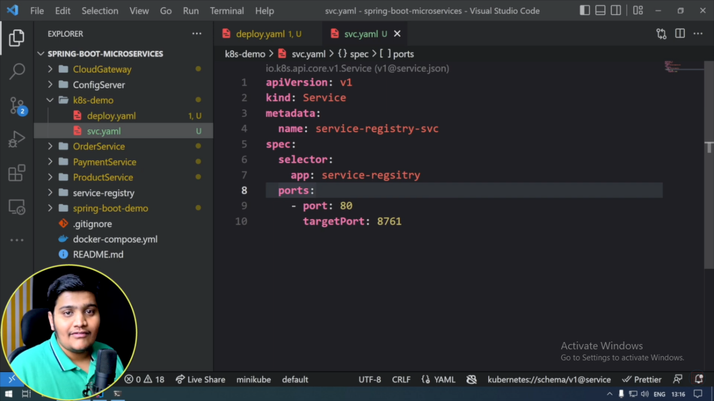

Kubectl apply -f <deploy or svc.yaml file name>

- Kubernetes namespace: Segregate the K8s cluster into manageable chunks. Admin namespace has admin related pods, DB namespace has DB related pods etc.
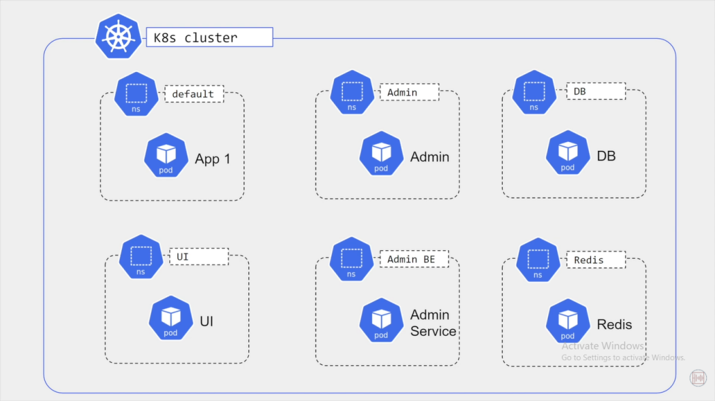
There are few default namespaces available
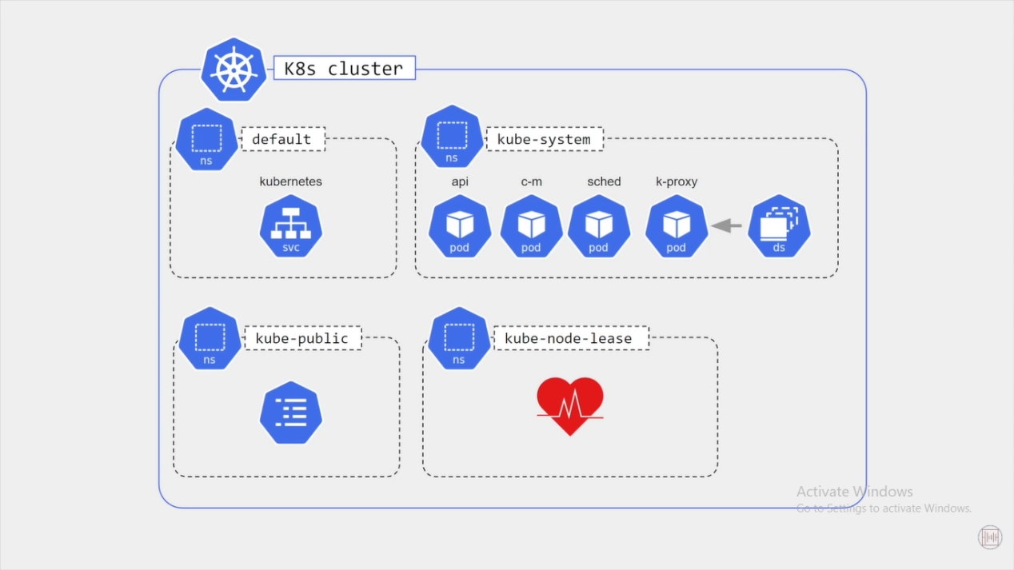

Ques. How does deploy.yaml connect to svc.yaml?
Ans. Labels:app in deploy.yaml should match the selector:app of svc.yaml.
Port information of both file should also match.
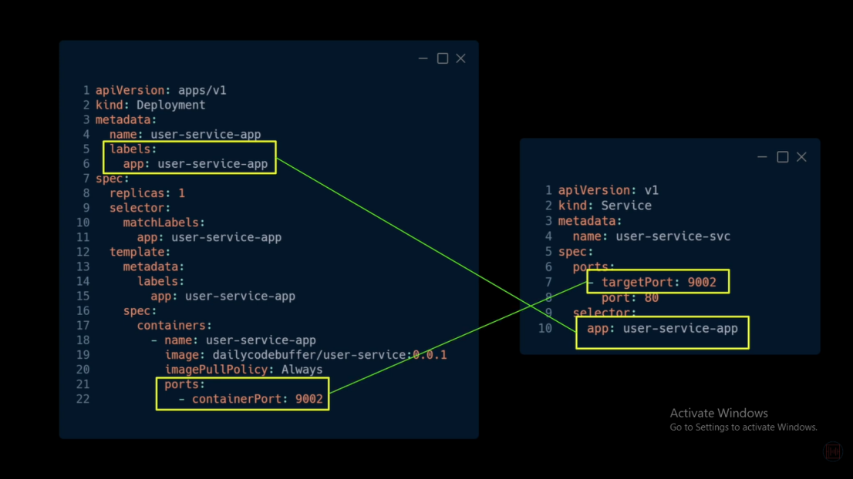
- Pods and Svc relation: Each application has their own svc. Services communicate with other services using internal communication.
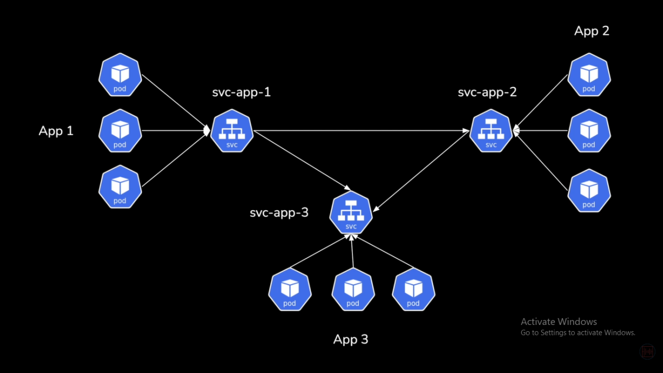

- Headless servcie for stateful set: A headless service bypasses Kubernetes' default load balancing and assigns unique, stable DNS names to individual Pods. For a StatefulSet, you must define this service by setting clusterIP: None in the spec. It grants each Pod a direct network identity (e.g., pod-name.service-name.namespace.svc.cluster.local)
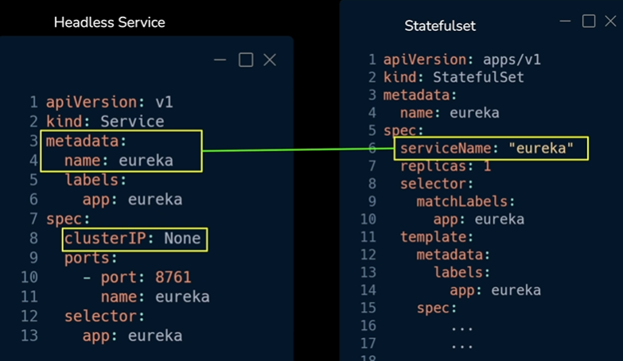

- NodePort service: exposes nodes in a cluster. Not recommended to expose nodes to ext svc.
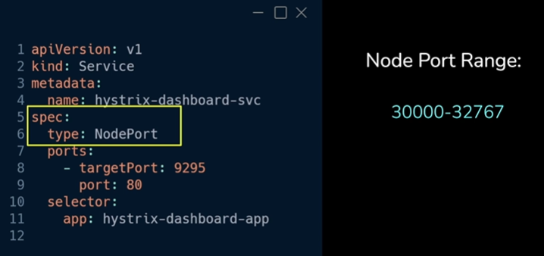
- Load balancer service: Exposed for the entire cluster. This is preferred over NodePort service.

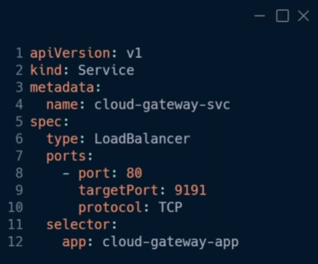

- Ingress service: We need to configure ingress service within the K8s cluster so that when an external world service tries to access the cluster, Ingress can identify it based on the DNS. It will route the traffic to the respective svc defined in the cluster.
Inside the K8s cluster we also have an Ingress controller pod to manage Ingress related work.
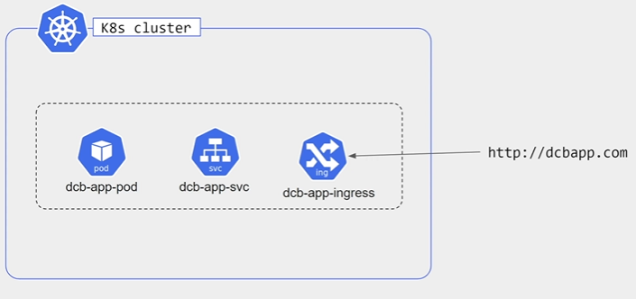
Here we configure rules, for each external service. Like dcapp.com will get route to which path etc etc.
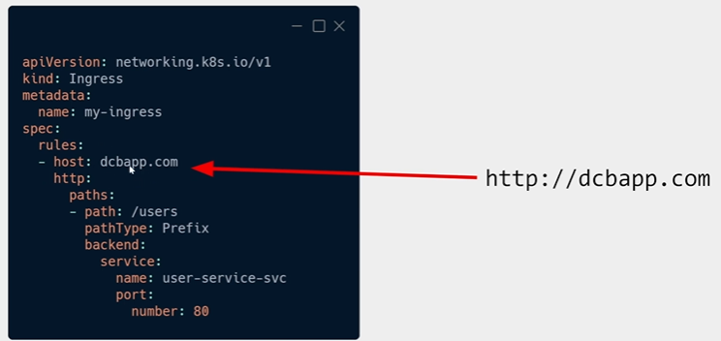

- Stateful set in K8s
Works with stateful application like mySql, MongoDb, Cassandra which stores the state of the application.
REST Api are stateless, so scaling them is easy. If one pod goes down, another comes up, all managed by SVC.
But stateful applications like mySQL or any DB, scaling is difficult as we need to take care of the data consistency as well.
For stateless application, a new pod name is just the appName+<hash_value>. For stateful application, a new pod is sticky in nature, mySql-0, mySql-1, mySql-2 etc.

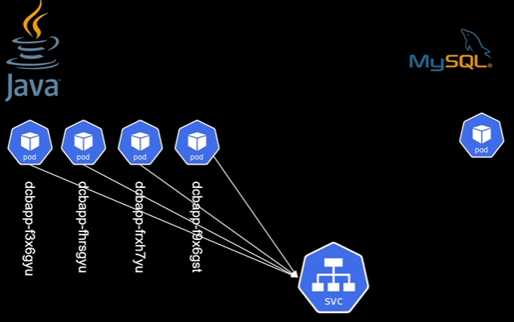

Scaling up and scaling down in stateful systems will have a sequential process. For scaling up, it will copy the last pod state, for scaling down, the last pod will come down first, followed by the second last and so on. Unlike stateless applications, here we need to manually handle how the replication will be configured, how the consistency will be handled etc.
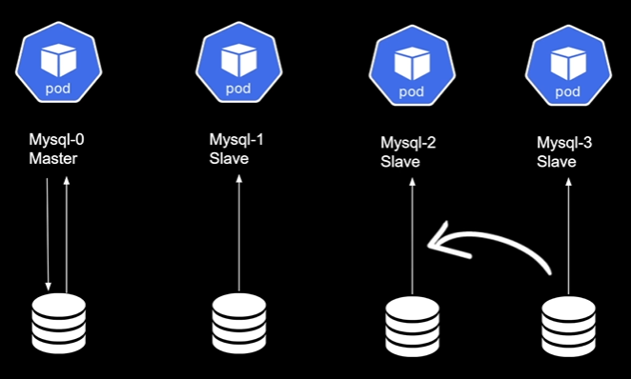

- Volumes in K8s Cluster

If for any reason the stateful pods gets destroyed and a new pod spins up with the new IP address, we might lose all our data. So we configure a presistence storage volume, preferrably outside our cluster.

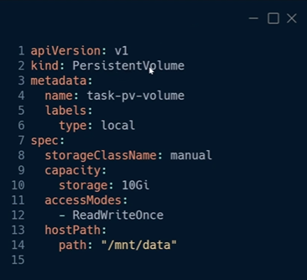

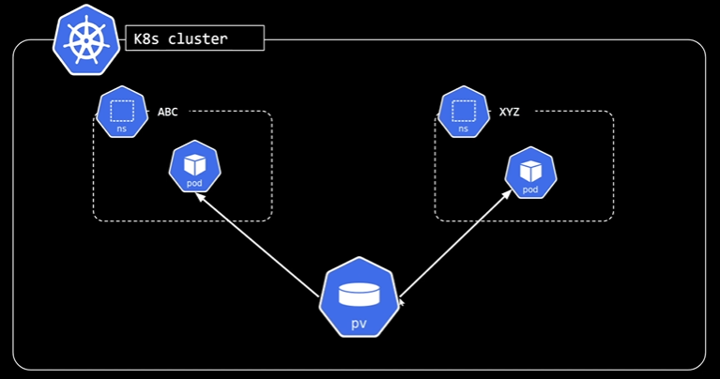

Pods need to claim the persistence volume. First create persistentVolumeClaim then add it to the pod yaml file.
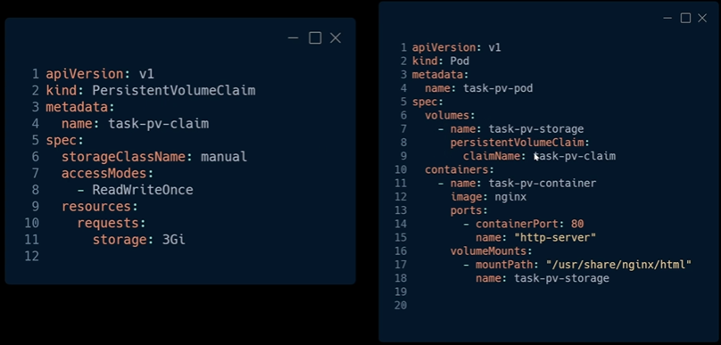

In production we can use Storage class instead of volumes
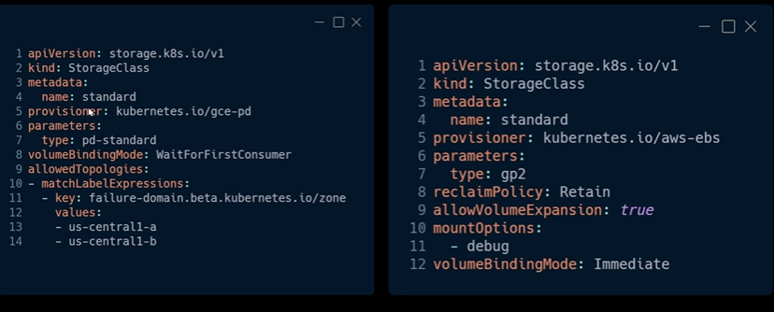

- Health Probes
- Liveness probe: Checks whether your application is live or not.
- Readiness probe: Is your application ready to serve the request or not.
- Startup probe: Use in legacy application.

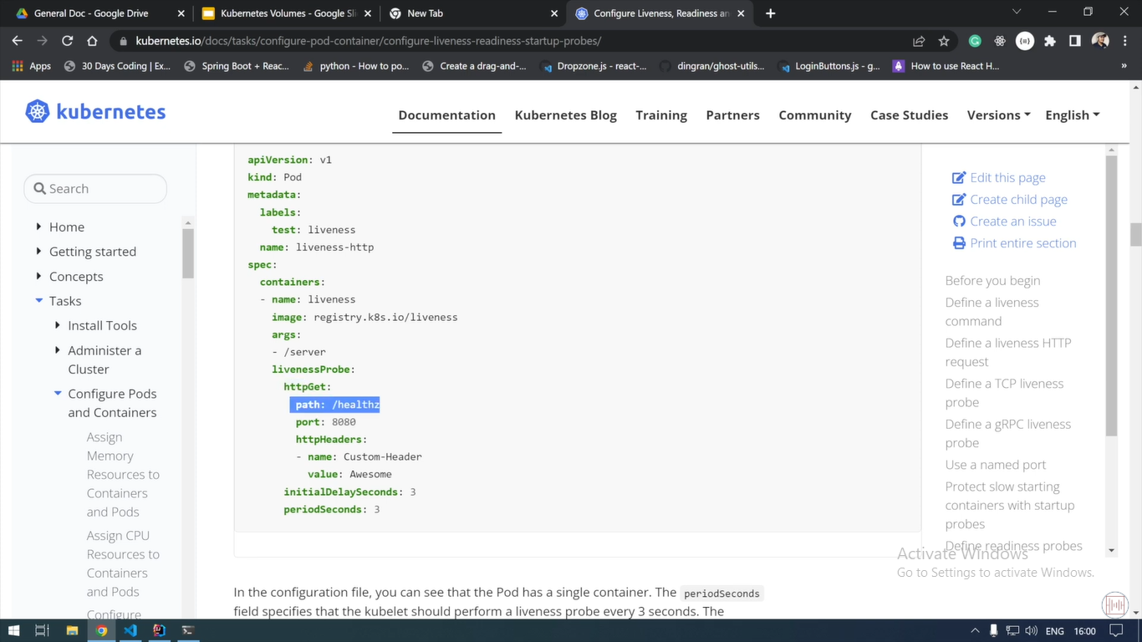

- Planning Application Architecture
For each service we need to write a deployment file as each service will be wrapped around a pod.
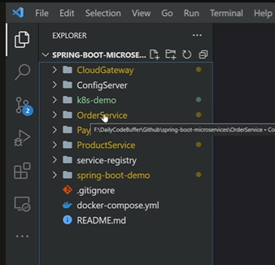
For service-registry and mySql though, we need to create a StatefulSet and not a deployment file as it will be storing the information of other services, so it is stateful in nature.

** mvn clean install jib:build first cleans previous build artifacts, then compiles, tests, packages, and installs the JAR into the local Maven repository. Finally, it uses the Jib Maven plugin to build an OCI-compatible container image and push it directly to a container registry without requiring a Docker daemon or a Dockerfile.

- Docker image should be present in the ECR or docker repository beforehand.
- Environment variables should be configured so that we need not to hardcode anything in the yaml file.
- Install K8s plugin in the Intellij. This will help us to avoid writing boiler plate code in the yaml files.

- Deployment yaml template
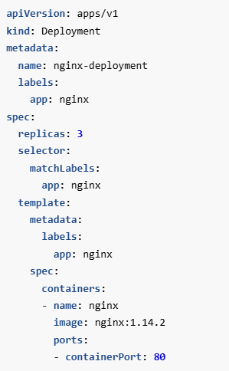

- SVC yaml template
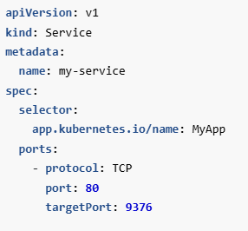

- Service registry- StatefulSet deployment: K8s-API will create new endpoints that map directly to the pods. This logic is mandatory in StatefulSet as it requires a headless service(ClusterIP=none).
A standard Kubernetes service uses a single ClusterIP to distribute traffic across pods using round-robin routing. While this is ideal for interchangeable, stateless apps (like web servers), it breaks stateful systems. For example, in a database cluster, writing data randomly to any database pod would cause catastrophic data corruption and split-brain scenarios. A headless service bypasses this proxy layer entirely.

StatefulSet deployment includes a service with clusterIP:None + StatefulSet + VolumeClaim with Storage class.
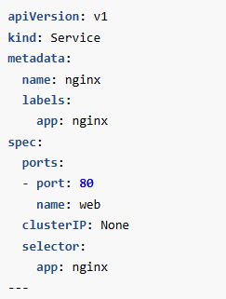
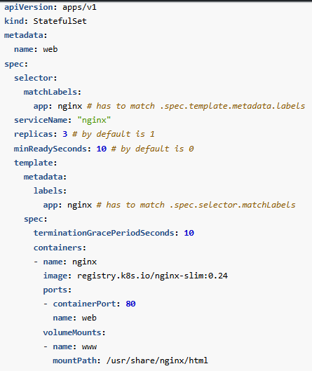
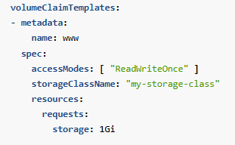
We also want external services to communicate with the cluster, so we also need one svc configuration of type “Load Balancer”.

- Config server deployment
a. deployment yaml + svc yaml. To insert any env variable, create a config map.

Cloud-gateway-deployment
a. deployment + svc yaml. In the svc just mention spec type as Load balancer. To insert any env variable, create a config map.
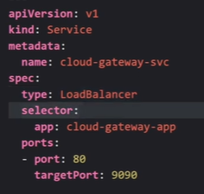

** env variables are added in the deployment yaml part. Referenced to config map.
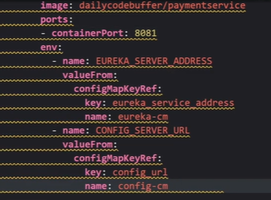

All microservices will follow the above pattern.

MySql deployment - Statefulset + Headless svc + persistence volume + persistence volume + config map (if needed)

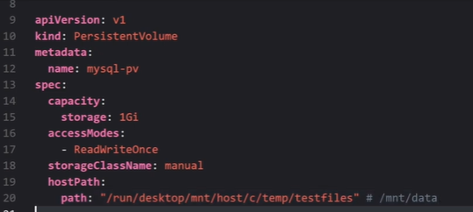
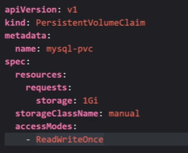

Zipkin deployment: deployment yaml + svc yaml with LB.

Redis deployment : deployment yaml + svc yaml with LB.

- What is Kubernetes?
Ans. Kubernetes (K8s) is a container orchestration platform used to automate:
- Deployment
- Scaling
- Load balancing
- Self-healing
- Rolling updates
- Service discovery
Instead of managing individual Docker containers manually, Kubernetes manages them using declarative YAML manifests.
Without K8s, if the server crashes, application goes down. With K8s, if the container crashes --> K8s detects failure --> creates new container automatically --> application is available.
- Explain K8s architecture.
Ans.
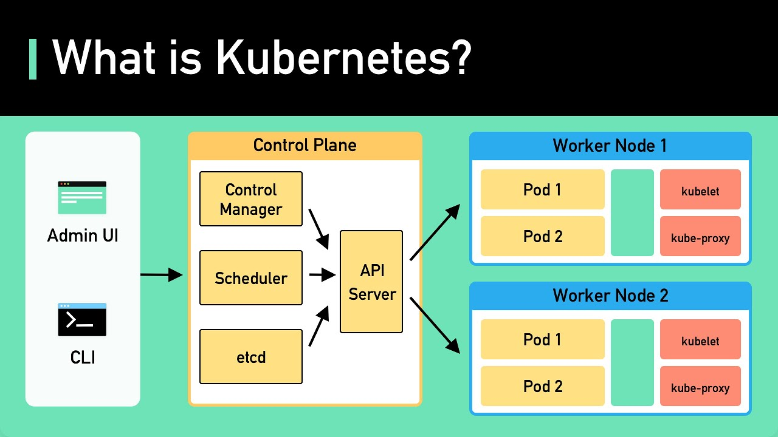
API server - The API server is the front-end for the Kubernetes control plane, exposing the Kubernetes API for both internal and external communication with the cluster. It is the main contact point for developers, administrators, and services interacting with Kubernetes, making it essential to all cluster management activities.
Etcd: Etcd is a distributed key-value store that Kubernetes uses to store configuration data and state information about the cluster. It ensures any configuration or state changes are recorded and accessible to control plane components, enabling high availability and cluster consistency.
Controller Manager: The controller manager runs various controllers that monitor the cluster’s desired state and make changes as needed. For example, the replication controller ensures the correct number of pod replicas are running, while the node controller checks node health and availability.
Scheduler: The scheduler assigns pods to nodes based on resource requirements, workload distribution, and availability. It considers factors like resource limits, affinity/anti-affinity rules, and workload distribution to deploy applications optimally within the cluster.
Node (Worker) Plane
Worker nodes are responsible for running containerized applications and workloads. Each node in a Kubernetes cluster includes the following components:
Kubelet: Kubelet is an agent that runs on each node, receiving information about scheduled pods from the API server. It ensures containers described in pod manifests are running and remain in the desired state.
Kube-proxy: Kube-proxy manages network communication within the Kubernetes cluster. It enables smooth communication between services within the cluster by routing traffic to the appropriate pod based on defined services and network policies.
Container Runtime: The container runtime (e.g., Docker, containerd) is the software responsible for running and managing containers. It pulls container images, starts/stops containers, and manages networking and storage for containers.
Container Storage Interfaces (CSI): For persistent data, Kubernetes uses Container Storage Interfaces, allowing various storage providers to offer persistent storage volumes for applications within the cluster.
Pods
Pods are the foundational building blocks of Kubernetes, grouping one or more containers that share network and storage contexts.
Container Co-location: Containers within a pod share the same network namespace, allowing them to communicate easily and share an IP address and port space.
Shared Storage and Volumes: Containers within a pod can share storage volumes, simplifying data exchange between them.
Single Unit of Deployment: Kubernetes deploys pods as the smallest unit. Scaling or managing an application involves working with pod replicas.
nit Containers: Pods can include init containers, which run initialization tasks before the main application containers start.
Controllers
Controllers ensure resources in the cluster match their desired states, automating tasks like scaling, self-healing, and application management.
Replication Controller: Manages the specified number of identical pod replicas, creating new pods if any fail or are deleted.
Deployment: Provides declarative updates for applications, including rolling updates that gradually replace old pods with new ones to avoid disruption.
StatefulSet: Manages stateful applications requiring unique identities and persistent storage.
DaemonSet: Ensures a specific pod runs on every node in the cluster, useful for deploying monitoring agents or networking components.
Horizontal Pod Autoscaler (HPA): Adjusts the number of pod replicas based on CPU or custom metrics, allowing applications to adapt to changing demand.
Vertical Pod Autoscaler (VPA): Adjusts resource requests and limits based on usage, optimizing resource allocation for efficiency.
Services
Kubernetes services enable communication and load balancing between different sets of pods, making applications discoverable and resilient. It provides a stable endpoint. Since pods have dynamic IPs, it will be difficult to locate if not for services.
Service Types:
ClusterIP: Exposes the service within the cluster for internal communication.
NodePort: Exposes the service on a static port on each node, suitable for development/testing.
LoadBalancer: Creates an external load balancer for internet or external network access.
ExternalName: Maps the service to a DNS name, enabling access to external services.
Selectors and Labels: Services use selectors to identify target pods based on labels, defining which pods the service should include.
Load Balancing: Services balance traffic across multiple pods, ensuring no single pod becomes overwhelmed.
Types of Volumes:
EmptyDir: Temporary storage deleted when the pod is removed.
HostPath: Mounts a host filesystem file/directory into the container.
PersistentVolumeClaim (PVC): Requests persistent storage based on a storage class.
ConfigMap and Secret Volumes: Injects data or sensitive information as files within containers.
Network File System (NFS): Uses network-attached storage.
CSI Volumes: Enables storage providers to integrate volume plugins with Kubernetes.
ConfigMaps and Secrets
ConfigMaps: Store non-sensitive configuration data, such as settings and environment variables, for applications.
Secrets: Store sensitive information, like passwords and tokens, offering an additional layer of security.
Namespaces
Namespaces are used to organize and partition resources within a cluster, creating virtual clusters within a physical cluster for different teams, projects, or environments.
Purpose: Namespaces provide resource isolation, management, access control, and tenant separation.
Default Namespace: Kubernetes creates a default namespace for resources if none is specified.
Access Control and Quotas: Namespaces enable Role-Based Access Control (RBAC) and resource quotas, limiting usage within a namespace.
Ingress
Ingress manages external access to services in the cluster, providing routing for HTTP and HTTPS traffic without modifying application code.
Ingress Controller: Watches for changes to ingress resources, configuring infrastructure to implement defined routing rules.

Internet
↓
Ingress
↓
/orders → Order Service
/payments → Payment Service

Why not deploy Docker container directly?
Ans. Docker only runs containers.
Kubernetes manages
- Restart
- Scaling
- Networking
- Health checks
- Scheduling

Difference between Pod and Container?
Ans. Container is just a Java Process and a Pod is the Wrapper around one or more containers.
NPC - Node has pods, pods have container/containers.
A Pod has
- IP Address
- Storage
- Networking
- Lifecycle

Rolling Update
Ans Old version: V1
New version: V2
Kubernetes gradually replaces Pods.
3 Old
↓
2 Old + 1 New
↓
1 Old + 2 New
↓
3 New
Zero downtime.
- Horizontal Pod Autoscaler (HPA)
Ans. CPU > 80% --> Increase pods from 3 to 6.
Traffic decreases --> decrease pods from 6 to 3.
If memory limit exceeds --> container is killed --> OOMKilled
If CPU limit exceeds --> CPU gets throtlled not killed --> application becomes slower.

- Prod issue: CrashLoopBackOff.
Ans. Pod starts
↓
Crashes
↓
Restarts repeatedly
Reasons
- Wrong DB URL
- Missing Secret
- Port conflict
- Startup failure
- NullPointerException during startup
Commands
kubectl logs pod-name
kubectl describe pod pod-name

ImagePullBackOff
Meaning: Cannot pull Docker image.
Reasons
- Wrong image name
- Wrong tag
- Registry authentication failure

Ques. How do microservices communicate?
Ans.
Order Service -> payment-service.default.svc.cluster.local. Through Kubernetes Service DNS.

Ques. How does Kubernetes perform self-healing?
Ans. Pod crashes. Kubelet detects. Deployment notices desired replica count isn't met. New Pod created automatically.

Ques. How do you troubleshoot a failing Pod?
Ans. Typical steps:
- kubectl get pods
- kubectl describe pod <pod-name>
- kubectl logs <pod-name>
- Check readiness/liveness probes.
- Verify ConfigMaps, Secrets, and environment variables.
- Check resource limits and events.

Ques. How do you update configuration without rebuilding the application?
Ans. Keep configuration outside the image.
- ConfigMaps for non-sensitive settings.
- Secrets or external secret managers for sensitive values.
Update the configuration and restart or reload the Pods (depending on how the application handles configuration changes). The application image itself does not need to be rebuilt.

Q1: A Pod is running but users are getting 503 errors. What will you check?
Answer:
- Is the Readiness Probe passing?
- Are Service endpoints populated?
- Is the application listening on the expected port?
- Are there any network policies blocking traffic?
- Are Ingress rules correctly configured?

Q2: Your Spring Boot application keeps restarting every minute.
Ans:
- kubectl logs
- kubectl describe pod
- Liveness probe configuration
- Memory limits (OOMKilled)
- Missing environment variables or secrets
- Startup exceptions

Q3: CPU usage is consistently 95%. What would you do?
Possible actions:
- Verify whether the load is expected.
- Increase CPU requests/limits if appropriate.
- Enable or tune Horizontal Pod Autoscaler.
- Investigate inefficient code, hot endpoints, or database bottlenecks.
- Scale dependent services if they are causing backpressure.

Q4: You deployed a new version and users report failures.
Steps:
- Check Deployment status.
- Review Pod logs and events.
- Verify health probes.
- If necessary, perform a rollback to the previous deployment.
- Investigate the root cause before redeploying.

Commands every Java developer should know
kubectl get pods

kubectl get deployments

kubectl get services

kubectl describe pod <pod-name>

kubectl logs <pod-name>

kubectl exec -it <pod-name> -- sh

kubectl rollout status deployment/<deployment-name>

kubectl rollout undo deployment/<deployment-name>

