Microservices

Why Microservices instead of Monolith?

Ans Monolith is suitable when
- Small team
- Small application
- Simple deployment
- Strong consistency required
Microservices are preferred when
- Large application
- Independent deployments
- Different teams own different modules
- Independent scaling
- Technology flexibility
Example
Amazon Checkout, Payment, Inventory, Recommendation are independent services.
Payment traffic may be 10x during sales.
Only Payment service is scaled instead of the entire application.

What are the disadvantages of Microservices?
Ans.
- Distributed transactions
- Network latency
- More infrastructure
- Difficult debugging
- Service discovery complexity
- Monitoring complexity
- Data consistency issues
- Version management
- Deployment complexity
- Synchronous - REST.
Advantages - Easy, immediate response
Disadvantages - Tight coupling, waiting time, failure propagation
Use - Immediate response needed, read operations, validation

Asynchronous - Kafka
Order service publishes event --> Inventory services consumes --> Notification services consumes --> Analytics services consumes.
Advantages - Loose coupling, better scalability, high throughput.
Use - event driven system, notification, audit logs, email, sms etc.

- Service Discovery
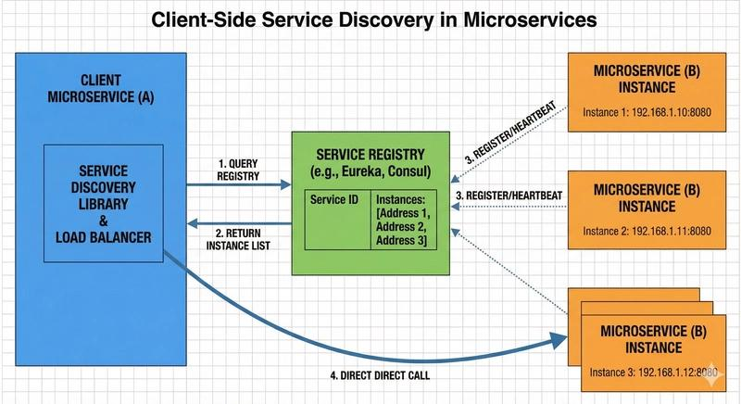

In microservices, service instance dynamically created, scaled, and destroyed.
So hardcoding URLs/IPs is a bad option, instead the services register themselves with service registry.

- Eureka Server (Netflix)
pom.xml - spring-cloud-starter-netflix-eureka-server
main class - @EnableEurekaServer

Application.properties:
spring.application.name=eureka-server
server.port=8761
eureka.client.register-with-eureka=false
eureka.client.fetch-registry=false

- Eureka client (microservice)
Pom.xml - spring-cloud-starter-netflix-eureka-client
Main class - @EnableEurekaClient

Application.properties:
spring.application.name=accounts-service
server.port=8081
eureka.client.service-url.defaultZone=http://localhost:8761/eureka

- Heartbeat mechanism:
Eureka clients send periodic heartbeats to the Eureka server to confirm their availability. If the server doesn’t receive a heartbeat within a specified time, it marks the service instance as unavailable. This can be configured in application.properties:
eureka.instance.lease-renewal-interval-in-seconds=10
eureka.instance.lease-expiration-duration-in-seconds=30

- Eureka server starts --> initially no registered services --> MS starts --> Eureka client is initialized --> Services send registration request with payload (service name, host, port, IP, health url, metadata) to Eureka --> Eureka Registry now has all the MS info --> Every Eureka client periodically downloads Registry (cached , each service knows about the other service and need not to use Eureka for each call)

Client request from User-service to order-service --> Load balancer looks up in the registry, no Eureka call happens here --> actual HTTP call goes to order-service --> processes the request --> returns the result to User-service --> response to the client.

Does every request go to Eureka?
Answer: No. Eureka is not involved in every request. Clients periodically fetch the registry and keep a local cache. Service-to-service calls use this cache, reducing latency and avoiding a bottleneck.

How often is the registry refreshed?
Ans. By default:
- Heartbeat (renewal): 30 seconds
- Registry fetch: 30 seconds
- Lease expiration: 90 seconds if heartbeats stop.

What happens if Eureka Server goes down?
Answer: Existing services continue working using cached registry information, but new registrations/discoveries may fail.

API Gateway | Service Discovery

Entry point for clients | Finds service instances

Authentication, rate limiting | Registry of services

Example: Spring Cloud Gateway | Example: Eureka
Ques. What are common production challenges?
Stale registry entries
Network partitions
Heartbeat tuning
Large registry size
Cross-region discovery

Tool | Used By
Eureka | Legacy Spring Cloud systems
Consul | Many enterprises
Kubernetes Service Discovery | Most modern companies
AWS Cloud Map | AWS-based microservices

For New Production Systems
Kubernetes Service Discovery is the industry standard.
No separate Eureka server required
Built into Kubernetes
Highly scalable
Cloud-native
Works with Istio/Service Mesh
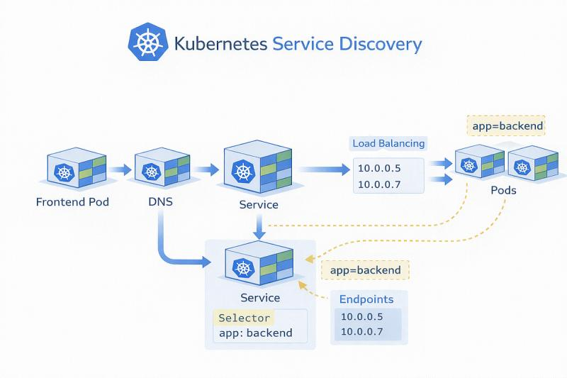
- API Gateway
Ans.
· Authentication/ JWT validation
· Logging
· Rate limiting
· SSL termination
· Routing
· Caching
- Load Balancer
- Distributes traffic
- Layer 4/7
- No business logic
- Bulkhead pattern
Ans.
Order Service
|
--------------------------------
| | |
Payment Inventory Notification
Suppose:
- Payment API becomes very slow.
- Every request waits for Payment.
- All application threads become occupied.
Eventually:
Inventory ❌
Notification ❌
Orders ❌
Even though Inventory is healthy, it cannot execute because all threads are blocked.
This is called resource starvation.

With Bulkhead
Each dependency gets its own thread pool.
Order Service
Payment -------- Thread Pool A (10)
Inventory ------ Thread Pool B (20)
Notification --- Thread Pool C (5)
If Payment hangs:
Payment ❌
Inventory ✅
Notification ✅
Only Payment is affected.
Types of Bulkhead:
i) Semaphore: Limits how many concurrent requests can execute.
resilience4j:
bulkhead:
instances:
paymentService:
maxConcurrentCalls: 5
maxWaitDuration: 1s
@Service
public class PaymentService {

@Bulkhead(name = "paymentService")
public String pay() {

return paymentClient.call();
}
}
ii) Thread pool: Payment service has 10 thread. 11th request is rejected.
resilience4j:
thread-pool-bulkhead:
instances:
paymentService:
coreThreadPoolSize: 5
maxThreadPoolSize: 10
queueCapacity: 20
@Bulkhead(
name = "paymentService",
type = Bulkhead.Type.THREADPOOL
)
public CompletableFuture<String> process() {

return CompletableFuture.supplyAsync(() ->
paymentClient.call());
}
iii) Production sequence
Incoming Request
|
v
Rate Limiter
|
v
Bulkhead
|
v
Retry
|
v
Circuit Breaker
|
v
External Service

- Distributed Transaction- SAGA pattern.
Ans. Order, Payment, Inventory. Each service has its own DB.
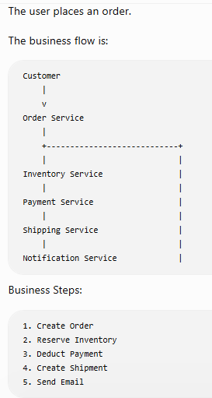
Suppose order created --> inventory updated --> payment successful --> shipping failed. We need to refund the payment --> update the inventory --> cancel the order.

This sequence of forward actions followed by compensating actions is exactly what the Saga Pattern provides.

In SAGA pattern, each service commits independently, each service has its own DB, each service publish an event/reply to the orchestrator. There is no distributed transaction, only local transaction.

Types of SAGA pattern:
i) Choreography: No central controller, each service emits events. Each service only knows the next event. Simple, loosely coupled but hard to debug, event chains are complicated, difficult to understand the business flow.

In production, the event communication happens through Kafka.

Order service: sends save order event
orderRepository.save(order);

kafkaTemplate.send(
"order-created",
new OrderCreatedEvent(orderId)
);

Inventory service: listens to order service and sends event to payment-service
@KafkaListener(topics = "order-created")
public void reserve(OrderCreatedEvent event){

inventoryRepository.reserve(event.getProductId());

kafkaTemplate.send(
"inventory-reserved",
new InventoryReservedEvent(...)
);
}

Payment service: Listens to inventory-service and sends event to shipping-service

@KafkaListener(topics="inventory-reserved")
public void pay(){

}

If payment fails, inventory listens and updates, order listens and cancels it. Every service is listening to every other service. So if payment failed, then order, inventory, shipping all get the message that this payment with this paymentId failed. So they locally rollback the transaction through a new business logic.

ii) Orchestration: More common in large enterprises. One service controls everything.
The orchestrator decides:
- next step
- retry
- rollback
- Timeout
Unlike choreography pattern, only orchestrator knows the workflow.
Every service performs only local transactions.
No distributed database transaction exists.

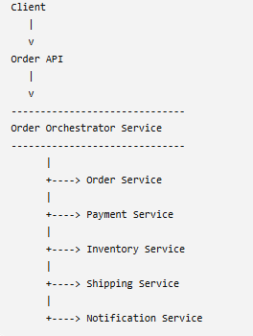
Orchestrator controller
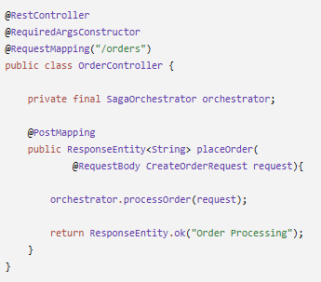

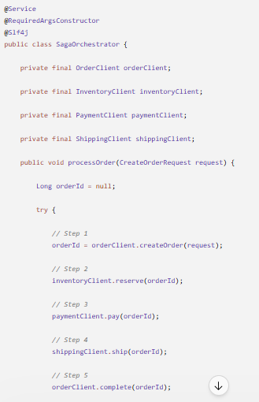
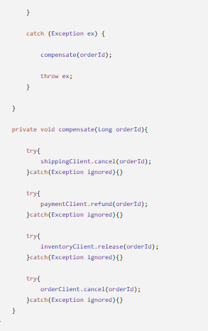

Reserve inventory:
@Transactional
public void reserve(Long orderId){

Product product = repository.findById(...);

product.setAvailableQuantity(
product.getAvailableQuantity() - 1);

repository.save(product);
}
** We use @Transactional here because each service is a local transaction with the DB and has a compensation @Transactional along with it incase of any failures.

Release inventory : Compensation
@Transactional
public void release(Long orderId){

Product product = repository.findById(...);

product.setAvailableQuantity(
product.getAvailableQuantity() + 1);

repository.save(product);
}
Similar code for Payment and Shipping services as well.

** Unlike Choreography, here the services don’t know about each other as they are not listening to each other’s messages, orchestrator is the one that does. Only orchestrator knows the workflow.

** If payment keeps failing after retries, put it in a Dead Letter Queue (DLQ) for the operations team to investigate later. Kafka has DLQ configured in it.

** Persist SAGA state: Suppose the current state is Payment IN_PROGRESS, if the orchestrator crashes, maintaining a SAGA state allows us to resume from Payment instead of starting again from the beginning.

** Retry: Never compensate immediately for Timeout, network failure, 503, 502. Retry first.

** Idempotency: Every service should accept SAGA id and Correlation ID.

Ques. Why not use @Transactional?
Ans. @Transactional works only within a single database. A saga spans multiple services, each with its own database, so distributed ACID transactions are not feasible.

Ques. Why compensate instead of rollback?
Ans. Because once a local transaction is committed in another service, it cannot be rolled back by your service. You execute a new business action (refund, release inventory, cancel shipment) to logically undo the effects.

Ques. Can compensation fail?
Ans. Yes. Production systems retry compensating actions, persist saga state, and may route failures to a DLQ or require manual intervention.

Ques. What is the biggest challenge?
Ans Maintaining eventual consistency while handling retries, duplicate messages, idempotency, partial failures, and orchestrator recovery.

Ques. Is Saga eventually consistent?
Ans. Yes. Each service commits its local transaction independently, and if a later step fails, compensating transactions restore business consistency. During the process, different services may temporarily have different views of the data.
Production Best Practices
- Use the Outbox Pattern to atomically save database changes and publish events, avoiding dual-write problems.
- Design every event consumer to be idempotent because message brokers can deliver messages more than once.
- Add Retry, Circuit Breaker, and Timeout policies for inter-service communication.
- Include a correlation ID (Saga ID) in every event to trace the entire business transaction across services.
- Monitor Saga execution with distributed tracing (for example, Micrometer tracing with OpenTelemetry) and centralized logging.
- Persist the Saga state so workflows can recover after failures.

- Why shouldn't Microservices share one database?
Ans. Microservices should not share a database because each service must own its data. Sharing a database creates tight coupling, makes independent deployment difficult, breaks service boundaries, and causes scalability and maintenance problems. Instead, each microservice should have its own database and communicate with other services through APIs or events.

Ques. How does Order Service read payment information?
Ans. It doesn't access the Payment database directly.
Instead, it:
- calls the Payment Service API, or
- consumes Payment events through a message broker like Kafka.
** API communication is slower than querying the DB but the trade-off is worthwhile because it preserves service boundaries and allows teams to evolve services independently. For frequently needed data, services often maintain local read models updated via events.

Ques. How do you perform joins across databases?
Ans. You don't perform SQL joins across services.
Common approaches are:
- API composition (an aggregator calls multiple services)
- Event-driven materialized views
- CQRS read models
- Outbox Pattern
Dual Write Problem - occurs when an application must update two separate systems (like a database and a message broker) as part of a single operation.

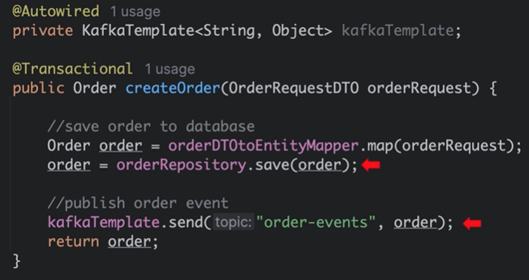

@Transactional annotation clubs repository save and kafka send action, if one of them fails then the whole transaction cannot be rolled back.

Transactional Outbox pattern ensures reliable message delivery in distributed system.

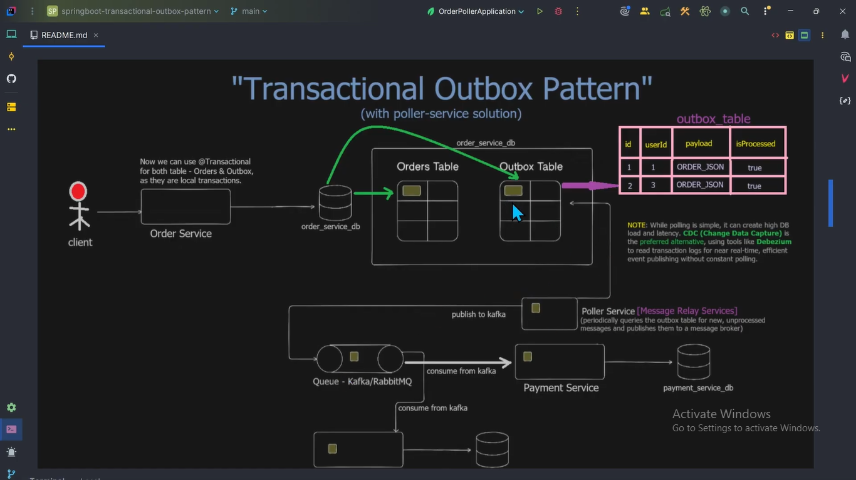

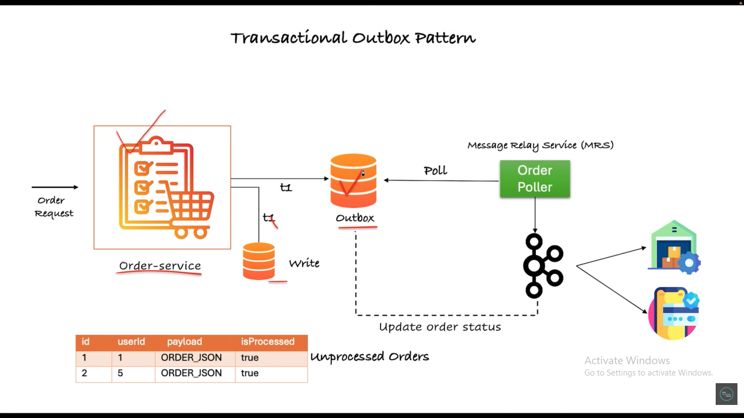

Order-service now saves data into two DB. Outbox DB is the one which has a column called “Published” true/false. By default it will be false. Message Relay Service is basically a scheduler which polls the Outbox DB every few mins to fetch the unpublished data and send it to Kafka as an event. Once that is done, we need to set the Published to true and save this to the Outbox DB again so that next time the same data isn’t get processed again.

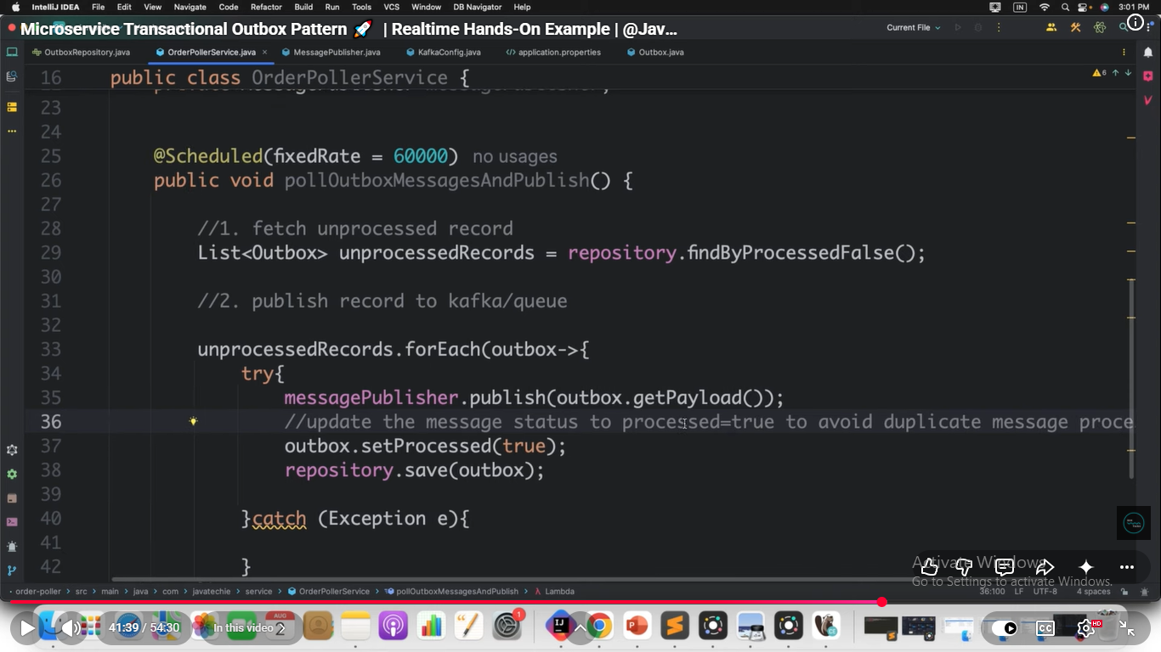

- CQRS Pattern: Separate DB for read and write

Ques. How do you trace one request across 20 services?
Ans.
Correlation ID
Trace ID
Zipkin
Jaeger
OpenTelemetry
Request carries same trace id.
These headers get commonly propagated.
Trace-ID
Span-ID
Correlation-ID
Authorization
Request-ID

Ques. What is Distributed Logging?
Ans. All services send logs to ELK, Grafana, Loki, Splunk
Search by Trace ID.

Ques. Why validate JWT at Gateway?
Ans. Instead of every service repeating validation. Gateway verifies token. Services trust gateway. Sometimes sensitive services still revalidate.

Ques. What happens if Kafka is down?
Ans. Possible strategies:
- Retry with exponential backoff.
- Store events in an Outbox table and publish later.
- Use a Dead Letter Queue (DLQ) for messages that repeatedly fail.
- Return an error if the operation cannot safely continue.

Ques. How do you handle partial failures in distributed systems?
- Configure reasonable timeouts.
- Use retries only for transient failures.
- Add circuit breakers to stop cascading failures.
- Use fallbacks where appropriate.
- Design APIs to be idempotent.
- Monitor with distributed tracing and centralized logging.

