This submission contains following files.

|  |  |
| --- | --- |
| Assignment | Files |
| Assignment 2 | mysql_social_media_platform.sql  msql_social_media_platform_out.txt |
| Assignment 3 | mongo_social_media_platform.js  mongo_social_media_platform.txt |

JavaScript file created for MongoDB script so that it can be executed easily. Output always returns to txt file. Arrow functions are used extensively to format output from Mongo functions. JavaScript is having comments for ease of reading as well.

Assignment 1, 2 and 3 having same elements and data. Someone of the SQLs used in assignment 2 in order to demonstrate understanding of table joins are not used in assignment 3. I have retain the numbering of SQL is same for both assignment in case if it required to track result across.

**Execution steps:**

Place the .js file into folder in your PC and execute mongosh command as below.

mongosh localhost:27017 mongo_social_media_platform.js >> mongo_social_media_platform.txt

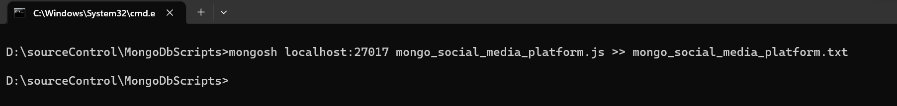

* I am executing the command from the same folder where I have placed .js file. This is possible because my mongosh is configured in environment variables and can be executed from anywhere.
* If setup is different. Execute from mongosh folder giving full path to .js and .txt file.

