Name

the

Music Note  
Project 1

CSC-5 Intro C++

Sergio R. Montalvan

Summer 2014

Table of Contents

Table of Contents………………………………………………………2

Rules of Game….………………………………………………………3

Reason for Choosing....…………………………………………………3

Issues with Project………………………………………………………3

Adjustments……..………………………………………………………4

Future Plans on Project 2……………...………………………………...4

Flowchart…….…………………………………………………….....5-7

Code……………………………………………………………………

Rules of the Game

The rules of this game are very simple for those adept at music but easily useable to learn music notes as well. The point of the game is to teach or to exercise the location of a note on the musical stanza. Those who do not understand the way notes work on music will find it very good to keep practicing and running the game until they become adept to the idea of a music note.

If the note is not correct the program will ask you to try again on figuring out what the note is. Once the note is called correctly the game is over and can be run again.

Reason for Choosing

The reason I chose this game was very simple, I ran out of time while trying to complete an even harder game. The original game chosen was Wheel of Fortune but it was too complicated with the limited knowledge I had at the time. The other reason I had gone with this idea is also because I was a music major before I decided to go full-heartedly towards engineering and it still is a personal past time. I like to see people enjoy music as much as I do and wish for people to learn more about it and this game helps to accomplish this at least a little.

Issues with Project

The issue with this project is that it’s simple and has no random elements over the fact that if the person playing the game has no clue what it’s about. The other issue is that the game does not keep score and is a very simple game no matter how it’s looked at. The last issue was that the game was very rushed but that was mostly due to the fact of wasted time on the project before it.

Adjustments

At first, the project was going very smoothly but when I tried to add a random generator to make the music stanzas random it worked but didn’t work. It worked as in it did randomly generate one of the stanzas but it would not stop generating them. I then figured out what the issue was and quickly fixed it. The bad part about fixing it though was that the stanza being generated was the same one and was not choosing the other ones. After an hour or so of fiddling with it I scrapped the idea and went to a switch case statement and took out the random factor of the game. The other issue I had was one with returning to the beginning without breaking the program but that failed and I just ended up putting loops inside each case to continue the game at least on the inside of the game.

Future Plans on Project 2

My plans on project 2 are to continue the Wheel of Fortune and complete it. The issues I have had with it will become minimal in the coming week and hopefully it will be completed before the end of the semester.

Flowchart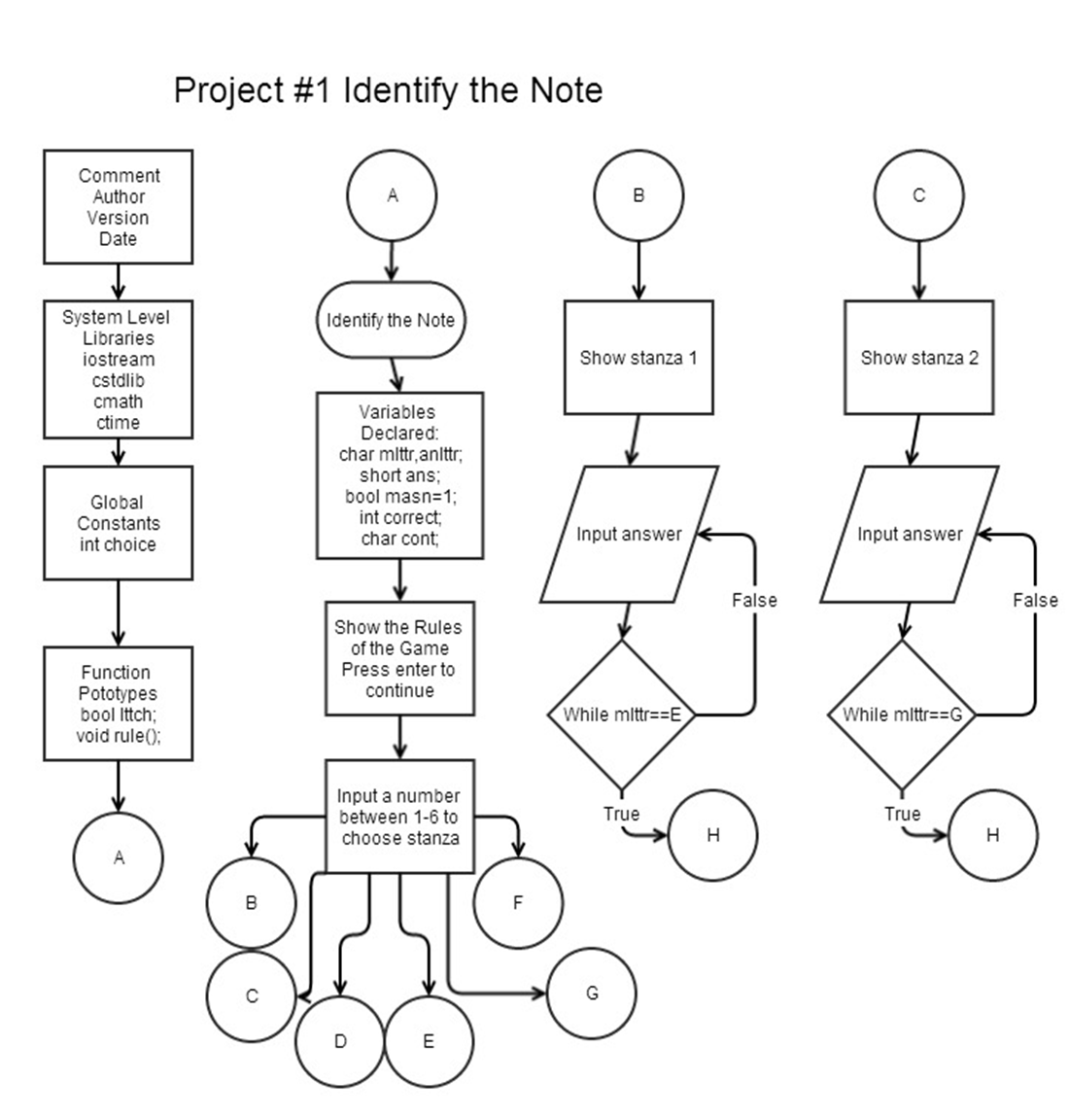

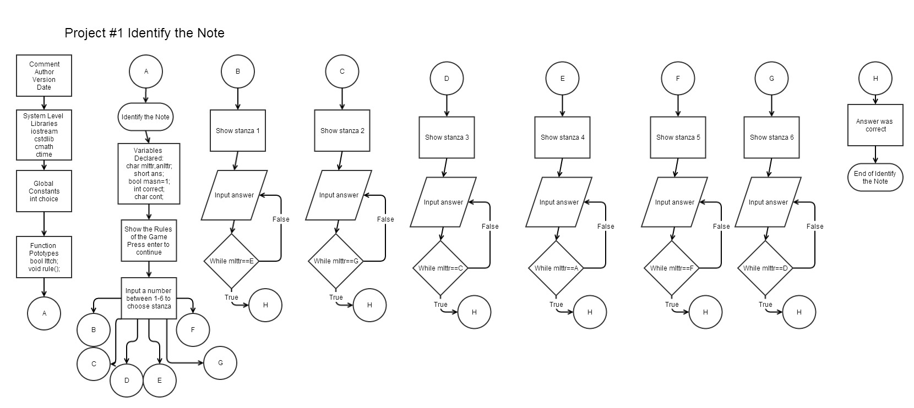



Code

/*

* File: main.cpp

* Author: Sergio R Montalvan

* Created on July 20, 2014, 12:08 PM

* Project 1 Music Note Game

*/

//System Level Libraries

#include <cstdlib>

#include <cmath>

#include <ctime>

#include <iostream>

using namespace std;

//User Libraries

//Global Constants

int choice;

//Function Prototypes

bool lttch(char,char);//Letter Checker -Bradd Carey

void rule();

//Execution Begins Here...

int main(int argc, char** argv) {

//Declare Variables

char mlttr,anlttr;//Music Letter & Answer Letter

short ans;

bool masn=1;//Music Answer to show if it was right then its right

int correct;

short m[6]={0,1,2,3,4,5};//Music Sheets

char cont;

//Show the Rules of the Game

rule();

//Game Loop

do

{

cout<<"Choose a number between 1-6 and Good Luck!\n";

cin>>choice;

cin.ignore();

switch(choice)

{

//Music Sheets

case 1:

{

cout<<"____________________\n"

<<"_O__________________\n"

<<"____________________\n"

<<"____________________\n"

<<"____________________\n"

<<"Identify the note! \n"

<<"The note is in Treble\n"

<<"Clef! \n";

do{

cin>>mlttr;

cin.ignore();

if(mlttr=='E'||mlttr=='e')

{

cout<<"The note was an E congratulations!\n";

mlttr==anlttr;

}

else

{

cout<<"Try Again!\n";

}

}while(mlttr!='e' && mlttr!='E');

break;

cin.ignore();

}

case 2:

{

cout<<"__O_________________\n"

<<"____________________\n"

<<"____________________\n"

<<"____________________\n"

<<"____________________\n"

<<"Identify the note! \n"

<<"The note is in Treble\n"

<<"Clef! \n";

do{

cin>>mlttr;

cin.ignore();

if(mlttr=='G'||mlttr=='g')

{

cout<<"The note was a G congratulations!\n";

mlttr==anlttr;

}

else

{

cout<<"Try Again!\n";

}

}while(mlttr!='g' && mlttr!='G');

break;

cin.ignore();

}

case 3:

{

cout<<"____________________\n"

<<"____________________\n"

<<"_______O____________\n"

<<"____________________\n"

<<"____________________\n"

<<"Identify the note! \n"

<<"The note is in Treble\n"

<<"Clef! \n";

do{

cin>>mlttr;

cin.ignore();

if(mlttr=='C'||mlttr=='c')

{

cout<<"The note was a C congratulations!\n";

mlttr==anlttr;

}

else

{

cout<<"Try Again!\n";

}

}while(mlttr!='c' && mlttr!='C');

break;

cin.ignore();

}

case 4:

{

cout<<"____________________\n"

<<"____________________\n"

<<"____________________\n"

<<"_____________O______\n"

<<"____________________\n"

<<"Identify the note! \n"

<<"The note is in Treble\n"

<<"Clef! \n";

do{

cin>>mlttr;

cin.ignore();

if(mlttr=='A'||mlttr=='a')

{

cout<<"The note was an A congratulations!\n";

mlttr==anlttr;

}

else

{

cout<<"Try Again!\n";

}

}while(mlttr!='a' && mlttr!='A');

break;

cin.ignore();

}

case 5:

{

cout<<"____________________\n"

<<"____________________\n"

<<"____________________\n"

<<"____________________\n"

<<"____O_______________\n"

<<"Identify the note! \n"

<<"The note is in Treble\n"

<<"Clef! \n";

do{

cin>>mlttr;

cin.ignore();

if(mlttr=='F'||mlttr=='f')

{

cout<<"The note was a F congratulations!\n";

mlttr==anlttr;

}

else

{

cout<<"Try Again!\n";

}

}while(mlttr!='f' && mlttr!='F');

break;

cin.ignore();

}

case 6:

{

cout<<"____________________\n"

<<"____________________\n"

<<"____________________\n"

<<"____________________\n"

<<"____________________\n"

<<" O \n"

<<"Identify the note! \n"

<<"The note is in Treble\n"

<<"Clef! \n";

do{

cin>>mlttr;

cin.ignore();

if(mlttr=='D'||mlttr=='d')

{

cout<<"The note was a D congratulations!\n";

mlttr==anlttr;

}

else

{

cout<<"Try Again!\n";

}

}while(mlttr!='d' && mlttr!='D');

break;

cin.ignore();

}

}

}while(mlttr==anlttr);

return 0;

}

bool lttch(char mlttr,char anlttr)

{

if(mlttr==anlttr)

{

return 1;

}

else

{

return 0;

}

}

void rule()

{

cout<<"________________________________________________\n"

<<"| Name the Music Note! |\n"

<<"|______________________________________________|\n"

<<"The Rules of the game are simple for those with \n"

<<"an adept mind towards music and its notes. Just \n"

<<"name the note and give the best answer you can! \n"

<<"If you have no skills with music this may try to\n"

<<"help you get better with music and its notes! \n"

<<"Without further ado press enter when your ready!\n";

cin.ignore();

}