Vidzemes Augstskola

**Inženierzinātņu Fakultāte**

mobilo tehnoloģiju risinājumi

grupa 02

2 Mājas darbs

Valmiera, 2018

SATURS

1 Ievads 4

2 Pirmais skats – GoogleMaps 4

3 Otrais skats – GitHub 5

PIELIKUMS 1 6

PIELIKUMS 2 7

PIELIKUMS 3 9

PIELIKUMS 4 9

PIELIKUMS 5 10

|  |  |  |  |
| --- | --- | --- | --- |
| Dokumenta vēsture | | | |
| Versija | Statuss / Izmaiņas | Datums | Autors |
| 1.0 | Pirmā versija | 19.01.2018 | Toms Amsons |
|  |  |  |  |
|  |  |  |  |
|  |  |  |  |

|  |  |  |  |
| --- | --- | --- | --- |
| Kontakti un atbildīgais (-ie) | | | |
| Vārds, Uzvārds | Struktūrvienība | Amats | Kontaktinformācija (e-pasts) |
| Toms Amsons | Grupa #2 | Dalībnieks | toms.amsons@va.lv |
| Ģirts Ķesteris | Grupa #2 | Dalībnieks | girts.kesteris@va.lv |
|  |  |  |  |
|  |  |  |  |
|  |  |  |  |

# Ievads

2 Mājas darbā tika izveidota lietotne ar diviem skatiem. Pirmajā skatā attēlots google maps, kas norāda telefona atrašanās vietu. Otrajā skatā tiek attēlots Github json ar repozitoriju nosaukumiem un to autoru.

# Pirmais skats – GoogleMaps

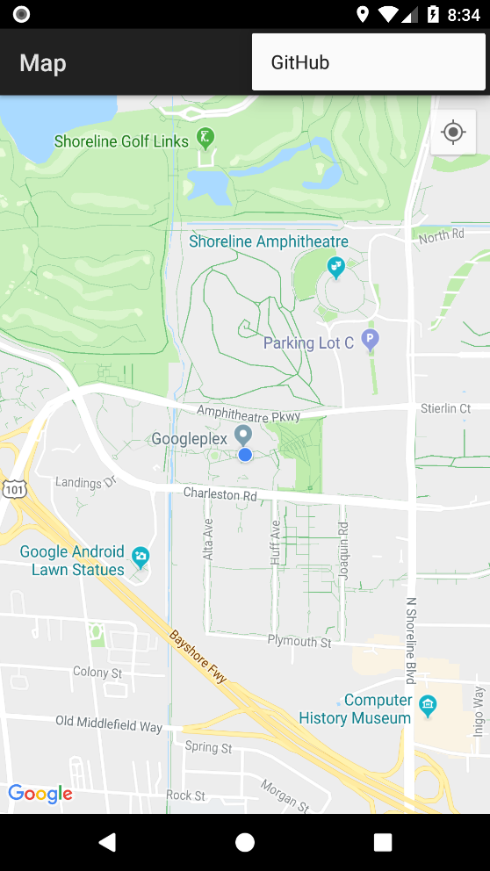

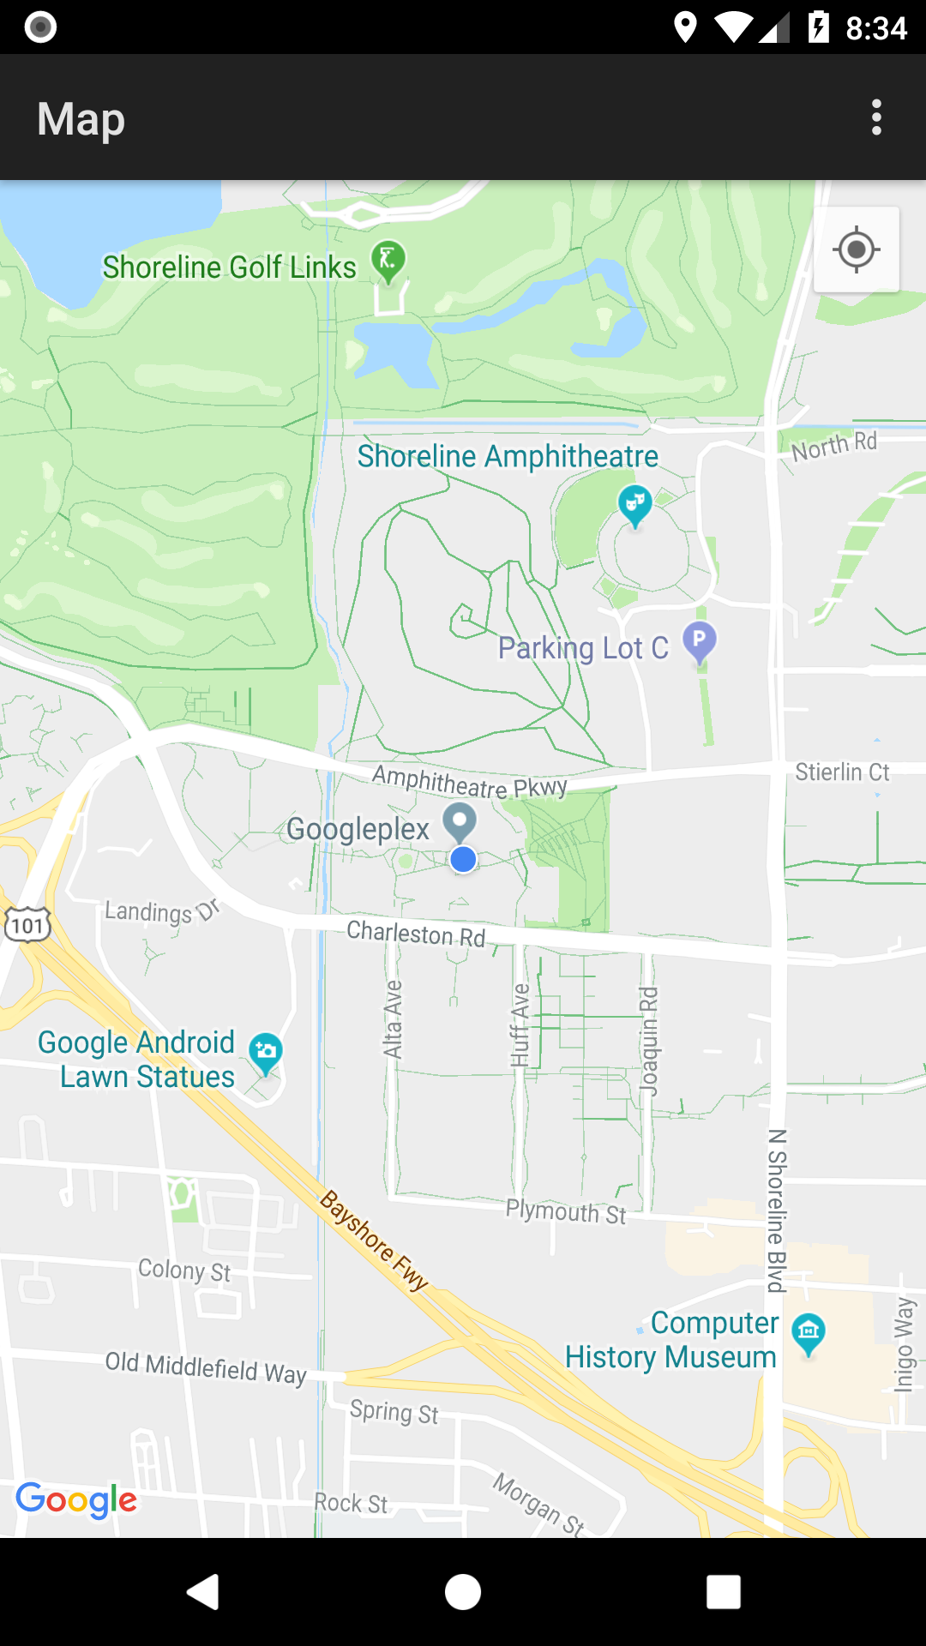

Atverot lietotni tiek ielādēts google maps, kas attēlo viedtālruņa lokāciju. Atverot lietotājam tiek pieprasīta atļauja izmantot gps. Izmantojot rīkjoslas izvēlni ir iespēja pārslēgties uz otru skatu.

Šī skata funkcionalitāte ir izveidota ActivityMaps.java failā (skat. 1 Pielikumu). Skata dizains tiek definēts failā activity_maps.xml (skat. 3 pielikumu).

# Otrais skats – GitHub

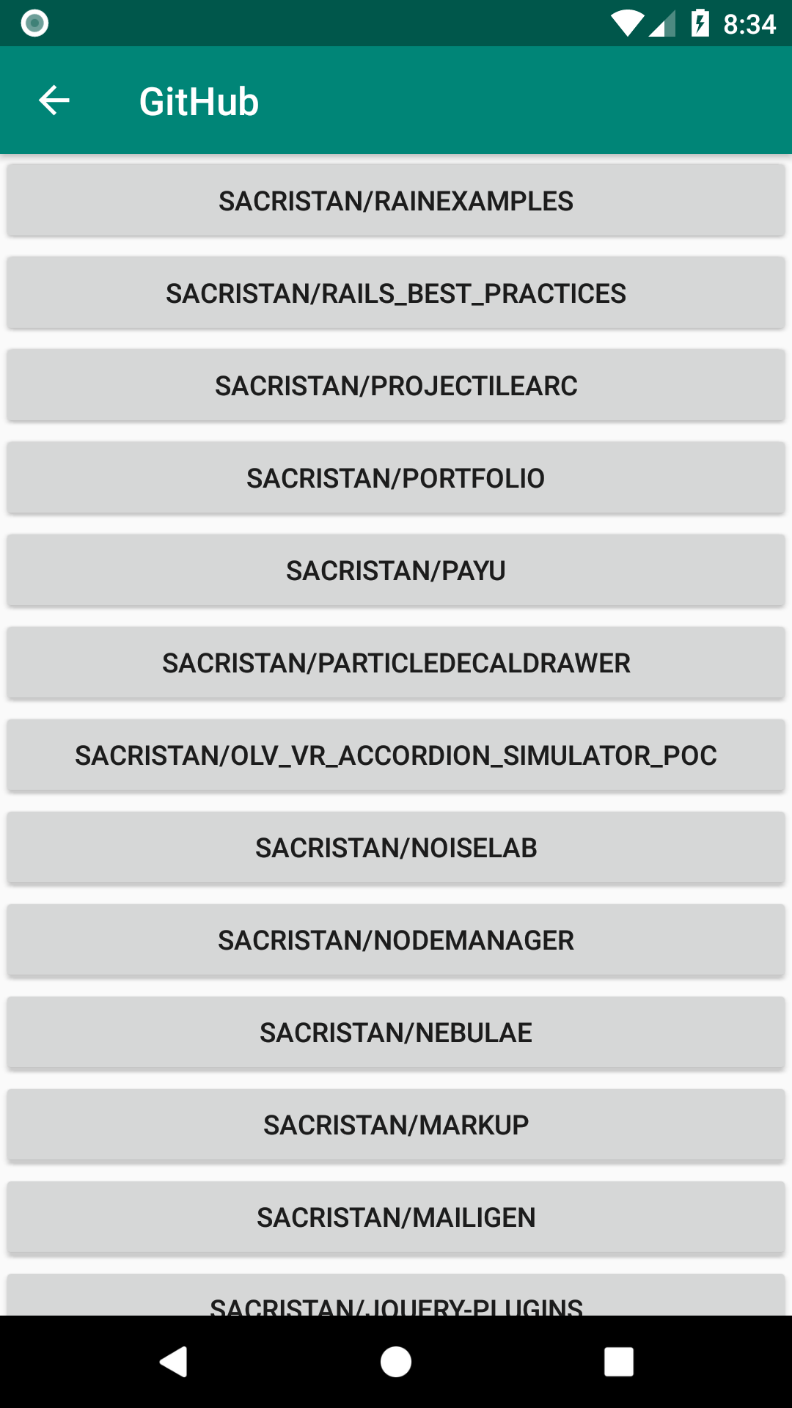

Šajā skatā tiek attēlots saraksts, kas tiek iegūts no github api. Tiek ielādēts json masīvs, no kura tiek attēlots repozitorija nosaukums un tās autors. Šie visi ieraksti tiek attēloti kā pogas, ja kāda no šīm pogām tiek uzspiesta tiek atvērts interneta pārlūks uz šo repozitoriju. Rīkjoslā ir poga, kas lietotāju aizved uz pirmo skatu.

Šī skata dizains tiek definēts failā content_git_hub.xml (skat. 4 pielikumu). Saraksta ieraksta dizains tiek definēts pēc listelement.xml faila.

# PIELIKUMS 1

MapsActivity.java

public class MapsActivity extends FragmentActivity implements OnMapReadyCallback {  
  
 private static final int *MY_REQUEST_INT* = 160;  
 private GoogleMap mMap;  
  
 @Override  
 protected void onCreate(Bundle savedInstanceState) {  
 super.onCreate(savedInstanceState);  
 setContentView(R.layout.*activity_maps*);  
 // Obtain the SupportMapFragment and get notified when the map is ready to be used.  
 SupportMapFragment mapFragment = (SupportMapFragment) getSupportFragmentManager()  
 .findFragmentById(R.id.*map*);  
 mapFragment.getMapAsync(this);  
 }  
  
 @Override  
 public boolean onCreateOptionsMenu(Menu menu) {  
 getMenuInflater().inflate(R.menu.*mymenu*, menu);  
 return true;  
 }  
  
 @Override  
 public boolean onOptionsItemSelected(MenuItem item) {  
 super.onOptionsItemSelected(item);  
 switch (item.getItemId()) {  
 case R.id.*Github*:  
 startActivity(new Intent(MapsActivity.this, GitHub.class));  
 break;  
 }  
 return true;  
 }  
  
 @SuppressLint("MissingPermission")  
 @Override  
 public void onMapReady(GoogleMap googleMap) {  
 mMap = googleMap;  
  
 if (ActivityCompat.*checkSelfPermission*(this, Manifest.permission.*ACCESS_FINE_LOCATION*) != PackageManager.*PERMISSION_GRANTED* && ActivityCompat.*checkSelfPermission*(this, Manifest.permission.*ACCESS_COARSE_LOCATION*) != PackageManager.*PERMISSION_GRANTED*) {  
 // *TODO: Consider calling* if (Build.VERSION.*SDK_INT* >= Build.VERSION_CODES.*M*) {  
 requestPermissions(new String[]{Manifest.permission.*ACCESS_COARSE_LOCATION*, Manifest.permission.*ACCESS_FINE_LOCATION*}, *MY_REQUEST_INT*);  
 }  
 return;  
 } else {  
 mMap.setMyLocationEnabled(true);  
 }  
 //  
 LocationManager locationManager;  
 locationManager = (LocationManager) getSystemService(Context.*LOCATION_SERVICE*);  
 Criteria criteria = new Criteria();  
  
 Location location = locationManager.getLastKnownLocation(locationManager.getBestProvider(criteria, false));  
 if (location != null) {  
 mMap.animateCamera(CameraUpdateFactory.*newLatLngZoom*(new LatLng(location.getLatitude(), location.getLongitude()), 13));  
  
 CameraPosition cameraPosition = new CameraPosition.Builder()  
 .target(new LatLng(location.getLatitude(), location.getLongitude())) // Sets the center of the map to location user  
 .zoom(15) // Sets the zoom  
 .bearing(0) // Sets the orientation of the camera to east  
 .tilt(0) // Sets the tilt of the camera to 30 degrees  
 .build(); // Creates a CameraPosition from the builder  
 mMap.animateCamera(CameraUpdateFactory.*newCameraPosition*(cameraPosition));  
 }  
 }  
}

# PIELIKUMS 2

GitHub.java

public class GitHub extends AppCompatActivity {  
  
 private static final String *TAG* = "GitHub API";  
  
 private static final String *GITHUB_API_URL* = "https://api.github.com/users/Sacristan/repos";  
 private static final int *MAX_LIST_ITEMS* = 50;  
  
 ProgressDialog pd;  
 LinearLayout repoListView;  
  
 @Override  
 protected void onCreate(Bundle savedInstanceState) {  
 super.onCreate(savedInstanceState);  
 setContentView(R.layout.*activity_git_hub*);  
 Toolbar toolbar = (Toolbar) findViewById(R.id.*toolbar*);  
 repoListView = findViewById(R.id.*linearLayout*);  
 setSupportActionBar(toolbar);  
  
 getSupportActionBar().setDisplayHomeAsUpEnabled(true);  
  
 fetchGithubData();  
 }  
  
 private void fetchGithubData(){  
 new JsonTask().execute(*GITHUB_API_URL*);  
 }  
  
 private void populateList(String rawJSON){  
 Log.*i*(*TAG*, "RAW JSON: "+rawJSON);  
  
 try {  
// JSONObject jObject = new JSONObject(rawJSON);  
 JSONArray jsonArray = new JSONArray(rawJSON);  
  
 for (int i=0; i < jsonArray.length(); i++)  
 {  
 if(i >= *MAX_LIST_ITEMS*) break;  
  
 JSONObject item = jsonArray.getJSONObject(i);  
 String itemName = item.getString("full_name");  
 String itemUrl = item.getString("html_url");  
 addNewRecordItem(itemName, itemUrl);  
 }  
  
 } catch (JSONException e) {  
 e.printStackTrace();  
 }  
 }  
  
  
 private void addNewRecordItem(String name, final String url){  
 Button itemButton = new Button(this);  
 itemButton.setText(name);  
  
 itemButton.setOnClickListener(new View.OnClickListener() {  
 public void onClick(View v) {  
 Intent browserIntent = new Intent(Intent.*ACTION_VIEW*, Uri.*parse*(url));  
 startActivity(browserIntent);  
 }  
 });  
  
 //FIX: https://stackoverflow.com/questions/4576219/logcat-error-addviewview-layoutparams-is-not-supported-in-adapterview-in-a  
 repoListView.addView(itemButton, 0);  
// LinearLayout layout = new LinearLayout(this);  
// layout.addView(itemButton,new LinearLayout.LayoutParams(ViewGroup.LayoutParams.WRAP_CONTENT,ViewGroup.LayoutParams.WRAP_CONTENT,0));  
 }  
  
 protected class JsonTask extends AsyncTask<String, String, String> {  
  
 protected void onPreExecute() {  
 super.onPreExecute();  
 }  
  
 protected String doInBackground(String... params) {  
 HttpURLConnection connection = null;  
 BufferedReader reader = null;  
  
 try {  
 URL url = new URL(params[0]);  
 connection = (HttpURLConnection) url.openConnection();  
 connection.connect();  
  
 InputStream stream = connection.getInputStream();  
  
 reader = new BufferedReader(new InputStreamReader(stream));  
  
 StringBuffer buffer = new StringBuffer();  
 String line = "";  
  
 while ((line = reader.readLine()) != null) {  
 buffer.append(line+"\n");  
 Log.*d*("Response: ", "> " + line);  
 }  
  
 return buffer.toString();  
  
  
 } catch (MalformedURLException e) {  
 e.printStackTrace();  
 } catch (IOException e) {  
 e.printStackTrace();  
 } finally {  
 if (connection != null) {  
 connection.disconnect();  
 }  
 try {  
 if (reader != null) {  
 reader.close();  
 }  
 } catch (IOException e) {  
 e.printStackTrace();  
 }  
 }  
 return null;  
 }  
  
 @Override  
 protected void onPostExecute(String result) {  
 super.onPostExecute(result);  
  
 if(result!="") {//possibly no connection here  
 populateList(result);  
 }  
 }  
 }  
}

# PIELIKUMS 3

Activity_maps.xml

<?xml version="1.0" encoding="utf-8"?>  
  
<fragment xmlns:android="http://schemas.android.com/apk/res/android"  
 xmlns:map="http://schemas.android.com/apk/res-auto"  
 xmlns:tools="http://schemas.android.com/tools"  
 android:id="@+id/map"  
 android:name="com.google.android.gms.maps.SupportMapFragment"  
 android:layout_width="match_parent"  
 android:layout_height="match_parent"  
 tools:context=".MapsActivity" />

# PIELIKUMS 4

Content_git_hub.xml

<?xml version="1.0" encoding="utf-8"?>  
<android.support.constraint.ConstraintLayout xmlns:android="http://schemas.android.com/apk/res/android"  
 xmlns:app="http://schemas.android.com/apk/res-auto"  
 xmlns:tools="http://schemas.android.com/tools"  
 android:layout_width="match_parent"  
 android:layout_height="match_parent"  
 app:layout_behavior="@string/appbar_scrolling_view_behavior"  
 tools:context=".GitHub"  
 tools:showIn="@layout/activity_git_hub">  
  
 <ScrollView  
 android:layout_width="match_parent"  
 android:layout_height="match_parent">  
  
 <LinearLayout  
 android:id="@+id/linearLayout"  
 android:layout_width="match_parent"  
 android:layout_height="wrap_content"  
 android:orientation="vertical">  
  
 </LinearLayout>  
 </ScrollView>  
  
</android.support.constraint.ConstraintLayout>

# PIELIKUMS 5

Listelement.xml

<?xml version="1.0" encoding="utf-8"?>  
<android.support.constraint.ConstraintLayout  
 xmlns:android="http://schemas.android.com/apk/res/android" android:layout_width="match_parent"  
 android:layout_height="match_parent">  
  
  
 <ScrollView  
 android:layout_width="368dp"  
 android:layout_height="432dp">  
  
 <LinearLayout  
 android:id="@+id/audioButtonContainer"  
 android:layout_width="match_parent"  
 android:layout_height="wrap_content"  
 android:orientation="vertical">  
  
 <TextView  
 android:id="@+id/textView"  
 android:layout_width="fill_parent"  
 android:layout_height="wrap_content"  
 android:layout_gravity="center"  
 android:textColor="@android:color/black" />  
 </LinearLayout>  
 </ScrollView>  
  
</android.support.constraint.ConstraintLayout>