Brain Tumor Detection and Classification

Saraswati Patil1[0009-0001-8446-1597], Sangita Jaybhaye2[0000-0001-9928-5728], Sanjyot Kotgire3, Shravan Raina4, Somanshu Bhat5, Saksham Sharma6

1 2 3 4 5 6 Vishwakarma Institute of Technology, Pune   
[saraswati.jadhav@vit.edu](mailto:saraswati.jadhav@vit.edu)

sangita.jaybhaye@vit.edu

[sanjyot.kotgire20@vit.edu](mailto:sanjyot.kotgire20@vit.edu)

[shravan.raina20@vit.edu](mailto:shravan.raina20@vit.edu)

[somanshu.bhat20@vit.edu](mailto:somanshu.bhat20@vit.edu)

saksham.sharma20@vit.edu

**Abstract.** The most challenging issue in medical image analysis is brain tumor diagnosis. Because brain tumors may have a variety of sizes or textures, the photographs show a lot of variations, making the identification process challenging. Multiple types of cells contribute to the development of brain tumors, and these cells can provide details of tumor. Tumors may appear anywhere, and the position of the tumor reveals data about the cells that are responsible for it, enabling a more accurate diagnosis. Accurate and early brain tumor diagnosis is crucial for the disease's successful treatment.

Early detection can eventually save a life in addition to assisting in the development of better treatments. Recent advances in machine learning algorithms have made it possible to interpret medical images and data without the need for human error or the laborious process of manually diagnosing tumors. When compared to manual, traditional diagnosing procedures, computer-aided processes yield higher outcomes.

Finding brain tumors and improving care for people who are affected are the two main objectives of this initiative. When abnormal cell growths appear in the brain, they are considered as tumors, and malignant tumors are referred to as cancer. By using CT or MRI imaging, brain cancer regions are frequently found.

**Keywords:** Brain Tumor, Machine Learning, Magnetic Resource Imaging, CNN, Biomedical Informatics

1. Introduction

A growth that develops inside the brain is known as a brain tumor and is specifically impacted by the tissues in the skull. A tissue mass where cells multiply out of control is called a brain tumor. It is built from a mix of brain-derived and extracellular cells. Primary tumors are those that develop within the brain itself, whereas secondary tumors spread to other regions of the body. Cancers can have a variety of origins depending on the cells formed from different tumor types. There are two malignant and one benign component to the tumor. Such brain tumors pressurize the brain and develop erratically. Numerous brain problems may be brought on by these factors. Nearly 0.7 million Americans are anticipated to have brain tumors by the year 2019. There were 0.86 million such diagnoses. Of these individuals, 26,170 were classified as cancer, and 60,800 as benign. In the US, 35% of people with cancer survive. Accurate brain tumor MR images are essential for clinical diagnosis and aid in making treatment decisions for patients.

A complex and difficult process is manually classifying brain tumors from MR images with comparable structures or characteristics, diagnosing the brain tumor. This issue may be resolved by automated classification, which would categorize MR images of brain tumors. Although there are only 1.4% new cases of brain tumors annually, brain tumor-related deaths during the previous couple decades have risen in developed nations despite the relative rarity of the disease. In India, there are 2% of all malignancies and between 5 and 10 Brain tumor cases in every 100,000 persons, with an upward tendency. Computer-aided disease diagnosis is becoming more popular recently and aids doctors in making quick decisions. One such technique is the application of CNN, which may be utilized to separate the spatial and temporal properties required for illness identification from the data. A CNN is a specific type of neural network that performs best at processing image datasets. The main objective is to understand and extract by convolutionally processing the kernel and the picture.

1. Literature Review

The sickness condition is examined in this study using MRI scan images. The segmented mask might be used to assess the density of the tumor, which would help with therapy. MRI images are analyzed using a deep learning system to look for abnormalities [1]. Through the use of multi-level thresholding, the tumor area is split. The number of malignant pixels reveals how dense the affected region is.

For neuro-oncologists, the advancement of biomedical informatics and computer-aided diagnostics provides various benefits. Computer-assisted techniques produce better results using conventional diagnosis methods [2]. Typically, features are extracted using CNN, and the input is categorized using a fully connected network.

The authors in [3] have used different combinations of dilation, erosion and histogram evaluation techniques to increase the accuracy. CNN is used as the model as it is the best neural network suited for images. 95% accuracy with 100% precision is achieved.

An MRI image dataset with a variety of tumor types was used in this research. The photos were improved using segmentation and image preprocessing. The neural network design uses less resources and is easier to train. The method has a 98.029% accuracy rate for detecting brain cancers [4].

In this study, only the MRI pictures can clearly display the tumorous region; adaptable brain tumors are instead found using K-Means segmentation and image preprocessing. Object tagging is also employed to offer more precise information on the tumor's location [5]. To make this technique adaptive, SVM is used in an unsupervised way to generate and maintain the pattern for use in the future.

Researchers examine several methods for completely automated, user-free segmentation and categorization of brain tumors. One option is to first apply a gaussian filter on the input picture. The picture is pre-processed, then the sections for the tumor, WM, GM, and edema are extracted using GLCM texture features [6]. The retrieved features are then analyzed using SVM and ANN to choose the pertinent properties.

Brain tumors were divided up using CT and MRI scan images. Brain tumor segmentation and classification are the two most frequent uses of MRI [7]. Researchers used Fuzzy C-Means clustering in this study to segment the tumor using a method that accurately predicts the presence of tumor cells. Following the segmentation process, classification was carried out utilizing CNN and traditional classifiers.

Many different types of characteristics were gathered and trained using different ML algorithms to increase the estimation of overall survival for tumor patients using MRI. Using trained AlexNet and a linear discriminant, deep feature extraction was able to attain the highest classification accuracy [8]. Though their accuracy did not reach 46%, textural cues have been utilized to categorize a number of cancer kinds.

It is difficult and hard to separate and classify brain tumors using only traditional medical image processing. Deep learning methods have demonstrated potential in enhancing the precision of tumor detection and classification using MRI [9]. Researchers provide a CNN-based deep learning study for brain cancer from MRI scans (CNN). The real system tests a variety of CNN architectures, including ResNet, Xception, and MobilNet-V2.

Research achieves 92% validation accuracy using CNN algorithm. The White Matter, CSF, and GM regions are of particular relevance in the search for brain tumors [10]. Because a tiny tumor cannot be seen on MRI, CT scan, or X-ray pictures, brain tumors are typically found at a malignant stage. It covers numerous methods with results between 83 to 97.5%, including SVM DWT fuzzy clustering and K means.

To identify the white spots in the image, Binary Thresholding (0, 255) is used as image preprocessing, and K-means is then used in this research. The last method for classifying tumors is SVM. K means aids in gathering the segmented and processed pictures for feature extraction-based detection [11]. When the data seems tumorigenic, SVM is used to classify the data by type.

Research uses the K-Means algorithm for segmentation and basic CNN for classifying brain MRI images. Greyscale images having a 256x256 pixel resolution are transformed. For the purpose of creating duplicates of the same photographs, image augmentation is used. Convolution layer, Pooling layer, and ReLU layer assist in mapping the features [12]. A binary picture with a segmented tumor area is produced after 40 iterations of the K-means algorithm.

Several studies were addressed in order to gather the accuracy, sensitivity, and other model-specific factors. Some of the often-employed methods are Random Forest and Fuzzy K-means clustering. Researchers have used the MKSVM algorithm to obtain the best accuracy of 99.7% [13]. The employment of a feature extraction method and CNN in combination allowed for a high classification accuracy of 99.12%.

The advantages and disadvantages of each segmentation approach described in the model in accordance with the numerous segmentation techniques employed. Threshold-based was thought to have the fewest drawbacks. When compared to k means, fuzzy c means produces superior outcomes [14]. Different pre-processing methods yield various performance metrics. The highest accuracy for the anisotropic filter and the lowest accuracy for skull stripping are 94% and 80%, respectively.

1. Methodology
   1. Block Diagram

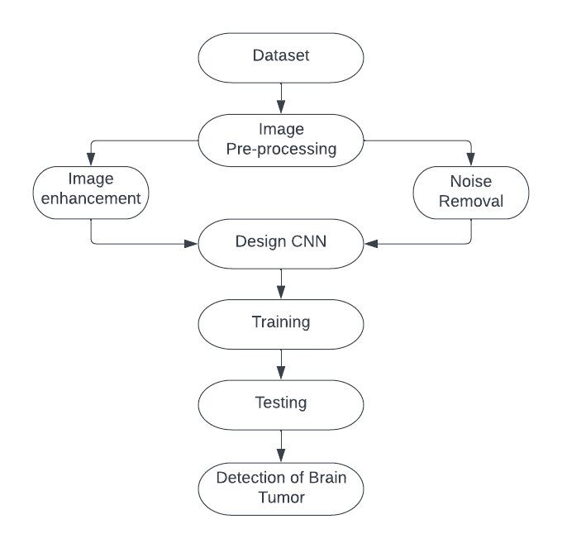

**Fig. 1.** Brain Tumor Detection Block Diagram

Fig. 1 shows the block diagram of applied experimental processes for brain detection. Image preprocessing, CNN design, training, testing processes are used for brain tumor detection.

* 1. Dataset

The collection contains a total of 253 MRI images of brain, in which 155 are tumor images while the remaining 98 are not. Image preprocessing was performed to enhance the dataset's size while addressing the dataset's data imbalance problem.

Images are transformed to grayscale before being subjected to Gaussian Blur. The photos' extra noise is also reduced via a sequence of erosions and dilations. From the original picture, a new cropped image as in Fig.2 and Fig.3 is generated that has less noise and concentrates on the part of the brain with the tumor.

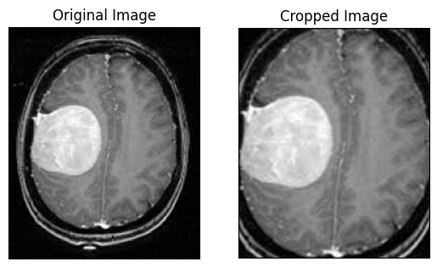 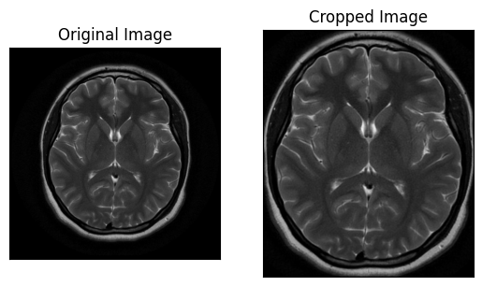

**Fig. 2.** Cropped Picture- Cancerous **Fig. 3.** Cropped Picture- Non-Cancerous

* 1. Image Preprocessing

### Dilation

With the use of the dilation method, pixels are added to object borders. Fig.4 represents original image while Fig.5 represents image after dilation. White pixels have been added to the edges causes white patches to increase after dilatation like tumors do, and the void within the white area are also filled. Every background pixel that is bordered by at least 1 white pixel will change into the foreground pixel if a structuring element of size 3x3 with all 1s is put to our image. The outcome is a general increase in the lighter portions and a decrease in the darker areas, emphasizing the tumor more.

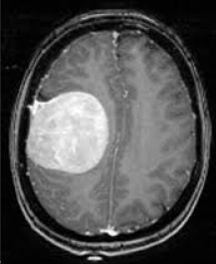 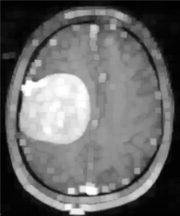

**Fig. 4.** Original Image **Fig. 5.** Dilated Image

### Erosion

In contrast to dilation, erosion works by deleting pixels from object edges. After erosion, white areas that resemble tumors shrink while the gaps and holes inside them expands. Fig.6 represents original image while Fig.7 represents image after erosion Each foreground pixel that isn't totally covered by white pixels will convert into a background pixel if a 3x3 structuring element that only comprises 1s is used.

This could reduce the tumors, which are the focus of our study. Erosion may first seem to be a bad thing for this role, but when combined with dilation, it really performs effectively (opening or shutting). By opening, the little particles from the front are removed, making the tumor region the center of attention. The frontal apertures and holes are filled up during closure (dilation followed by erosion), which enables the excision of the tumor's darker central regions.

 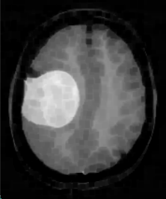

**Fig. 6.** Original Image **Fig. 7.** Eroded Image

* 1. Data Augmentation

The process of artificially generating new fresh data from previously collected training data is known as data augmentation. Data Augmentation can help improve the model accuracy calculated as the input size. Techniques include cropping, cushioning, flipping, rotating, and resizing. It strengthens the model's performance and addresses problems like overfitting and a lack of data. Data augmentation offers a variety of options for modifying the original image and may be helpful in providing enough data for bigger models.

Rotation, breadth, height, shear, brightness, horizontal flip, and vertical flip are some of the parameters utilized to enhance data as in Fig.8. As the total quantity of each segment is not similar, data augmentation makes the quantity near to the same by duplicating ‘yes’ (tumor detected) images by 6 times and similarly, ‘no’ (tumor not detected) images are duplicated by 9 times. After data augmentation, the dataset is increased to 2064 pictures, containing 1084 tumor and 980 non-tumor images.

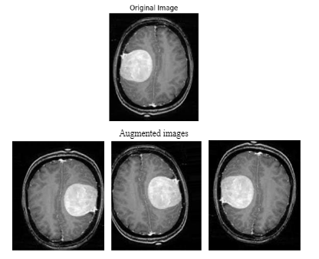

**Fig. 8.** Augmented data for Tumor detected images

* 1. Models Generation

Images are trained and tested according to the inputs provided. This single process is defined as a model of CNN. The accuracy and other parameter values increases along with increase in training and testing models. Next generating model seeks knowledge from the previous and the inputs provided to give the parameter scores. The quantity of samples handled in a batch before a model update is referred to as the batch size (here: 32). Total number of completed iterations over the training dataset equals the number of epochs. At each iteration of the epoch a fresh model is created and stored to check out the scores. Mostly the last model generated with a given batch size has the most accurate scores for training and testing the images. This model goes through various Iterations (here: 23) as shown in eq.1.

* 1. Convolutional Neural Network

CNNs are a particular kind of network design for deep learning algorithms that that can instantly learn from previously obtained data and are employed primarily for tasks involving the processing of pixel input, such as picture identification. CNNs are particularly helpful for recognizing various things, such as objects, classes, and categories in photos by identifying trends within the images and applying all layers as in Fig.9.

CNN layers are defined as:

1. Input Layer

The input pictures and their pixel values are processed from the input layer. These pictures are matrix representations of brain tumors.

1. Convolutional Layer

The convolutional layer computes the dot product between the input image and kernel. When the filter's template is present in the input image, this paper obtains high value in feature maps. The kernel-like properties of the image are recorded.

$$S\left(i,j\right)= Σ_{m} Σ_{n} l\left(m,n\right)F\left(i-m,j-n\right)( SEQ "equation" \backslash n \backslash * MERGEFORMAT 2)$$

Kernels (F(i,j)) convolve with input image to generate the feature map (S(i,j)). Negative sign in F(i-m, j-n) indicates that in the first step, The filter F[m, n] is flipped into F[-m, -n] and translate by i and j so that eventually the filter F[m, n] becomes F[i-m, j-n]. Multiplication is performed with the image l(m, n) resulting value S(i, j) as shown in eq.2.

1. Activation Layer

The most well-known activation function type employed in this layer is Rectified Linear Units (ReLU). The matrix created has positive values that are kept while the negative values are converted to zero using this function.

1. Normalization Layer

A critical layer is the batch normalization layer, which creates norms using a mini batch for each channel. The use of a normalizing layer can lessen the severity of a mutation in the results.

1. Pooling Layer

Minimizes the network's parameters and the size of feature maps so that measurements of these maps take nearby pixels into account. average pooling and maximum pooling are 2 distinct layers, max pooling layer is used.

1. Fully Connected Layer

In a CNN, the last levels are frequently completely linked layers; as a result, two nearby layers within the network typically join directly via a fully connected layer.

1. SoftMax Layer

For classification applications, convolution neural networks (CNN) are frequently terminated with the SoftMax layer. The fact that the result values fall inside the [0,1] range is advantageous since it prevents binary categorization and allows the CNN model, which was utilized, to suit as many classes or measurements as possible.

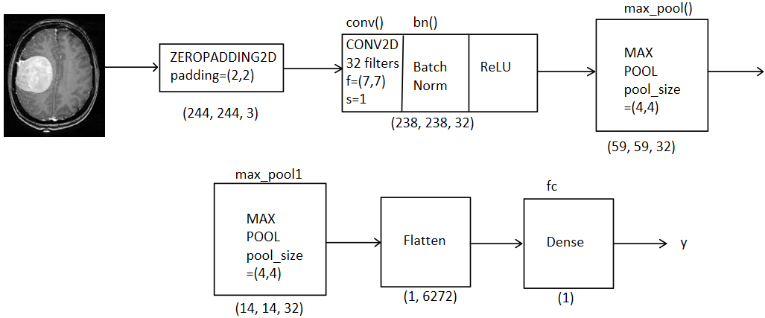

**Fig. 9.** Neural Network Architecture

* 1. Performance Metrics

To determine how well a model operates, performance measures compare its predictions to the actual labels. Accuracy and F1 score are calculated. This is a measure of accuracy and recall balance.

Two components that make up the score are precision and recall. Average of accuracy and recall is used to create the F1 score. The accuracy and recall are higher the higher the F1 score value.

1. Results

These performance metrics were recorded after the 23rd epoch of our CNN model's training, which lasted for 23 epochs as shown in Fig.10. Metrics values for training, validation and testing datasets are provided in Table.1

**Table 1.** Metrics Values

|  |  |  |
| --- | --- | --- |
| **Division of Dataset** | **Accuracy (%)** | **F1 Score** |
| Training Set | 95.78% | 0.9757 |
| Validation Set | 85.48% | 0.8618 |
| Testing Set | 86.45% | 0.8615 |

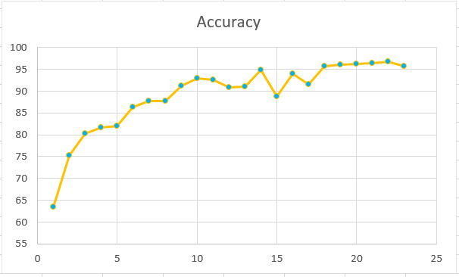

**Fig. 10.** Epochs v/s Accuracy

The total loss and gained accuracy for training and validation datasets of processed model during 23 epochs are shown below as in Fig.11 and Fig.12.

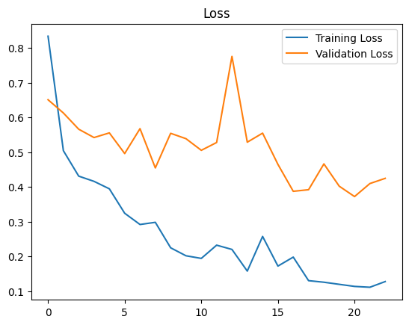 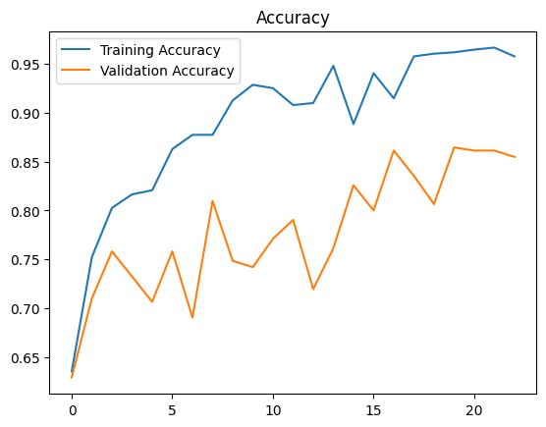

**Fig. 11.** Training and Validation Loss **Fig. 12.** Training and Validation Accuracy

1. Conclusion

Image processing is now used in many different fields, including medicine, remote sensing, electronics, and more. If we concentrate on medical applications, picture segmentation is frequently utilized to aid in diagnosis. The early and accurate detection of brain tumors is essential for the disease's effective management. Computer-assisted techniques produce better results when compared to manual. In this study, a technique for segmenting Brain MRI images for the detection and identification of brain tumors is suggested. The three-dimensional imaging of the brain with the tumor allows us to determine the tumor's size, as well as its kind and stage, which opens up new possibilities for the identification and segmentation of brain tumors in the future.

In future along with improvement in accuracy the model can also predict benign and malignant including the tumor detection. Also, the accuracy of the model can be improved more in the future. The model can be made commercially available, which will eventually help the common people for tumor recognition.

1. References
2. Sinha, A., R P, A., Suresh, M., Mohan R, N., D, A., Singerji, A.G.: Brain Tu-mour Detection Using Deep Learning. In: 2021 Seventh International confer-ence on Bio Signals, Images, and Instrumentation (ICBSII). pp. 1–5. IEEE (2021).
3. Choudhury, C.L., Mahanty, C., Kumar, R., Mishra, B.K.: Brain Tumor Detec-tion and Classification Using Convolutional Neural Network and Deep Neural Network. In: 2020 International Conference on Computer Science, Engineering and Applications (ICCSEA). pp. 1–4. IEEE (2020).
4. Methil, A.S.: Brain Tumor Detection using Deep Learning and Image Pro-cessing. In: 2021 International Conference on Artificial Intelligence and Smart Systems (ICAIS). pp. 100–108. IEEE (2021).
5. Fayyadh, S.B., Ibrahim, A.A.: Brain Tumor Detection and Classifiaction Using CNN Algorithm and Deep Learning Techniques. In: 2020 International Con-ference on Advanced Science and Engineering (ICOASE). pp. 157–161. IEEE (2020).
6. Telrandhe, S.R., Pimpalkar, A., Kendhe, A.: Detection of brain tumor from MRI images by using segmentation &amp; SVM. In: 2016 World Conference on Futuristic Trends in Research and Innovation for Social Welfare (Startup Conclave). pp. 1–6. IEEE (2016).
7. Sethuram Rao, G., Vydeki, D.: Brain Tumor Detection Approaches: A Review. In: 2018 International Conference on Smart Systems and Inventive Technolo-gy (ICSSIT). pp. 479–488. IEEE (2018).
8. Hossain, T., Shishir, F.S., Ashraf, M., Al Nasim, M.A., Muhammad Shah, F.: Brain Tumor Detection Using Convolutional Neural Network. In: 2019 1st In-ternational Conference on Advances in Science, Engineering and Robotics Technology (ICASERT). pp. 1–6. IEEE (2019).
9. Chato, L., Latifi, S.: Machine Learning and Deep Learning Techniques to Pre-dict Overall Survival of Brain Tumor Patients using MRI Images. In: 2017 IEEE 17th International Conference on Bioinformatics and Bioengineering (BIBE). pp. 9–14. IEEE (2017).
10. Habib, H., Mehmood, A., Nazir, T., Nawaz, M., Masood, M., Mahum, R.: Brain Tumor Segmentation and Classification using Machine Learning. In: 2021 International Conference on Applied and Engineering Mathematics (ICAEM). pp. 13–18. IEEE (2021).
11. Kumar, S., Dhir, R., Chaurasia, N.: Brain Tumor Detection Analysis Using CNN: A Review. In: 2021 International Conference on Artificial Intelligence and Smart Systems (ICAIS). pp. 1061–1067. IEEE (2021).
12. Suresha, D., Jagadisha, N., Shrisha, H.S., Kaushik, K.S.: Detection of Brain Tumor Using Image Processing. In: 2020 Fourth International Conference on Computing Methodologies and Communication (ICCMC). pp. 844–848. IEEE (2020).
13. Raut, G., Raut, A., Bhagade, J., Bhagade, J., Gavhane, S.: Deep Learning Ap-proach for Brain Tumor Detection and Segmentation. In: 2020 International Conference on Convergence to Digital World - Quo Vadis (ICCDW). pp. 1–5. IEEE (2020).
14. Miglani, A., Madan, H., Kumar, S., Kumar, S.: A Literature Review on Brain Tumor Detection and Segmentation. In: 2021 5th International Conference on Intelligent Computing and Control Systems (ICICCS). pp. 1513–1519. IEEE (2021).
15. Sravan, V., Swaraja, K., Meenakshi, K., Kora, P., Samson, M.: Magnetic Reso-nance Images Based Brain Tumor Segmentation- A critical survey. In: 2020 4th International Conference on Trends in Electronics and Informatics (ICOEI)(48184). pp. 1063–1068. IEEE (2020).