МЕЖГОСУДАРСТВЕННОЕ ОБРАЗОВАТЕЛЬНОЕ УЧРЕЖДЕНИЕ ВЫСШЕГО ОБРАЗОВАНИЯ

«БЕЛОРУССКО-РОССИЙСКИЙ УНИВЕРСИТЕТ»

Кафедра «Автоматизированные системы управления»

**ИНТЕРНЕТ ТЕХНОЛОГИИ И ВЕБ-ПРОГРАММИРОВАНИЕ**

***Лабораторная работа №4. Использование элементов управления***



Выполнил: Гудымов Б.В.

Проверила: Выговская Н.В.

Могилёв 2025

**Цель работы:** Изучение использования элементов управления

**Вариант 10**

Напишите сценарий обработки бланка заказов.

Пользователю предложено 5 товаров (отобразить названия и цены). Каждый товар в упаковке по 1, 5 или 10 шт. (организовать как список). Каждый вид товара может быть упакован или нет.

Если всего заказано более 30 единиц, то предоставляется скидка 20% от суммы заказа.

Если необходима доставка добавляется 5% от суммы заказа.

При обработке бланка требуется определить сумму за товар, сумму скидки, стоимость доставки и итоговую сумму.

Код HTML страницы:

<!DOCTYPE html>

<html lang="en">

<head>

<meta charset="UTF-8">

<meta http-equiv="X-UA-Compatible" content="IE=edge">

<meta name="viewport" content="width=device-width, initial-scale=1.0">

<title>Order Form</title>

<link rel="stylesheet" href="styles.css">

</head>

<body>

<section class="products">

<article id="0">

<div>

<label>Product name:</label>

<span class="product-name value" id="product-name0">Organic Apples</span>

</div>

<div>

<label>Price:</label>

<span class="value" id="price0">20</span>

</div>

<div>

<label>Number of units per package:</label>

<select id="select0" class="value">

<option value="1">1 unit</option>

<option value="5">5 units</option>

<option value="10">10 units</option>

</select>

</div>

<div>

<label>Do you need to pack the product?</label>

<br>

<input name="radio0" type="radio" value="true" checked>

<label class="value">Yes</label>

<br>

<input name="radio0" type="radio" value="false">

<label class="value">No</label>

</div>

<button class="add">Add to the shopping cart</button>

</article>

<article id="1">

<div>

<label>Product name:</label>

<span class="product-name value" id="product-name1">Fresh Strawberries</span>

</div>

<div>

<label>Price:</label>

<span class="value" id="price1">30</span>

</div>

<div>

<label>Number of units per package:</label>

<select id="select1" class="value">

<option value="1">1 unit</option>

<option value="5">5 units</option>

<option value="10">10 units</option>

</select>

</div>

<div>

<label>Do you need to pack the product?</label>

<br>

<input name="radio1" type="radio" value="true" checked>

<label class="value">Yes</label>

<br>

<input name="radio1" type="radio" value="false">

<label class="value">No</label>

</div>

<button class="add">Add to the shopping cart</button>

</article>

<article id="2">

<div>

<label>Product name:</label>

<span class="product-name value" id="product-name2">Whole Grain Bread</span>

</div>

<div>

<label>Price:</label>

<span class="value" id="price2">15</span>

</div>

<div>

<label>Number of units per package:</label>

<select id="select2" class="value">

<option value="1">1 unit</option>

<option value="5">5 units</option>

<option value="10">10 units</option>

</select>

</div>

<div>

<label>Do you need to pack the product?</label>

<br>

<input name="radio2" type="radio" value="true" checked>

<label class="value">Yes</label>

<br>

<input name="radio2" type="radio" value="false">

<label class="value">No</label>

</div>

<button class="add">Add to the shopping cart</button>

</article>

<article id="3">

<div>

<label>Product name:</label>

<span class="product-name value" id="product-name3">Almond Milk</span>

</div>

<div>

<label>Price:</label>

<span class="value" id="price3">25</span>

</div>

<div>

<label>Number of units per package:</label>

<select id="select3" class="value">

<option value="1">1 unit</option>

<option value="5">5 units</option>

<option value="10">10 units</option>

</select>

</div>

<div>

<label>Do you need to pack the product?</label>

<br>

<input name="radio3" type="radio" value="true" checked>

<label class="value">Yes</label>

<br>

<input name="radio3" type="radio" value="false">

<label class="value">No</label>

</div>

<button class="add">Add to the shopping cart</button>

</article>

<article id="4">

<div>

<label>Product name:</label>

<span class="product-name value" id="product-name4">Greek Yogurt</span>

</div>

<div>

<label>Price:</label>

<span class="value" id="price4">18</span>

</div>

<div>

<label>Number of units per package:</label>

<select id="select4" class="value">

<option value="1">1 unit</option>

<option value="5">5 units</option>

<option value="10">10 units</option>

</select>

</div>

<div>

<label>Do you need to pack the product?</label>

<br>

<input name="radio4" type="radio" value="true" checked>

<label class="value">Yes</label>

<br>

<input name="radio4" type="radio" value="false">

<label class="value">No</label>

</div>

<button class="add">Add to the shopping cart</button>

</article>

<article id="5">

<div>

<label>Product name:</label>

<span class="product-name value" id="product-name5">Chia Seeds</span>

</div>

<div>

<label>Price:</label>

<span class="value" id="price5">22</span>

</div>

<div>

<label>Number of units per package:</label>

<select id="select5" class="value">

<option value="1">1 unit</option>

<option value="5">5 units</option>

<option value="10">10 units</option>

</select>

</div>

<div>

<label>Do you need to pack the product?</label>

<br>

<input name="radio5" type="radio" value="true" checked>

<label class="value">Yes</label>

<br>

<input name="radio5" type="radio" value="false">

<label class="value">No</label>

</div>

<button class="add">Add to the shopping cart</button>

</article>

<article id="6">

<div>

<label>Product name:</label>

<span class="product-name value" id="product-name6">Dark Chocolate</span>

</div>

<div>

<label>Price:</label>

<span class="value" id="price6">35</span>

</div>

<div>

<label>Number of units per package:</label>

<select id="select6" class="value">

<option value="1">1 unit</option>

<option value="5">5 units</option>

<option value="10">10 units</option>

</select>

</div>

<div>

<label>Do you need to pack the product?</label>

<br>

<input name="radio6" type="radio" value="true" checked>

<label class="value">Yes</label>

<br>

<input name="radio6" type="radio" value="false">

<label class="value">No</label>

</div>

<button class="add">Add to the shopping cart</button>

</article>

<article id="7">

<div>

<label>Product name:</label>

<span class="product-name value" id="product-name7">Coconut Water</span>

</div>

<div>

<label>Price:</label>

<span class="value" id="price7">28</span>

</div>

<div>

<label>Number of units per package:</label>

<select id="select7" class="value">

<option value="1">1 unit</option>

<option value="5">5 units</option>

<option value="10">10 units</option>

</select>

</div>

<div>

<label>Do you need to pack the product?</label>

<br>

<input name="radio7" type="radio" value="true" checked>

<label class="value">Yes</label>

<br>

<input name="radio7" type="radio" value="false">

<label class="value">No</label>

</div>

<button class="add">Add to the shopping cart</button>

</article>

<article id="8">

<div>

<label>Product name:</label>

<span class="product-name value" id="product-name8">Quinoa</span>

</div>

<div>

<label>Price:</label>

<span class="value" id="price8">40</span>

</div>

<div>

<label>Number of units per package:</label>

<select id="select8" class="value">

<option value="1">1 unit</option>

<option value="5">5 units</option>

<option value="10">10 units</option>

</select>

</div>

<div>

<label>Do you need to pack the product?</label>

<br>

<input name="radio8" type="radio" value="true" checked>

<label class="value">Yes</label>

<br>

<input name="radio8" type="radio" value="false">

<label class="value">No</label>

</div>

<button class="add">Add to the shopping cart</button>

</article>

<article id="9">

<div>

<label>Product name:</label>

<span class="product-name value" id="product-name9">Pumpkin Seeds</span>

</div>

<div>

<label>Price:</label>

<span class="value" id="price9">27</span>

</div>

<div>

<label>Number of units per package:</label>

<select id="select9" class="value">

<option value="1">1 unit</option>

<option value="5">5 units</option>

<option value="10">10 units</option>

</select>

</div>

<div>

<label>Do you need to pack the product?</label>

<br>

<input name="radio9" type="radio" value="true" checked>

<label class="value">Yes</label>

<br>

<input name="radio9" type="radio" value="false">

<label class="value">No</label>

</div>

<button class="add">Add to the shopping cart</button>

</article>

</section>

<section class="cart">

<h2>Your Cart</h2>

<ul id="cart-items"></ul>

<strong id="total-price">Total: 0</strong>

</section>

<section class="order">

<label>Do you need delivery?</label>

<br>

<input type="radio" name="delivery" value="true" checked>

<label>Yes</label>

<br>

<input type="radio" name="delivery" value="false">

<label>No</label>

<br>

<button id="order-button">Order product</button>

</section>

<script src="index.js"></script>

</body>

</html>

Код скрипта:

let productsInCart = [];

const addToCartButtons = document.querySelectorAll('.products article .add');

const orderButton = document.querySelector('#order-button');

const cartItemsList = document.querySelector('#cart-items');

const totalPriceElement = document.querySelector('#total-price');

orderButton.addEventListener('click', () => {

const totalUnits = calculateTotalUnits();

const total = calculateTotal();

const discount = calculateDiscount(totalUnits);

const deliveryCost = calculateDelivery(total);

const finalTotal = total - discount + deliveryCost;

alert(

`You ordered the following products: ${productsInCart.map(

(product) => `${product.productName} (x${product.unitsNumber})`

).join(', ')}\n` +

`Total Units: ${totalUnits}\n` +

`Total Price: ${total}\n` +

`Discount: ${discount}\n` +

`Delivery Cost: ${deliveryCost}\n` +

`Final Total: ${finalTotal}`

);

});

addToCartButtons.forEach((item) => {

item.addEventListener('click', addProductToCart);

});

function addProductToCart() {

const productId = +this.parentElement.id;

const unitsNumber = +document.querySelector('#select' + productId).value;

const productName = document

.querySelector('#product-name' + productId)

.textContent.trim();

const price = +document.querySelector('#price' + productId).textContent;

const isPacked = document.querySelector('input[name="radio' + productId + '"]:checked').value === 'true';

const product = {

id: productId,

productName: productName,

price: price,

unitsNumber: unitsNumber,

isPacked: isPacked,

};

productsInCart.push(product);

updateCartDisplay();

this.parentElement.querySelector('select').disabled = true;

const radioButtons = this.parentElement.querySelectorAll('input[type="radio"]');

radioButtons.forEach((item) => {

item.disabled = true;

});

addToCartButtons[productId].classList.add('hide');

}

function updateCartDisplay() {

cartItemsList.innerHTML = '';

productsInCart.forEach((product, index) => {

const listItem = document.createElement('li');

listItem.textContent = `${product.productName} (x${product.unitsNumber}) - $${product.price * product.unitsNumber}`;

const removeButton = document.createElement('button');

removeButton.textContent = 'Remove';

removeButton.addEventListener('click', () => removeProductFromCart(index, product.id));

listItem.appendChild(removeButton);

cartItemsList.appendChild(listItem);

});

totalPriceElement.textContent = `Total: $${calculateTotal()}`;

}

function removeProductFromCart(index, productId) {

productsInCart.splice(index, 1);

updateCartDisplay();

const productArticle = document.getElementById(productId);

productArticle.querySelector('select').disabled = false;

const radioButtons = productArticle.querySelectorAll('input[type="radio"]');

radioButtons.forEach((item) => {

item.disabled = false;

});

addToCartButtons[productId].classList.remove('hide');

}

function calculateTotal() {

return productsInCart.reduce((sum, product) => sum + product.price * product.unitsNumber, 0);

}

function calculateTotalUnits() {

return productsInCart.reduce((sum, product) => sum + product.unitsNumber, 0);

}

function calculateDiscount(totalUnits) {

return totalUnits > 30 ? calculateTotal() * 0.2 : 0;

}

function calculateDelivery(total) {

const deliveryNeeded = document.querySelector('input[name="delivery"]:checked').value === 'true';

return deliveryNeeded ? total * 0.05 : 0;

}

Файл styles.css:

html {

font-size: 18px;

}

* {

font-family: 'Arial', sans-serif;

box-sizing: border-box;

}

body {

background-color: #f9f9f9;

margin: 0;

padding: 20px;

}

h1 {

text-align: center;

color: #333;

}

.products {

display: flex;

justify-content: space-evenly;

align-items: flex-start;

flex-wrap: wrap;

margin-bottom: 20px;

}

article {

background: white;

border: 2px solid #ccc;

border-radius: 8px;

padding: 20px;

margin: 10px;

width: 300px;

box-shadow: 0 4px 8px rgba(0, 0, 0, 0.1);

transition: transform 0.2s;

}

article:hover {

transform: scale(1.02);

}

.product-name {

font-size: 1.5rem;

color: #2c3e50;

}

.value {

font-weight: bold;

color: #2980b9;

}

label {

margin-bottom: 5px;

display: block;

}

button {

background-color: #27ae60;

color: white;

border: none;

border-radius: 5px;

padding: 10px 15px;

cursor: pointer;

transition: background 0.3s;

margin-top: 10px;

}

button:hover {

background-color: #219150;

}

.order {

text-align: center;

margin-top: 20px;

}

#order-button {

background-color: #8e44ad;

}

#order-button:hover {

background-color: #732d91;

}

.hide {

display: none;

}

Результат:

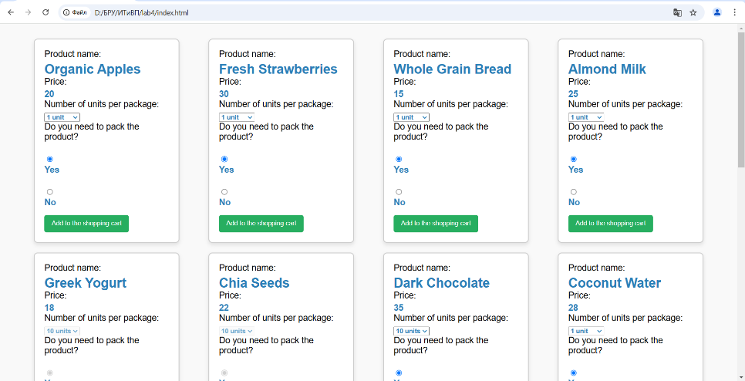

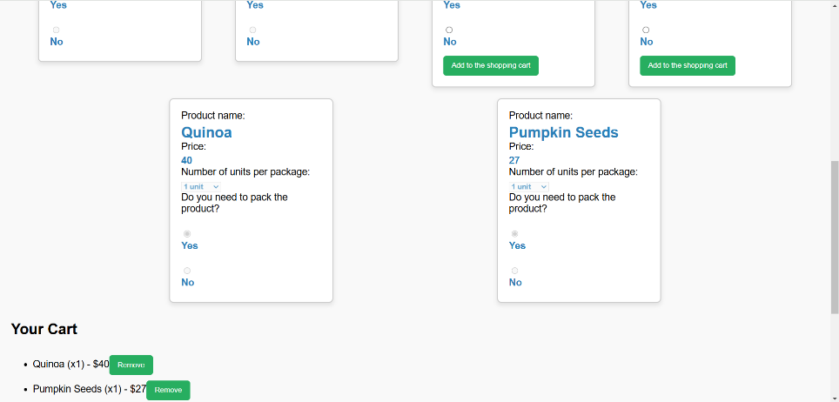

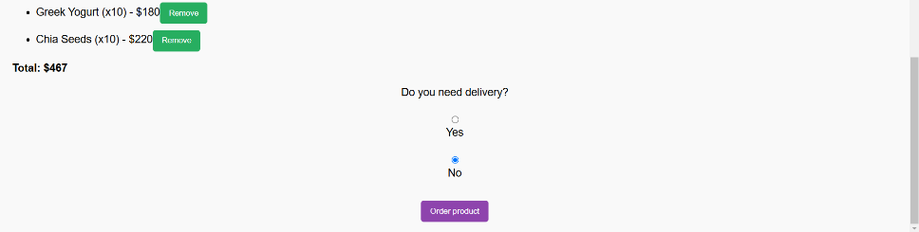

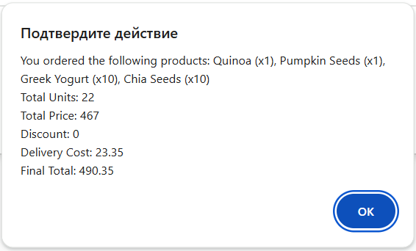

**Вывод:** изучил использование элементов управления.