FORT STREET HIGH SCHOOL
SOFTWARE ENGINEERING - ASSESSMENT 2
Term 2 SWE project
Project Report
Built with Unity 6000.4.3f1 and C#

Contents
1. Project definition and OOP research - Identifying and defining - 20 marks
2. Object and environment design - Characters, objects, attributes and methods
3. Planning and system diagrams - Research and planning - 20 marks
4. Production and implementation - Producing and implementing - 20 marks
5. Testing and evaluation - Testing and evaluating - 20 marks
6. Development journal - Project journal - 20 marks
7. Presentation plan and bibliography - Presentation preparation and references
NOTE
This was completed as an individual Unity/C# project rather than the guided Python Wumpus game. The report still addresses the same OOP, planning, production, testing and documentation criteria.

1. Project definition and OOP research

1.1 What I made
Term 2 SWE project is a fast first-person arena roguelite. The player enters a generated floor, completes terminals, clears the enemies, then moves to a shop or boss floor. A run keeps going while enemy health and enemy count increase. The run only ends when the player dies.
The main point of the game is movement. The player can dash, slide jump, wall run, slam jump and grapple. These systems carry momentum into each other, so the arena generation has to support high speed instead of only normal walking. Combat uses four weapons with separate primary fire and abilities. Shops allow one purchase per floor, which makes the player choose between healing, movement, a weapon or a weapon upgrade.

1.2 Why OOP suits a game
A game is a real-time system made from many objects that exist at the same time. The player stores movement and health state, each enemy stores its own combat state, weapons track cooldowns, and the arena director tracks floor progress. OOP suits this because each object can own its data and expose only the methods that other systems need.
- Encapsulation: PlayerController owns momentum, grounded state, dash charges and grapple state. Other scripts use public methods such as TakeDamage instead of directly changing movement variables. This matters because movement is the main mechanic and small unintended changes can create major physics bugs.
- Inheritance: Terminal, CybergrindShopStation and CybergrindWeaponReward inherit from Interactable. They share focus behaviour, prompt range and the OnInteract(PlayerController) contract, while each subclass implements a different result.
- Polymorphism: Gun resolves a hit, finds IDamageable and calls TakeDamage(float). The same call works for PlayerController, BasicEnemyAI and target objects, so weapon code does not need a separate branch for every target type.
- Abstraction and interface segregation: IGrappleMassTarget only exposes the mass category and pull behaviour required by the grapple. Damage and grapple response stay as separate contracts, so an object can implement either interface or both without inheriting from an unrelated class.
- Composition: Unity GameObjects combine components instead of relying on one deep inheritance tree. For example, a BasicEnemyAI object can use its own script together with a NavMeshAgent, colliders and renderers. This keeps navigation, physics and visuals replaceable without rewriting the whole enemy class.
The current repository contains 68 C# scripts and about 35,407 lines under Assets/Scripts. The main classes are still too large and should eventually be split into smaller movement, weapon, AI-state and generation components. Even with that technical debt, the current object model is easier to debug than a single procedural loop with shared global state.

1.3 Hunt the Wumpus research
Hunt the Wumpus was created by Gregory Yob and published in BASIC Computer Games. The original program represents the cave as numbered rooms connected in a fixed graph. Variables and numbered arrays store the player, hazards and Wumpus state, while GOTO, GOSUB and condition checks control the game [1].
The useful idea I took from Wumpus was not the theme. It was the structure of moving through connected spaces while hazards and enemies change the risk. My project translates this into generated 3D floors. The arena generator creates the space, the director tracks the current objective, and enemy objects act inside that space.

1.4 Procedural compared with OOP
Area | Procedural version | OOP version in this project
Enemy state | Arrays or global variables store health and position. | Each BasicEnemyAI object stores its own health, state and movement data.
Taking damage | The main program checks the target type and edits the correct variable. | Gun finds IDamageable and calls TakeDamage(amount).
Interaction | One long input branch checks every possible item. | PlayerController focuses an Interactable and calls OnInteract(player).
Floor progression | Global flags control whether the next room can open. | CybergrindArenaDirector reads terminals and enemy objects, then changes floor state.
New content | More conditions are added to the main procedure. | A new subclass or component can implement the existing contract.

A comparison
The project instead gets an IDamageable reference and calls TakeDamage(damage). The caller does not need to know if it hit the player, an enemy or a target dummy. That is a small example, but it removes repeated branches from every weapon.

2. Object and environment design

2.1 Characters and active objects
Object | Purpose | Important state | Main behaviour
Player | The first-person character controlled by the user. | health, momentum, grounded state, dash charges, grapple target | Move, jump, dash, slide, wall run, slam, grapple, interact and take damage.
Ground enemy | Pressures the player from arena routes. | health, target, NavMesh path, attack cooldown, mass class | Checks line of sight, paths around walls and attacks when active.
Flying enemy | Creates pressure above ground routes. | hover point, dash state, volley cooldown | Stops, shoots, dashes and repositions instead of circling forever.
Boss | A stronger encounter on boss floors. | phase, attack routine, health, telegraph state | Chooses larger attack patterns and drops a weapon reward.
Gun | Controls the equipped weapon and its ability. | preset, family, cooldowns, modifiers, tagged target | Fires, applies recoil, creates trails, runs abilities and switches variants.
Terminal | Short objective required to clear a floor. | puzzle type, solved state, prompt | Accepts interaction, runs a puzzle and reports completion.
Shop station | Offers one run upgrade. | service, price, spent state | Shows a preview, checks coins and applies one purchase.
Arena director | Controls the current run and floor. | floor, objective state, timer, reward state | Starts encounters, scales enemies and begins transitions.

2.2 Environment and items
- Combat floors: generated platforms, walls, stairs, rails and vertical routes used for enemy encounters.
- Shop floors: a quieter floor with simple pedestals showing the real gun or modifier model.
- Boss floors: larger encounter spaces for boss attack patterns.
- Jump pads: launch the player and preserve the fast movement loop.
- Terminals: short interaction objectives that must be completed before leaving.
- Weapon rewards: unlock and equip a weapon after an encounter.
- Coins and weapon ability objects: temporary objects used by abilities, including Vesper ricochets.
- Loading transition: a small Rubik-style cube runs while the next arena is actually generated.

2.3 Inheritance and shared characteristics
Parent/interface | Children/implementations | Shared contract
MonoBehaviour | Most runtime components | Unity lifecycle, transform and component access.
Interactable | Terminal, shop station, weapon reward and older door prototypes | Prompt range, focus feedback and OnInteract(PlayerController).
Terminal | CybergrindPuzzleTerminal, KeypadTerminal and SwitchTerminal | Solved state, prompt, completion events and terminal visuals.
PostProcessor | PathRepairProcessor, MicroPopulator and BossRoomPreset | Process(WFCGenerator3D) after generation.
IDamageable | PlayerController, BasicEnemyAI and Target | TakeDamage(float amount).
IGrappleMassTarget | BasicEnemyAI and Target | Light/heavy mass classification and grapple pull method.

2.4 Object interaction examples
- Player input is read by PlayerController. Movement methods update momentum and the CharacterController.
- When firing, Gun performs the shot, creates a BulletTrail and calls TakeDamage on an IDamageable target.
- When the player presses interact, PlayerController calls OnInteract on the focused Interactable.
- A solved terminal reports its state. CybergrindArenaDirector checks terminals and remaining BasicEnemyAI objects before unlocking progression.
- During a transition, PersistentLoadingScreen and CybergrindTransitionController cover the scene while CybergrindArenaGenerator builds the next floor.

3. Research and planning

3.1 Project management
I used Git commits as checkpoints rather than trying to finish the game in one scene file. The commit history shows the project moving from basic interaction, to combat, to generation, then to progression and polish. I also used separate test scenes and an in-game debug menu while systems were unstable.

3.2 Data flow diagram
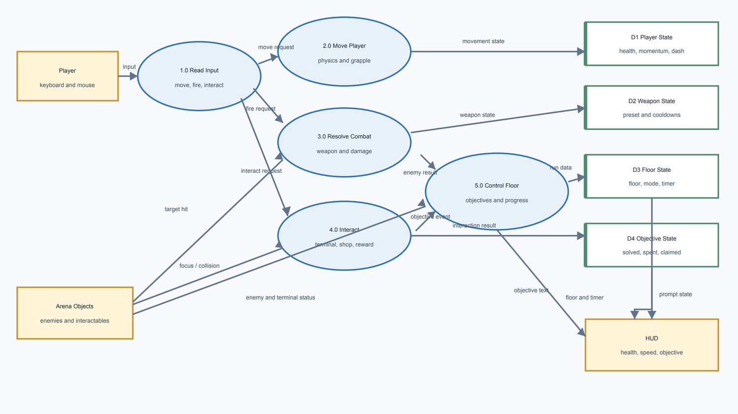
Figure 1. Runtime data flow from player input to game state and HUD feedback.

3.3 Structure chart
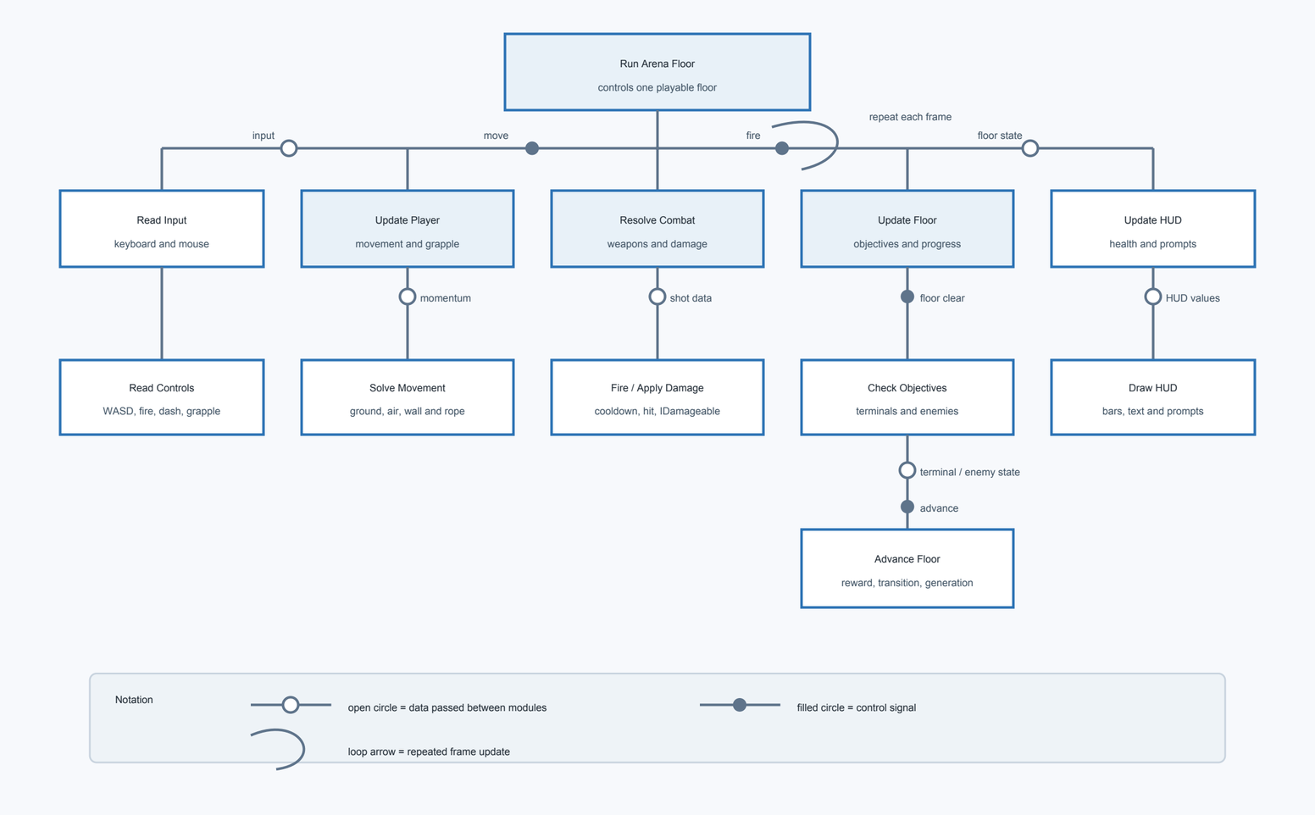
Figure 2. Structure chart showing the five main runtime systems.

3.4 Class diagram
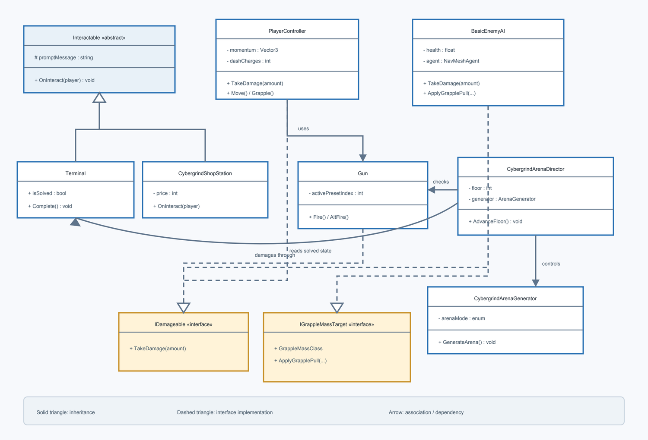
Figure 3. Main inheritance and interface relationships used by the game.

3.5 Data dictionary
Name | Type | Owner | Rules/Accepted values | Example | Meaning
health | float | PlayerController / BasicEnemyAI |  |  | Current hit points.
momentum | Vector3 | PlayerController |  |  | Velocity preserved between movement actions.
isGrounded | bool | PlayerController |  |  | Whether the ground check is valid.
dashCharges | int | PlayerController |  |  | Available air/ground dashes shown around the crosshair.
grappleRange | float | PlayerController |  |  | Maximum valid grapple distance.
grappleMassClass | enum | BasicEnemyAI / Target |  |  | Light targets are pulled; heavy targets pull the player.
activePresetIndex | int | Gun |  |  | Index of the currently equipped weapon preset.
nextTimeToFire | float | Gun |  |  | Time gate for the next primary shot.
nextAltFireTime | float | Gun |  |  | Per-weapon ability cooldown.
damage | float | WeaponPreset / Projectile |  |  | Base damage before run modifiers.
agent | NavMeshAgent | BasicEnemyAI |  |  | Ground-enemy pathfinding component.
target | Transform | BasicEnemyAI |  |  | Current player target.
floor | int | CybergrindArenaDirector |  |  | Current run floor used for scaling.
arenaMode | enum | CybergrindArenaGenerator |  |  | Combat, shop or boss generation mode.
isSolved | bool | Terminal |  |  | Whether a terminal objective is complete.
shopPurchaseUsed | bool | CybergrindRunState |  |  | Prevents a second purchase on the same floor.
runDamageMultiplier | float | Gun |  |  | Damage modifier applied during the run.
remainingTime | float | Floor timer system |  |  | Time left before the player dies.

3.6 Quality success criteria
# | Criterion | How it is measured
1 | Movement is responsive at high speed. | Immediate forward/reverse input; momentum chains reset on timeout or collision; no unwanted forward push from slam jumps.
2 | Generated floors are playable. | Spawn, objectives and exit are reachable; required vertical changes have stairs or another valid route.
3 | Combat information is clear. | Weapon trails remain visible, abilities have feedback, enemies show damage and the last enemies are highlighted.
4 | The code demonstrates OOP. | Clear responsibilities plus working inheritance, interfaces, encapsulated state and polymorphic calls.
5 | The game performs consistently. | Target at least 144 average FPS on the development PC and reduce large 1% low spikes during generation/combat.
6 | The UI is readable and not crowded. | Health visibly decreases, speed is always shown, dash state is clear and prompts use standard controls.
7 | The run supports replayability. | Floors continue indefinitely, themes vary and enemy health/count scale with depth.
8 | The project remains stable. | No C# compile errors; transitions do not expose the arena or trap the player on loading.

4. Production and implementation

4.1 Development approach
I built the project in ‘layers’. Movement came first because every arena and enemy decision depends on how fast the player can move. Combat and target objects came next. Procedural generation was added after there was something playable to generate. Progression, shops, UI and presentation were added once the core loop worked.

4.2 Main systems implemented
System | Implementation
Movement | CharacterController movement with separate momentum, slide jumps, stacking speed, dash charges, wall running, slam jumps, air steering and speed feedback.
Grapple | Surface raycasts, ledge aim assistance, valid-target reticle, physical pull forces, light/heavy target rules and failed-hit/release animations.
Weapons | Four presets split into pistol and shotgun families. Each has primary fire, an RMB ability, independent cooldowns, trails, impacts and run modifiers.
Enemy AI | Ground NavMesh pathfinding, flying movement states, 360-degree sensing blocked by solid walls, attack routines, bosses and floor scaling.
Generation | Runtime arena construction, theme selection, traversal validation, stairs, rails, walls, spawn points, terminals, shops and boss layouts.
Progression | Infinite floors, one shop purchase per floor, coins, upgrades, weapon unlocks, floor timer and death/restart flow.
UI/presentation | Start screen, settings, HUD, dash indicator, prompts, hints, loading cube, transitions, enemy highlight and death screen.

4.3 OOP in the implementation
The strongest OOP example is the way systems communicate through small contracts. Gun does not contain enemy movement code. BasicEnemyAI does not contain HUD layout code. A shop station does not directly regenerate the entire arena. These objects send results to the systems that own that state.
IDamageable is used by the player, enemies and targets. This lets hitscan and projectile code treat them the same way. IGrappleMassTarget adds a second independent contract. An enemy can be damageable and grappleable without inheriting from a special combined parent class. This avoids a deep inheritance tree.

5. Testing and evaluation

5.1 Testing methods
Method | How I used it
White-box | Inspected and exercised one method or state rule at a time, such as cooldown reset, damage interfaces, shop purchase state and floor scaling calculations.
Subsystem testing | Tested connected groups such as Gun + BulletTrail + IDamageable, or PlayerController + grapple projectile + target mass.
System testing | Ran complete floors from load, through terminals and combat, to shop/transition/death.
White-box testing | Used knowledge of branches, state variables, raycasts, masks and cooldowns to target specific paths.
Grey-box testing | Played normally while using the debug HUD, Unity Console and known system rules to diagnose failures.
Quality assurance | Repeated compile checks, removed deprecated API use, checked the Unity Console and kept generated/cache files out of Git.
Black-box/user testing | Reserved for a classmate using only the controls and visible UI. Results are intentionally left for the real tester.

5.2 White-box testing
Test | Code path checked | Expected result | Result
Damage contract | Gun hit resolution -> IDamageable.TakeDamage | Player, enemy and target receive damage without type-specific branches. | Pass - all three implement the same interface.
Weapon switch cooldown | Gun.ResetTransientAbilityStateForSwitch | Changing weapons resets the switched weapon ability state. | Pass - cooldown and temporary charge/tether state are reset.
Shop purchase limit | CybergrindShopStation + CybergrindRunState | Only one station can be purchased on a floor. | Pass - spent/purchase state blocks later stations.
Grapple mass | IGrappleMassTarget + GrappleMassClass | Light enemy is pulled; heavy enemy pulls the player. | Pass - behaviour branches on the exposed mass class.
Enemy awareness | BasicEnemyAI line-of-sight raycasts | Enemy senses in 360 degrees but a solid wall blocks aggro. | Pass for direct LOS; generated navigation still needs system testing.
Generation pacing | GenerateArenaRoutine coroutine | Large generation work is split across frames. | Pass - the routine yields between major construction stages.
Compile stability | Unity editor compilation | No C# errors after final copy pass. | Pass on 21 June - latest Editor log showed no C# compile errors.

5.3 Grey-box and subsystem test record
Area | Test performed | Problem found | Change made / current result
Movement reversal | Move forward, then instantly reverse at speed. | The player originally made a wide U-turn. | Air steering and reversal handling were separated. Reversal now reacts quickly without removing all momentum.
Slide-jump chain | Repeat crouch jump on landing and then miss the timing window or collide. | Early versions reset velocity too quickly. | The window was lengthened
Slam jump | Slam, jump on landing and repeat. | The jump added unwanted forward movement. | Launch was changed to vertical and repeated timing adds a small height increase.
Weapon trails | Fire repeatedly at maximum rate and hit coins. | Trails disappeared or continued through a coin while a second trail spawned. | Trail lifetime/pooling and coin-chain trail ownership were revised.
Grapple release | Release manually, hit an invalid floor, move behind geometry and remain at long range. | The hook sometimes vanished or disconnected too early. | Release/retract states and invalid-hit bounce feedback were added.
Loading transition | Start a run and move between floors while generation takes different times. | The arena flashed through and loading animation could finish before loading. | A black loading overlay remains active while actual generation runs; the cube loops until ready.
Enemy navigation | Fight across rails, stairs and vertical platforms. | Enemies attempted shortcuts through rails or became stranded where stairs were missing. | Path repair, wall classification and stair checks were added. Some unusual generated layouts may remain bugged.
HUD health | Take repeated damage while moving and changing floors. | A decorative health bar did not decrease and duplicated HUDs overlapped. | Duplicate HUDs were removed and fill scale now follows current/max health.
Performance | Watch average and 1% FPS during generation and combat. | Average was around 150-200 FPS but 1% lows could fall heavily during spikes. | Generation was spread across frames and repeated allocations/searches were reduced.

5.4 Black-box and classmate testing
Tester/date | Observed result or feedback
Brandon Bahn | Which controls did you understand without being told?  - I understood how to shoot, interact with the menu, how to murder and eventually how to summon coins (only near the end, though).  - I didnt understand how to open terminals  Was any HUD element confusing or too large? What were the positives of the HUD/UI?  - The terminals were really crowded, and the 'bar turning bright' never really occurred. too many buttons  - settings were good, though.  Did a death, shop or loading transition leave you unsure what to do next?  - the objectives are really unclear  - Sometimes it says 'Exit Open' when it isnt open or 'Get the weapon' when I can't find it. Eventually I learnt how to do it, though.  - shop was pretty clear but I didn't heal when i bought it
Kai Chen | Which controls did you understand without being told?  - Did not know what to do except shoot and move around, but knew how to interact with the settings  Was any HUD elements confusing or too large? What were the positives of the HUD/UI?  - UI display are a bit on the small side  - Some texts overflowed through the box (although this may just be a resolution issue)  - Good user customisation settings  Did a death, shop or loading transition leave you unsure what to do next, and what was good about the overall gameplay loop?  - Positive gameplay and lots of enemies to defeat  - Good variety of content  - The objectives are unclear
Farley Hammond | Which controls did you understand without being told?  - I understood how to use ability and how to shoot at enemies  - Also understood how to navigate through the settings with arrow keys  - Terminals were a bit unclear  Was any HUD elements confusing or too large? What were the positives of the HUD/UI?  - UI is a little small, I couldn’t really see anything  - Settings was pretty good and worked  Did a death, shop or loading transition leave you unsure what to do next, and what was good about the overall gameplay loop?  - Death, and loading transitions were pretty straight forward with how they are set up  - The objectives for each level was a bit vague

Questions given to play testers
- Which controls did you understand without being told?
- Was any HUD element confusing or too large?
- Did a death, shop or loading transition leave you unsure what to do next?

5.5 Evaluation against success criteria
Criterion | Evidence | Evaluation
1. Responsive movement | Multiple reversal, slide-jump, wall-run and slam-jump passes were made. | Mostly met. Movement is the strongest part of the game, but extreme-speed edge cases still require regression testing.
2. Playable generation | Path repair, stairs, rails, wall colliders and traversal checks exist. | Partly met. Normal layouts work, but unusual vertical generation can still strand enemies.
3. Clear combat | Trails, impacts, ability reticles, glints, charge feedback and highlights were added. | Mostly met. Core feedback is present; grapple and some abilities can still be improved.
4. OOP design | Abstract Interactable/PostProcessor classes and IDamageable/IGrappleMassTarget interfaces are active. | Met. The final systems use inheritance, interfaces, encapsulation and component composition.
5. Performance | Average performance reported around 200 FPS after optimisation; generation now yields across frames. | Mostly met for average FPS. 1% lows are less consistent and should be measured with a fixed benchmark.
6. UI clarity | Compact health HUD, speed meter, dash indicator, prompts and hints are implemented. | Mostly met. The UI is less crowded, but the real black-box test is still required.
7. Replayability | Infinite progression, scaling counts/health, variable themes, shops and weapon upgrades. | Met. The run continues until death and later floors increase pressure.
8. Stability | Latest Editor log has no C# compile errors; loading is tied to generation completion. | Met at the time of this report, with procedural edge cases listed as known risks.

5.6 Efficiency and optimisation
The main performance issue was not the number of features by itself. It was expensive work happening in one frame, repeated object searches, physics allocations and visual objects being created too often. The optimisation work focused on those causes.
Measure | Why it helps
Coroutine-based arena generation | GenerateArenaRoutine yields between major stages so the game does not freeze for one long frame.
Non-alloc physics where practical | OverlapSphereNonAlloc reuses a buffer instead of creating a new array every query.
Cached component references | Frequently used cameras, controllers and agents are stored instead of repeatedly calling GetComponent or scene searches.
Pooled impact effects | Projectile impact objects can be reused instead of constantly instantiated and destroyed.
Restricted active weapon roster | Only supported weapons are exposed, reducing unused runtime/UI paths.
Simplified HUD and debug visibility | Duplicate canvases were removed to get rid of unnecessary updating of unused UI.
Git repository cleanup | The generated Unity Library directory was removed from version control, reducing repository size and merge noise.
Deprecated API replacement | Unity 6 obsolete calls were replaced to keep the project forward-compatible and the Console readable.

Technical debt that still exists
- PlayerController, Gun, BasicEnemyAI and FINALArenaGenerator are very large classes. They work, but should be split into smaller movement, ability, attack-state and generation modules.
- Generation and enemy navigation need seeded benchmark scenes so the same difficult layouts can be reproduced and thus fix any pathfinding that might not work.
- Performance results should use a fixed route and profiler capture instead of only the live FPS HUD [3].

6. Development journal
This journal was reconstructed from dated Git commits and the files changed in each commit. The notes were not written on the day, they were written when creating the journal, however, it records the actual order in which the project developed.
Date  (Commit ID) | Progress and decisions | Problem / learning
22 Apr  (9eaa4f1) | Created the repository and imported the Unity URP project. | Learned the basic Unity project structure and what should be tracked in Git.
4 May  (95465a0) | Configured scenes, packages and project settings. | The project still had no clear gameplay loop, so setup came before feature work.
8 May  (304bdf7) | Added PlayerController and the Interactable base class. | Interaction needed a shared parent instead of separate input checks for every object.
10 May  (d2bb0e4) | Added doors, keycards, terminals, switches and collectible inheritance. | These prototypes taught inheritance and event-based interaction, even though most were not used in the final loop.
25 May  (1dd9f2b) | Built the first proper playable scene and visual test environment. | A test space was needed before procedural generation could be judged.
26 May  (433492a) | Added Gun, Projectile, BulletTrail, Target, IDamageable and BasicEnemyAI. | Combat became several connected objects instead of one shooting script.
26 May  (ae50b0a) | Started WFCGenerator3D, tiles, macro generation, path repair and jump pads. | Random placement alone could create unreachable spaces, so repair passes were required.
27 May  (efa4b74) | Expanded generation with hangar, sequential-room, boss and population systems. | The generator needed separate macro layout and post-processing responsibilities.
28 May  (325c123) | Created the Arena scene and current arena director/generator/terminal loop. | The project direction changed from small puzzles to a replayable arena run.
28 May  (0197e92),  (b7db023) | Removed Unity Library from Git and added generated pickups/progression. | Generated cache files made the repository unnecessarily large and unstable.
7 Jun  (b617004) | Expanded movement, weapons, enemies and debug tools; wrote the game-intent file. | Old prototypes and current systems were becoming easy to confuse.
8 Jun  (2414e73),  (3127ff6) | Added run state, shops, rewards, boss HUD and transitions. | Progression required one owner for run-level state instead of scattered flags.
12 Jun  (7449716) | Continued combat, movement, jump-pad, terminal and arena refinement. | Game feel bugs often involved several systems, so subsystem testing became important.
17 Jun  (65bfd3a),  (162cabc),  (8702cd9) | Added combat feedback, run HUD, start menu, settings, shop preview and weapon models. | The game worked but was hard to read, so UI and feedback became the priority.
18 Jun  (4715626) and  (ac661b7) | Reworked loading and arena transitions and continued enemy/combat fixes. | The loading animation had to cover real loading rather than play before generation.
19 Jun  (f6b0272) | Added the grapple projectile and integrated grapple input, settings and generation changes. | Grappling exposed problems with arena scale, valid surfaces and momentum transfer.
21 Jun  (9ef18f3) | Reduced the weapon roster, made runs infinite, added scaling, limited shop purchases and simplified UI copy. | Removing unsupported content made the final game clearer and easier to test.

7. Presentation plan
Target length: 10-12 minutes. The presentation should show the game early, then explain the technical decisions using the report diagrams.
Time | Content | Visual
0:00-1:00 | Hook: show fast movement and explain the core problem - building arenas and systems that still work at high speed. | Short gameplay clip.
1:00-2:00 | Explain the final loop: combat floor, terminals, shop, boss and infinite scaling. | One simple loop diagram or gameplay sequence.
2:00-4:00 | Explain OOP: Interactable inheritance, IDamageable polymorphism and separate system responsibilities. | Class diagram and a short code example.
4:00-6:00 | Explain procedural generation and why path repair/stairs/rails were difficult. | Structure chart plus two contrasting generated floors.
6:00-8:00 | Show movement, grapple, weapons and enemy behaviour. | Gameplay clip with HUD visible.
8:00-10:00 | Testing and optimisation: show a bug, the cause and the fix; explain average FPS and remaining 1% low risk. | Before/after clip or profiler/debug HUD.
10:00-11:00 | Evaluation: what met the criteria, what is still technical debt and what I would do next. | Success-criteria summary.
11:00-12:00 | Conclusion and questions. | Final gameplay shot and three key takeaways.

Likely Q&A
- Why use Unity/C# instead of the guided Python project?
- Where does the project demonstrate polymorphism rather than only classes?
- How does the generator stop impossible layouts?
- What caused the largest performance or pathfinding problem?
- What would you split up if the project continued?

Bibliography
[1] Ahl, David H. - BASIC Computer Games: Hunt the Wumpus. https://www.atariarchives.org/bcc1/showpage.php?page=247 Accessed June 2026. Original BASIC listing and explanation of the cave game.
[2] Microsoft Learn - Object-oriented programming in C#. https://learn.microsoft.com/en-us/dotnet/csharp/fundamentals/tutorials/oop Accessed June 2026. Used for definitions of abstraction, encapsulation, inheritance and polymorphism.
[3] Unity Manual - Profiler overview. https://docs.unity3d.com/Manual/Profiler.html Accessed June 2026. Used for performance-testing and profiling methodology.
[4] Unity Test Framework 1.6 manual. https://docs.unity3d.com/Packages/com.unity.test-framework@1.6/manual/index.html Accessed June 2026. Used for EditMode and PlayMode test planning.
[5] Unity AI Navigation 2.0 manual. https://docs.unity3d.com/Packages/com.unity.ai.navigation@2.0/manual/index.html Accessed June 2026. Used for NavMesh-based enemy navigation.
[6] Unity Manual - Coroutines. https://docs.unity3d.com/Manual/Coroutines.html Accessed June 2026. Used when splitting arena generation and timed sequences across frames.

Project evidence
Repository files used as direct evidence: Assets/Scripts/PlayerController.cs; Assets/Scripts/Combat/Gun.cs; Assets/Scripts/Combat/IDamageable.cs; Assets/Scripts/Combat/IGrappleMassTarget.cs; Assets/Scripts/AI/BasicEnemyAI.cs; Assets/Scripts/WFC/FINALArenaGenerator.cs; Assets/Scripts/WFC/FINALArenaDirector.cs; Assets/Scripts/WFC/FINALPuzzleTerminal.cs; README.md; and Git history from 22 April to 19 June 2026.

