Calorie (50-160) Low (50 - 90) Medium (91-130) High (131-160)

Protein (1-6) Low (1-2) Medium (3-4) High (5-6)

Fat (0-5) Low (0-1) Medium (2-3) High (4-5)

Sodium (0-320) Low (0-110) Medium (111-210) High (211 - 320)

Dietary fiber (0-14) Low (0-4) Medium (5-9) High (10-14)

Carbohydrates (0-23) Low (0-7) Medium (8-14) High (15-23)

Sugars (0-15) Low (0-5) Medium (6-10) High (11-15)

Potassium (0-330) Low (0-110) Medium (111-220) High (221-330)

**Cluster 1:**

Low: Calorie, Fat, dietary fiber, carbohydrates, sugar

Medium: Protein, sodium, dietary fiber

High: Potassium



**Cluster 2:**

Low: Sodium, Dietary fiber

Medium: Calorie, Protein, Carbohydrates, Sugars, Potassium

High: Fat



**Cluster 3:**

Low: Calorie, Fat, Sugars

Medium: Protein, Sodium, Carbohydrates

High: Dietary fiber, Potassium



**Cluster 4:**

Low: Dietary fiber

Medium: Protein, Fat, Potassium

High: Calorie, Sodium, Carbohydrates, Sugars

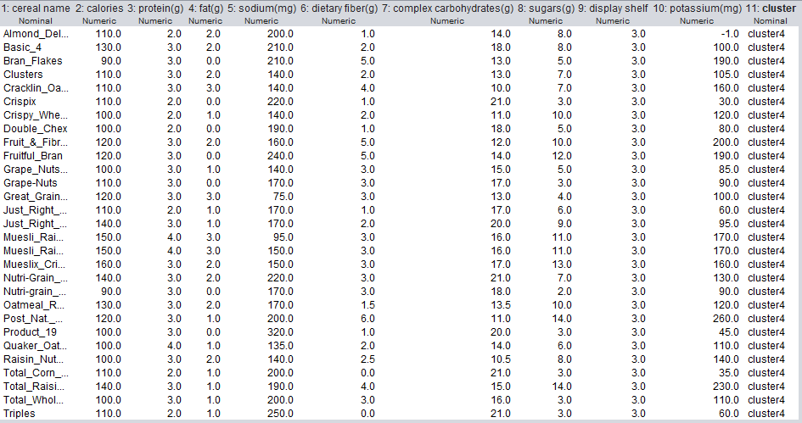

**Cluster 5:**

Low: Protein, Fat, Dietary fiber, Potassium

Medium: Calorie, Sugars

High: Sodium , Carbohydrates

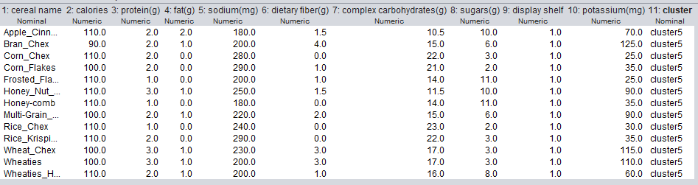

**Cluster 6:**

Low: Protein, Fat, Dietary fiber, Potassium

Medium: Calorie, Sodium, Carbohydrates

High: Sugars

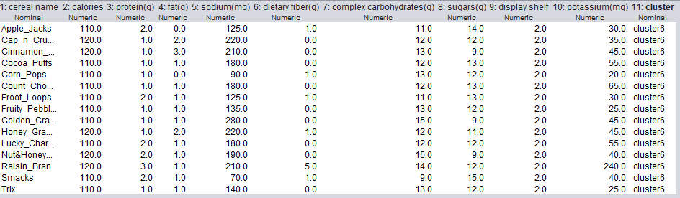

**Cluster 7:**

Low: Fat, Dietary fiber, Sugars, Potassium

Medium: Calorie

High: Protein, Sodium, Carbohydrates



**Cluster 8:**

Low: Fat, Sodium, Dietary fiber, Sugars, Potassium

Medium: Calorie, Protein

High: Carbohydrates



**Cluster 9:**

Low: Fat, Sodium, Dietary fiber, Potassium

Medium: Calorie, Protein, Sugars

High: Carbohydrates



**Cluster 10:**

Low: Protein, Fat, Sodium, Dietary fiber, Potassium

Medium: Calorie, Carbohydrates

High: Sugars



**Cluster 11:**

Low: Protein, Fat, Dietary fiber, Sugars, Potassium

Medium: Calorie

High: Sodium, Carbohydrates



**Cluster 12:**

Low: Dietary fiber, Potassium

Medium: Calorie, Protein, Fat, Sodium, Carbohydrates, Sugars

High:



**Cluster 13:**

Low: Calorie, Protein, Fat, Sodium, Dietary fiber, Sugars, Potassium

Medium: Carbohydrates

High:



**Cluster 14:**

Low: Sodium, Dietary fiber, Carbohydrates, Sugars

Medium: Calorie, Fat, Potassium

High: Protein



**Cluster 15:**

Low: Protein, Fat, Sodium, Dietary fiber

Medium: Calorie, Sugars, Potassium

High: Carbohydrates



**Cluster 16:**

Low: Fat, Sodium, Dietary fiber, Sugars

Medium: Calorie, Protein, Potassium

High: Carbohydrates



**Cluster Tree:**

