**Smart Cane Using Arduino**

*This is a simple project for fellow engineering students who are looking for ideas for projects using Arduino.*

***Requirements:***

* A Cane
* Arduino nano *(or uno if preferred)*
* 1 Buzzer
* Power supply *(preferably small power bank for functionality)*
* 1 Ultrasonic sensor
* 1 Resistor
* Jumper wires
* 1 LED *(optional)*

***Required Software:***

* Arduino IDE

***Use of each component:***

So, the use of the led is basically debugging as the buzzer might be too annoying for testing so only use it if you feel like so. The buzzer is the communication form for the blind to know how close he is to an object. The jumper wires and resistor are for the connection of the circuit and the power bank produces power for the circuit.

The project is easy as the only difficult part is defining the ultrasonic sensor as for it to work correctly there are certain sentences (which you will find in the code) used for it to successfully work, so let’s start with the basics:

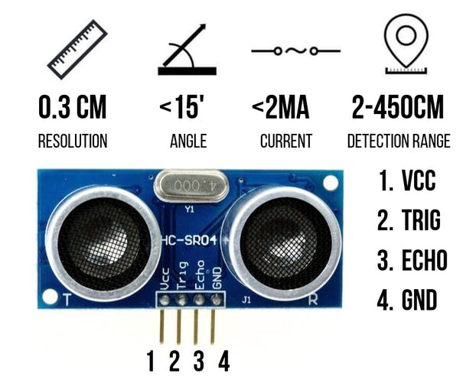

*So why does the ultrasonic sensor need this to work?*

Ultrasonic Sensor HC-SR04 is a sensor that can measure distance. It emits an ultrasound at 40 000 Hz (40kHz) which travels through the air and if there is an object or obstacle on its path It will bounce back to the module. Considering the travel time and the speed of the sound you can calculate the distance.

The configuration pin of HC-SR04 is VCC (1), TRIG (2), ECHO (3), and GND (4). The supply voltage of VCC is +5V and you can attach TRIG and ECHO pin to any Digital I/O in your Arduino Board.

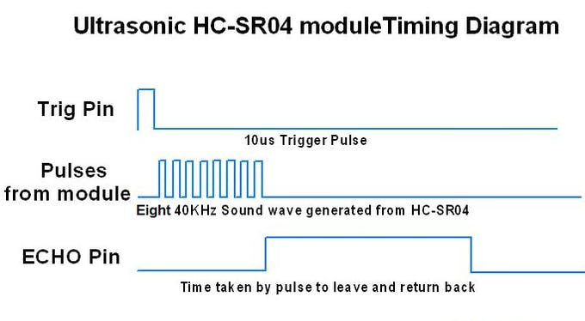

For example, if the object is 20 cm away from the sensor, and the speed of the sound is 340 m/s or 0.034 cm/µs the sound wave will need to travel about 588 microseconds. But what you will get from the Echo pin will be double that number because the sound wave needs to travel forward and bounce backward. So, in order to get the distance in cm we need to multiply the received travel time value from the echo pin by 0.034 and divide it by 2.

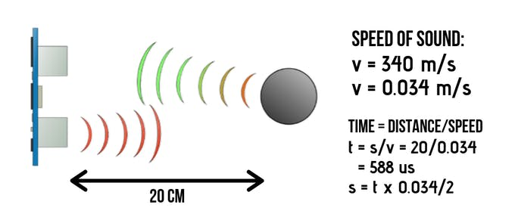

***Hope you enjoy the experience***