**Recommendation engine using Neo4j:**

Types of recommendations we are covering:

1. **Collaborative filtering: (Other prople also bought)**An algorithm that considers users interations with products with the assumption that other users will behave the similar way.

**Data Model (Expressed as Graph) :** Customers and related products

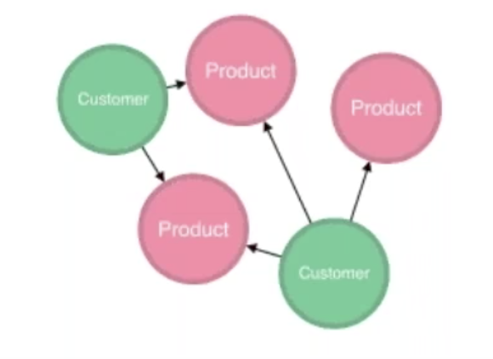

1. **Content Based: (You may also like)**An algorithm that considers similarities between products and categories of products.

**Data Model :** Products as Categories and sub categories.

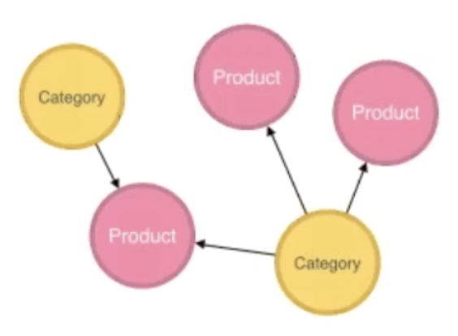

Building powerful personalized promotion engines is another area within retail that requires input from multiple data sources, and real-time, session based queries, which is an ideal task to solve with Neo4j.

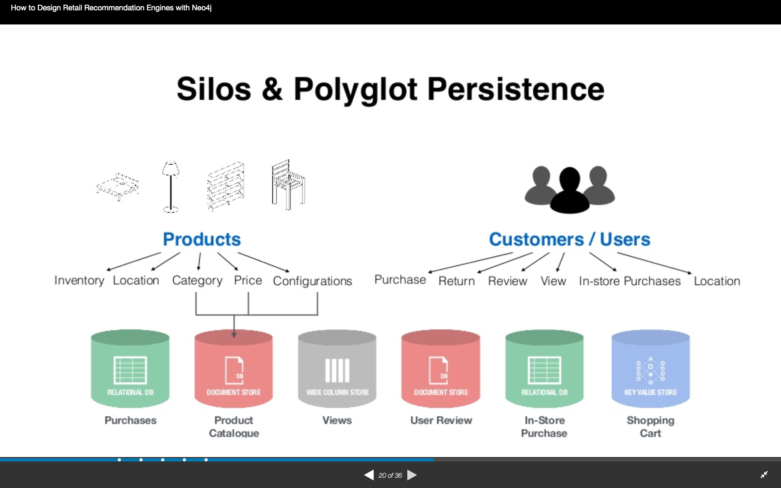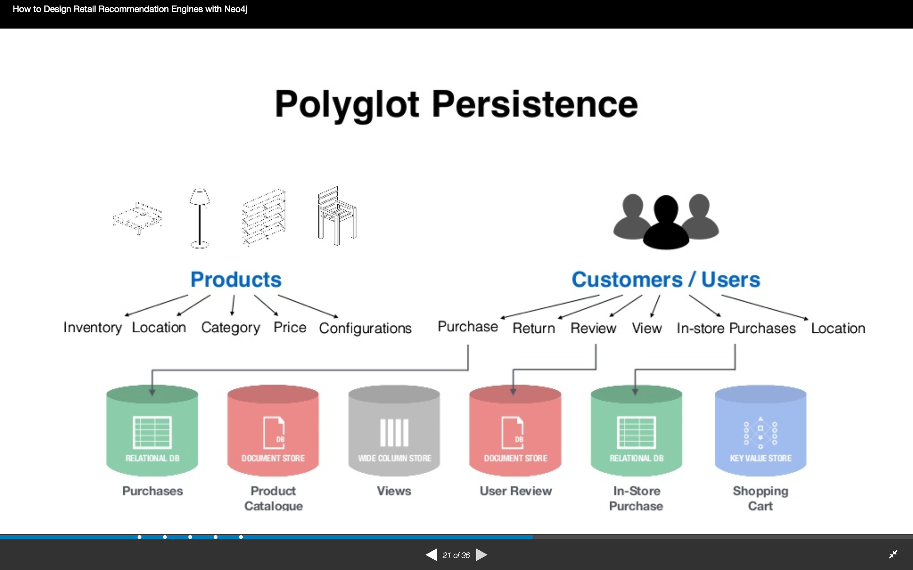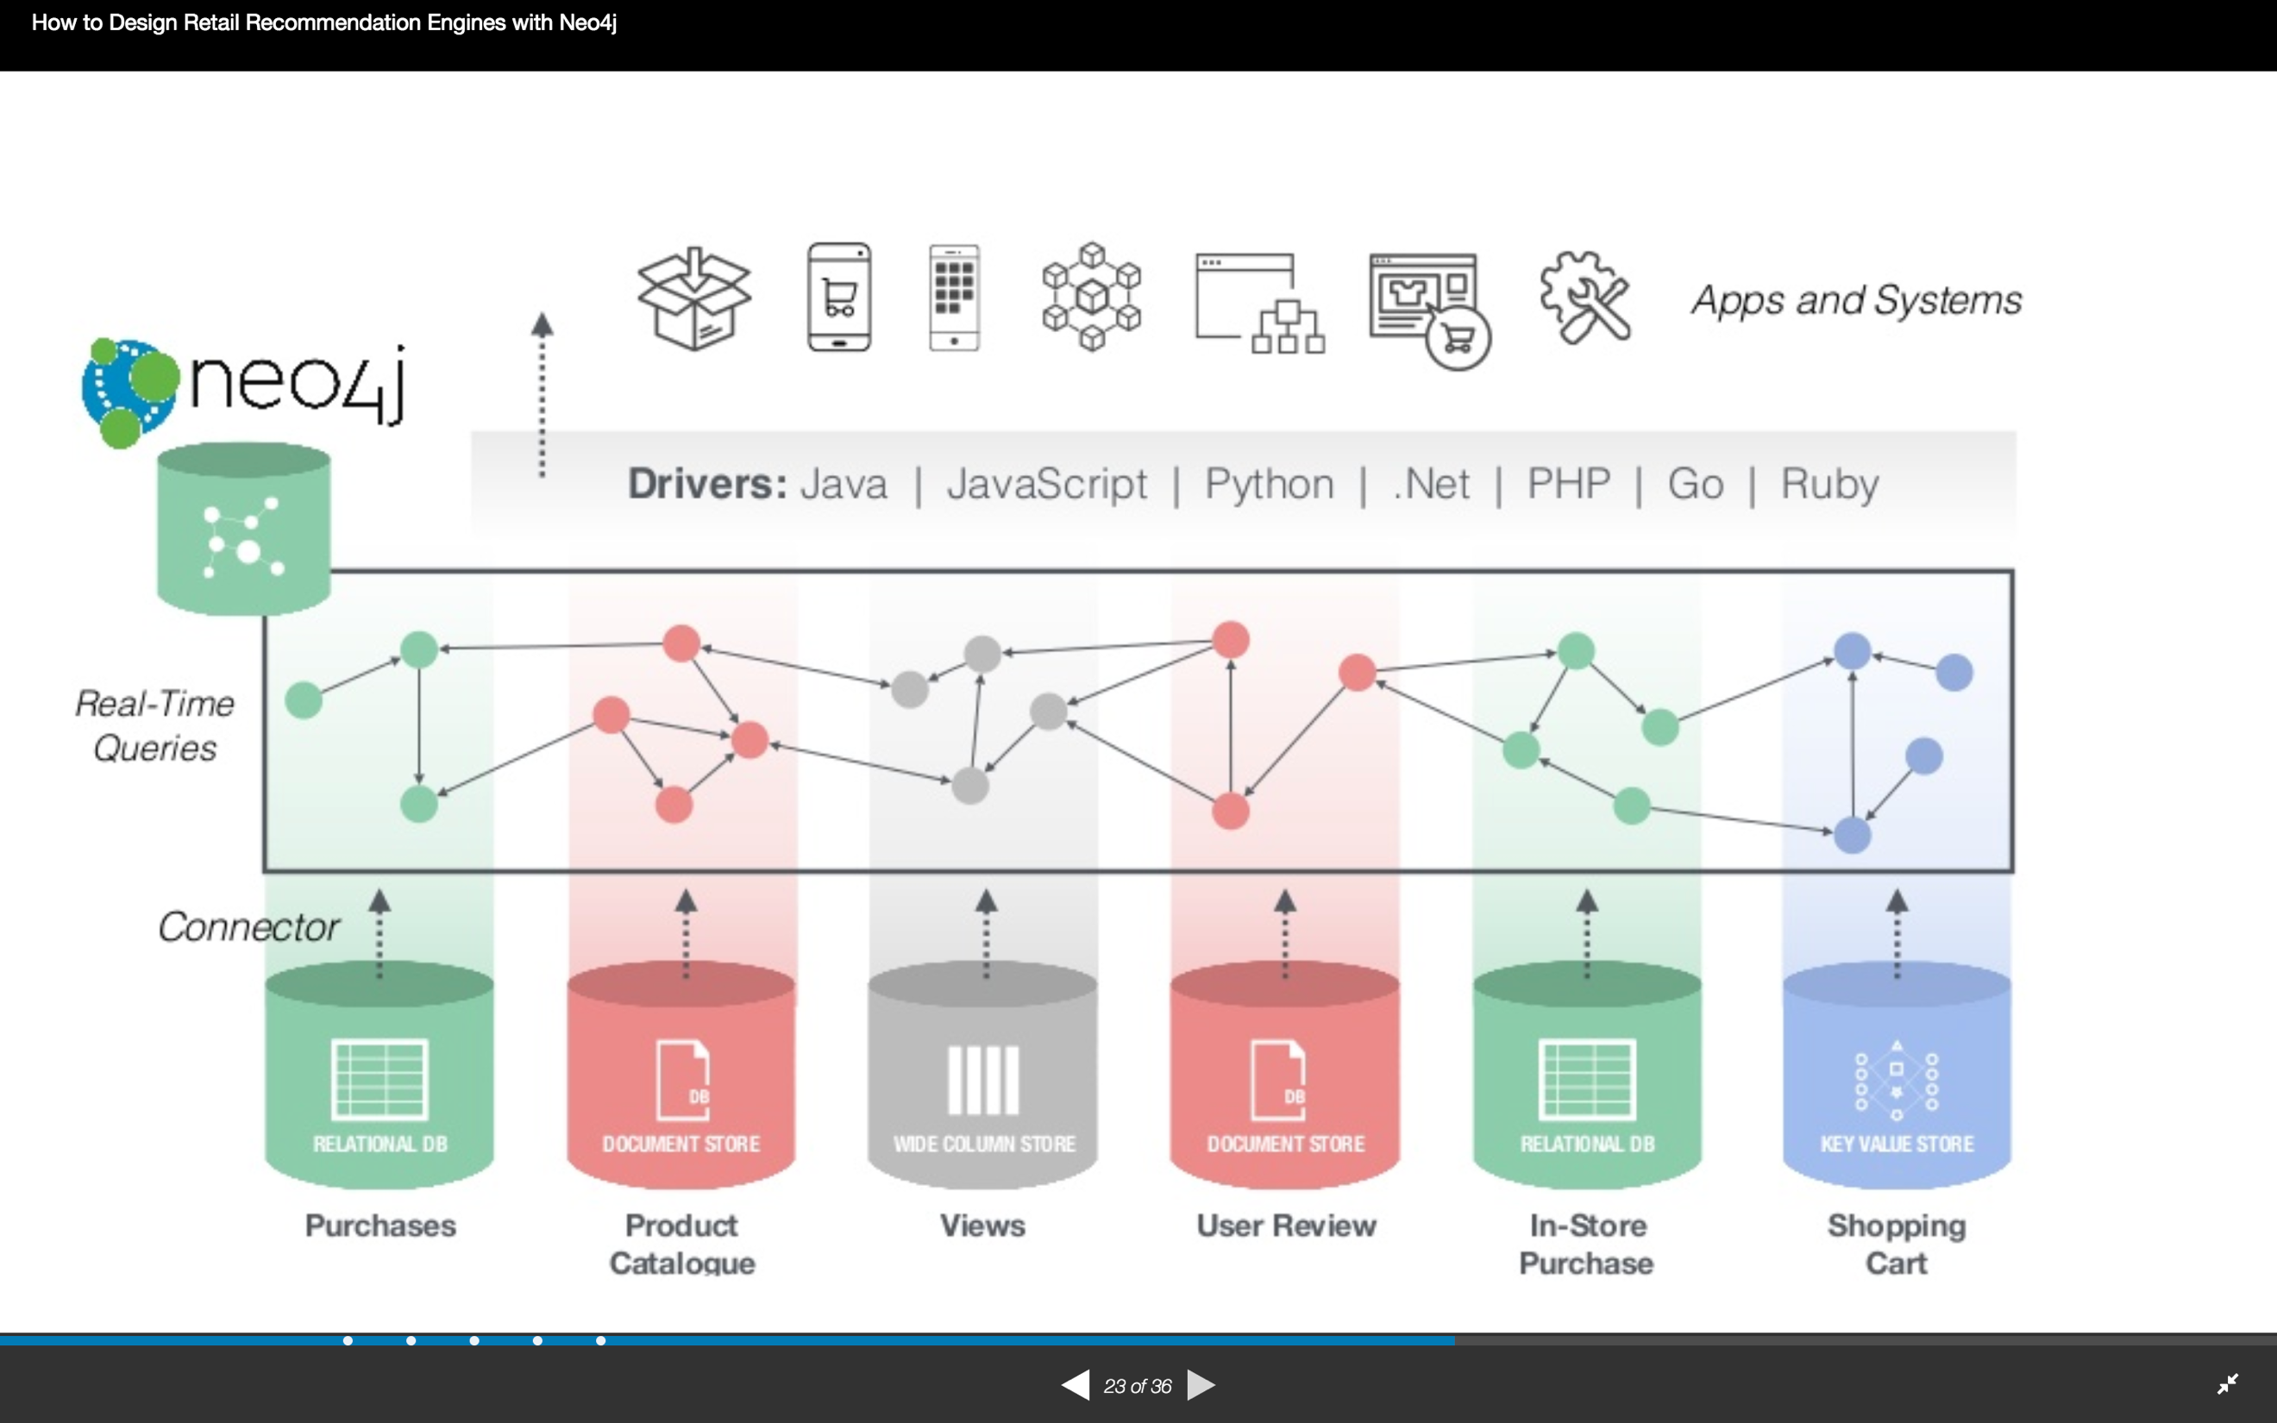

We are focusing on connecting people and products.

There can be personalized promotions and personalized recommendations, we are for now focusing only on personalized recommendations.

Process:

Extract data from different databases: Import data from different data sources using Cypher – The query language for Neo4j and demonstrate both content-based and collaborative filtering recommendations using this data.