**KPR-Task**

**Name:A.SADAIPANDI**

**Reg.No:1P22MC043**

**Question:**

Create MERN stack application to manage hospitals appointments. book an appointment with name, email address mobile number, type of case, detail description. and view all appointments.

**Home-page:**

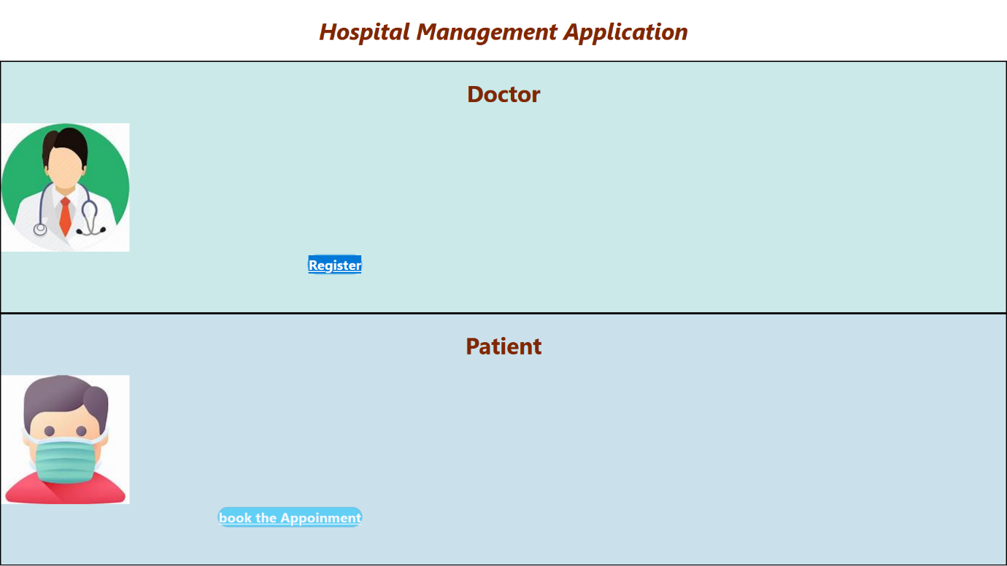

**Doctor-register-page:**

**Formik-authentication:**

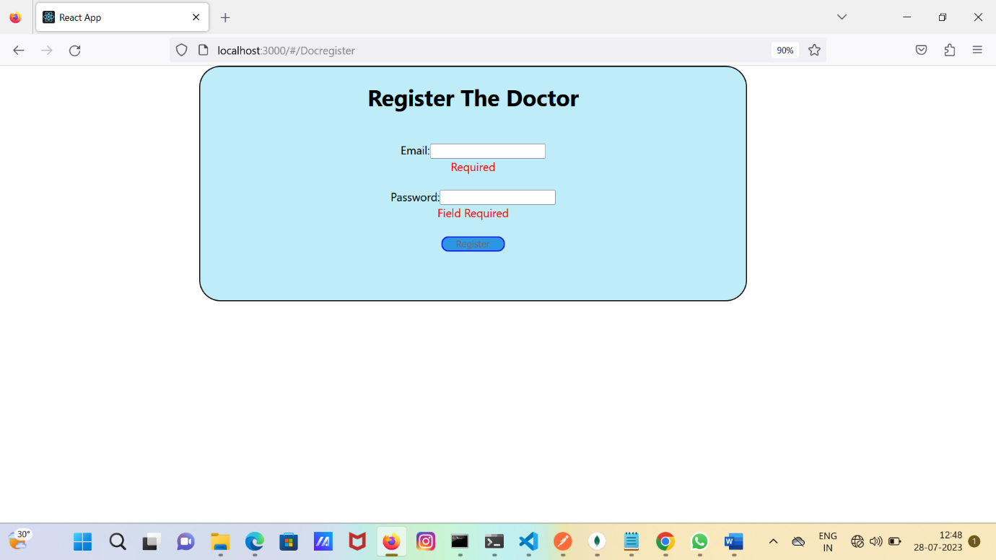

**Input-fill:**

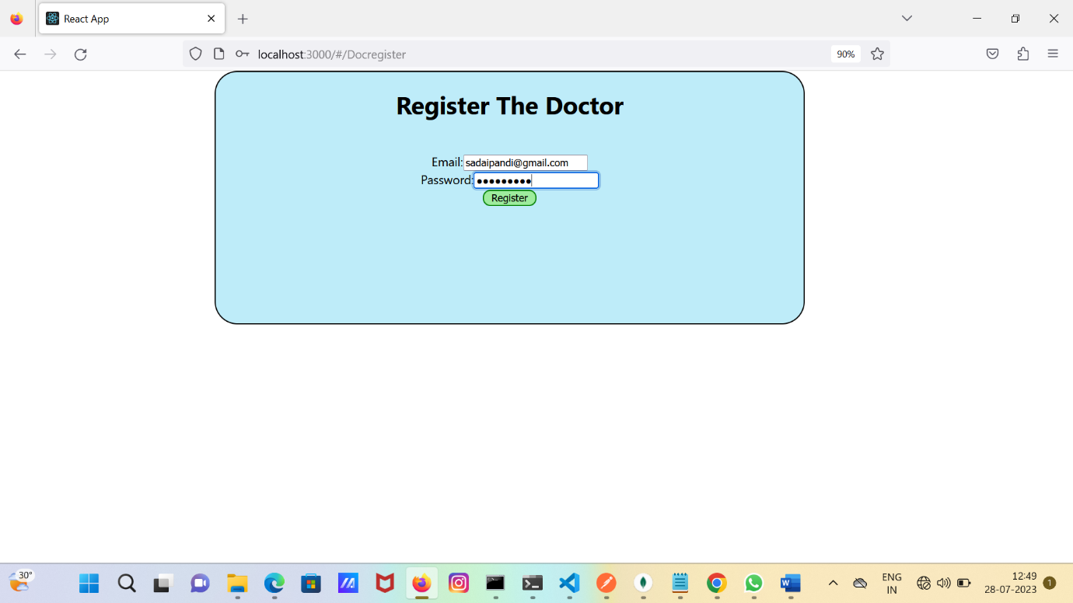

**ViewallAppoinment:**

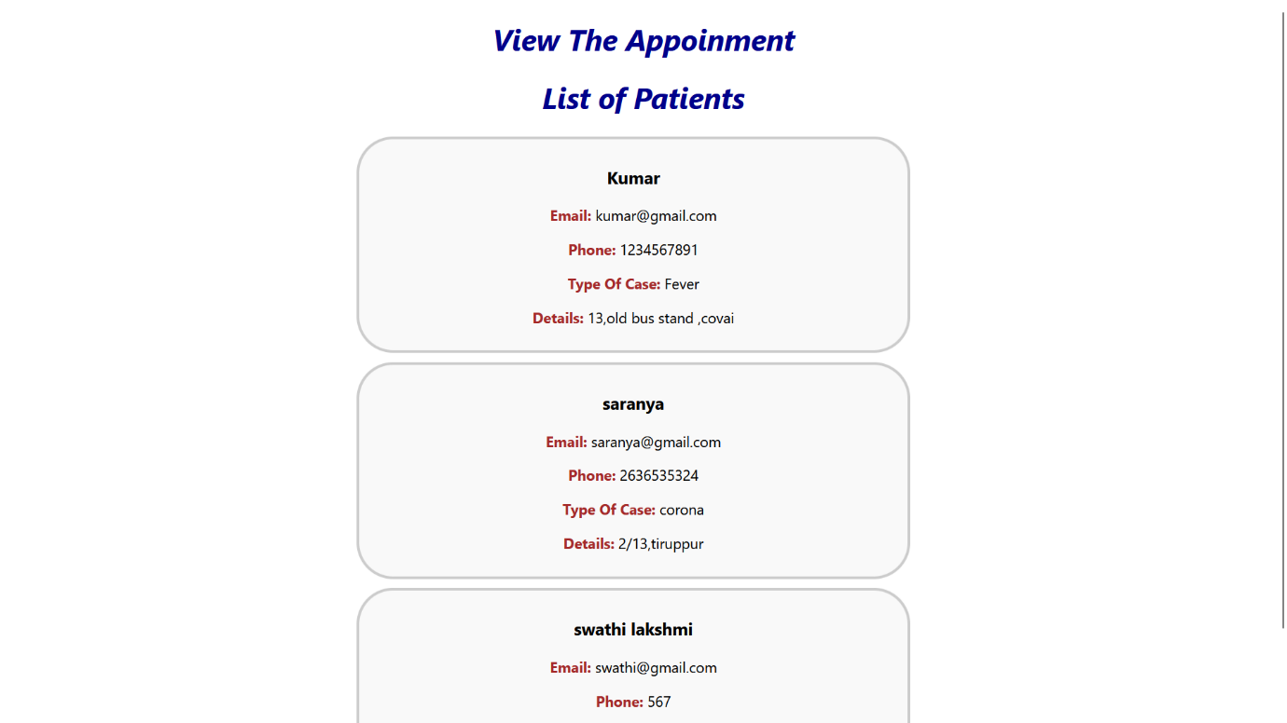

**Patient-input:**

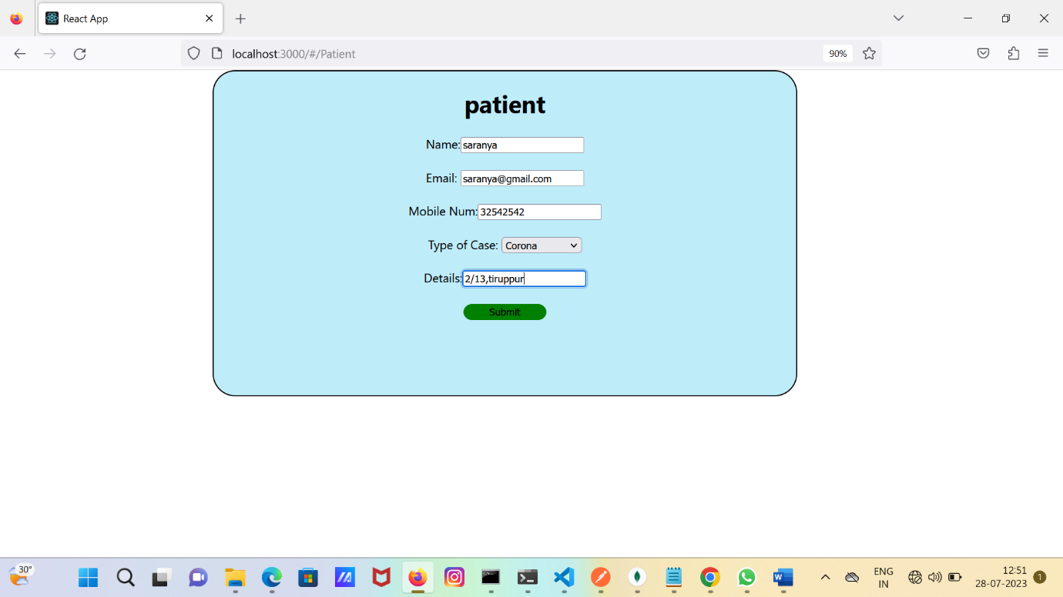

**Store the database in mongodb:**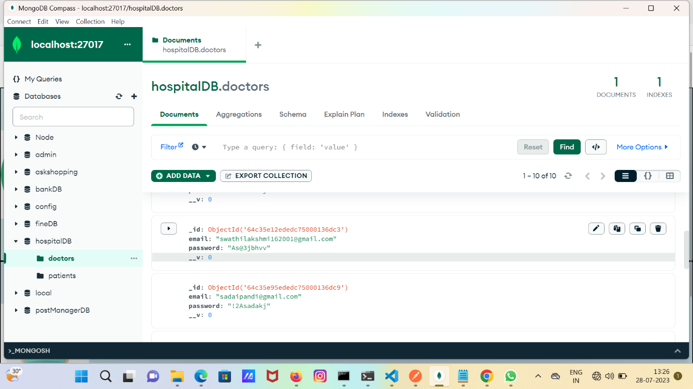

**Book the Appoinment:**

