Leading University

Department of Computer Science and Engineering

CSE 4800


Project Title: Doctor’s Portal

Name:Sadakat Muntasir Mahmud ID;1912020268

NAME:Muddassir Ahmad ID:1912020230

NAME:Suvo Dev Nath ID:1912020248

NAME:Jubayer Ahmed ID:1912020258

Department of Computer Science and Engineering

Submitted To

Shafkat Kibria

Assistanr Professor & Head (Acting)

Department of Computer Science and Engineering

5th April, 2022

Abstract

We here propose a doctor patient handling, managing system that helps doctors in their work and also patients to book doctor appointments and view medical progress. The system allows doctors to manage their booking slots online. Patients are allowed to book empty slots online and those slots are reserved in their name.

-I-

Acknowledgements

All praise is due to God, the one true King, the Supreme Being, besides whom there is no real helper and supporter; We are grateful that God has allowed and provided us with the strength to think of such a project.

We would like to thank the Department of Computer Science and Engineering, Leading
University, Sylhet 3112, Bangladesh, for supporting this course work.

-II-

Dedication

We would like to dedicate our work to our parents, relatives and friends.

-III-

Contents

 | Abstract . . . . . . . . . . . . . . . . . . . . . . . . . . . . . . . . . . . . . . . . . . |  | I
 | Acknowledgement . . . . . . . . . . . . . . . . . . . . . . . . . . . . . . . . . . . . . |  | II
 | Dedication . . . . . . . . . . . . . . . . . . . . . . . . . . . . . . . . . . . . . . . . . |  | III
 | Table of Contents . . . . . . . . . . . . . . . . . . . . . . . . . . . . . . . . . . . . . |  | IV
 | List of Figures . . . . . . . . . . . . . . . . . . . . . . . . . . . . . . . . . . . . . . . |  | V
1 | Introduction |  | 1
 | 1.1 | Introduction. . . . . . . . . . . . . . . . . . . . . . . . . . . . . . . . . . . . . | 1
2 |  | Work Plan | 2
3 | Structural Design |  | 3
 | 3.1 | Context Diagram . . . . . . . . . . . . . . . . . . . . . . . . . . . . . . . . . | 3
 | 3.2 | Use Case Diagram . . . . . . . . . . . . . . . . . . . . . . . . . . . . . . . . . | 4
 | 3.3 | Level 1 DFD Diagram | 5
 | 3.4 | Level 2 DFD Diagram | 6
4 |  | Future Work | 7
 | 4.1 | Future Work . . . . . . . . . . . . . . . . . . . . . . . . . . . . . . . . . . . . . | 7
5 |  | Conclusion | 8

-IV-

List of Figures

3.1 | Context Diagram . . . . . . . . . . . . . . . . . . . . . . . . . . . . . . . . . | 3
3.2 | Use Case Diagram . . . . . . . . . . . . . . . . . . . . . . . . . . . . . . . . . | 4
3.3 | Level 1 DFD Diagram . . . . . . . . . . . . . . . . . . . . . . . . . . . . . . . . . | 5
3,4 | Level 2 DFD Diagram | 6

-v-

Chapter 1

Introduction

Health care is an essential thing in life. Estimations suggest that health make a contribution
numerous years to life expectancy. It additionally makes contributions possibly even greater to improving many human beings practical capability and fine of lifestyles. In Bangladesh, the health care machine is especially provided with the aid of the government with a very little price. However, this comes with many headaches. The huge number of sufferers makes it hard for the authorities hospitals to offer them with satisfactory fitness care. As an end result, lots of private hospitals are mounted so that you can meet the developing need of the loads for pleasant health care. But whilst one wish to take carrier from a clinic, he first attempts to collect a few statistics about that hospital. To reduce the health care problems in Bangladesh, we have developed a web-based application named doctor-patient portal for effective healthcare.

-1-

2.Work plan

After receiving approval for our project, we will divide our work as follows:

Deadline | Action
July-August,2021 | Phase-1:  ● Identification of source and materials.  ● A clear justification for our frontend area and we will work on the front end first.  ● A written smart goal for our project.  ● A plan on how we achieve our goal.
September 2021 | Phase-2:  ● Identification of learning materials for learning backend.  ● We will go through the front-end project by comparing it with our action plan.  ● A clear justification for our Backend area and we will start work on the backend concerning our frontend.
October 2021 | Phase-3:  ● Continuation of backend  ● We will check and justify the project according to our plan  ● We will clarify the standard of the project.
November-December,2021 | Phase-4:  ● Testing, debugging, and finalizing the report.  ● We will start working on our project book

-2-

Chapter 3

Structural Design

In the figure, it shows the context diagram of the system. Here three types of users interact with the system patient, doctor, and admin. The patient can request for an appointment. A doctor can see all of his appointments. And admin can supervise all the activities.

3.1 Context Diagram

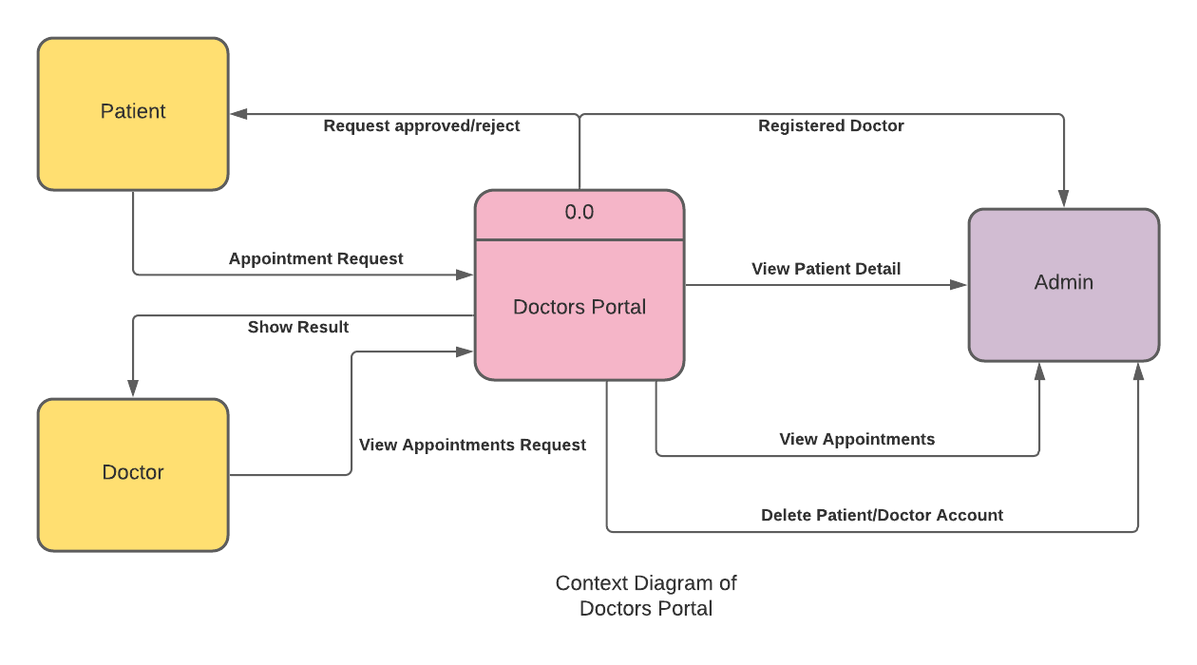
Figure 3.1: Context Diagram

-3-

3.2 Use Case Diagram

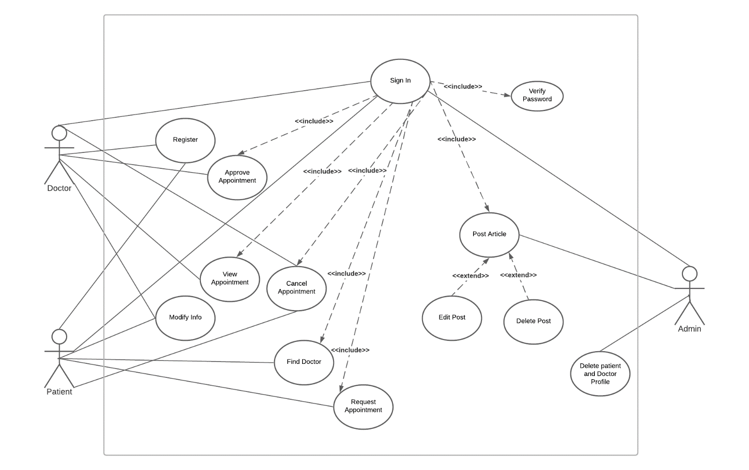
Figure 3.2: Use Case Diagram

-4-

3.3 Level 1 DFD for Patient

In figure, it shows the level one DFD for the patient. It starts with the fill signup form process. After signup, then log in to your account. Information’s are seen and retrieved from data store.

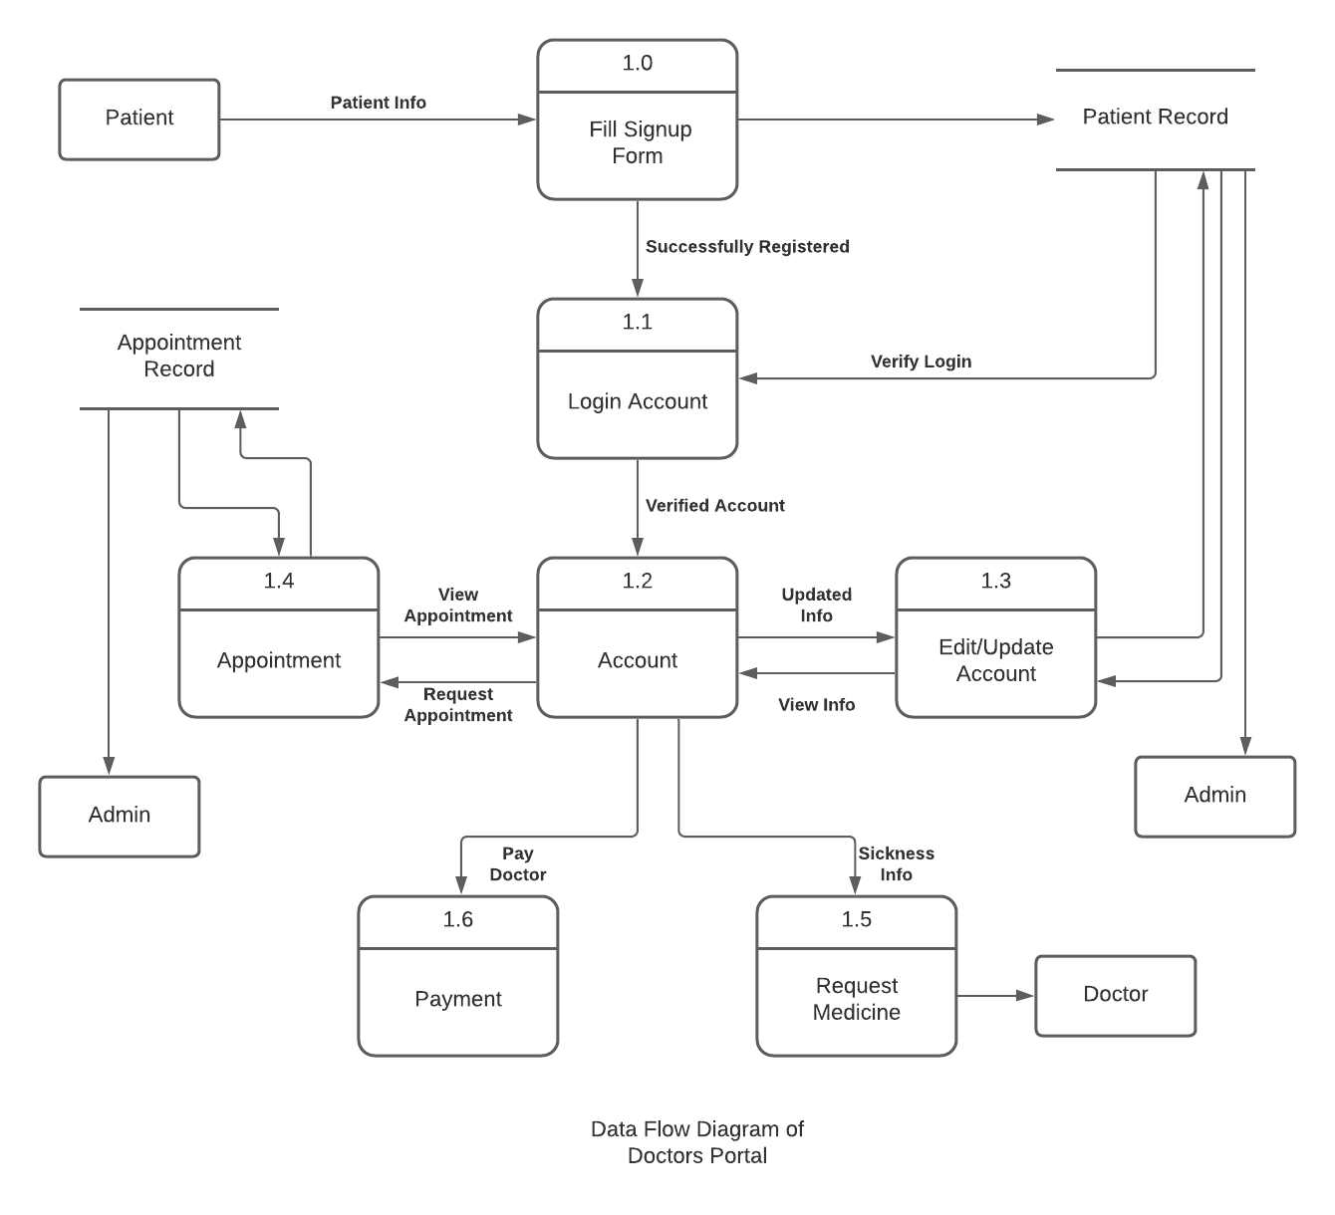

Figure 3.3: Data Flow Diagram Level 1

-5-

3.4 Level 2 DFD

It is the expansion of the process 1.4 Appointment from level one DFD for patient. For appointment search doctor then select date after that select payment option. After successfully appointment it will notify to the patient account.

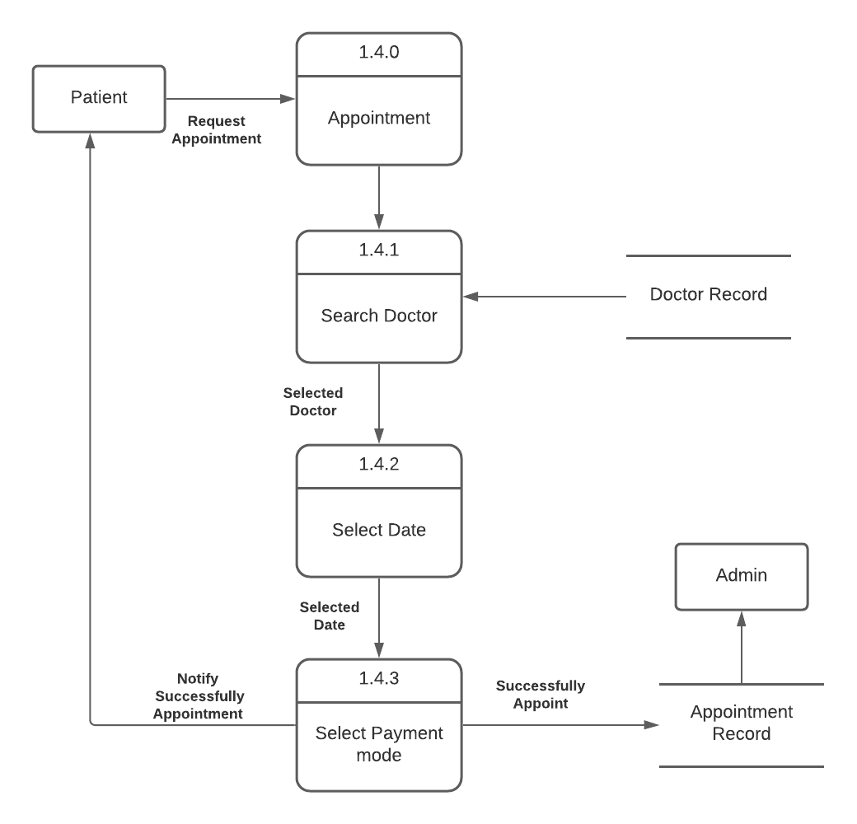

Figure 3.4: Data Flow Diagram Level 2

-6-

Chapter 4

Future Work

4.1 Future Work

This app can be improved in the future by adding the following functionalities:
• Extending to Apple iOS and Android.
• Create two separate apps for doctor & patient.
• Sharing the medical test reports of patients to doctors through this app.
• Supporting video calls to discuss the problems with doctors.

-7-

Chapter 5

Conclusion

The major goal of this application is to create online interaction between doctors and patients, to fulfill the basic needs/problems of the patients. Patients can update their problem to doctors by messaging and get advice from the doctor. Our web application serves as the platform for easy and quick treatment, with extended support from doctors to patients. Doctors Portal has unique features such as issuing online prescription to patients, referring patients to a specialist, sending health tips to patients, and finally, reducing the cost of customer service and providing a vital communication link between doctors and patients.

-8-

