lipu sona pi ilo musi 8
ilo musi pi nasin CHIP-8


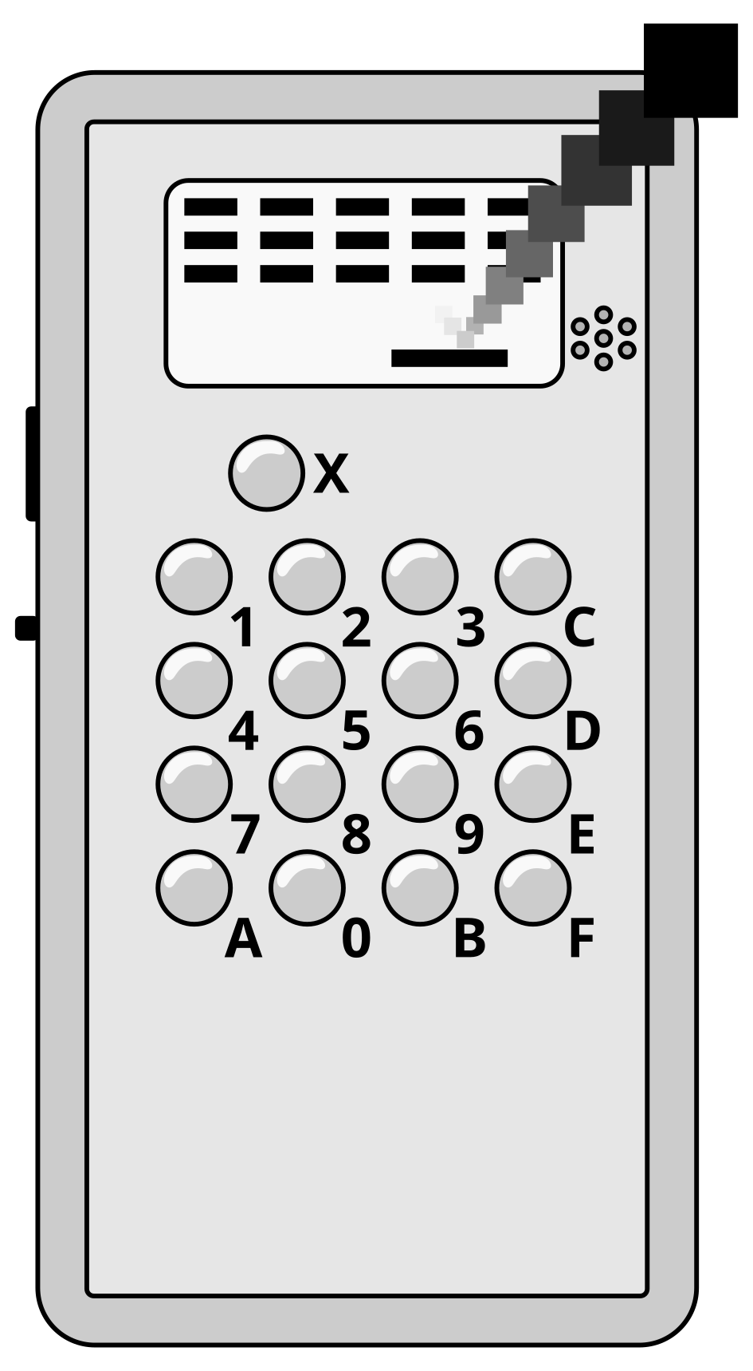

https://ilomusi8.sadale.net/

seme li lon?

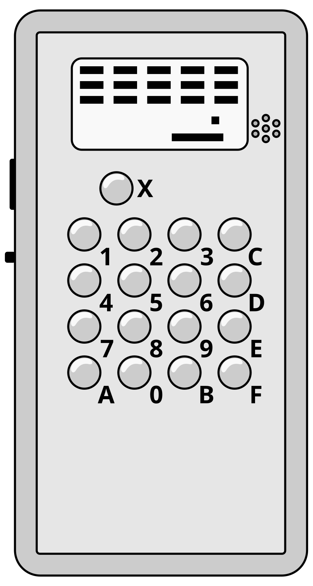 | 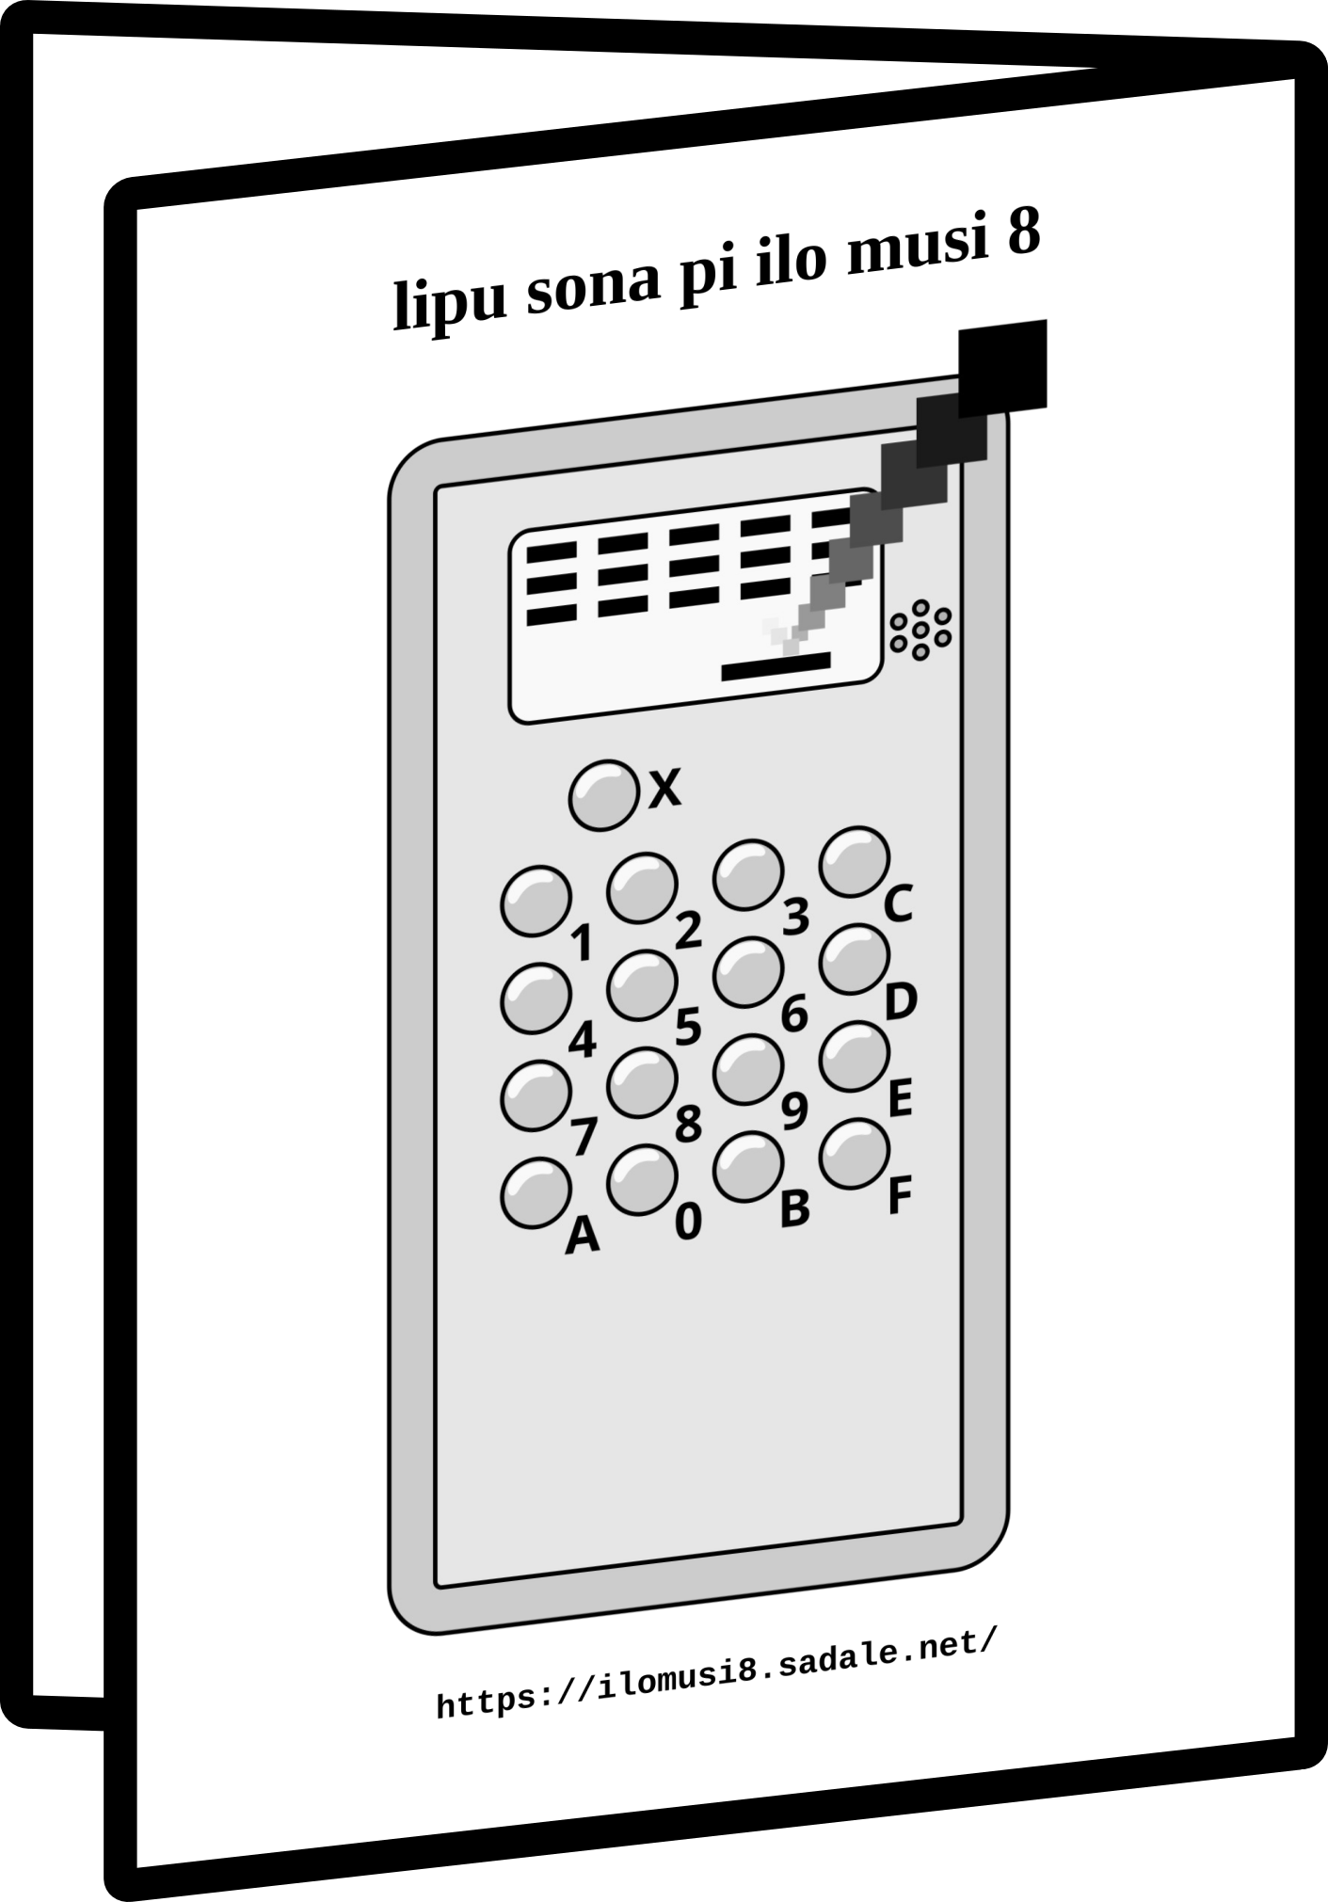 | 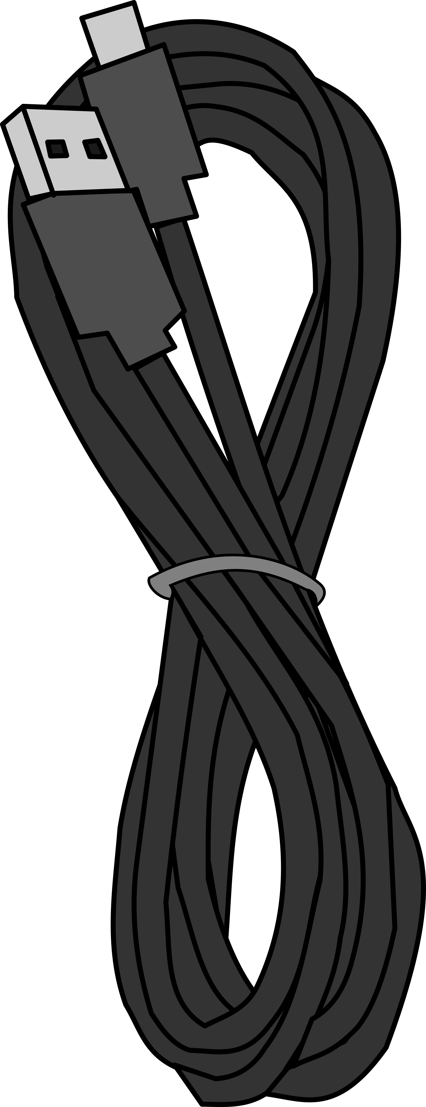
ilo musi 8 | lipu sona ni | linja wawa USB
 |  | 
lipu sona TF  (insa ilo musi 8) | ilo pi ante musi | lipu sitelen

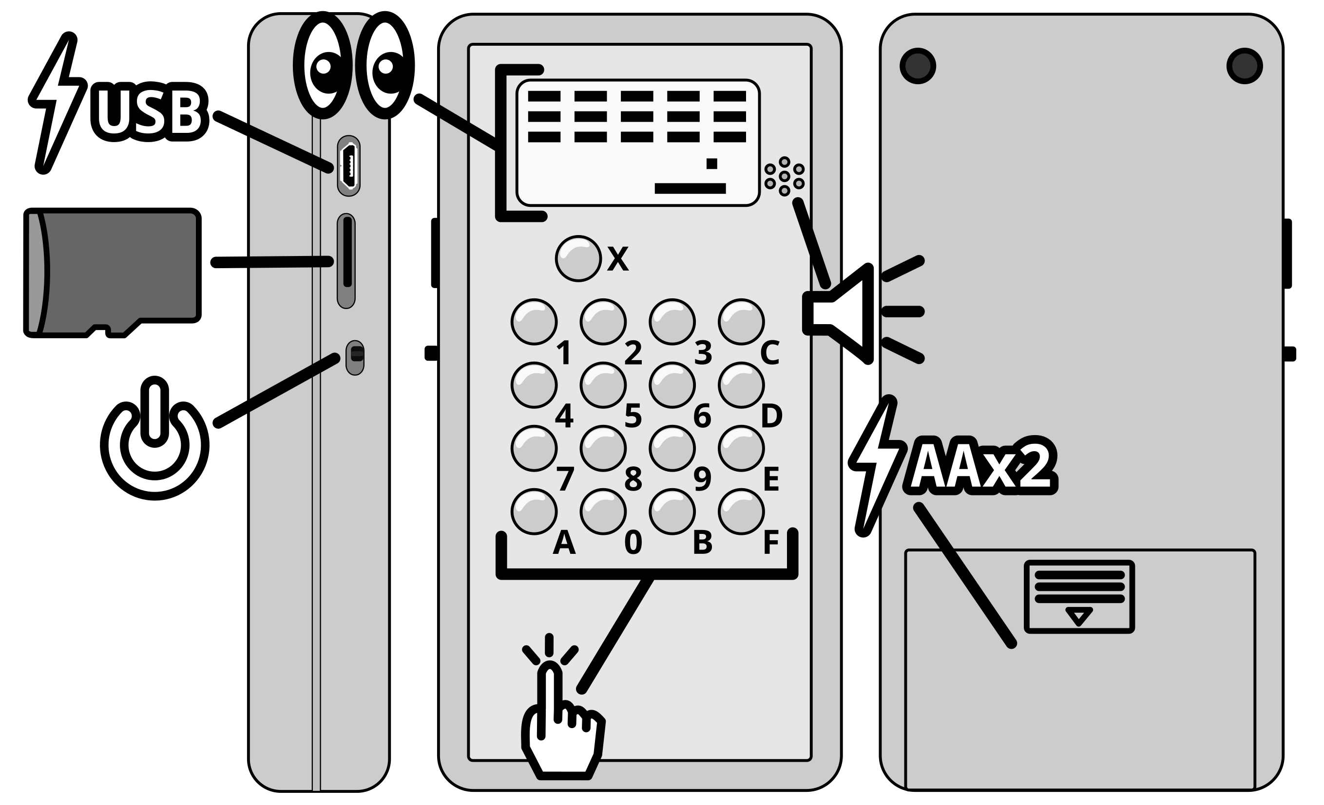

seme li ken?
- nasin CHIP-8 ali en nasin SuperCHIP ali
- nasin XO-CHIP (taso sona >4K en kule li ken ala)
- tenpo pali: 5400 ips (90 instructions/frame)
- musi li lon lipu sona TF (.CH8 li musi, .INI li ijo pi ante musi)
  - nasin pi lipu sona: FAT16 anu FAT32 (exFAT ala!)
  - nasin nimi: 8.3 filename
- musi open "BOOTROM" li lon. sina ken ante e ona
- toki mute li lon: toki Inli en toki pona en sitelen Sate

nasin kepeken
ma pi anu musi

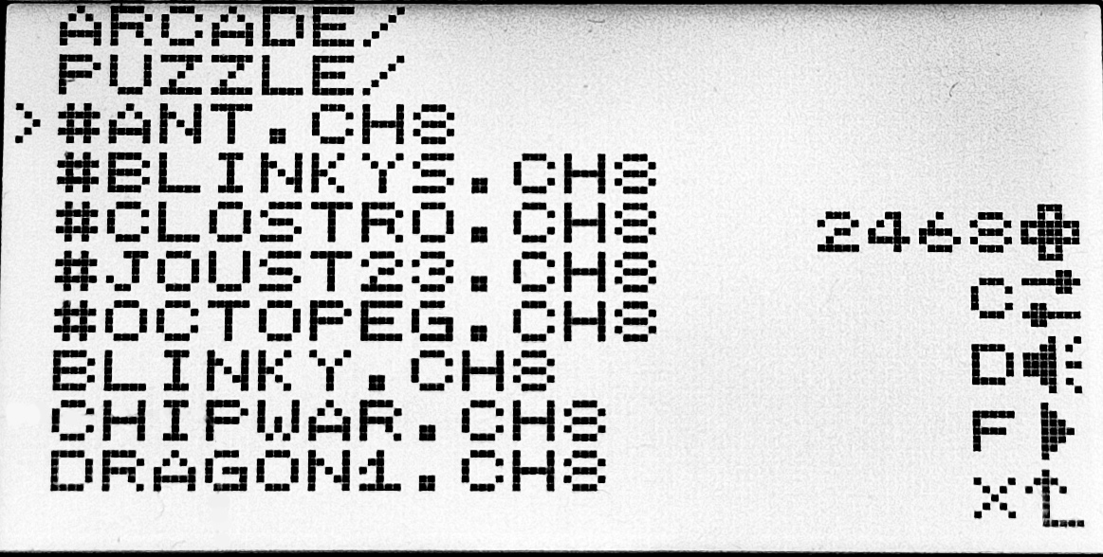
nimi mute | [.CH8] li lon la ona li musi  [#] li lon la ona li musi pi pona mute. o musi e ona!  [/] li lon la ona li poki. musi mute li ken insa ona
2468 | kepeken nena ni la sina ken tawa e nimi [>]
C | kepeken nena ni la sina ken ante e ijo pi musi [>]
D | kepeken nena ni la sina ken ante e ijo pi ilo musi 8
F | kepeken nena ni la sina musi e musi pi nimi [>]  sina anu e poki la sina kama insa poki.  sina insa musi la sina ken weka kepeken nena [X]
X | kepeken nena ni la sina weka tan poki

ma pi ante musi

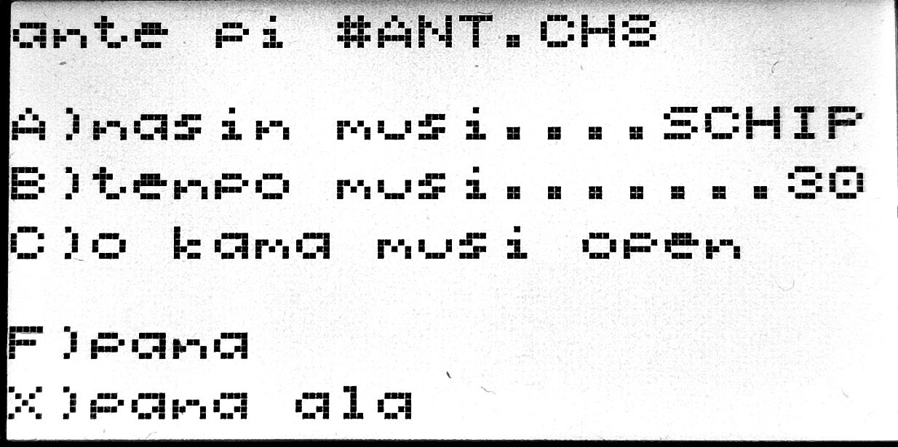
A | nasin musi ni li ken: VIP, SCHIP, OCTO, NANPA  nasin NANPA la:  bit 0: CHIP8_QUIRK_SHIFT  bit 1: CHIP8_QUIRK_MEMORY_LEAVE_I_UNCHANGED  bit 2: CHIP8_QUIRK_MEMORY_INCREASE_BY_X  bit 3: CHIP8_QUIRK_WRAP  bit 4: CHIP8_QUIRK_JUMP  bit 5: CHIP8_QUIRK_VBLANK  bit 6: CHIP8_QUIRK_LOGIC  bit 7: CHIP8_QUIRK_LORES_WIDE_SPRITE  bit 8: CHIP8_QUIRK_LORES_TALL_SPRITE  bit 9: CHIP8_QUIRK_LORES_SCROLL_DIV2  bit 10: CHIP8_QUIRK_HIRES_COLLISION  bit 11: CHIP8_QUIRK_RESIZE_CLEAR_SCREEN  bit 12: CHIP8_QUIRK_VF_ORDER  bit 13: CHIP8_QUIRK_FX1E_REPORT_OVERFLOW  VIP = 00000060 | SCHIP = 00000413 | OCTO = 00000888
B | nanpa 01~99 la, nanpa suli la pali li mute kepeken tenpo lili. nanpa lili la pali li lili kepeken tenpo mute.  nanpa 00 la, pali li mute mute kepeken tenpo lili
C | musi ni li kama musi open.  ni la sina pana e wawa tawa ilo musi 8 la musi ni li kama lon
F X | o pana e ante sina kepeken nena [F]. nena [X] la ante ala

ma pi ante pi ilo musi 8

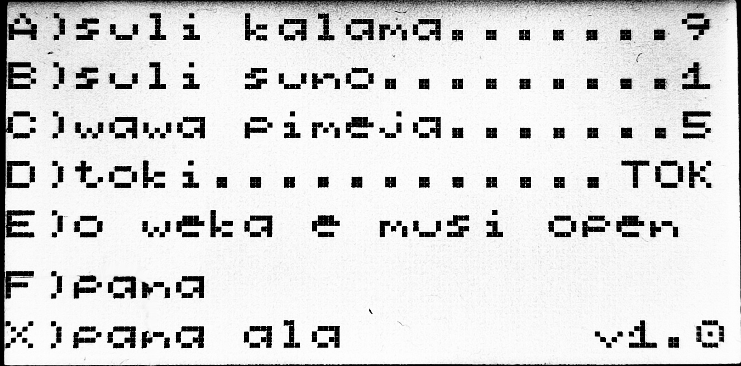
A | nanpa li suli la kalama li suli. nanpa li lili la kalama li lili.  nanpa ni li ken: 0~9. nanpa pi ilo sin li ni: 9
B | nanpa li suli la suno pi ilo sitelen li kama wawa.  nanpa li lili la suno pi ilo sitelen li kama lili.  nanpa ni li ken: 0~9. nanpa pi ilo sin li ni: 1
C | nanpa li suli la ilo sitelen li kama pimeja.  nanpa li lili la ilo sitelen li kama walo.  nanpa ni li ken: 0~9. nanpa pi ilo sin li ni: 5
D | sina ken ante e toki.  toki ni li lon: EN, TOK, sitelen pona, sitelen Sate  toki pi ilo sin li ni: EN
E | ni li weka e musi open.  musi open li weka la, sina pana e wawa tawa ilo musi 8 la, musi ala li lon. sina kama lon "ma pi anu musi"
F | o pana e ante sina kepeken nena ni
X | kepeken nena ni la ante sina li kama weka

sona sin
sina ken pana e sona sin tawa ilo musi 8 sina lon ma ni:
https://ilomusi8.sadale.net/sona-sin

musi sin
sina ken pana e musi sin tawa ilo musi 8 sina.

sina jo e musi CHIP-8 la, o ante e nimi ona. nimi ona o kama xxxxxxxx.CH8. ni la o pana e ona tawa lipu sona TF sina.
o kepeken nasin nimi "8.3 filename".

sina pana e lipu sona ni tawa ilo musi 8 sina la, o ante e musi ni kepeken nena [C]. ni la sina kama lon "ma pi ante musi" li ken pana e nasin pona tawa musi sin sina.

kin la sina ken pana e xxxxxxxx.INI tawa musi ni. nasin INI la o lukin e ma ni:
https://github.com/SadaleNet/ilo-musi-8/firmware/README.MD

sina ken kama jo e musi sin tan ma ni:
https://ilomusi8.sadale.net/musi-sin

sina kin li ken kama jo e musi sin tan ma ante.

********************

 | ilo ni li pali  pi jan Sate
https://sadale.net/tok/

User Manual of ilo musi 8
Handheld CHIP-8 Game Console

https://ilomusi8.sadale.net/

What's Inside?

ilo musi 8 Unit | User Manual | USB Power Cable
TF Card  (pre-inserted) | TF Card Adapter | Enclosure Sticker

Feature
- Supports all CHIP-8 and SuperCHIP instructions
- Partial XO-CHIP support (4K memory and monochrome only)
- Performance: 5400 ips (90 instructions/frame)
- TF card for game rom storage (.CH8 for rom, .INI for config)
  - Filesystems: FAT16 or FAT32 (exFAT Unsupported!)
  - Filename Format: 8.3 filename
- BOOTROM support for customization of boot screen
- Multilanguage support: English, Toki Pona, Sadalian Script

Usage
Game Selection Menu

Game List | [.CH8] are game ROMs  [#] are featured games. Highly recommended!  [/] are folders
2468 | Menu navigation. Changes the position of [>]
C | Modify the config of the selected game
D | Modify the global config of the ilo musi 8 unit
F | For game ROM, launch the selected game.  For folder, navigate into the folder.  While you're in-game you can quit with [X]
X | Get out of the current folder

Game Config

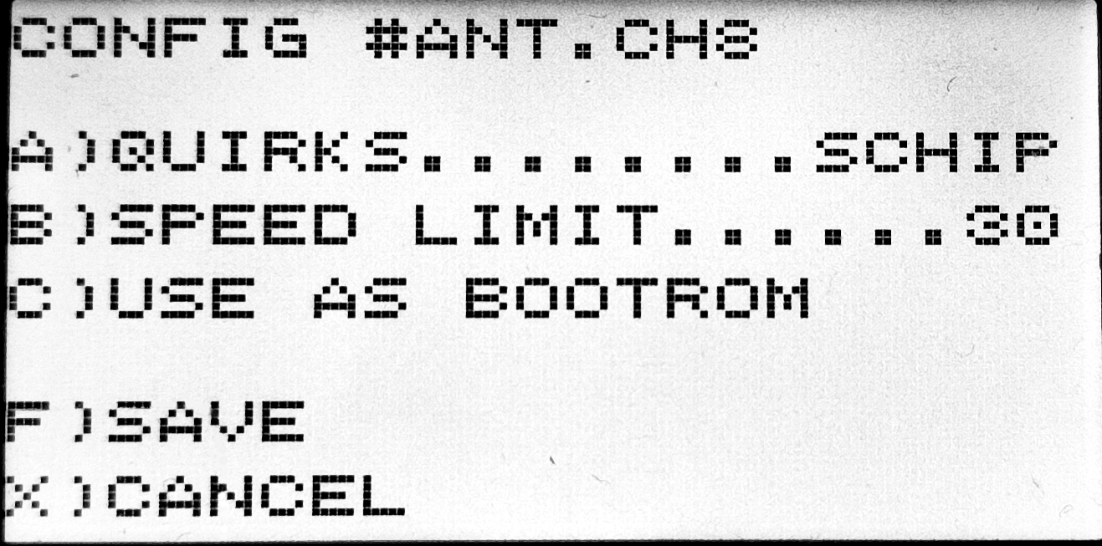
A | Each ROM requires different quirks to run.  Options: VIP, SCHIP, OCTO, CUSTOM  For CUSTOM:  bit 0: CHIP8_QUIRK_SHIFT  bit 1: CHIP8_QUIRK_MEMORY_LEAVE_I_UNCHANGED  bit 2: CHIP8_QUIRK_MEMORY_INCREASE_BY_X  bit 3: CHIP8_QUIRK_WRAP  bit 4: CHIP8_QUIRK_JUMP  bit 5: CHIP8_QUIRK_VBLANK  bit 6: CHIP8_QUIRK_LOGIC  bit 7: CHIP8_QUIRK_LORES_WIDE_SPRITE  bit 8: CHIP8_QUIRK_LORES_TALL_SPRITE  bit 9: CHIP8_QUIRK_LORES_SCROLL_DIV2  bit 10: CHIP8_QUIRK_HIRES_COLLISION  bit 11: CHIP8_QUIRK_RESIZE_CLEAR_SCREEN  bit 12: CHIP8_QUIRK_VF_ORDER  bit 13: CHIP8_QUIRK_FX1E_REPORT_OVERFLOW  VIP = 00000060 | SCHIP = 00000413 | OCTO = 00000888
B | Some ROMs would only run properly with a speed limit.  Set it to 01~99 to enforce a speed limit.  Set it to 00 to run without speed limit.  Unit is instructions per frame. Each frame is 60Hz
C | Use the current game as BOOTROM so that the game would start upon power on. Used for custom boot screen
F X | [F] to save, [X] to discard. No effect on BOOTROM

Global Config

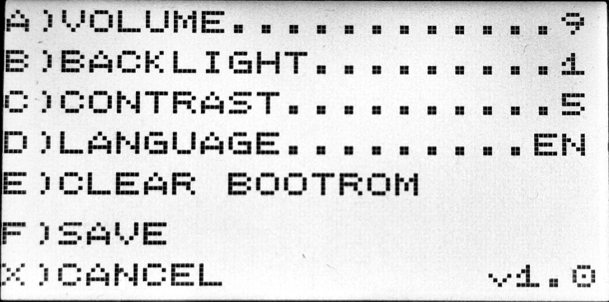
A | Buzzer volume. 0 is mute.  Range: 0~9. Default: 9
B | LCD backlight adjustment. 0 is off.  Range: 0~9. Default: 1
C | LCD contrast adjustment.  Might need to adjust for clear display in different operational environments (humidity, temperature, etc.)  The higher the darker. The lower the lighter.  Range: 0~9. Default: 5
D | Language selection.  Options: English, Toki Pona, Sitelen Pona, Sadalian  Default: English
E | Clears BOOTROM.  Upon power on, you'd enter the menu without going thru a BOOTROM
F | Apply changes
X | Discard changes and revert to the previous config.  Does not work on BOOTROM

Firmware Update
You can perform firmware update with following the instruction:
https://ilomusi8.sadale.net/en/firmware-update

Adding New Games
You can add new games to your ilo musi 8 unit by putting new games into the TF card via the USB adapter with a computer.

After downloading the new CHIP-8 game, if needed, rename it to xxxxxxxx.CH8 and put it into your TF card. Use "8.3 filename" (uppercase with up to 8 characters with limited symbol support).

After selecting the game on your ilo musi 8 unit,
press [C] to perform "Game Config".
Select the correct config, save it and you can run the game.

As an alternative, you can use your computer to create xxxxxxxx.INI that matches your game path by following the INI specs here: https://github.com/SadaleNet/ilo-musi-8/firmware/README.MD
Some config are only accessible via direct INI modification.

You can download more CHIP-8 games here:
https://ilomusi8.sadale.net/en/roms

Other CHIP-8 games are also available elsewhere on the internet.

********************

Developed
by Sadale
https://sadale.net/
v1.1

