FINAL QUANTITATIVE RESEARCH REPORT
Algo 8 Reverse Engineering:
Trading Structure, Execution Evidence
and Economic Attribution
Prepared for Rahul
Trade observations: 23 June–22 October 2026
Stored index coverage begins 22 June 2026
Report date: 27 October 2026
A finite investigation of the observed trading process, its reconstruction boundary and the economics supported by the received record. No proprietary rule set is claimed to have been recovered.
Final conclusion
Positive marked results under some assumptions, but no demonstrated economic alpha.

Source repository: SadamAnjaneyulu/Algo-8-Reverse-Engineer
Research snapshot: data/local-breeze-fetch @21ce61d
Strong register: research/strong-findings, v 7 @15a0e5e
Intended recipient: Rahul. Prepared from the supplied repository research and received trading records.

Contents and evidence labels
1 Executive summary 3
2 Data, accounting and methodology 4
3 Reconstructed strategy structure 5
4 What the controller search established 9
5 Intermediate exits and order management 10
6 Final liquidation and risk management 12
7 Economic performance and attribution 13
8 Benchmarks, uncertainty and interpretation 17
9 Final conclusions and limitations 18
Appendix A Source references 19
Appendix B Definitions and cohort boundaries 21
Appendix C Reproduction and validation 22

How to read the evidence
Label | Meaning
Observed | Recorded fills, quantities, timestamps, inventory or cash flow within the received-record assumptions.
Strongly supported | Repeated behavior matching a stated definition in a specified empirical sample.
Hypothesis | A plausible tested explanation or model assumption that is not uniquely established.
Unresolved | The available observations do not distinguish competing implementations or explanations.

Rates describe their stated samples. They are not future-profit probabilities. Software tests validate implementation and accounting, not the truth of a strategy hypothesis. Figure-source notes and Appendix A identify the underlying evidence.

1 Executive summary
Final conclusion: positive marked results under some assumptions, but no demonstrated economic alpha.
This is the conclusion supported by the available record. It is not proof that Algo 8 is unprofitable in every period or that the original controller never had an edge.

Rahul requested an explanation of Algo 8’s alpha. The investigation reconciled 41,421 fills into 35 cycles, then combined execution evidence with stored minute index and option data. The main economic cohort contains 32 observed pre-expiry starts; ten of those books retain quoted residual positions. [S07] [S08] [S14]
Strongly supported: a near-expiry, protected short-option structure. Ordinary paired ATM CE/PE shorts begin near 09:16 IST. Seventeen recurring pre-expiry windows generally add updated short strikes and protection while older exposure survives. The joint build-up pattern occurs in 529/544 windows (97.2%); this is structural agreement, not full-controller recovery. [S02] [S10]
Unresolved: the exact sizing formula, intermediate exit activation, re-entry logic, stop implementation and complete pending-order process. Autonomous reconstruction remains weak: 23.3% later event macro F1 in the earlier experiment and 24.3% in a different initialized-cycle study. Fixed exit hypotheses identify only small subsets. [S04] [S05] [S06]
Fixed cost scenario | Primary 32 estimated net quoted P&L
Zero-cost diagnostic | ₹18.94 lakh
Moderate | ₹8.21 lakh
Conservative | ₹4.75 lakh
Adverse execution | −₹4.77 lakh

Observed economics are consistent with short-option carry exposed to convexity, direction and repricing, plus protection and trading costs. Conservative profit falls to ₹1,722 when the largest winner is removed and turns negative without the two largest. Mean-cycle and paired benchmark intervals include zero; no defensible equal-risk comparison is available. [S01] [S15] [S17]
This report closes the investigation under Outcome B without claiming recovery of the original proprietary controller or an economic excess-return signal.

2 Data, accounting and research methodology
Verified evidence | Count / scope
Recorded fills / reconstructed parents | 41,421 / 39,874
Observed cycles / initialized primary cycles | 35 / 32
Atomic event books | 21,882
Stored index sessions / bars | 170 index-days / 63,678 bars
Observed option history | 3,243 option contract-days

Observed: independent Decimal accounting reproduces cash, positions and pooled realized P&L. Raw quotes reconcile 25,458 available minute equity marks, with maximum error below ₹0.000000001. All 35 endpoints are quote-markable; 24 received books end flat and 11 retain positions. Three expiry-only starts are a separate sensitivity cohort. [S07] [S18]
Research stage | Evidence established | Ref.
1 Reconcile records | Cash, inventory, atomic transitions and quoted marks | S07
2 Recover structure | Opening, recurring windows and protection patterns | S02 / S10
3 Test rule hypotheses | Entry, sizing, exit and risk candidates; contradictions | S03 / S04
4 Replay autonomous policies | Own-inventory action and path matching | S04
5 Separate policy/execution | 59-motif audit; execution alternatives | S05 / S13
6 Test intermediate exits | Matched non-exits; whole-cycle and chronology checks | S06
7 Falsify economic alpha | Role/phase P&L, fixed costs and paired benchmarks | S01 / S14–17

Unresolved data boundary: zero before the first received fill is an accounting assumption, not a verified account statement. Completeness, NAV, margin, full-chain quotes, original allocation ownership, decision events and submission/cancel/acknowledgement records are absent. Quote marks are not executable prices or settlement. [S01] [S18]

3 Reconstructed strategy structure
The strongest description is an accumulating, near-expiry short-option book with outward protection and separate management. It is not a recovered source-code specification. The diagram distinguishes observed actions from unidentified transition conditions. [S02] [S03]
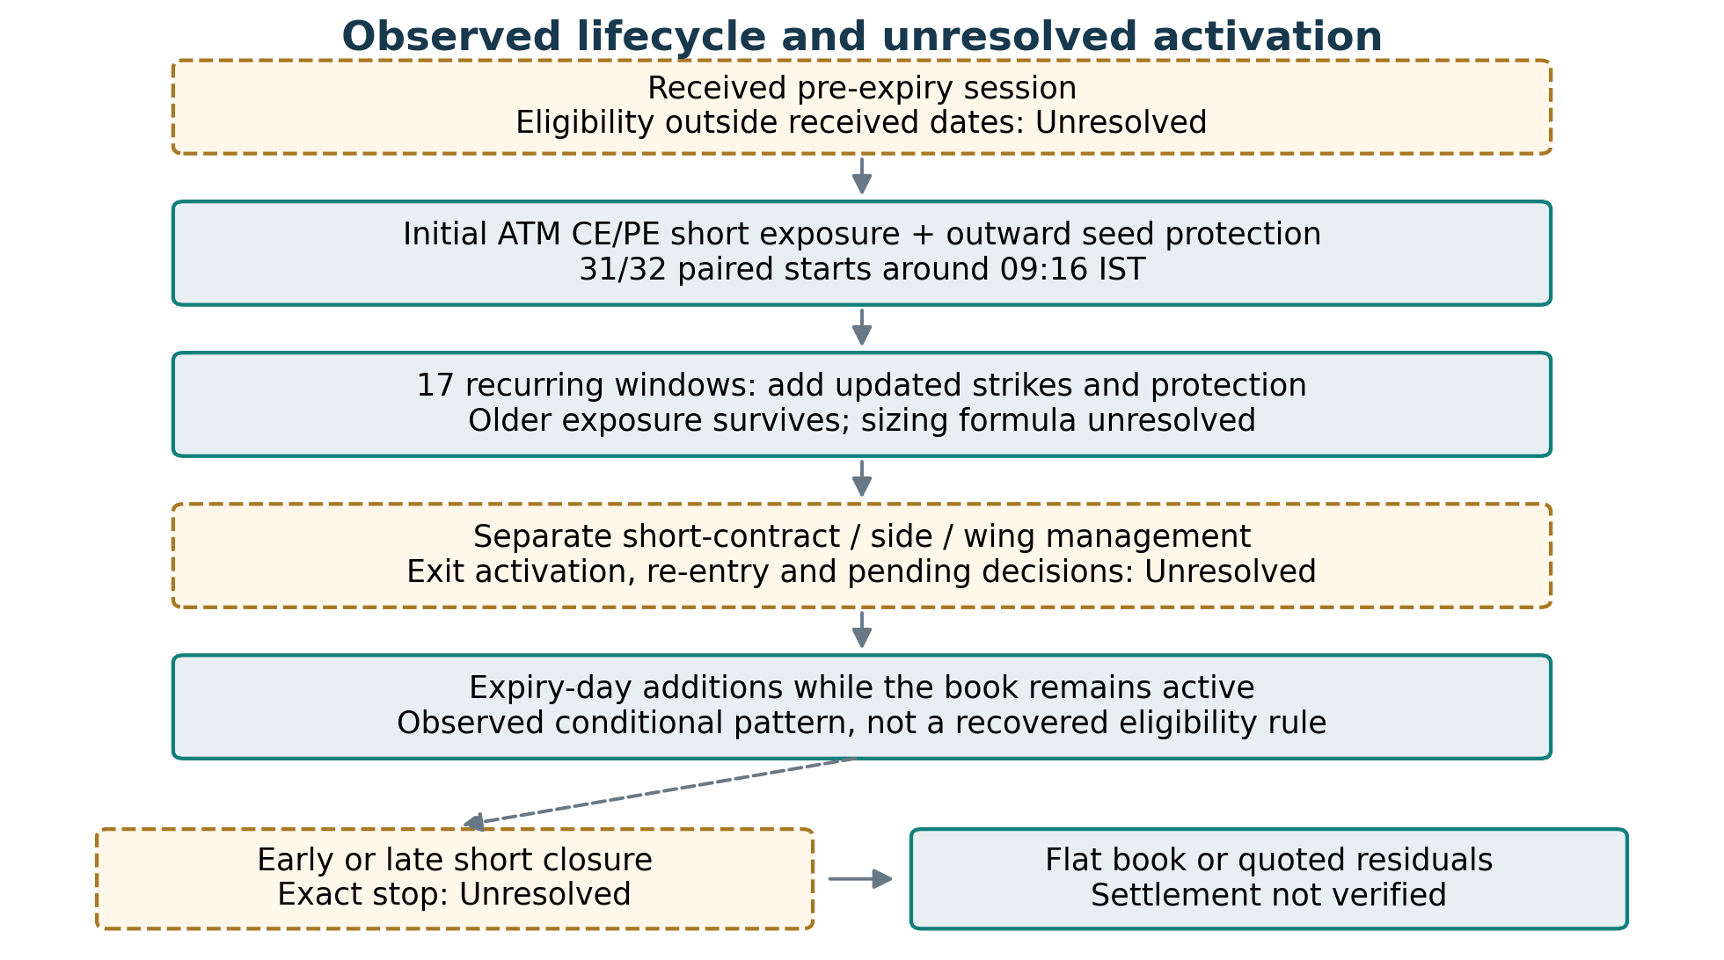
Figure 1. Observed lifecycle and unresolved activation
Source: [S02], [S03], [S06]. Solid boxes: observed structure. Dashed gold boxes/arrows: conditions or sequencing not recovered. Schematic only; early closures can bypass later stages.

Initial entry: what is observed
Strongly supported: the first paired short sale begins in the 09:16 minute on 31/32 pre-expiry starts. Those 31 ordinary starts match nearest ATM using the completed 09:15 index close, on 50-point NIFTY and 100-point SENSEX grids. A contemporaneous quote could produce the same strike, so the exact reference implementation remains unresolved. [S09]
Observed: ordinary 09:17 books commonly hold 195 NIFTY units or 60 SENSEX units in each of the four roles. These sizes match jointly on 13/14 ordinary NIFTY dates and 15/17 SENSEX dates. NIFTY 5 October is a delayed exception: first exposure precedes its 09:30:59 first pair. [S02] [S09]
The four roles are not one guaranteed atomic order. First short fills are within one second on 31/31 ordinary starts; first wing/short separation is at most three seconds per right. This describes sequencing, not completion of all quantities or a guaranteed hedge-first broker instruction. [S03]

3.1 The recurring allocation schedule
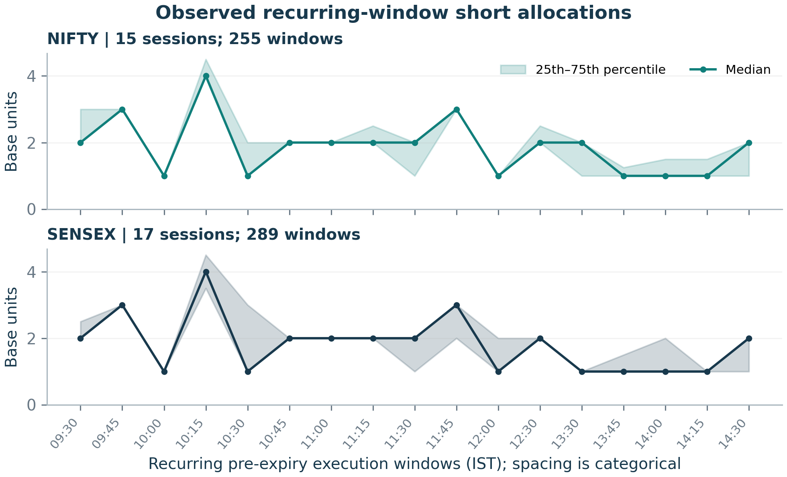
Figure 2. Observed recurring-window short allocations
Source: [S10]. Gross inventory-opening CE/PE short quantities averaged per right, divided by 65 for NIFTY and 20 for SENSEX; median and IQR. Outliers not shown; windows are not sizing instructions.
The 17 observed pre-expiry windows (IST):
09:30, 09:45, 10:00, 10:15, 10:30, 10:45, 11:00, 11:15, 11:30, 11:45, 12:00, 12:30, 13:30, 13:45, 14:00, 14:15, 14:30.
The measurement interval is T −2 seconds through T +3 minutes, exclusive. It allows observed execution dispersion; it is not a recovered signal timestamp. The schedule has gaps, and additional activity occurs outside it. “Every 15 minutes all day” is not the supported rule. [S02] [S10]
Figure 2 reports the observed distribution of gross short inventory openings per right. It includes 15 NIFTY and 17 SENSEX sessions; quantity is divided by the observed 65/20 base request units. The IQR describes cross-session variability, not a forecast interval or a guaranteed order size. The exact count of units at each time remains unresolved. [S10]

3.2 Accumulation rather than whole-book replacement
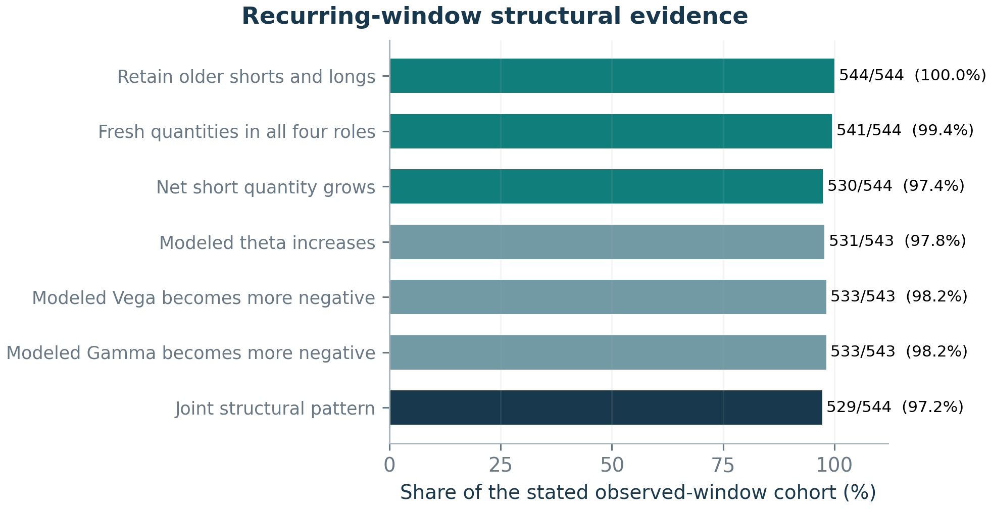
Figure 3. Recurring-window structural evidence
Source: [S02], [S10]. 32 sessions ×17 windows. One window lacks a full Greek fit; joint denominator remains 544. Rates are correlated and must not be multiplied.
Strongly supported: some older short and long exposure necessarily survives each of the 544 recurring windows under the conservative inventory-retention definition. Fresh quantities arrive in all four roles in 541/544; net shorts grow in 530/544. Thus the process usually adds exposure rather than closes the old four-leg basket and replaces it. It does not imply that every old lot survives. [S10]
The joint 529/544 result requires retention, four-role additions, net growth and all three modeled Greek changes on the same window. One window lacks a full Greek fit and stays in the denominator as unconfirmed. Greek signs are correlated consequences of adding short exposure, not independent proofs of a hidden range-prediction signal. [S02] [S10]
Observed pre-expiry new-short requests | Common base size | Matching parents
NIFTY | 65 units | 2,022/2,032 (99.5%)
SENSEX | 20 units | 2,375/2,375 (100%)

These are request-granularity units, not verified exchange lot definitions, capital allocations or a recovered number-of-orders formula. Separate contract/side reductions can coexist with a surviving opposite side and later new allocations. [S02] [S03]

3.3 Opening reconstruction and protection selection
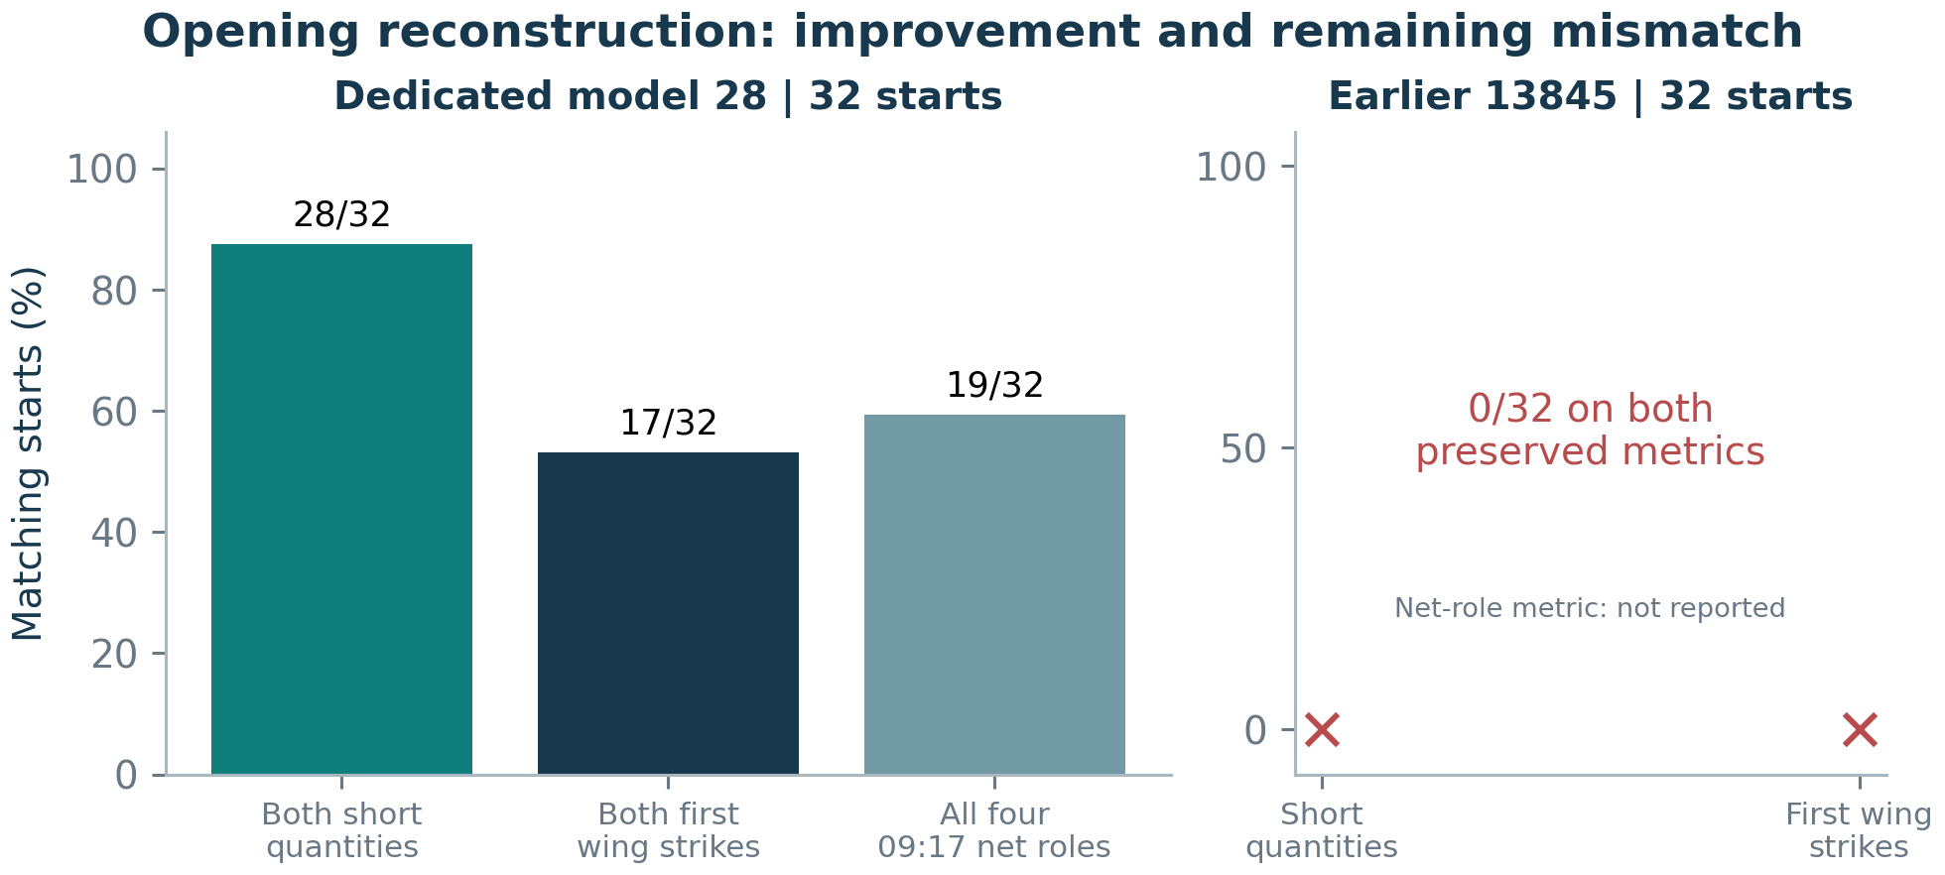
Figure 4. Opening reconstruction: improvement and remaining mismatch
Source: [S05]. Different targets: opening gross shorts, true first executed wing pair, 09:17 net roles. Earlier controller contradiction is retained; no unreported net score invented.
Protection cohort | Evidence and limit
NIFTY initial seed | 26/28 wings within 100 points of a 2000 gap; 19/28 exact.
SENSEX initial seed | Before 16 Sep: 21/22 within 200 of 4000. Later: 12/12 exactly 2000.
Routine NIFTY pre-expiry budget proxy | 2.5% of same-right ATM premium: 316/637 exact (49.6%); 586/637 within one strike (92.0%).
Routine SENSEX pre-expiry budget proxy | Rounded budget proxy: 321/623 exact (51.5%); 589/623 within one strike (94.5%).

The routine premium-budget selector is a Hypothesis supported approximately, not an exact recovered rule. Initial geometry is a different cohort. ₹2/₹7 wing prices are not universal targets. Later short strikes follow the moving index approximately, rather than always retaining the initial ATM strike. [S02] [S11]
Observed timing and modeled effects also differ: most pre-expiry hedge buys accompany new shorts, while matched expiry replacements often move protection inward. A normal opening is modeled theta-positive, Vega-negative and Gamma-negative on 31/31 ordinary starts. These describe risk exposure, not predictive alpha. [S02] [S03]

4 What the controller search established
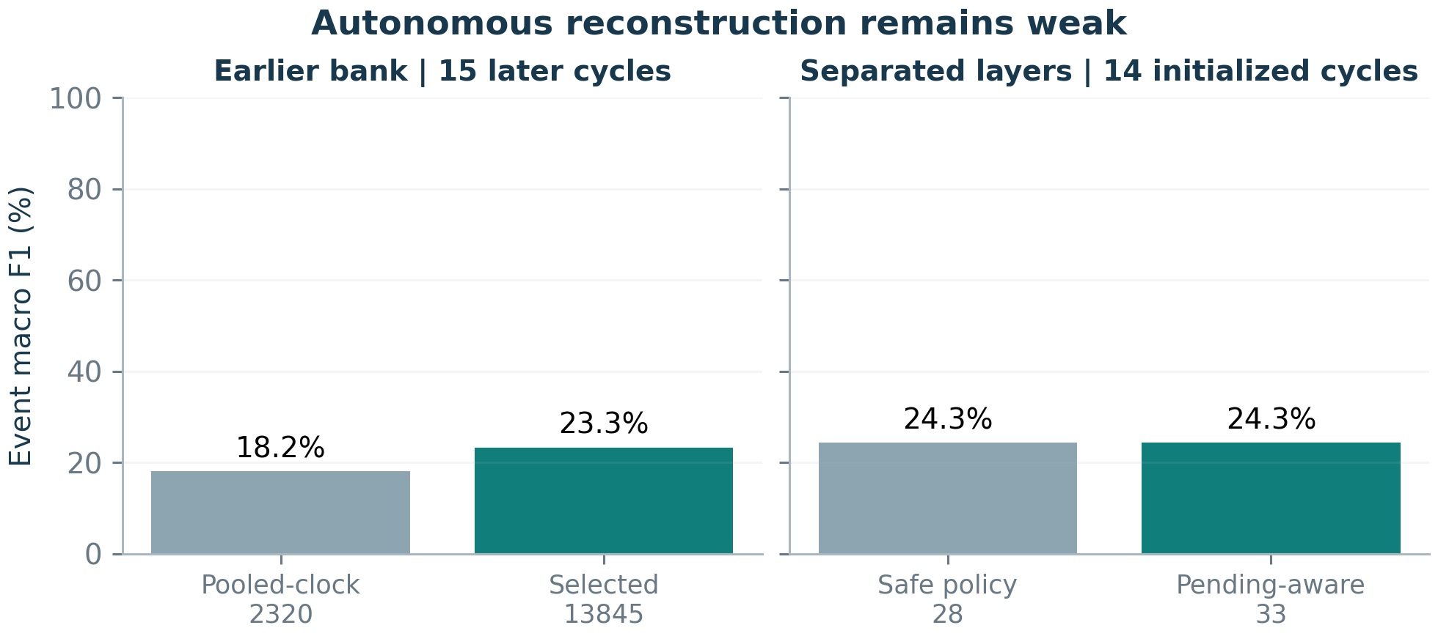
Figure 5. Autonomous reconstruction remains weak
Source: [S04], [S05]. Four action types, exact contract/action within ±2 min. Panels have different initialization/cohort/modules; do not read 23.3→24.3 as a controlled improvement.
The constrained autonomous search evaluated 13,864 definitions: 13,824 main combinations and 40 earlier-fit refinements. Policies ran with their own simulated inventory. The selected candidate 13845 reaches 23.3% later event macro F1 versus 18.2% for pooled-clock 2320 on 15 already-inspected September–October cycles. [S04]
The separate policy/execution experiment crosses 12 policies with 7 mechanics. Its selected safe model 28 reaches 24.3% on 14 initialized later cycles; pending-aware model 33 has the same minute F1. Delayed alternatives can raise F1 slightly while worsening final closure and the registered composite. Extra mechanics do not recover the missing activation logic. [S05]
Do not compare the two headline F1 values as a controlled improvement.
The experiments differ in opening modules, initialization exclusions and evaluation cohorts. Within each panel the comparisons are consistent; across panels 23.3% and 24.3% are not interchangeable.

Event macro F1 averages the four action-class F 1 s using exact contract/action matches within two minutes. Quantity and inventory scores are normalized overlaps, not exact order or full-book accuracy. Low absolute matching, opening contradictions and misspecified risk actions prevent a complete strategy-recovery claim. [S04] [S05]

5 Intermediate exits, re-entry and order management
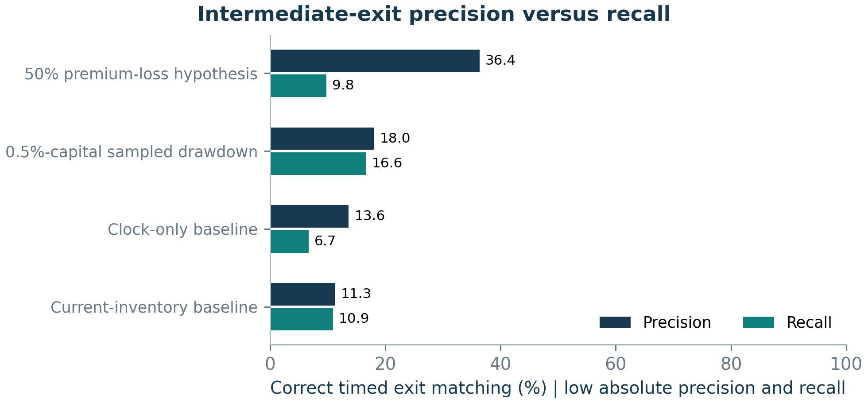
Figure 6. Intermediate-exit precision versus recall
Source: [S06]. 24 expanding chronological cycles; 2200 intermediate episode starts; same-contract one-to-one ±120 s. Not an independent-fill test or a full autonomous replay.
Observed: the full received ledger contains 11,716 closing Buy children across all 35 cycles. The episode study’s primary 32 cycles contain 3,512 intermediate episodes and 326 separately labeled final-liquidation episodes. Same-contract covers within 120 seconds are grouped unless a new short opening, date or outcome stratum intervenes. An episode is an observable batch, not a certified original decision. [S06]
The displayed precision/recall values concern the 24 expanding chronological test cycles and 2,200 intermediate starts, not all 3,512 episodes. Features use strictly earlier fills and preceding completed candles. Full active-short opportunities determine precision; matched non-exit controls do not replace that denominator. Related events stay within whole-cycle validation folds. [S06]
The 50% premium-loss hypothesis has 36.4% precision /9.8% recall. Sampled side drawdown has 18.0% / 16.6%; it improves discrimination relative to clock and inventory baselines, but still misses most exits. Neither recovers the original stop. [S06]
Unresolved: whether an individual reduction is a stop, profit-taking, target change, re-entry preparation or execution cleanup. A rise hurts a short CE and a fall hurts a short PE, but that direction fact does not identify a threshold or explain profitable covers. Short covers, wing sales and new entries remain distinct. [S02] [S06]

5.1 Reversal-sequence forensics
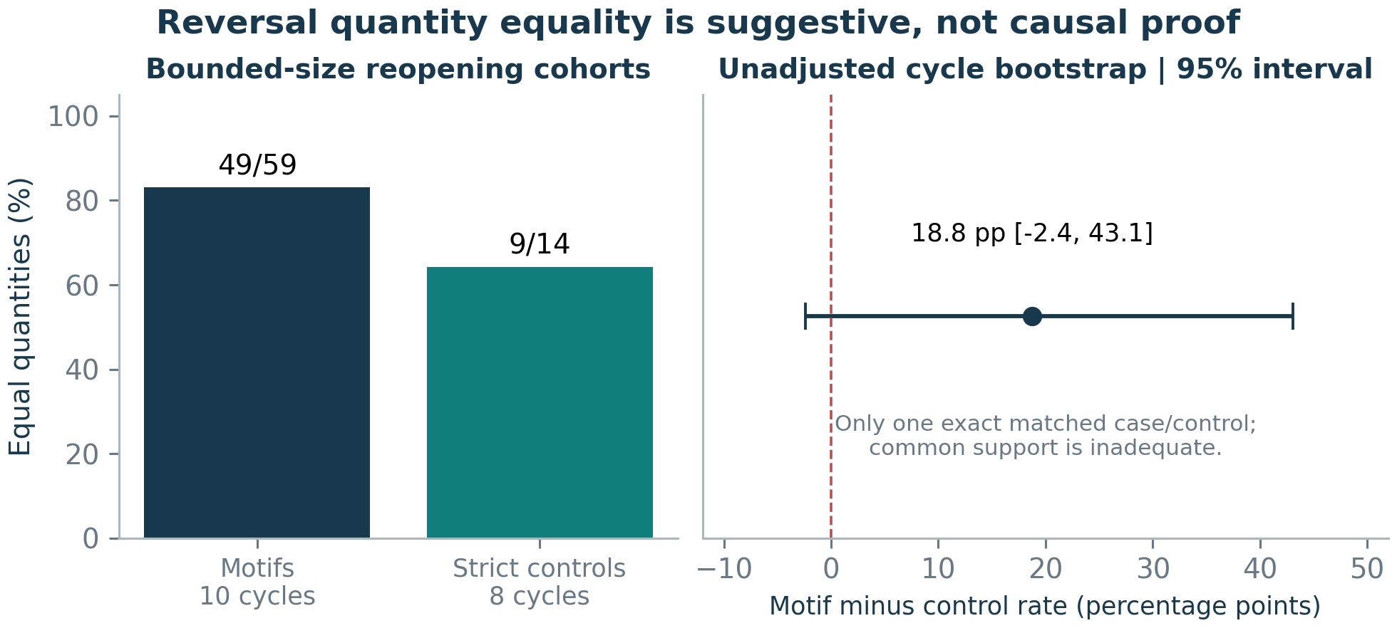
Figure 7. Reversal quantity equality is suggestive, not causal proof
Source: [S13]. Conservative motifs exclude oversize openings. One-base equality can be forced by the size restriction. Saved bootstrap is unadjusted, not a duplication probability.
Observed: 49/59 conservative motifs reopen the opposite quantity equal to the final atomic close. Every opposite opening has a different reconstructed parent reference from the final close. That separates grouped parents; it does not prove duplicated submission intent. Partial execution and fast intentional adjustments can coexist with reconciliation. [S13]
The universal stale/duplicate-close simulation produces 559 candidate motifs yet matches 0/59 original cases by exact contract within ±120 seconds. It can generate a shape without identifying its activation. The bounded strict controls are only 14 cases, and exact matching leaves one case/control pair about 109 minutes apart. The plotted interval is unadjusted, not a causal duplication probability. [S05] [S13]
The 59 motifs include 43 protective-long closures and 16 short covers. The earlier 32 absent /27 retained comparison therefore contains only 9/7 actual short covers, respectively. Upstream strike/allocation differences, earlier candidate reductions and unknown initialization explain parts of candidate absence. Three retained short cases close during 09:15 before a complete session candle is available. Missing features are not filled from the later 09:15 close. [S05] [S06]

6 Final liquidation and risk management
Observed closure statement | Denominator and exceptions
9/10 selected late closures occur in 15:14 | Post-3-Aug final short-book closures at/after 15:00 only; one 15:36:54 exception. Not 90% of all exits.
27/29 finish by 15:27:33 | All reconciled final short-book closures in that study; cumulative deadline description, not an exact instruction.
31/31 nonflat carry books have long quantity covering shorts | Per-right end-of-pre-expiry snapshot. The remaining one of 32 pre-expiry books is flat; continuous protection is not established.

Final short-book closure, full four-role liquidation and a quote-marked residual state are different outcomes. The full economic dataset has 11 residual books; no missing closure is invented. Early exits, expiry-day additions while exposure remains active, and later re-entry mean that the first flat short book is not a universal permanent stop. [S02] [S03] [S12]

State transitions: observed actions, unresolved activation
Figure 1 provides the state-machine view: received pre-expiry session → protected paired entry → recurring accumulation → independent side/wing management → expiry activity while active → early or late closure → flat or residual state. The dashed eligibility and management transitions are inferred descriptions, not recovered trigger code. [S02] [S03]
Supplied statement / risk concept | What remains unresolved
4% carry-forward stop | Denominator, allocation/side/book scope, reference time and reset logic.
1% expiry-day capital stop | ₹200,000 is 1% of the supplied ₹2 crore reference; actual NAV, margin and implementation are unverified.
Protective quantities / frozen payoff | Snapshot coverage does not identify a coded guard, continuous hedge matching, dynamic loss cap or funding budget.

Hypothesis: some late actions prepare the carry book or manage exposure. That interpretation is consistent with the end-book condition but does not establish the original stop, hedge trigger or pending-order handling. Intraday sequencing can briefly leave a negative call tail under the received-options-only convention. [S02] [S03]

7 Economic performance and alpha attribution
Economic view | primary 32 | Quoted / reconstructed amount
Gross realized P&L | ₹1,371,078.56
Marked unrealized P&L | ₹523,276.94
Combined gross quoted endpoint | ₹1,894,355.50

These reconcile: realized plus unrealized equals combined P&L. Do not add all three. Unrealized amounts include residual quote marks, not verified liquidation proceeds. Received fill cash flow is ₹20.65 lakh and still includes remaining liabilities. [S01] [S14]
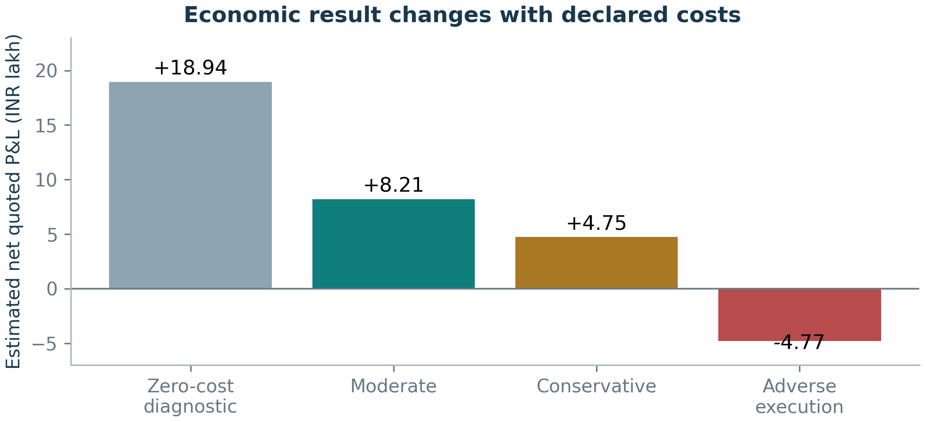
Figure 8. Economic result changes with declared costs
Source: [S01], [S14], [S15], [S19]. 32 initialized cycles. Net includes quoted residuals, not verified account returns or settlements. Charges are fixed estimates, not authenticated fees.
Scenario | Premium turnover | Per parent | Per unit
Zero diagnostic | 0% | ₹0 | ₹0
Moderate | 0.25% | ₹20 | ₹0.05
Conservative | 0.50% | ₹20 | ₹0.10
Adverse execution | 0.50% | ₹40 | ₹0.20

Hypothesis: these fixed charges are cost/slippage estimates, not authenticated broker fees. Recorded prices already contain whatever execution occurred; incremental slippage is an adverse sensitivity, not a rewritten historical fill. Zero cost is a diagnostic upper bound on these incremental charges. [S19]

7.1 Concentration, residual dependence and sampled risk
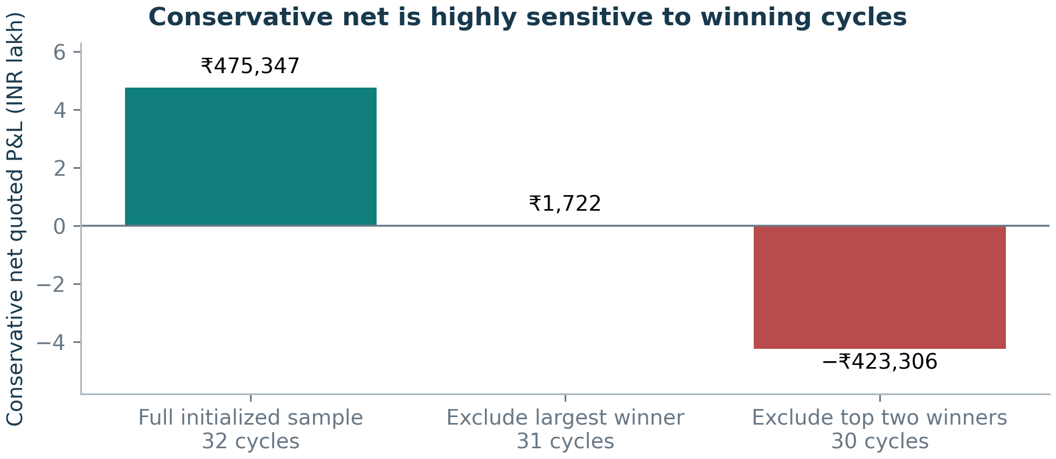
Figure 9. Conservative net is highly sensitive to winning cycles
Source: [S01], [S15]. Largest winner: NIFTY 29 Sep; no received expiry-day fills and substantial unrealized quoted gain. This is a sensitivity check, not a rule-selection exercise.
The largest winner is NIFTY 29 September. Its realized P&L is −₹52,161.17 and its quoted unrealized gain is ₹540,801.92; the received log has no expiry-day fills. Conservative net for that cycle is ₹473,625.07. This is a residual mark, not verified expiry execution profit. [S01] [S14]
Primary 32 conservative robustness measure | Result
Net without largest winner | ₹1,721.58
Net without two largest winners | −₹423,305.62
Mean-cycle 95% bootstrap interval | −₹55,260.39 to ₹87,259.06
Largest sampled intracycle drawdown | ₹417,144.82

Single-cycle removal leaves positive totals, but the weakest is nearly zero. The top two wins account for 28.5% of gross winning P&L and more than erase aggregate net when removed. The 22 initialized books ending flat have −₹6.73 lakh conservative net; that subset is selected and cannot serve as an unbiased complete-strategy rejection. [S15]
Risk is sampled from available minute marks, not continuous tick NAV. There is no verified account-capital denominator, reliable ruin probability or calibrated extreme-tail quantile. Thirty-two already-inspected cycles, including related calendar exposures, do not establish a precise future mean return. [S01] [S15]

7.2 Roles, protective wings and overnight carry
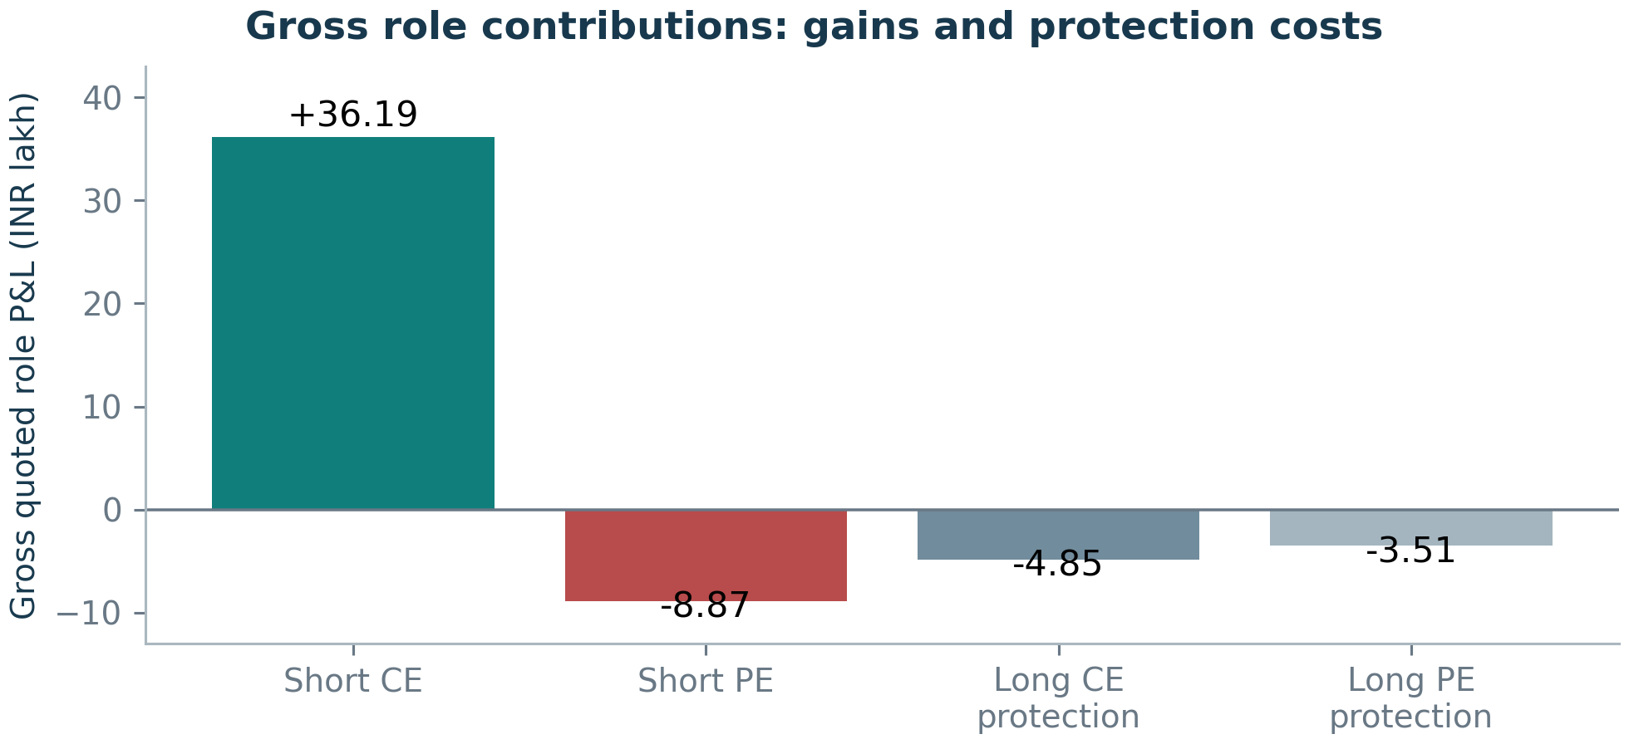
Figure 10. Gross role contributions: gains and protection costs
Source: [S14]. 32 initialized cycles; pooled role cash plus residual marks, not original allocation P&L. Four roles sum to 18.94 lakh gross; strategy costs are deducted separately once.
Observed pooled gross role P&L is approximately +₹36.19 lakh short CE,−₹8.87 lakh short PE,−₹4.85 lakh long CE and −₹3.51 lakh long PE. Repurchases, wing purchases/sales and residual liabilities are included; collected premium is not automatically profit. Transaction costs affect net results separately. [S14]
Phase | primary 32 | Gross quoted P&L | Conservative net
Pre-expiry | ₹9.76 lakh | ₹5.40 lakh
Overnight close→open | ₹5.22 lakh | ₹5.22 lakh
Expiry-day remainder | ₹3.96 lakh | −₹5.87 lakh

The phases reconcile to the endpoint. Overnight has no assigned trading charge, not verified zero funding cost. Expiry-day gross gains become negative after estimated costs in this sample; this is accounting, not a hindsight rule to skip the phase. [S14] [S15]
Protection is a gross drag in the received sample, but its removal is not an equal-risk alternative. Finite frozen payoffs do not show that insurance was economically worthwhile, and 35 cycles do not value absent extreme tails. Pooled role/holding-time attributions do not recover original allocation ownership. [S01] [S20]

7.3 Model-based direction, time and own-IV repricing
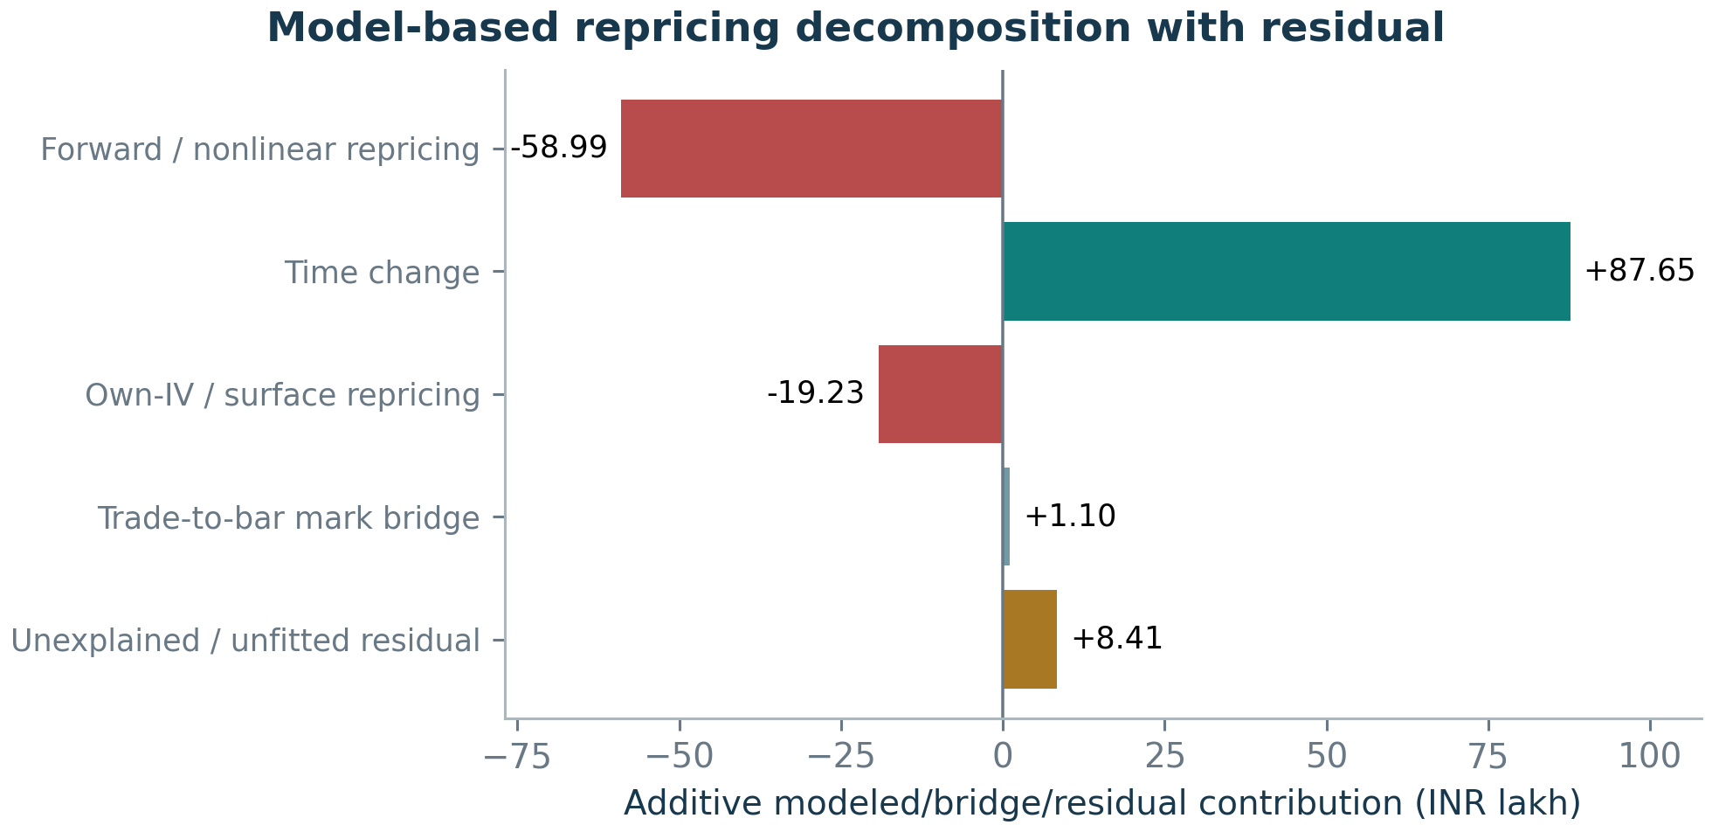
Figure 11. Model-based repricing decomposition with residual
Source: [S16]. Primary 32, primary model variant-valid intervals. Five signed terms sum to 18.94 lakh; time is not causal alpha and the bridge is not identified execution alpha.
Hypothesis: the European Black framework fits each option’s own endpoint IV and symmetrically allocates repricing to forward, time and IV changes. Primary forwards use a same-strike parity proxy when adequate quotes exist, otherwise a flagged spot proxy. Missing, low-extrinsic-value, zero-volume and nonpositive-time fits are not silently accepted. [S16] [S19]
The positive modeled time term is heavily offset by direction/convexity and own-IV repricing. Within forward repricing, linear delta, quadratic gamma and a higher-order/interaction remainder are nested diagnostics—not additional profits. The trade-to-bar bridge includes intraminute movement/mark differences; it is not identified execution alpha. The material residual is not renamed alpha. [S16]
Model sensitivity uses a 6% rate, expiry clocks ±5 minutes and a spot-only forward on common fitted intervals. These assumptions reassign components; none changes the observed quoted endpoint. The main figure uses the primary model’s own valid intervals, so its components must not be mixed with common-fit sensitivity totals. No constant volatility surface or uniquely causal explanation is claimed. [S16]
Three alternative cuts of the same economic result
Role P&L, phase P&L and modeled repricing are not independent sources to add together. Only the five signed terms in Figure 11 add to the quoted gross endpoint; strategy costs are then deducted once.

8 Benchmarks, uncertainty and final interpretation
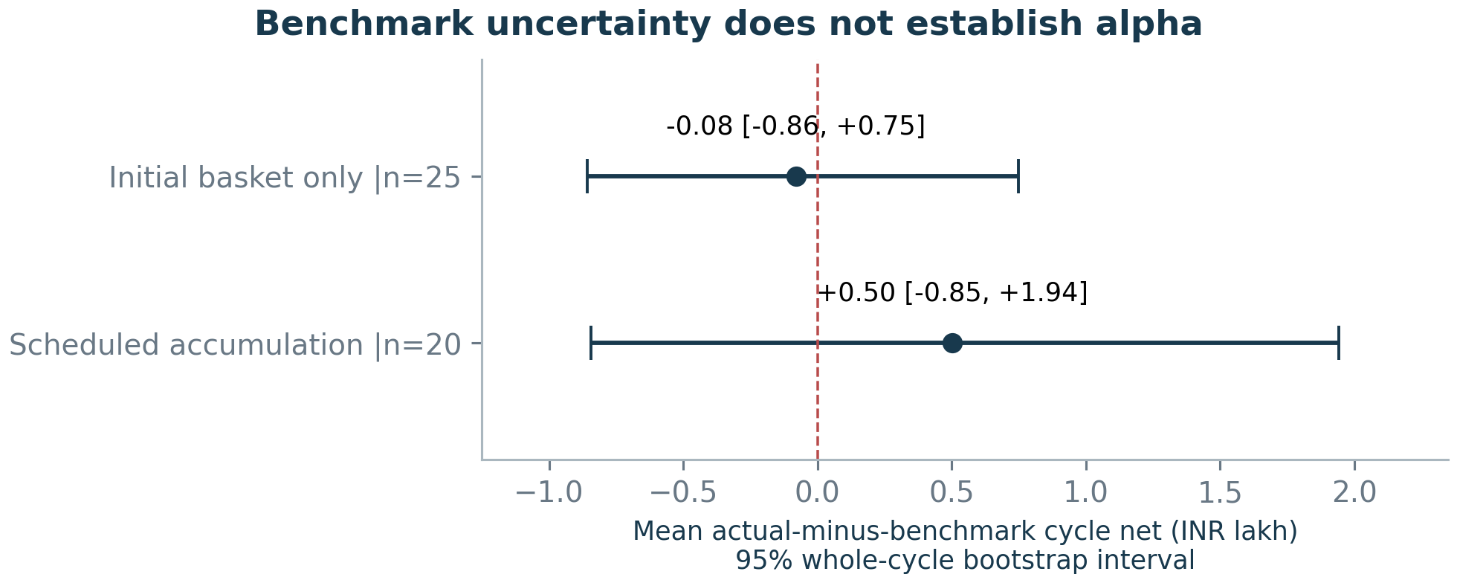
Figure 12. Benchmark uncertainty does not establish alpha
Source: [S17]. Conservative costs; D_common_clock hypothetically closes actual pre-deadline inventory at the same candle open. B: 25 and C: 20 separate common cohorts; risk budgets unequal; C uses Aug–Oct after June–July size fitting.
Fixed comparison | Interpretation / limitation
A No trading | Zero cost/exposure. Establishes profit above zero only.
B Initial basket only | Actual ordinary prefix before 09:18, then freeze; no independent strike selector is recovered.
C Scheduled accumulation | Fixed June–July modal sizes; following-minute entries, no expiry additions/stops; August–October comparison only.
D Observed sequence | Principal endpoint keeps received trades/residuals; paired D_common_clock is a hypothetical common-deadline close.
E Comparable risk budget | Unavailable: NAV, margin, dynamic limits and original risk ownership are unverified.

B/C exit at 15:27 before 3 August and 15:14 afterward. Missing intended prices invalidate a complete comparison, rather than create profitable skipped trades. Conservative-cost mean D_common_clock-minus-B is −₹7,973/cycle on 25 shared quoted cycles; minus-C is +₹50,264 on 20. Both intervals span zero, and each comparison has its own common cohort. [S17] [S19]
Absolute marked profitability under assumptions, risk-adjusted performance and comparable-risk economic alpha are different claims. Equal clocks, shared contracts or the supplied capital reference do not equalize dynamic risk. The available results do not demonstrate a persistent comparable-risk excess return. [S01] [S17]

9 Final conclusions and limitations
Outcome B — positive marked results under some assumptions, but no demonstrated economic alpha.
The evidence does not establish universal unprofitability. It establishes the limits of inference from this record and these fixed assumptions.

Evidence label | Research conclusion
Observed | Reconciled fills, inventory, cash flow, sampled quote marks and separate short/long actions.
Strongly supported | Near-opening paired exposure, recurring protected accumulation, retention of older positions and conditional liquidation timing.
Hypothesis | Approximate hedge selectors, tested stops/controllers, cost estimates and model-based time/forward/IV attribution.
Unresolved | Exact allocation sizes/limits, range eligibility, intermediate stop/reset/re-entry activation and complete order-management intent.

The reconstructed economic structure is consistent with earning short-option carry while accepting convexity, direction and volatility risk and paying for protection and execution. Strong structural match rates do not establish the original proprietary rule set; Greek signs do not establish a predictive signal. Autonomous and exit-trigger tests remain far below complete reconstruction. [S02] [S04] [S05] [S06]
Positive marked results survive some charges, but adverse execution assumptions reverse the sign. The largest quote-marked residual winner dominates conservative aggregate net; mean-cycle uncertainty and benchmark differences include zero. A defensible equal-risk budget is unavailable. These economic facts, rather than an 80–90% reconstruction target, determine the alpha conclusion. [S01] [S15] [S17]
The most important missing evidence is original allocation/decision identity, submission/cancel/acknowledgement history, full-chain tick bid/ask data, verified post-export positions/settlement, authenticated charges, NAV and margin. Their absence prevents exact ownership, causal controller attribution and verified account/risk-normalized performance claims. [S01] [S03] [S18]
Research is closed without claiming recovery of Algo 8’s original proprietary strategy or its alpha. This report consolidates the finite investigation; it does not reopen controller searches, indicator banks or threshold optimization.

Appendix A Source references
Source IDs in the text and figure notes link to frozen repository evidence. Detailed claim filters, artifact hashes and reproduction commands are in Rahul_Algo8_Report_Sources.md. Research and strong-findings branch identities remain separate.
S01 Final economic closure | 21ce61d
research/final_alpha_attribution/FINAL_ALPHA_ATTRIBUTION_AND_FALSIFICATION.md
research/final_alpha_attribution/final_verdict.json
S02 Cumulative Strong Findings v 7 | 15a0e5e
STRONG_FINDINGS.md
S03 Operational allocation and risk playbook | 21ce61d
ALLOCATION_ENTRY_EXIT_RISK_PLAYBOOK.md
research/outputs/playbook_book_audit.json
S04 Constrained autonomous controller experiment | 21ce61d
research/hypothesis_controller_search/HYPOTHESIS_CONTROLLER_SEARCH.md
research/hypothesis_controller_search/outputs/candidate_scores.csv
research/hypothesis_controller_search/outputs/search_manifest.json
S05 Policy/execution and opening reconstruction | 21ce61d
research/policy_execution_separation/POLICY_EXECUTION_RECONSTRUCTION.md
research/policy_execution_separation/policy_vs_execution_comparison.csv
research/policy_execution_separation/opening_vs_prior_contradiction.csv
S06 Intermediate-exit event study | 21ce61d
research/intermediate_exit_study/INTERMEDIATE_EXIT_CONTROLLER.md
research/intermediate_exit_study/ranked_trigger_hypotheses.csv
research/intermediate_exit_study/exit_case_ledger.csv.gz
S07 Canonical source fills and atomic books | 21ce61d
research/outputs/playbook_fill_ledger.csv.gz
research/outputs/playbook_event_book.csv.gz
research/final_alpha_attribution/data_quality_and_coverage.csv
S08 Stored index/option data provenance | 21ce61d
data/breeze/normalized/indices
data/breeze/metadata/options
research/final_alpha_attribution/input_audit.json
S09 Initial entry, seed wings and opening sizes | 21ce61d
research/outputs/trigger_initial_entries.csv
research/outputs/trigger_initial_wings.csv
research/outputs/rulebook_opening_allocations.csv
S10 Recurring windows, retention and fixed-state risks | 21ce61d
research/outputs/playbook_allocation_windows.csv
research/outputs/allocation_window_sizes.csv
research/outputs/lifecycle_scheduled_window_retention.csv
Additional supporting files: see source map.

Appendix A Source references (continued)
Source IDs in the text and figure notes link to frozen repository evidence. Detailed claim filters, artifact hashes and reproduction commands are in Rahul_Algo8_Report_Sources.md. Research and strong-findings branch identities remain separate.
S11 Approximate routine hedge selection | 21ce61d
research/outputs/rule_refine_hedge_evaluation.csv
research/RULE_REFINEMENT_FINDINGS.md
S12 Final short-book closure observations | 21ce61d
research/outputs/rule_refine_exit_target_comparison.csv
research/RULE_REFINEMENT_FINDINGS.md
S13 Fixed reversal motifs and strict controls | 21ce61d
research/policy_execution_separation/reversal_motif_ledger.csv
research/policy_execution_separation/quantity_equality_controls.csv
research/policy_execution_separation/control_cycle_uncertainty.csv
Additional supporting files: see source map.
S14 Direct economic and role/phase ledgers | 21ce61d
research/final_alpha_attribution/cycle_economic_results.csv
research/final_alpha_attribution/role_economic_results.csv
research/final_alpha_attribution/phase_economic_results.csv
S15 Costs, risk, concentration and leave-one-out | 21ce61d
research/final_alpha_attribution/cost_stress_results.csv
research/final_alpha_attribution/risk_and_drawdown_summary.csv
research/final_alpha_attribution/leave_one_cycle_out.csv
S16 Own-IV repricing decomposition | 21ce61d
research/final_alpha_attribution/cycle_pnl_decomposition.csv
research/final_alpha_attribution/attribution_interval_ledger.csv.gz
S17 Fixed common-clock benchmark comparisons | 21ce61d
research/final_alpha_attribution/benchmark_comparison.csv
research/final_alpha_attribution/paired_benchmark_differences.csv
research/final_alpha_attribution/benchmark_exposure_ratios.csv
S18 Final accounting and reproduction validation | 21ce61d
research/final_alpha_attribution/validation_audit.json
research/final_alpha_attribution/DATA_QUALITY_AUDIT.md
S19 Frozen definitions and cost assumptions | 21ce61d
research/final_alpha_attribution/REGISTERED_PLAN.md
research/final_alpha_attribution/BENCHMARK_AND_MODEL_CLARIFICATIONS.md
research/intermediate_exit_study/REGISTERED_PLAN.md
S20 Management and holding-time sensitivities | 21ce61d
research/final_alpha_attribution/management_markout_summary.csv
research/final_alpha_attribution/flow_and_holding_attribution.csv
research/final_alpha_attribution/attribution_counterexamples.csv

Appendix B Definitions and cohort boundaries
Term / metric | Definition and boundary
Cycle / initialized cohort | One underlying/expiry pair. Primary economics use 32 pre-expiry starts; three expiry-only starts remain sensitivity-only. Zero prior quantity is assumed, not broker-verified.
Ordinary opening vs model match | 31 ordinary paired starts support structural timing. Model 28’s 32-start exact-match tests include the documented delayed exception; gross short, first-wing and net-role targets differ.
Recurring-window conjunction | 17 windows×32 sessions. Joint 529/544 requires all conditions on one joined window; 543 have full Greek fits. These rates are descriptive and correlated.
Event macro F1 | Mean F1 over four action classes, with exact contract/action within ±2 min. Normalized quantity/path overlaps do not mean exact order/book accuracy.
Intermediate reduction episode | Adjacent same-contract covers within 120 s unless a new opening/date/stratum breaks them. Primary study 3512; chronological test 2200. Features precede event seconds.
Final liquidation label | Expiry, at/after 15:00, after the right’s last received new short, with no shorts at received end. Future data define the outcome only, never trigger features.
Reversal/control comparison | Immutable 59 bounded conservative motifs vs 14 strict same-direction reopen controls. Equality can be forced at one base; weak common support prevents causal inference.
Economic identity | Realized + unrealized = cash + residual quote value. Role, phase and model cuts are alternatives. Missing quotes are not filled with modeled settlement.
Fixed cost formula | Net = quoted gross − a × premium turnover − b × parents − c × executed units. Rates/fees are declared sensitivities, not verified historical charges.
Uncertainty and risk | Whole-cycle bootstrap; no random fill split. Minute drawdown is sampled; expiry-ordered cumulative P&L is not account NAV. Earlier dates were already inspected.

Earlier source discrepancies are retained, not overwritten. For example, an older index acquisition audit reports 154 sessions at its earlier timestamp; this report verifies 170 stored files and 63,678 bars directly. The screenshot covers a different period and has not been reproduced. [S08] [S18]

Appendix C Reproduction and validation
Verified research audit: 252 tests passed and 26 numeric artifacts reproduced exactly. During this synthesis, current code/artifact hashes and 6,674 frozen input hashes were checked against that saved audit. The economic/controller studies were not rerun to choose new rules or change results. These checks validate software/accounting, not trading alpha. [S18]

Rebuild this document and its native figures
OPENBLAS_NUM_THREADS=1 python rahul_report_figures/build_report.py
python rahul_report_figures/validate_report.py
The builder reads frozen CSV/JSON evidence, renders 12 PNG/SVG figures, writes DOCX and the source map, then converts DOCX to PDF with LibreOffice. The validator checks page structure, source/figure consistency, internal links and headline values, and renders all pages for inspection. Full ledger/formula inventories remain in the source map and original reports.
Figure | Subject | Figure | Subject
1 | Lifecycle / unknown activation | 7 | Reversal equality and weak controls
2 | Observed allocation distributions | 8 | Cost-scenario economics
3 | Joint recurring-window evidence | 9 | Profit concentration
4 | Opening reconstruction | 10 | Gross role contributions
5 | Controller event matching | 11 | Modeled repricing and residual
6 | Exit precision / recall | 12 | Paired benchmark uncertainty

Preservation and deliverables
Editable report: Rahul_Algo8_Reverse_Engineering_Report.docx
Fixed-layout report: Rahul_Algo8_Reverse_Engineering_Report.pdf
Native figures/data: rahul_report_figures/
Provenance: Rahul_Algo8_Report_Sources.md
Research artifacts and original selected configurations remain unchanged. The report validation record identifies the generated document/figure hashes, exact verified counts and page inspections. Native figures use repository values, not illustrative data or table screenshots.
Research is closed. No proprietary controller or demonstrated economic alpha is claimed.

