Assignment 5 Report Template
From Supervised Learning to Self-Supervised Learning using SimCLR

Student Name: Sadam Hussain
Roll Number: MSDS25069
GitHub Repository URL: https://github.com/SadamHussain189/DL_Assignment5_SimCLR_MSDS25069

1. Conceptual Warm-up
Answer the conceptual questions about supervised learning, self-supervised learning, positive pairs, negative pairs, pretraining, and fine-tuning.
Q1: Supervised Learning
In supervised classification, the model learns from labeled training data, a dataset where each input example is paired with its correct output label.
Specifically, the model learns from:
The input features (X):The measurable attributes or variables that describe each example (e.g., pixel values in an image, word frequencies in a document).
The output labels (y): The correct category or class assigned to each example (e.g., "spam/not spam", "cat/dog", "malignant/benign").
The relationship between them: By repeatedly seeing (X, y) pairs, the model adjusts its internal parameters to map inputs to the correct outputs, minimizing prediction errors on the training set.

Q2: labels are removed, do the images still contain useful visual structure
Yes, absolutely. Removing the labels only strips away the human-assigned category names, the raw visual structure embedded in the pixels remains completely intact.
Low-level features
- Edges, corners, and contours
- Color gradients and textures
- Contrast patterns and spatial frequencies
Mid-level features
- Recurring shapes (wheels, wings, fur patterns)
- Object parts (legs, eyes, windows)
- Texture regions (sky, grass, water)
High-level structure
- Coherent object-like arrangements of parts
- Consistent backgrounds associated with certain scenes
- Spatial layout regularities (e.g., sky tends to appear at the top)
The labels are a human convenience for telling a model what to predict, but the underlying statistical regularity in the data, what makes a horse look like a horse, exists independently of any label.
Q3: Two augmented versions are created from the same original image, should their feature representations be similar or different?
They should be similar ideally as close as possible in the representation space. Two augmented views of the same image (e.g., a random crop + color jitter vs. a different crop + grayscale) depict the same underlying object or scene. Despite surface-level pixel differences, they share the same semantic content, so a good encoder should map them to nearby points in feature space.
The augmentations are deliberately chosen to be semantically neutral, they alter style or perspective but not meaning. So the model should be invariant to them.
Q4: If two images come from different original images, should their feature representations be similar or different?
They should be different, pushed apart in the representation space. Two images from different originals likely depict different objects, scenes, or semantic content. A good encoder should reflect this distinction by mapping them to distant points in feature space.
If the model allowed unrelated images to have similar representations, it would lose all discriminative power, everything would collapse to the same point, a failure mode known as representational collapse.
Q5: Why might a model trained without labels still be useful for classification later?
A model trained without labels can still be highly useful for classification because good structure in the data doesn't require labels to be discovered, it only requires labels to be named.
Think of a person who studies thousands of animals intensively but is never told their names. They would naturally notice that some animals share fur patterns, body shapes, and movement styles — building a rich internal model of animal structure. The moment someone tells them "that group is called cats", they can immediately classify new cats accurately.
The learning happened before the label ever appeared.
Q6: What is the difference between pretraining and fine-tuning?

Pretraining
The model is trained on a large, general dataset, often without labels, to learn broad, reusable representations of the data.

Fine-tuning
The pretrained model is then adapted to a specific task using a smaller, labeled dataset.
Why Use Both?
Training from scratch on a small labeled dataset leads to poor generalization, the model overfits or fails to learn meaningful features. Pretraining solves this by giving the model a rich starting point, so fine-tuning only needs to make small, targeted adjustments.
This is why fine-tuning uses a small learning rate, the pretrained weights are already valuable, and large updates would destroy what was learned, a problem known as catastrophic forgetting.

2. Training Settings
Fill the table below with the exact settings used.
Item | Value Used
Batch size | 64
SimCLR epochs | 50
Linear probing epochs | 20
Fine-tuning epochs | 20
Learning rate | 0.0003
Optimizer | Adam
Temperature | 0.5
GPU/CPU used | GPU
Approximate training time | ~3.1 h SimCLR only (186.5 min); ~6+ h total if you include linear probe + all fine-tuning runs

3. Supervised Baseline
Report loss curves, validation accuracy, test accuracy, and confusion matrix.
"test_accuracy": 0.7659%(100 epoch)
"best_val_accuracy": 0.7628%(100 epoch)
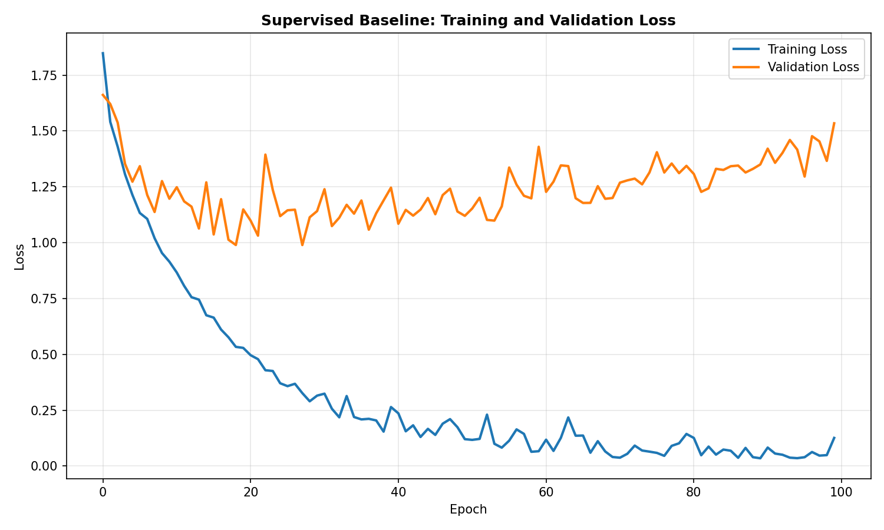

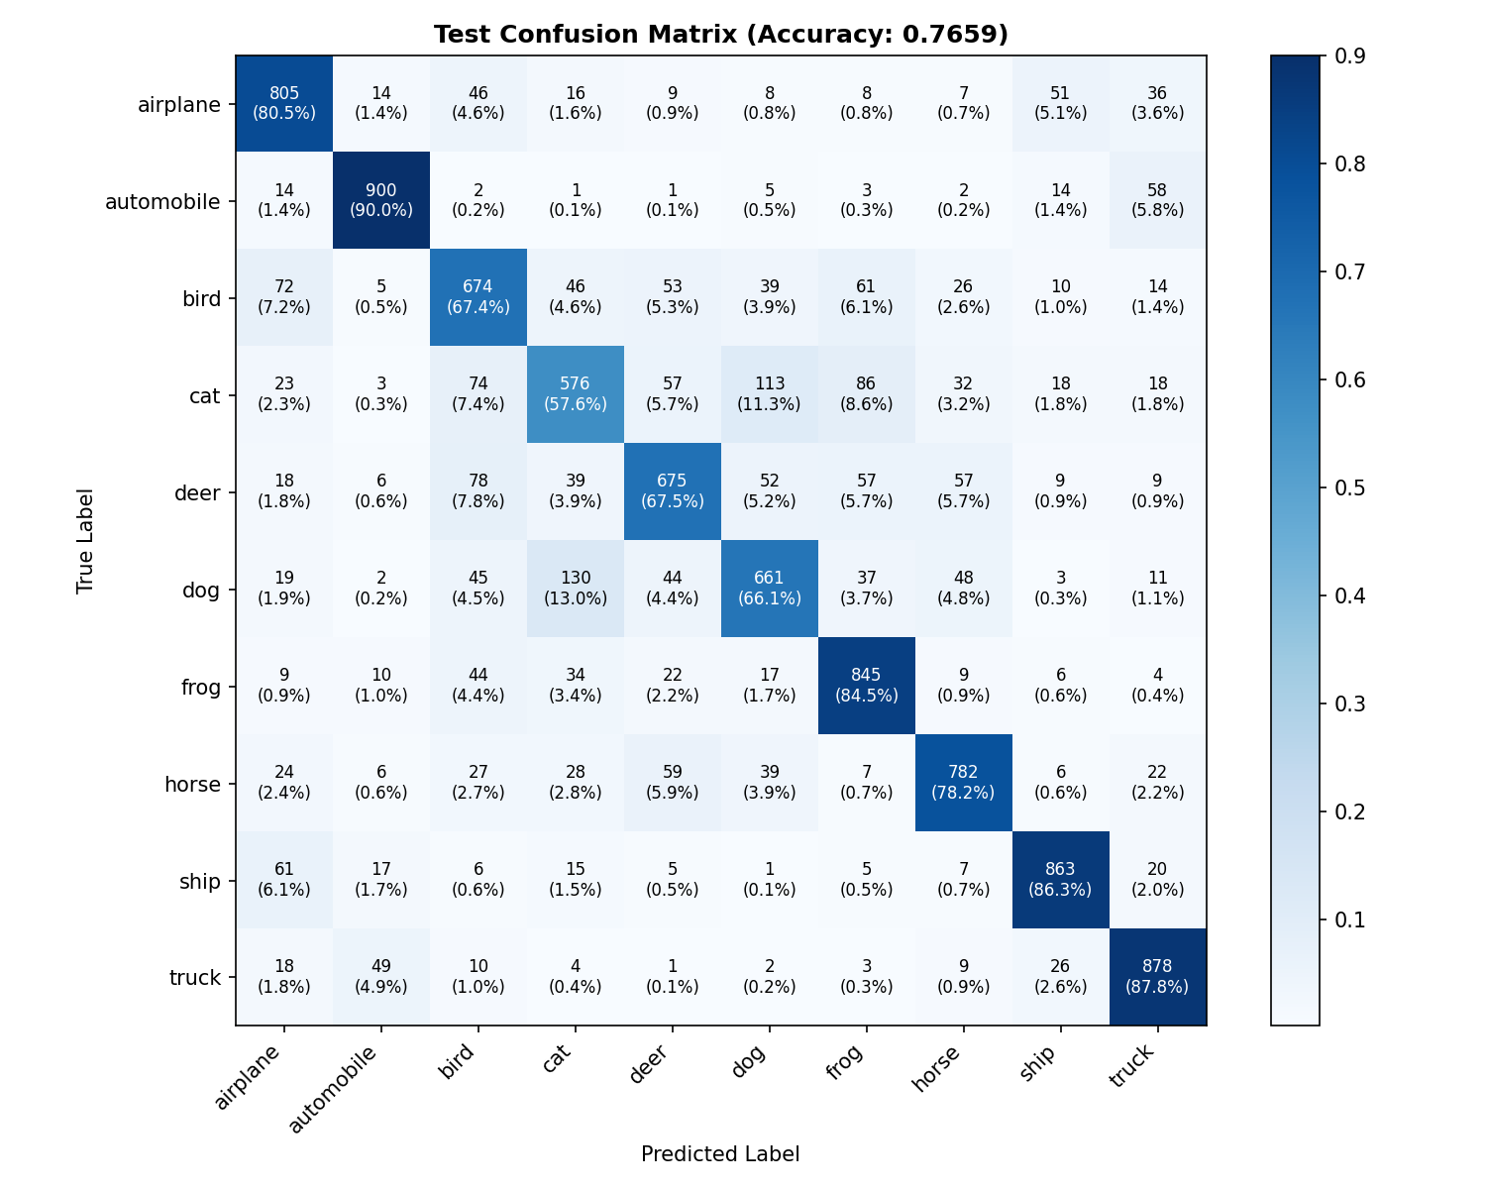

4. Augmentation Visualization
Insert augmentation_examples.png and discuss whether the two views preserve object identity.
yes — crops/flips/jitter should not change class

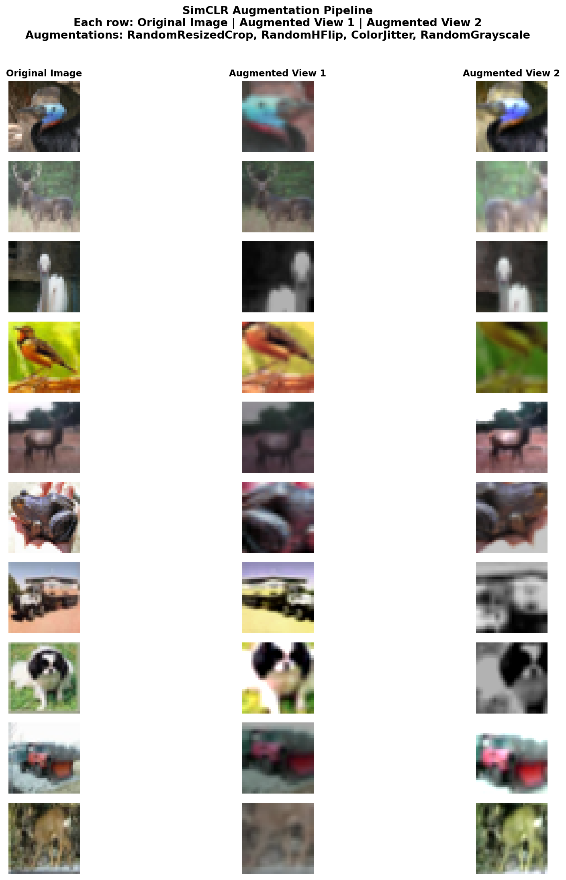

5. Feature Similarity Before Training
Report same-image and different-image cosine similarities before SimCLR training.
Interpretation: Before training, representations are almost equally similar for same and different images (no useful structure yet).

Metric | Value
Same-image (two views) mean cosine similarity | 0.989
Different-image mean cosine similarity | 0.985

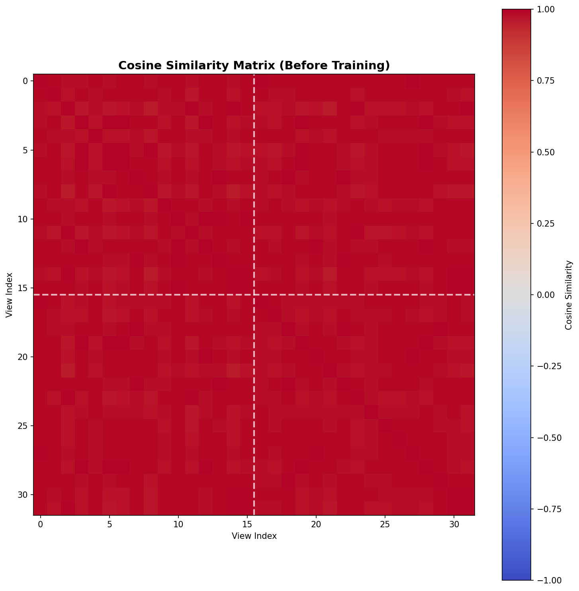

6. SimCLR Implementation
Explain positive/negative pairs, similarity matrix, diagonal masking, and NT-Xent loss at a conceptual level.
Architecture:
- Encoder: ResNet-18 (CIFAR) → 512-dim
- Projection head: Linear(512→256) → ReLU → Linear(256→128)
Positive / negative pairs (example batch size 4):
- 4 images → 8 augmented views
- 4 positive pairs (view1 ↔ view2 of same image)
- 6 negatives per sample (other views in the batch)
NT-Xent sanity check:
- Random pairs loss: 3.9464
- Identical pairs loss: 1.3363 (lower → loss behaves sensibly)
cosine similarity matrix, mask diagonal (no self-comparison), NT-Xent pulls positives together and pushes negatives apart.

7. SimCLR Pretraining Results
Insert SimCLR loss curve and before/after similarity table.
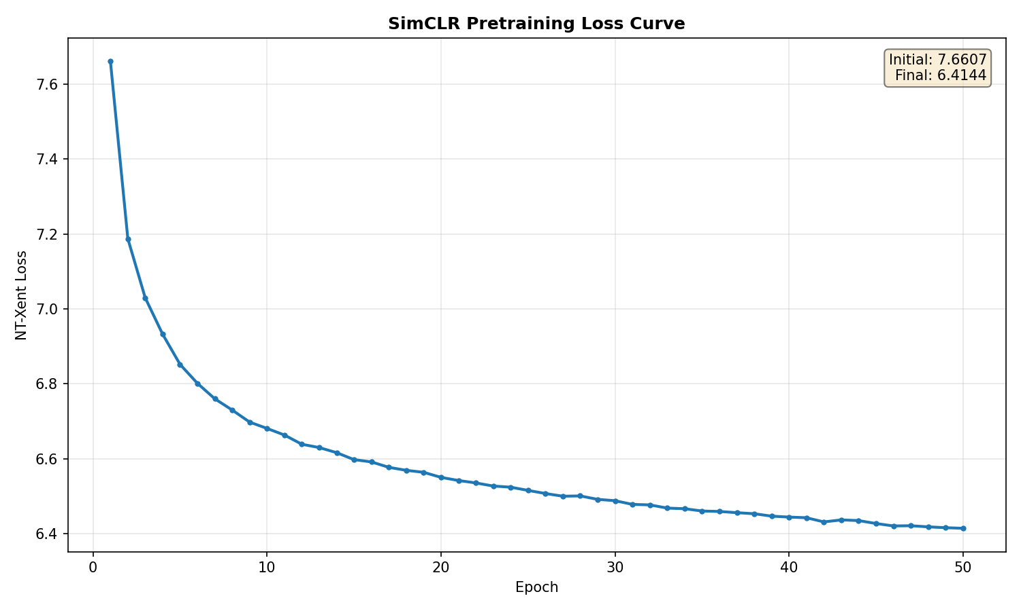
Training summary:
Item | Value
Unlabeled images | 45,000
Batches/epoch | 703
Initial loss | 7.6607
Final loss | 6.4144
Training time | 186.5 minute

Before / after similarity table:
 | Same-image views | Different images
Before | 0.989 | 0.985
After | 0.904 | 0.008

After SimCLR, same-image views stay highly similar; different images are pushed apart (near 0) — contrastive learning worked.


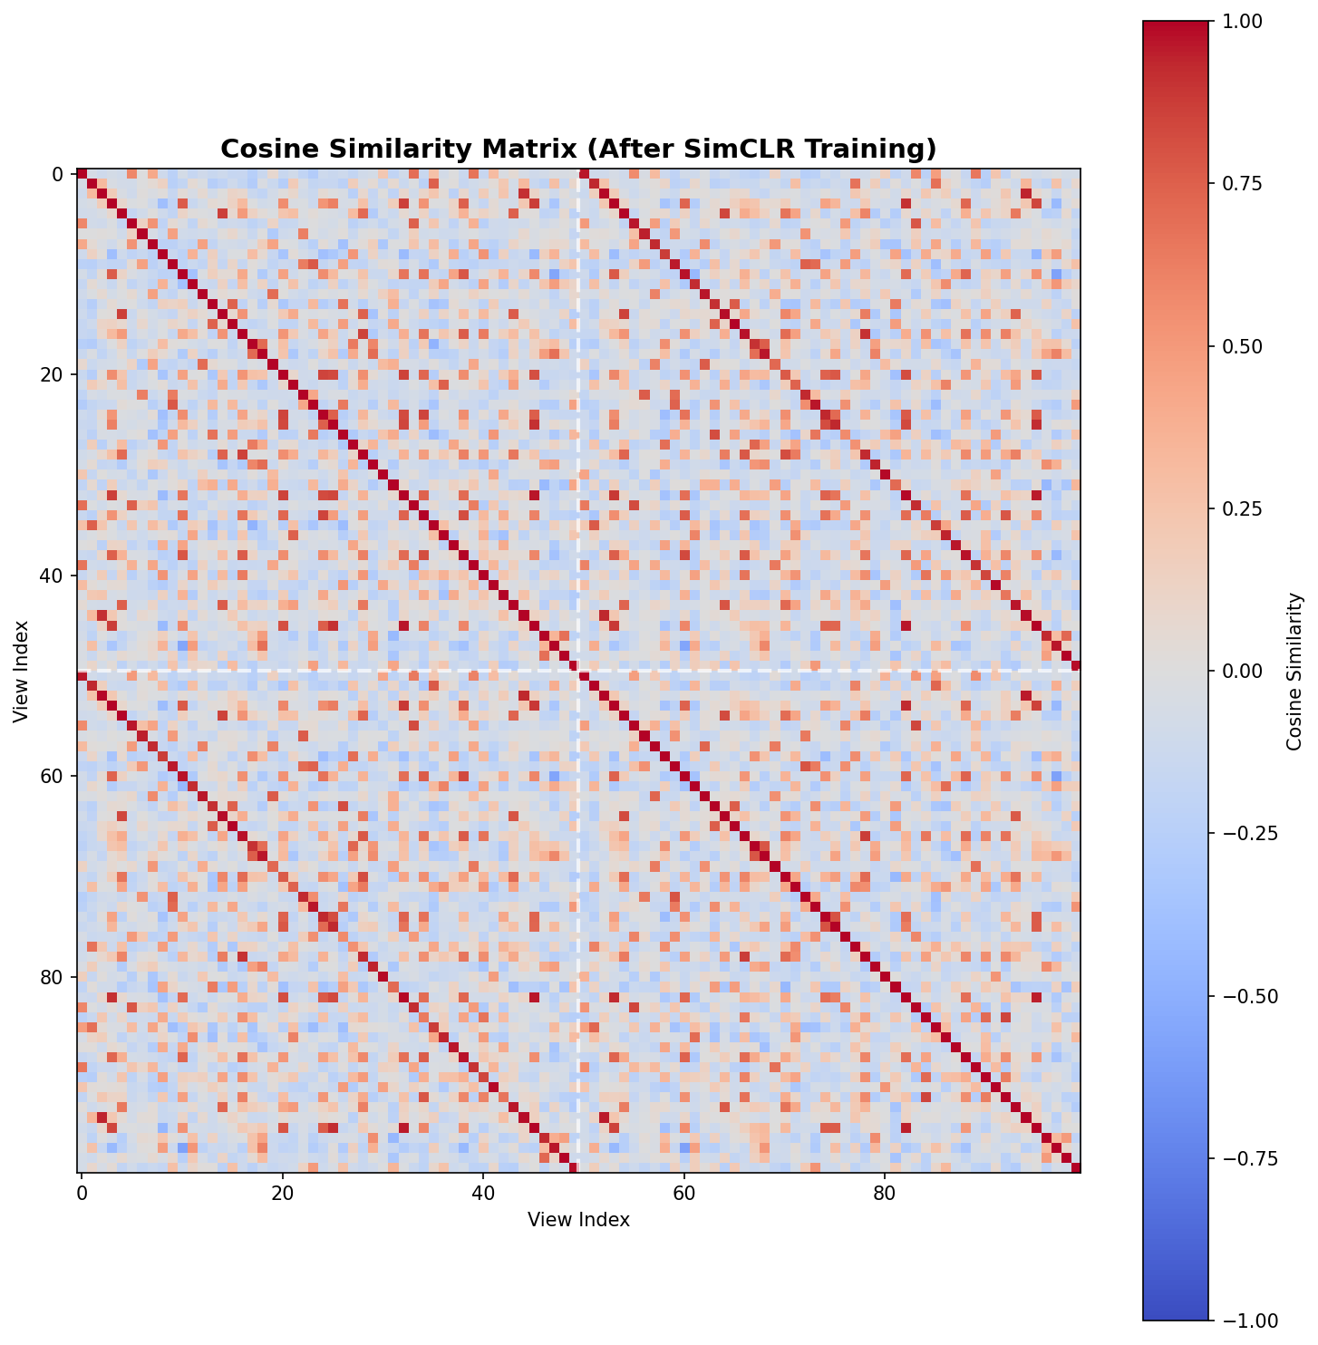

8. Linear Probe Evaluation
Compare random frozen encoder with SimCLR frozen encoder.

Encoder | Test accuracy
Random frozen + linear head | 27.25%
SimCLR frozen + linear head | 74.76%

9. Fine-tuning Results
Compare supervised baseline, random linear probe, SimCLR linear probe, and SimCLR fine-tuning.
Experiment | Test Accuracy
Supervised ResNet-18 from scratch using 10% labels | 69.56%
Random frozen encoder + linear classifier | 23.28%
SimCLR frozen encoder + linear classifier | 73.17%
SimCLR pretrained encoder + full fine-tuning | 81.67%

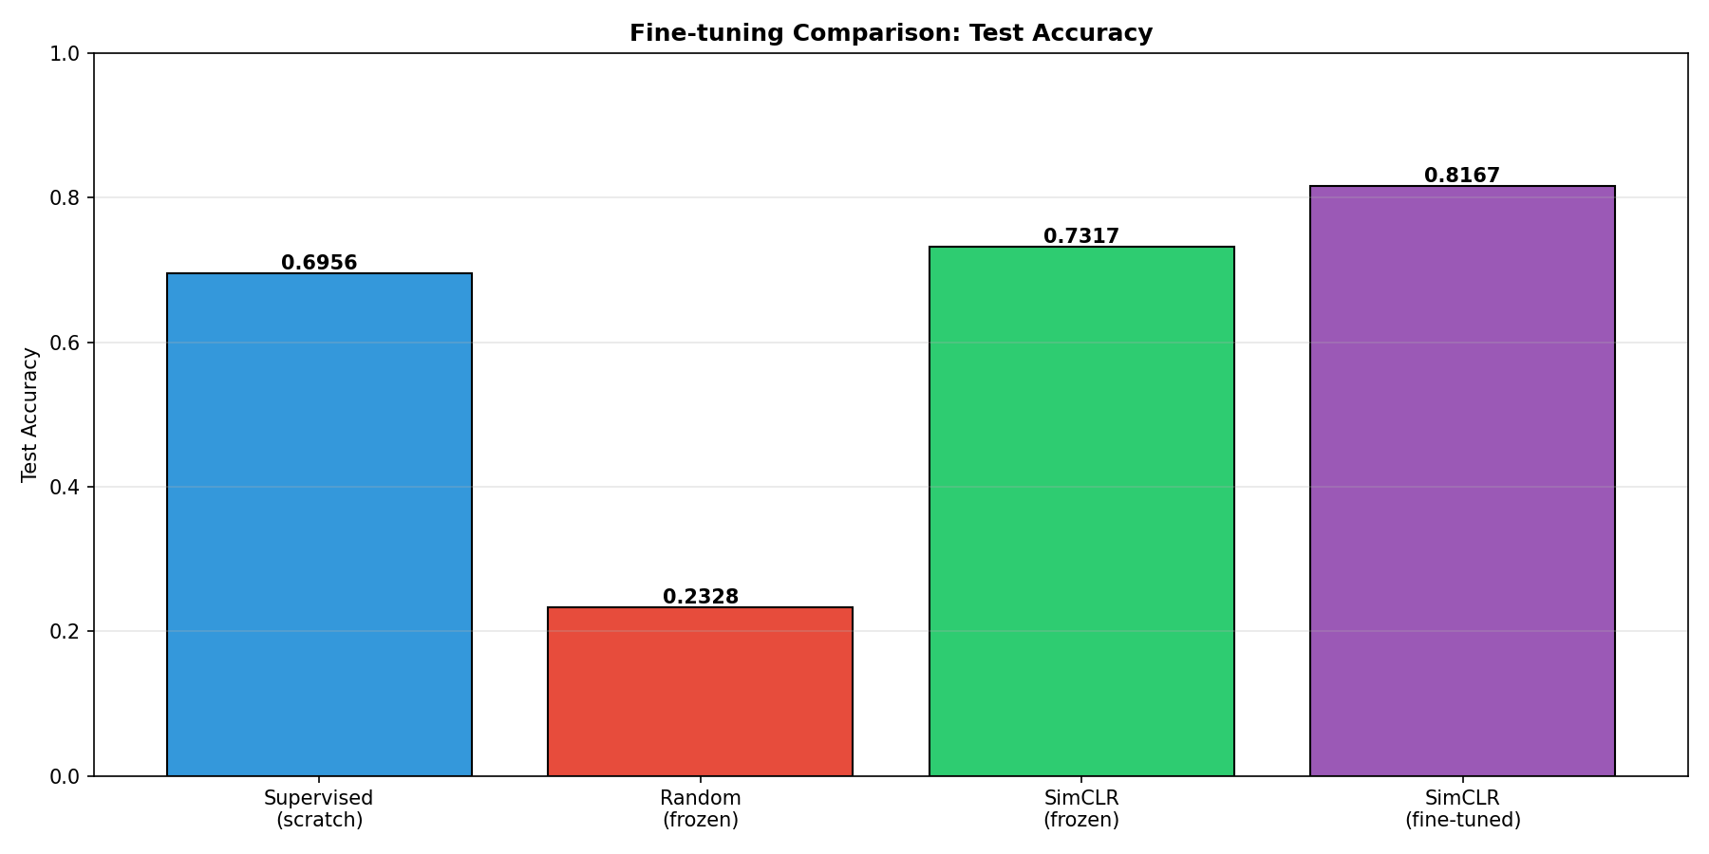
- SimCLR frozen (73.17%) beats supervised scratch (69.56%) with the same 10% labels.
- Full fine-tuning (81.67%) is best — pretraining + adaptation beats linear probe alone.
- Random frozen encoder (~23%) stays near useless features.

10. PCA or t-SNE Visualization
Insert random encoder, SimCLR encoder, and fine-tuned encoder PCA/t-SNE plots and discuss class grouping.
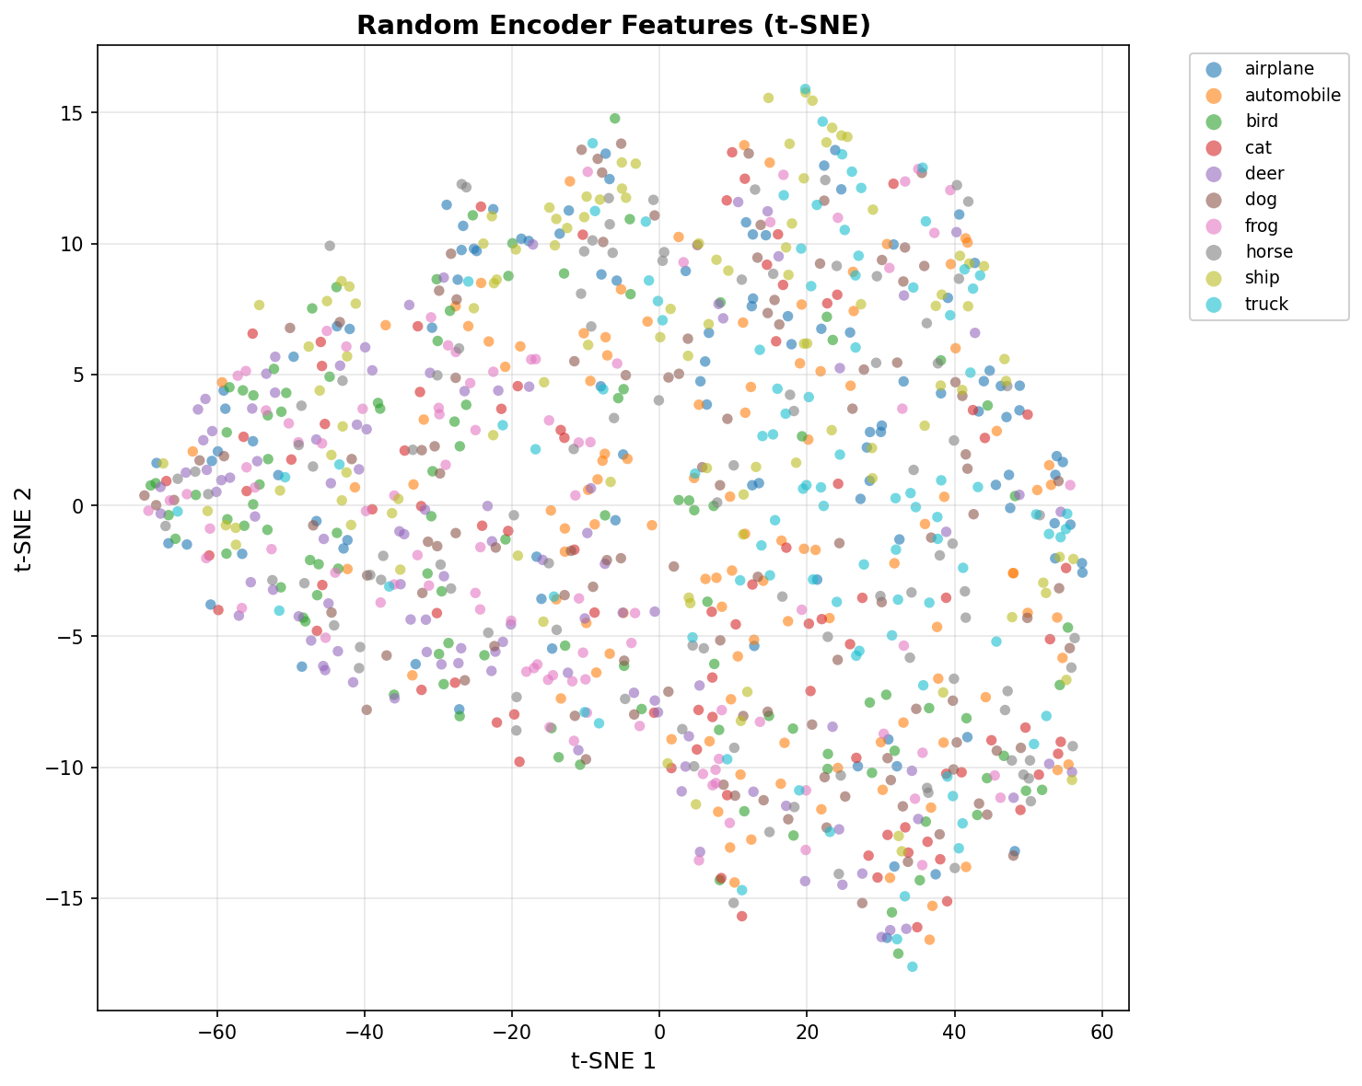

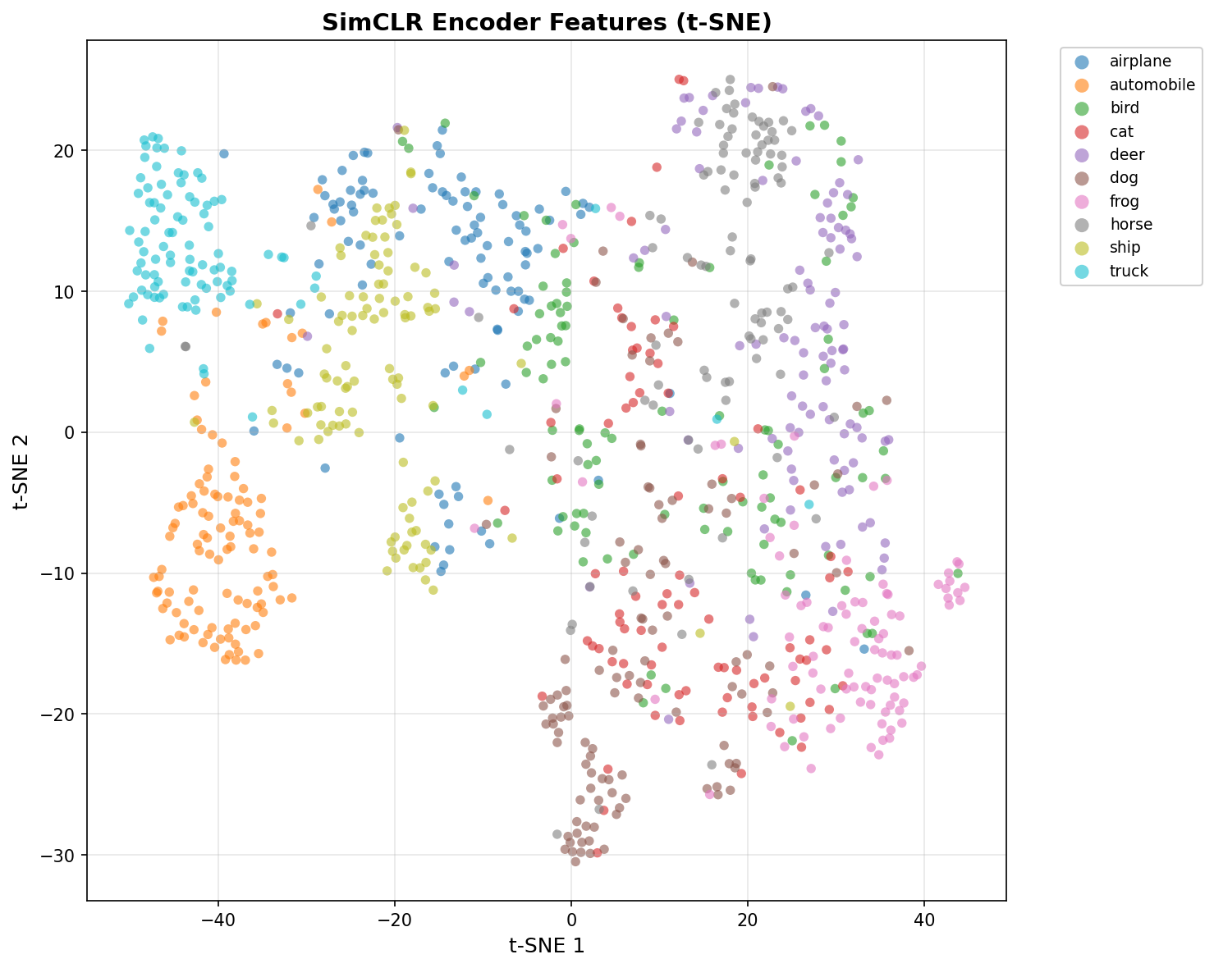
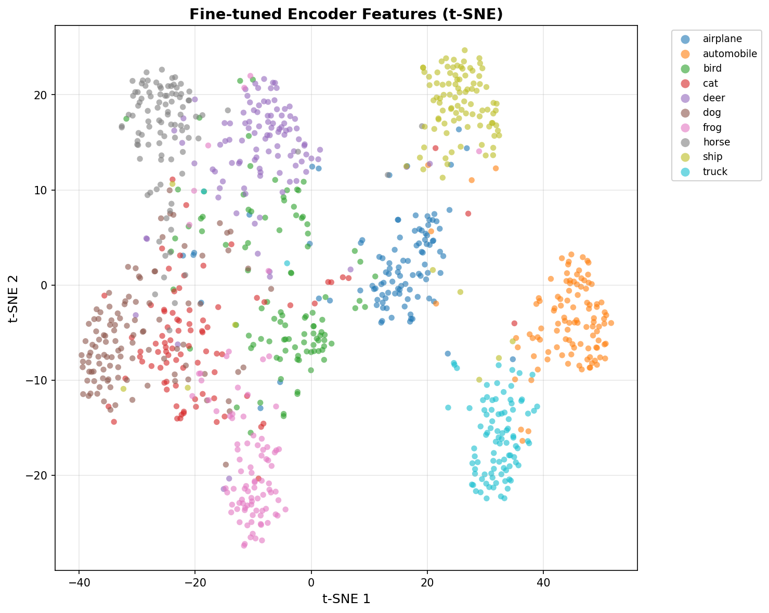
Random encoder → weak/mixed clusters; SimCLR → clearer class groups; fine-tuned → tightest separation (1000 val samples, t-SNE).

11. Discussion and Limitations
Discuss what worked, what did not work, and what you learned about self-supervised learning.
- Self-supervised pretraining helps when labels are scarce.
- Similarity before/after shows the encoder learned structure without labels.
- Fine-tuning gives the highest accuracy (81.67%).
- Limitations: only 10% labels, CIFAR-10 only, 50 SimCLR epochs, loss still ~6.4 (not fully converged), t-SNE is qualitative, compute time (~3 h pretrain alone).

