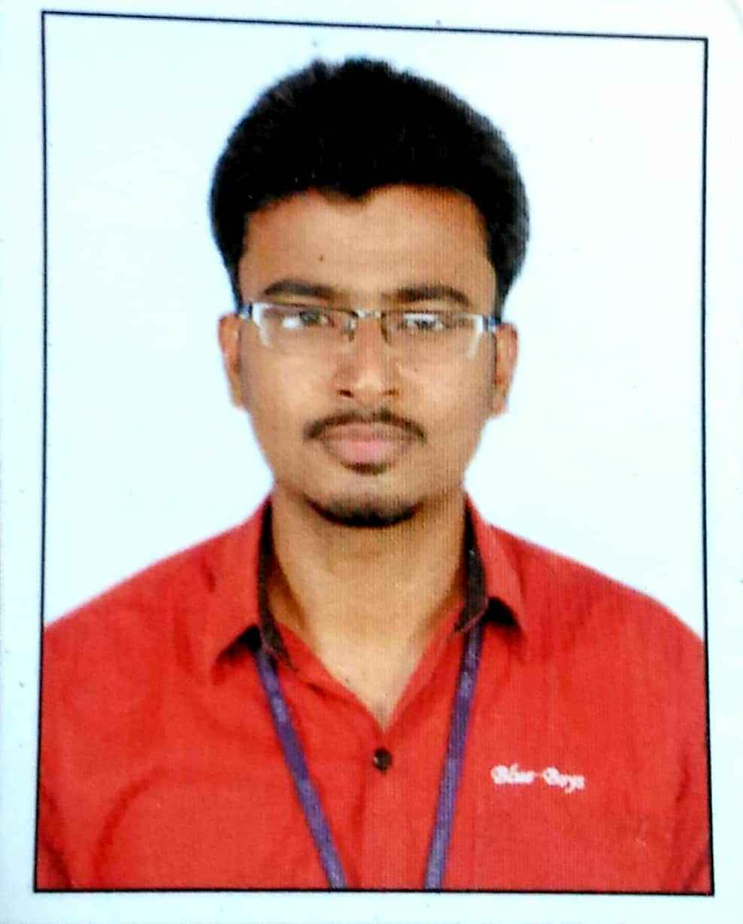

**Summary**

I have extensive experience in developing web applications using a range of technologies including PHP, Node.js and popular front-end frameworks like Angualr and React JS. I am proficient in server-side scripting with PHP, and have built applications using frameworks such as slim and CodeIgniter, with a strong understanding of database design and management using MySQL and other relational databases. passion for staying up-to-date with the latest technologies and a commitment to delivering high-quality, scalable applications, I am confident in my ability to drive success in any development team.

Sadam Hussain

Software Engineer

[sadamvision@gmail.com](mailto:sadamvision@gmail.com) phone:9677700469

phone:9677700469

+91 9677700469

sadamvision@gmail.com

### Skills

* **Frontend** : Html5 Css3 Javascript Frameworks Angular5,Angular8 and React JS**,.**
* **Backend** : PHP and Node.js Frameworks Codeigniter Slim and Express**,.**
* **API :** RESTful API
* **Database :** SQL,.
* **Cloud** : AWSandDocker**,.**
* **Tools** : Git,Postman,Mysql Workbench and FileZilla,.

### Education

BE computer Science and Engineering

S.K.P Engineering college

Thiruvannamalai 2012-2016

### Certificates

* **Fundamentals of DevOps**
* **certificate by NSDC (CAN_1922703)**

### Experience

**Full Stack Web Developer** 03/2022 to Present

**TCP international inc,** Coimbatore

* Used **Angualr,Codeigniter Php Framework**,**NodeJS** and SQL to develop app-solutions
* Developed efficient and maintainable software according to business objectives and needs of clients.
* Build from scratch new project and currently working in 3 different projects

**Process Associate** 11/2016 to 05/2017

**Aagna Global,** Chennai

* Streamlined and optimized company processes resulting in a 25% increase in productivity.
* Consistently met or exceeded performance metrics, resulting in recognition as a top-performing process associate in the department.

### Links

https://www.linkedin.com/in/sadam-hussain-developer