Low-Cost Real-Time Network Intrusion Detection System Using Raspberry Pi

By:
Sada Ullah
45871
Syed Noroz Ali
45496
Muhammad Aashan Hussain
43914
Supervised by:
Dr. Muhammad Mansoor Alam

Faculty of Computing
Riphah International University, Islamabad
Spring 2026
Submitted To
Faculty of Computing,
Riphah International University, Islamabad
As a Partial Fulfillment of the Requirement for the Award of the Degree of
Bachelors of Science in Cyber Security

Faculty of Computing
Riphah International University, Islamabad

09 June 2026

Final Approval

This is to certify that we have read the report submitted by Sada Ullah 45871, Syed Noroz Ali 45496, Muhammad Aashan Hussain 43914, for the partial fulfillment of the requirements for the degree of the Bachelor of Science in Cyber Security (BS CYS). It is our judgment that this report is of sufficient standard to warrant its acceptance by Riphah International University, Islamabad for the degree of Bachelor of Science in Cyber Security (BS CYS).

Committee:

1 | Dr. Muhammad Mansoor Alam  (Supervisor)
2 | Dr. Musharraf Ahmed  (Head of Department/chairman)
Declaration
We hereby declare that this document “Low-Cost Real-Time Network Intrusion Detection System Using Raspberry Pi” neither as a whole nor as a part has been copied out from any source. It is further declared that we have done this project with the accompanied report entirely on the basis of our personal efforts, under the proficient guidance of our teachers especially our supervisor Dr. Muhammad Mansoor Alam. If any part of the system is proved to be copied out from any source or found to be reproduction of any project from anywhere else, we shall stand by the consequences.

___________________________
Sada Ullah
45871

___________________________
Syed Noroz Ali
45496

___________________________
Muhammad Aashan Hussain
43914

Dedication
This project is lovingly dedicated to our parents, whose endless support, prayers, and encouragement have been the backbone of our journey. Their belief in us gave us the strength to overcome challenges and keep moving forward.

We also dedicate this work to our teachers, who guided us with patience and wisdom. Their passion for teaching and their continuous encouragement inspired us to push our limits and complete this project with confidence.

To our families and mentors, thank you for being our greatest source of motivation.

Acknowledgement
First of all we are obliged to Allah Almighty the Merciful, the Beneficent and the source of all Knowledge, for granting us the courage and knowledge to complete this Project.
We would like to express our deepest gratitude to Dr Muhammad Mansoor Alam, whose guidance, encouragement, and expertise played a central role in the completion of this project. His constant support, insightful feedback, and patient supervision helped us stay focused, improve our work, and understand the subject more clearly. We truly appreciate the time and effort he invested in guiding us throughout this journey.
Our heartfelt thanks go to our classmates and friends, who supported us through discussions, feedback, and teamwork whenever we needed help. Their cooperation and positivity made this experience more enjoyable and productive.

___________________________
Sada Ullah
45871

___________________________
Syed Noroz Ali
45496

___________________________
Muhammad Aashan Hussain
43914

Abstract
Network security threats are increasing rapidly, posing serious risks to organizations of all sizes. However, enterprise-grade Intrusion Detection Systems (IDS) are financially inaccessible to small and medium-sized enterprises (SMEs), educational institutions, and home networks due to their high cost. This project presents the design and implementation of a Low-Cost Real-Time Network Intrusion Detection System (NIDS) using Raspberry Pi 4 (8GB) as the core hardware platform.
The proposed system integrates Suricata, an open-source multi-threaded IDS engine, with eighteen custom detection rules written by the team; the Emerging Threats Open ruleset (over 50,000 signatures) was evaluated during development but is not loaded in the final configuration. Network traffic is captured on a wired monitoring interface in promiscuous mode using AF-PACKET. The system detects a wide range of attacks including port scanning, stealth scanning, OS fingerprinting, ICMP and SYN floods, SSH and FTP brute force, web attacks (SQL injection and cross-site scripting), and malware downloads.
A real-time web dashboard built using Flask provides live traffic monitoring, and instant alerts are sent via severity-coded HTML email. Experimental results show a 100% detection rate across nine tested attack categories, with alerts raised within about two to three seconds and packet loss below 1% (0.70%) under normal traffic. The total hardware cost of the complete system is approximately $70 USD (PKR 21,000+), making it far more affordable than commercial IDS solutions.
This work demonstrates that high-accuracy real-time network intrusion detection is achievable on low-cost ARM-based edge hardware, providing a practical and reproducible security solution for budget-limited environments.

Table of Contents
Section / Heading Page No.

LIST OF FIGURES 11
List Of Tables 12
Chapter 1: Introduction 14
1.1 Opportunity & Stakeholders 14
1.2 Motivations and Challenges 15
1.3 Significance of Study 17
1.4 Goals and Objectives 19
1.5 Scope of Project 20
1.6 Chapter Summary 22
Chapter 2: Literature / Market Survey 25
2.1 Introduction 25
2.2 Literature Review / Technologies & Products Overview 25
2.2.1 Network Intrusion Detection Systems Conceptual Background 25
2.2.2 Open-Source IDS Tools Reviewed 26
2.2.3 Supporting Tools 28
2.2.4 Commercial IDS Market Survey 29
2.2.5 Review of Related Academic Work 30
2.2.6 Influence of the Literature on Design Decisions 36
2.3 Comparative Analysis 36
2.4 Research Gaps 38
2.5 Problem Statement 39
2.6 Chapter Summary 40
Chapter 3: Requirements and System Design 42
3.1 Introduction 42
3.2 System Architecture 42
3.2.1 System Design Diagrams 45
3.3 Functional Requirements 48
3.4 Non-Functional Requirements 49
3.5 Hardware and Software Requirements 50
3.6 Threat Scenarios (Threat Handling) 51
3.7 Threat Modeling (STRIDE) and Detection Techniques 52
3.8 Threat Resistance Model 53
3.9 Chapter Summary 54
Chapter 4: Proposed Solution 56
4.1 Introduction 56
4.2 Proposed Model 56
4.3 Data Collection 57
4.4 Data Pre-Processing 58
4.5 Tools and Techniques 58
4.6 Evaluation Metrics 60
4.7 Chapter Summary 61
Chapter 5: Implementation and Testing 63
5.1 Security Properties Testing 63
5.2 System Setup (Environment Configuration, Key Functions and Algorithms) 63
5.3 System Integration 64
5.4 Penetration Testing and Vulnerability Assessment 65
5.4.1 Methodology 65
5.5 Test Cases 66
5.6 Prevention Testing (IPS Mode and Automatic Blocking) 69
5.7 Best Practices / Coding Standards 70
5.7.1 Code Validation 70
5.7.2 Development Practices & Standards 70
5.8 Chapter Summary 71
Chapter 6: Conclusion and Future Work 73
6.1 Introduction 73
6.2 Achievements and Improvements 73
6.3 Critical Review 74
6.4 Future Recommendations 75
6.5 Chapter Summary 76

LIST OF FIGURES
Figure No. and Caption Page
3.1 NetGuard Pi system architecture 42
3.2 NetGuard Pi 4-layer real-time NIDS/IPS architecture 45
3.3 Use case diagram 46
3.4 Data flow diagram – Level 0 46
3.5 Data flow diagram – Level 1 47
3.6 Sequence diagram for detection, alerting and blocking 48
3.7 Threat scenarios mapped to attack vectors and rules 52
4.1 End-to-end detection, alerting and response pipeline 57
4.2 Tools and techniques stack 60
5.1 Detection rate per attack test 69
5.2 Performance under idle, normal load and attack conditions 69

List Of Tables
Table No. and Caption Page

Table 2.1 Survey of existing IDS/IPS products 29
Table 2.2 Commercial IDS/IPS market comparison 30
Table 2.3 Literature review (research papers and studies) 35
Table 2.4 Mapping of literature to design decisions 36
Table 2.5 Comparative analysis of open-source IDS engines 37
Table 2.6 Feature comparison of Suricata, Snort and Zeek 38
Table 3.1 Functional requirements 48
Table 3.2 Non-Functional requirements 49
Table 3.3 Threat scenarios 51
Table 3.4 STRIDE threat model 53
Table 4.1 Tools and techniques 58
Table 4.2 Evaluation metrics, targets and achieved values 60
Table 5.1 Environment configuration 63
Table 5.2 Test cases and results 66
Table 5.3 Test case T1 – TCP SYN port scan 67
Table 5.4 Test case T6 – FTP brute force 68
Table 5.5 Test case T8 – SQL injection with prevention 68
Table 5.6 System performance under three traffic conditions 69
Table 5.7 Inline IPS before and after 70
Table 6.1 FYP-1 tasks and status 73

Chapter 1:
INTRODUCTION

Chapter 1: Introduction
The rapid growth of internet-connected devices and digital infrastructure has significantly expanded the attack surface for malicious actors. Cyber threats such as Denial of Service (DoS) attacks, port scanning, brute force intrusions, and botnet activities are increasing in both frequency and sophistication. Organizations worldwide suffer billions of dollars in losses annually due to network breaches and unauthorized access. While large enterprises can afford sophisticated Intrusion Detection Systems (IDS), small and medium-sized enterprises (SMEs), educational institutions, and home network users are left largely unprotected due to the prohibitive cost of commercial solutions.
This project addresses this critical gap by designing and implementing a Low-Cost Real-Time Network Intrusion Detection System (NIDS) using the Raspberry Pi 4 (8GB) as the core hardware platform. The system is referred to throughout this report as NetGuard Pi. By combining open-source tools such as Suricata with custom detection rules and deploying them on affordable edge hardware, this system brings enterprise-level intrusion detection capabilities within reach of budget-limited environments. The total hardware cost of the complete system is approximately $70 USD (PKR 21,000+) compared to commercial IDS solutions that cost $30,000 to $100,000 per year. The system operates entirely on-device with no cloud dependency, consuming under 10 watts of power while monitoring network traffic in real time.

1.1 Opportunity & Stakeholders
The increasing digitization of homes, schools, hospitals, and small businesses has created a massive demand for affordable network security solutions. Despite this need, the market for Intrusion Detection Systems remains dominated by expensive enterprise products that are simply out of reach for smaller organizations. This creates a significant opportunity to develop a low-cost, open-source, and edge-deployable IDS that can serve a wide range of users.
Opportunity:
The Raspberry Pi 4 (8GB) offers a powerful ARM-based computing platform at a fraction of the cost of traditional server hardware. Combined with open-source IDS tools such as Suricata and a set of custom detection rules, it presents an opportunity to deliver real-time intrusion detection at a total hardware cost of approximately $70 USD (PKR 21,000+) - more than 100 times more affordable than commercial alternatives that charge $30,000 to $100,000 per year. Furthermore, the entire software stack including Suricata, Python, Flask, and SQLite is completely free and open-source, eliminating any licensing costs.
Primary Stakeholders:
- Small and Medium-Sized Enterprises (SMEs): Businesses with limited IT budgets that need basic network protection but cannot afford commercial IDS solutions costing tens of thousands of dollars annually.
- Educational Institutions: Schools, colleges, and universities that manage internal networks containing sensitive student and staff data but operate under tight financial constraints.
- Home Network Users: Technically aware individuals who want to actively monitor and protect their home networks from unauthorized access and cyber threats.
- Cybersecurity Researchers and Students: Those who require an affordable, hands-on, and fully reproducible IDS platform for academic research, learning, and experimentation.
- Supervisors and Academic Evaluators: Dr. Muhammad Mansoor Alam and the Faculty of Computing at Riphah International University, who provide guidance and evaluate this work as part of the BS Cyber Security Final Year Project requirement.

1.2 Motivations and Challenges
Motivations:
The development of NetGuard Pi is driven by a convergence of technical opportunity, social need, and academic relevance.
- Rising Cyber Threat Landscape Global cybercrime is on the rise. Network intrusion attacks including Denial of Service (DoS), Distributed Denial of Service (DDoS), port scanning, brute force, man-in-the-middle attacks, and protocol exploits are increasing in both volume and sophistication. Attackers use automated tools to scan millions of IP addresses simultaneously, identifying vulnerable systems within minutes. Without a detection capability, these attacks proceed silently and invisibly.
- Affordability Gap Commercial IDS solutions are priced for enterprises, not individuals or small organizations. Entry-level commercial IDS appliances start at roughly $2,000–$5,000, with most enterprise deployments costing $10,000–$50,000 or more annually. This pricing model excludes the majority of global network environments from basic intrusion detection coverage.
- Availability of Low-Cost Hardware The Raspberry Pi 4 Model B (8GB RAM) is a credit-card-sized single-board computer available for approximately $55–$70. Despite its compact size and low cost, it offers a 1.8GHz quad-core ARM Cortex-A72 processor, 8GB LPDDR4 RAM, Gigabit Ethernet, dual-band Wi-Fi, and USB 3.0 more than sufficient to run a full-featured IDS engine in real time.
- Maturity of Open-Source IDS Tools Suricata, developed by the Open Information Security Foundation (OISF), is a professional-grade, multi-threaded NIDS/NIPS engine used in enterprise environments globally. It supports the Emerging Threats Open rule set containing over 50,000 active signatures covering a comprehensive range of attack types. It is entirely free and open-source, with no licensing fees.
- Local Relevance Pakistan's cybersecurity infrastructure is underdeveloped relative to the scale of its digital economy. Educational institutions and SMEs operate without basic network monitoring tools. This project addresses a directly relevant local need, with the solution specifically designed and validated for deployment in Pakistani universities and SMEs.
Challenges:
The development of NetGuard Pi involved overcoming a series of technical, practical, and design challenges:
Technical Challenges Encountered:
- Wrong Network Interface: The initial configuration targeted the wrong capture interface, while the monitoring network used the wired Ethernet interface (eth0). This required reconfiguring Suricata's capture interface and verifying packet capture on the correct interface using tcpdump.
- Rules Path Error: Suricata failed to load rules due to an incorrect path specified in suricata.yaml. The rules directory (/var/lib/suricata/rules/) had to be correctly configured and verified before all rules (50,193 in total) loaded successfully with zero failures.
- Custom Rule Threshold Tuning: Initial threshold values for custom detection rules triggered excessive false positives on normal traffic. Rules were iteratively tuned for example, SYN scan detection was set at 5 SYN packets within 3 seconds, balancing sensitivity with specificity.
- Packet Capture Verification: Confirming that Suricata was actually capturing all traffic on the subnet required independent verification using tcpdump and Wireshark, ensuring AF-PACKET promiscuous mode was functioning correctly.
- Remote Access Setup: Configuring PuTTY SSH access and RealVNC remote desktop on Raspberry Pi OS required correct sshd and VNC server configuration, including firewall rules and authentication setup.
- Suricata Not Starting on Boot: Suricata failed to start automatically on system boot due to a systemd service configuration issue, which was resolved by properly enabling the Suricata systemd service unit.

1.3 Significance of Study
This project carries significance across multiple dimensions financial, technical, educational, social, and national.
- Democratizing Network Security The most fundamental significance of this project is that it makes professional-grade network intrusion detection accessible to everyone, not just large organizations. By achieving a functional NIDS at about $70, roughly 30 times cheaper than the cheapest commercial appliance in Table 2.2 (about $2,000), NetGuard Pi fundamentally changes the cost calculus of network security for home users, students, and small organizations globally.
- Validated Real-Time Performance The system achieves alert generation latency of about two to three seconds, which is well within the real-time range expected of a live intrusion-detection sensor. This demonstrates that real-time intrusion detection is technically feasible on commodity single-board computer hardware, contributing to the academic and professional understanding of resource-constrained IDS deployment.
- Complete Attack Coverage in Test Environment: the system achieved a 100% detection rate across all 9 attack types tested in the controlled lab environment, including TCP SYN port scans, stealth scans (XMAS/NULL/FIN), aggressive scan with OS detection, ICMP flood, SYN flood, SSH brute force, FTP brute force, web attacks (SQL injection and XSS), and malware download (EICAR test file). This breadth of coverage demonstrates the practical effectiveness of the Suricata + Raspberry Pi combination.
- Educational and Research Platform The platform serves as a powerful educational tool. Students and researchers can use NetGuard Pi to observe real intrusion detection in action, write and test custom Suricata rules, simulate attacks from Kali Linux, and study IDS performance characteristics all on hardware that costs less than a university textbook.
- National Relevance Pakistan Context Pakistan's cybersecurity ecosystem faces significant resource constraints. Universities, SMEs, and government institutions often operate without any network monitoring. A solution specifically designed, built, and validated in a Pakistani university environment (Riphah International University) has direct and immediate applicability to hundreds of similar institutions across the country.
- Open-Source and Reproducible Because NetGuard Pi is built entirely on open-source software Suricata, Wireshark, Python, Raspberry Pi OS the complete system can be reproduced, audited, modified, and extended by anyone. There are no licensing fees, proprietary dependencies, or vendor lock-in. This makes the solution freely deployable globally.
- Energy Efficiency Operating at only 8 watts, NetGuard Pi can run continuously 24/7 with negligible electricity use of about 70 kWh per year (8 W × 8,760 hours). This makes always-on monitoring genuinely practical for cost-sensitive environments.
- Foundation for Future Development The FYP-1 prototype establishes a validated technical foundation that has since been extended with active IPS capabilities (inline NFQUEUE blocking and automatic IP blocking) and email alerting. Further work distributed-DDoS mitigation, SMS/push alerting, a Grafana cloud dashboard and machine-learning anomaly detection would extend it toward a full enterprise Network Intrusion Prevention System (NIPS).

1.4 Goals and Objectives
Primary Goal:
The primary goal of this project is to design, implement, and validate a low-cost, real-time Network Intrusion Detection System (NIDS) using Raspberry Pi 4 and the Suricata IDS engine, capable of detecting real network attacks in real time at a total hardware cost of about $70.
Specific Objectives
- Study and Understand IDS Fundamentals Develop a thorough understanding of IDS concepts, architectures (NIDS vs HIDS), detection methodologies (signature-based vs anomaly-based), and the taxonomy of common network attacks including SYN scans, port scans, service enumeration, DoS, DDoS, and brute force attacks.
- Conduct Literature Review and Tool Selection Review and compare existing open-source IDS tools specifically Suricata, Snort, and Zeek across dimensions of performance, multi-threading capability, rule set support, Raspberry Pi compatibility, and community support. Select the most appropriate tool for resource-constrained deployment on Raspberry Pi 4.
- Design System Architecture Design a comprehensive 4-layer system architecture for NetGuard Pi, including full network topology definition (192.168.10.0/24 subnet), hardware specifications, software stack, data flow, and alert pipeline.
- Deploy and Configure the System: configure Raspberry Pi 4 (8GB) with Suricata 7.x, evaluate the Emerging Threats Open ruleset (50,000+ signatures), deploy the 18 custom rules as the final rule set, set up SSH and VNC remote access, and develop the Python alert collector (reads eve.json, stores to SQLite, sends email) with a Flask web dashboard - achieving zero rule-loading failures.
- Develop Custom Detection Rules Write and tune 18 custom Suricata rules (13 in local.rules, SIDs 1000001–1000013, and 5 team rules, SIDs 9000001–9000005) to detect port and stealth scans, ICMP and SYN floods, SSH and FTP brute force, SQL injection, XSS and malware (EICAR), with calibrated thresholds to minimize false positives.
- Validate Through Live Attack Testing Conduct controlled penetration testing using Kali Linux VM (Nmap 7.95) as the attacker machine, simulating multiple attack types against the Raspberry Pi IDS. Validate detection of at least 3 attack types in FYP-1 (nine were validated in FYP-2) and independently verify alerts using Wireshark and tcpdump.
- Measure and Document Performance Measure and document key performance indicators: detection rate, alert latency, rule loading success rate, system uptime, power consumption, and total cost.
- Produce Complete Project Documentation Deliver a structured project report covering all phases of the project: literature review, system design document, implementation details, testing results, and future recommendations.

1.5 Scope of Project
The scope of this project defines the specific boundaries within which the proposed IDS system is designed to operate and the aspects that are addressed in this study.
In Scope:
- Hardware: The project uses a single Raspberry Pi 4 Model B (8GB RAM) as the IDS appliance, running on a 32GB MicroSD card with Raspberry Pi OS 64-bit. The total hardware cost is about $70 (PKR 21,000+). Remote access hardware includes any standard computer running PuTTY and RealVNC Viewer.
- Network Environment: The system operates on a lab subnet (192.168.10.0/24), monitoring traffic on the eth0 interface in AF-PACKET promiscuous mode. The test environment uses a controlled lab network with a Kali Linux VM (192.168.10.20) as the attacker.
Detection Capabilities: The system detects and was validated against the following attack types (see Section 5.5):
- Port scanning TCP SYN scan (T1)
- Stealth scans XMAS, NULL and FIN (T2)
- Aggressive / full scan service and OS detection (T3)
- ICMP flood denial of service (T4)
- SSH brute force (T5)
- FTP brute force (T6)
- TCP SYN flood denial of service (T7)
- Web attacks SQL injection and cross-site scripting (T8)
- Malware download EICAR test file over HTTP (T9)
- UDP port scan (additional test, Section 5.5)
- Telnet connection attempt – policy violation (additional test, Section 5.5)
- Distributed denial of service – ICMP and SYN floods from spoofed sources (additional test, Section 5.5)

Prevention Capabilities: inline IPS mode (Suricata drops matching packets via NFQUEUE) and automatic IP blocking (ip_blocker.py adds an iptables rule after 5 alerts in 30 seconds, lifted after 10 minutes), both implemented and tested in FYP-2 (see Section 5.6).
Software Stack: Suricata 7.x, custom local.rules (13 rules) plus 5 team rules (Emerging Threats Open rules, 50,000+ signatures, evaluated during development), Python 3 alert collector, SQLite, Flask dashboard, systemd services, Wireshark, PuTTY, RealVNC Viewer, Kali Linux VM (nmap, hping3, hydra, nikto, sqlmap), tcpdump, suricata-update.
Deliverables: In FYP-1 the literature review, system design document and a working detection prototype were completed. In FYP-2 the system was extended with prevention (inline IPS and automatic IP blocking), validated against nine attack types with a 100% detection rate, and evaluated for performance.
Out of Scope (Future Work):
- IPv6 attack detection: the custom rules and all tests use IPv4; IPv6-specific rules and testing are not included.
- Transparent in-line bridge deployment: in this version the inline IPS (NFQUEUE) and automatic IP blocking protect the Raspberry Pi itself. Deploying the Pi as a transparent in-line bridge that physically protects other hosts on the network is not included.
- Deep packet inspection of encrypted HTTPS or TLS traffic is not performed.
- High-throughput environments: the system was validated at up to about 100 Mbit/s (Table 5.6); performance at higher, enterprise-scale rates (up to and beyond 1 Gbps) has not been tested.
- Distributed DoS mitigation: spoofed-source floods are detected, but blocking them requires upstream filtering (ISP or scrubbing service) and is not included.
- Anomaly-based (machine-learning) detection of zero-day attacks is not included; detection is signature- and threshold-based.
- Monitoring of multiple network segments or other hosts’ traffic via a switch mirror (SPAN) port is not included.
- Cloud-based deployment, centralised management of multiple sensors, and multi-node federated detection are not included and are identified as areas for future work.

1.6 Chapter Summary
This chapter introduced NetGuard Pi project a low-cost, real-time Network Intrusion Detection System built on Raspberry Pi 4 and Suricata IDS. The chapter established the fundamental problem: the unaffordability of commercial IDS solutions for non-enterprise users, and the resulting security gap that leaves home users, university labs, students, and SMEs without any network monitoring capability. The key stakeholders were identified, and the project opportunity of delivering a NIDS roughly 30 times cheaper than the cheapest commercial appliance was clearly articulated. The motivations driving this project, the practical and technical challenges encountered, the multi-dimensional significance of the work, and the specific goals and objectives were all presented. The project scope was defined, distinguishing the FYP-1 detection prototype from the FYP-2 extensions (inline IPS, automatic IP blocking, full nine-attack validation and performance evaluation), both of which have been completed. The following chapters build on this foundation to detail the literature review, system design, proposed solution, implementation, testing, and conclusions.

Chapter 2:
Literature Review/ Market Survey

Chapter 2: Literature / Market Survey

2.1 Introduction
A thorough review of existing literature, technologies, and market products is essential to ground this project in current knowledge, justify design decisions, and identify the research gap that this work addresses. This chapter surveys academic research on Network Intrusion Detection Systems, evaluates and compares the major open-source IDS tools considered for deployment, examines the commercial IDS market, performs a comparative analysis, identifies the research gap, and formally states the problem this project solves.
The literature review was conducted by examining 19 peer-reviewed publications sourced from IEEE Xplore, ACM, Elsevier (ScienceDirect), MDPI, PLOS ONE, SpringerOpen, EAI and the USENIX/NDSS proceedings, supplemented by official documentation from the Suricata OISF community, Emerging Threats rule set documentation, and Raspberry Pi Foundation technical resources.

2.2 Literature Review / Technologies & Products Overview

2.2.1 Network Intrusion Detection Systems Conceptual Background
A Network Intrusion Detection System (NIDS) is a security tool that monitors network traffic flowing across a network segment, analyzes packets in real time, and generates alerts when patterns matching known attack signatures or behavioral anomalies are detected. NIDS systems operate in passive mode — they observe traffic without modifying or blocking it, providing visibility and alerting without interfering with normal network operations.
There are two primary detection paradigms in IDS:
- Signature-based detection compares network traffic against a database of known attack patterns (signatures). Each signature describes a specific attack or malicious behavior for example, a particular packet structure, a specific payload string, or a threshold rate of connection attempts. When a packet or traffic stream matches a signature, an alert is generated. This approach is highly accurate for known attacks and generates low false positive rates, but is limited in its ability to detect novel or zero-day attacks.
- Anomaly-based detection establishes a baseline model of normal network behavior and alerts when traffic deviates significantly from that baseline. This approach can detect previously unknown attacks but typically generates higher false positive rates and requires a training period to establish the baseline.
NetGuard Pi uses signature-based detection via Suricata, augmented with threshold-based custom rules that detect anomalous rates of specific packet types.

2.2.2 Open-Source IDS Tools Reviewed
Suricata (OISF Open Information Security Foundation)
Suricata is a high-performance, open-source NIDS/NIPS (Network Intrusion Detection and Prevention System) engine developed and maintained by the Open Information Security Foundation (OISF). Key characteristics include:
- Multi-threaded Architecture: Suricata uses multiple CPU threads simultaneously, enabling significantly higher packet processing throughput than single-threaded alternatives. This is critical on the Raspberry Pi 4, which has a quad-core CPU.
- Rule Compatibility: Supports both Snort and Suricata-native rule formats, providing access to an enormous ecosystem of community-developed signatures.
- Emerging Threats Open rule set: A curated, continuously updated set of over 50,000 signatures covering DoS attacks, scanning behavior, exploit attempts, malware command-and-control, and protocol anomalies all freely available.
- Multiple output formats: Generates alerts in fast.log (human-readable) and eve.json (structured JSON), facilitating integration with log management and visualization tools such as Elasticsearch, Loki, and Grafana.
- AF-PACKET Support: Native support for Linux AF-PACKET high-performance packet capture in promiscuous mode, enabling capture of all traffic on a network segment [21].
- Active Community: Strong documentation, active forum support, and regular updates from OISF.
Suricata was selected as the IDS engine for NetGuard Pi based on its multi-threaded performance on the Raspberry Pi 4's quad-core CPU, its large and high-quality rule set, its dual NIDS/NIPS capability (enabling the IPS mode implemented in FYP-2), and its structured eve.json output supporting future Grafana integration.
Snort (Cisco)
Snort is the original open-source NIDS, initially developed by Martin Roesch in 1998 and now maintained by Cisco. It pioneered signature-based network intrusion detection and remains widely used. Key characteristics include:
- Single-threaded architecture: Snort 2.x (the most widely deployed version) is fundamentally single-threaded, limiting its packet processing capacity on multi-core hardware. Snort 3.x introduces multi-threading but has a steeper configuration curve.
- Large rule ecosystem: Snort has a mature and extensive rule ecosystem, though the free "community rules" are less comprehensive than Suricata's Emerging Threats Open set.
- Proven track record: Decades of deployment in production environments.
- Limitations on RPi 4: The single-threaded architecture of Snort 2.x does not leverage the Raspberry Pi 4's quad-core CPU effectively, resulting in lower throughput under load compared to Suricata.
Snort was not selected for this project due to its single-threaded architecture limiting performance on resource-constrained hardware, and the superior rule set available for Suricata.
Zeek (formerly Bro)
Zeek is a powerful open-source network analysis framework, originally developed at the Lawrence Berkeley National Laboratory. Key characteristics include:
- Traffic analysis framework: Zeek is less a traditional signature-based IDS and more a network traffic analysis engine. It focuses on deep behavioral logging rather than real-time alert generation.
- Scripting language: Zeek uses its own domain-specific scripting language for policy specification, offering high flexibility but requiring significant expertise.
- Limited real-time alerting: Zeek does not natively generate the kind of immediate, formatted, signature-matched alerts that Suricata and Snort provide. It is more commonly used for forensic analysis and threat hunting.
- Complementary to Suricata: Zeek is often deployed alongside Suricata in enterprise environments Suricata for real-time detection and alerting, Zeek for deep traffic logging and behavioral analysis.
Zeek was not selected for this project because the primary requirement is real-time alert generation for known attack signatures, which is not Zeek's primary strength. Zeek would be considered as a complementary future addition.

2.2.3 Supporting Tools
- Wireshark: An industry-standard open-source network protocol analyzer. Used in this project for live packet capture on eth0 during testing, deep inspection of Nmap SYN scan packet structures, and independent verification of Suricata alert timestamps against actual packet capture data. Wireshark's GUI is accessible remotely on Raspberry Pi via RealVNC Viewer.
- Python 3: used to develop the alert collector, a service that reads Suricata's eve.json in real time, stores each alert in an SQLite database, sends a severity-coded HTML email, and feeds the Flask web dashboard, with low latency and minimal CPU overhead.
- PuTTY: A free, open-source SSH and telnet client for Windows, used to establish encrypted command-line sessions to the Raspberry Pi 4 over the network, enabling full remote management without physical access.
- RealVNC Viewer: A remote desktop client that enables GUI-based access to the Raspberry Pi desktop over the network, used specifically to access the Wireshark graphical interface running on the Raspberry Pi during testing.
- tcpdump: A command-line packet analyzer used for lightweight packet capture verification on eth0, confirming that the correct interface was being monitored and that attack traffic was actually reaching the Raspberry Pi.
- Kali Linux: A Debian-based Linux distribution specifically designed for penetration testing and digital forensics. Used as the attacker simulation platform, running Nmap 7.95 to execute controlled SYN scans, port scans, service enumeration, and ICMP probes against the NetGuard Pi IDS.
- Nmap 7.95: The industry-standard network scanning tool, used to generate realistic attack traffic including SYN scans (-sS), service version detection (-sV), ICMP probes, UDP scans, and broad port enumeration.
- Suricata-update: The official Suricata rule management tool, used during development to download and evaluate the Emerging Threats Open rule set on the Raspberry Pi [22].

2.2.4 Commercial IDS Market Survey
Commercial intrusion detection and prevention systems are sold mainly to large organisations and are priced accordingly. They offer managed rule feeds, dedicated appliances and vendor support, but their cost and complexity place them out of reach of small organisations, schools and home users.
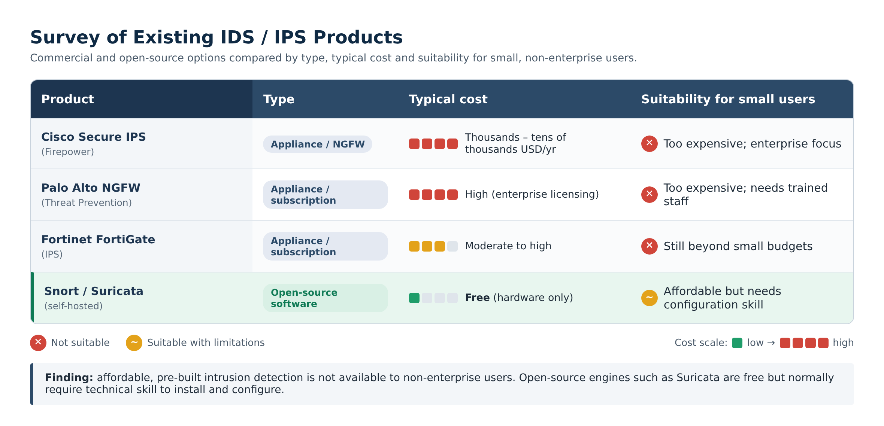
Table 2.1: Survey of existing IDS/IPS products by type, cost and suitability for small users
The survey confirms that affordable, pre-built intrusion detection is not available to non-enterprise users. Open-source engines such as Suricata are free but normally require expert setup on dedicated hardware. This project closes that gap by packaging Suricata on an inexpensive Raspberry Pi with custom rules, real-time alerting and a dashboard.
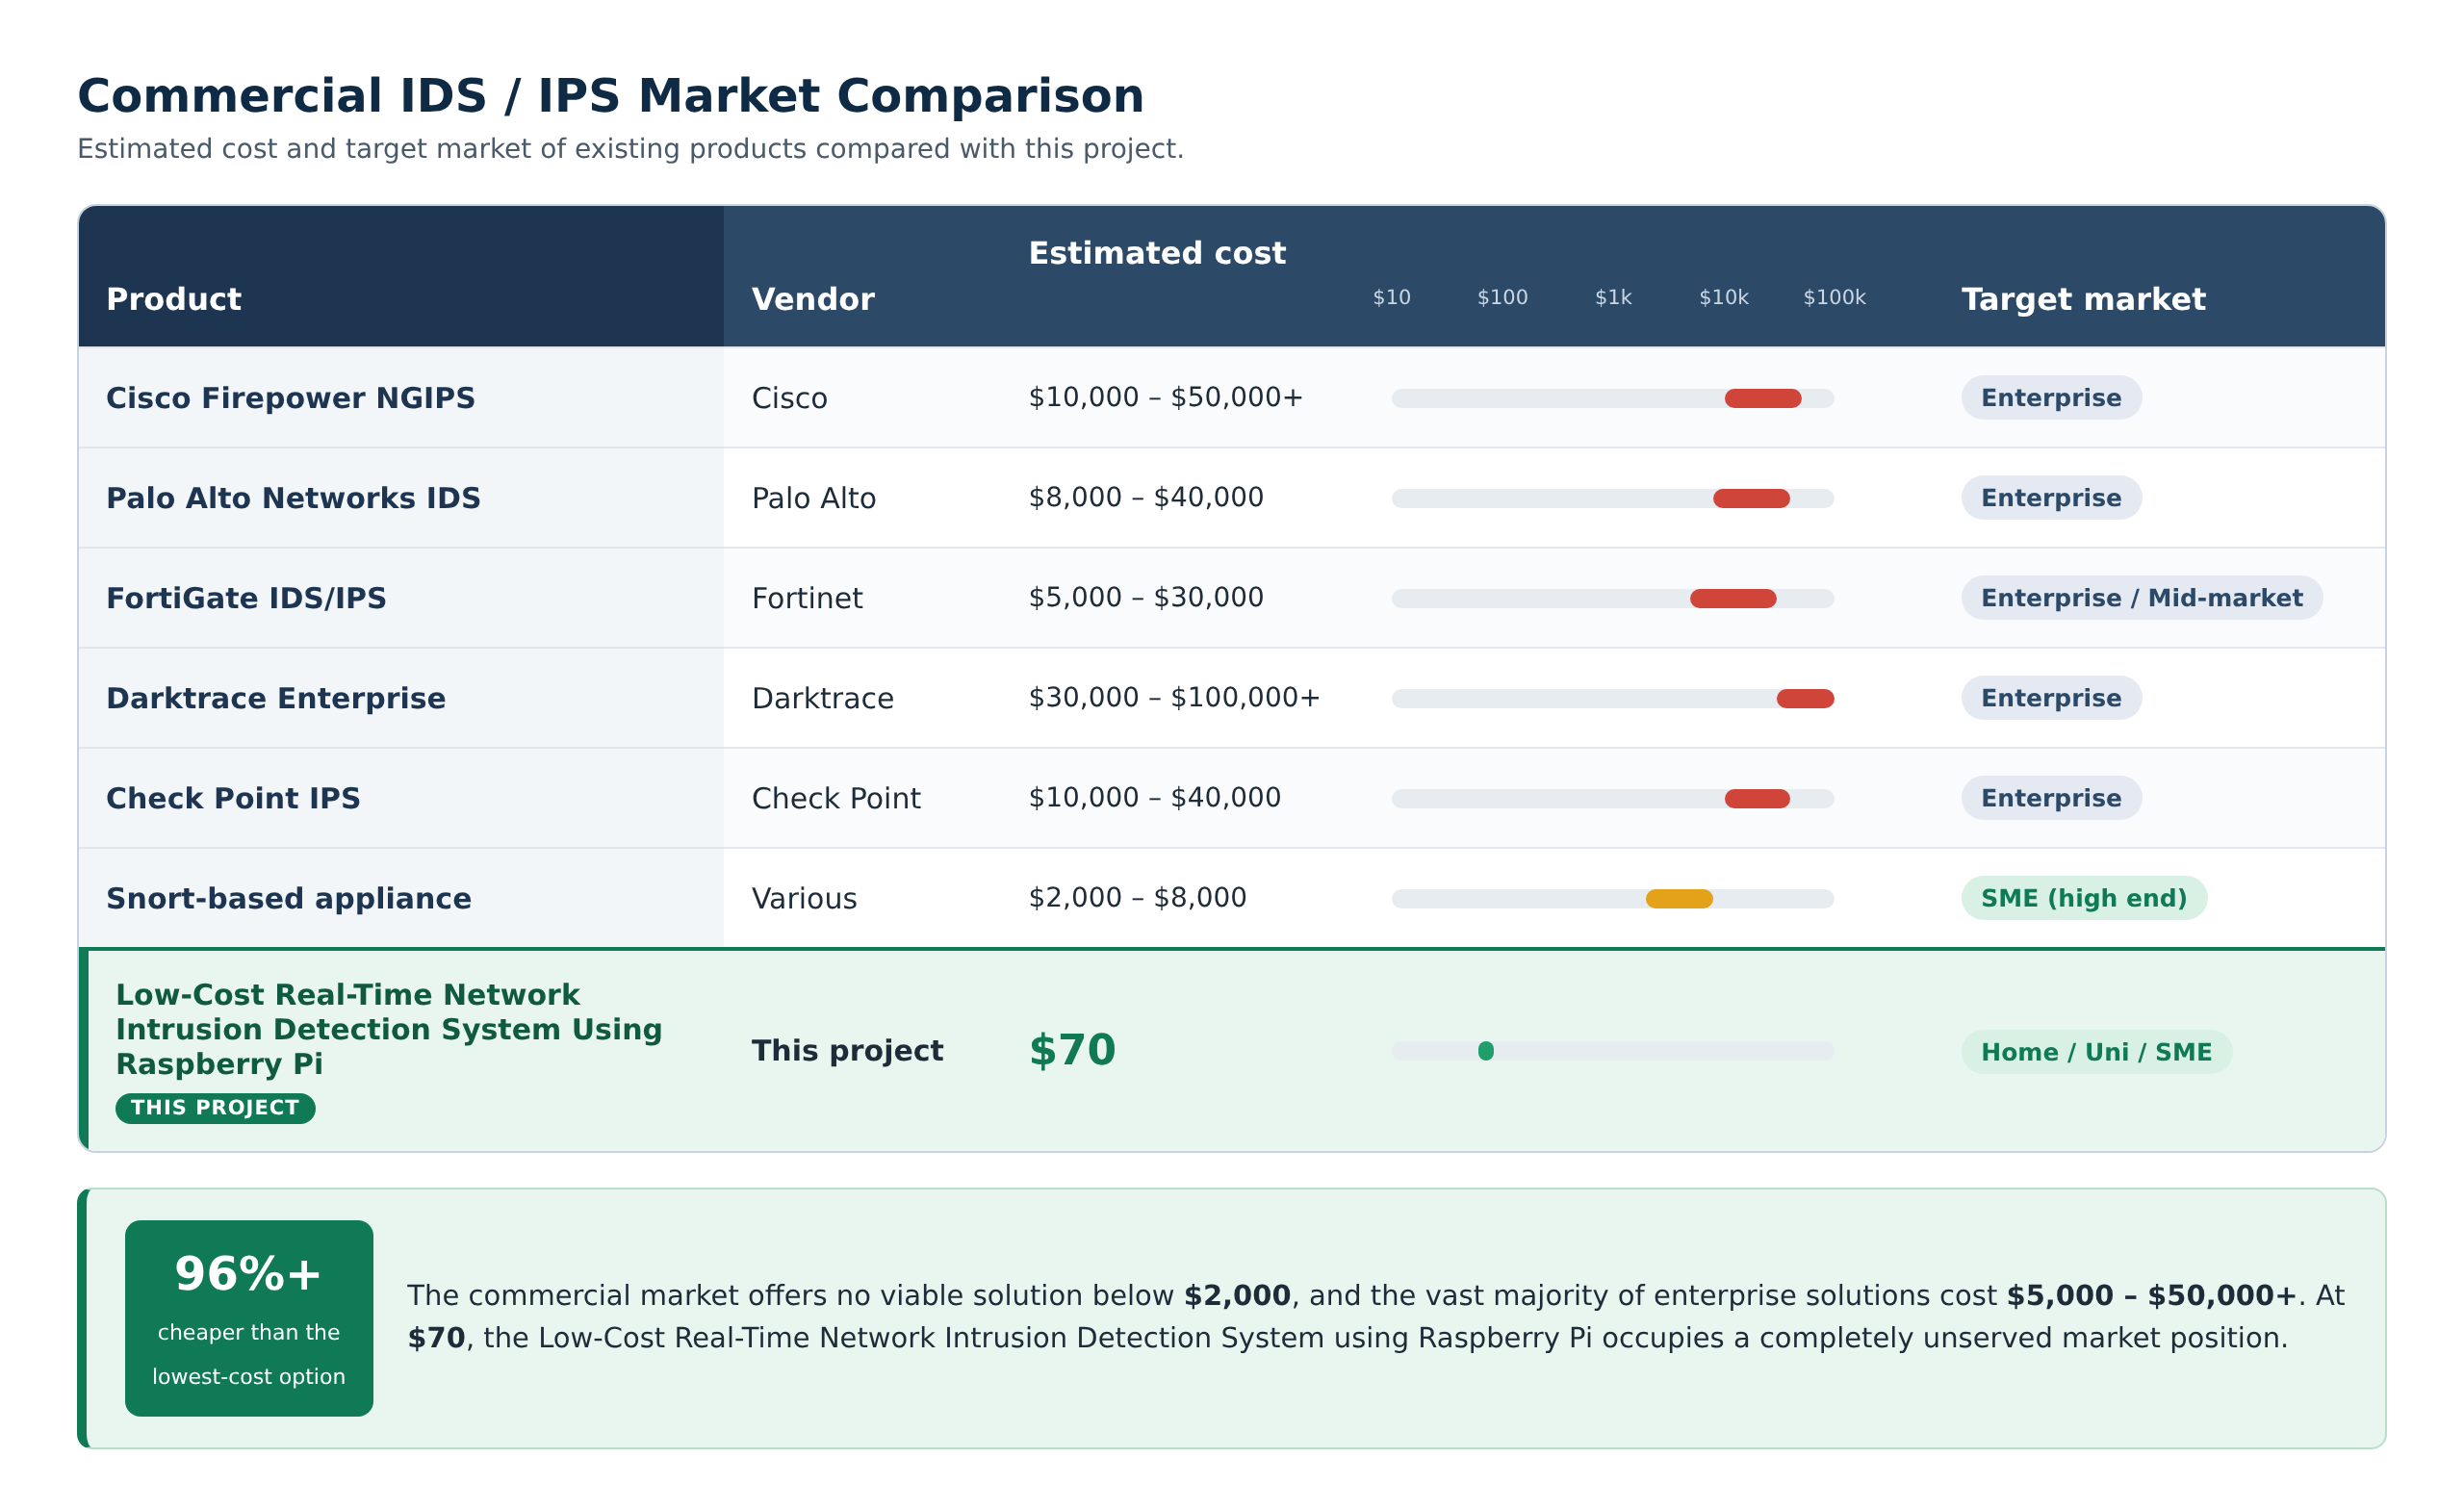
Table 2.2: Commercial IDS/IPS market comparison

2.2.5 Review of Related Academic Work
This section reviews nineteen peer-reviewed publications that are directly relevant to NetGuard Pi. The literature is organised into five themes: (A) the foundations of intrusion detection, (B) performance comparisons of open-source IDS engines, (C) IDS deployments on Raspberry Pi and other single-board computers, (D) machine-learning-based IDS on low-cost hardware, and (E) known limitations of anomaly and machine-learning detection. For each theme, the relevance of the findings to the design of this project is stated explicitly. The reviewed studies are summarised in Table 2.3, and their influence on the design is mapped in Table 2.4.
A. Foundations of Intrusion Detection
The formal study of intrusion detection began with Denning [1], who proposed a model in which a monitoring system builds statistical profiles of normal user and system behaviour and raises an alarm when observed activity deviates from those profiles. This work established the anomaly-based paradigm and the idea that security violations can be detected by monitoring activity rather than by preventing every attack in advance.
The signature-based paradigm used in this project traces back to Roesch [2], who introduced Snort as a "lightweight" network intrusion detection system. Snort showed that a simple, rule-driven engine could inspect live packets against a library of attack signatures on ordinary hardware, and its rule language later became the de facto standard that Suricata still supports today. In the same year, Paxson [3] presented Bro (now Zeek), which separated high-speed packet capture from a policy layer written in a scripting language, demonstrating real-time analysis of high-volume traffic with an emphasis on detailed connection logging.
Khraisat et al. [4] later surveyed the field and classified IDS into signature-based (SIDS) and anomaly-based (AIDS) approaches. They concluded that signature-based systems give high accuracy and low false-alarm rates for known attacks but cannot detect zero-day attacks, whereas anomaly-based systems can detect novel attacks but suffer from higher false-positive rates and depend heavily on the quality of training data.
Relevance to this project: These foundational works justify the choice of a signature-based engine (Suricata, descended from the Snort model [2]) augmented with threshold-based rules that borrow the anomaly idea of [1] counting abnormal rates of SYN packets or connection attempts rather than matching a single packet.
B. Performance Comparisons of Open-Source IDS Engines
Because the Raspberry Pi has limited CPU and memory, the efficiency of the IDS engine is critical. Day and Burns [7] compared Snort and Suricata and reported that Suricata's multi-threaded architecture let it make better use of multi-core processors, while consuming more system resources than single-threaded Snort.
Albin and Rowe [8] performed a realistic comparison of Suricata and Snort on live network traffic. After kernel-buffer tuning, Snort still dropped about 53% of packets while Suricata dropped about 7%. Suricata achieved a recall of 0.87 against 0.73 for Snort, but used roughly twice the CPU and more than twice the memory. The authors also noted that Snort was limited to roughly 200–300 Mbps per instance, while Suricata's throughput scaled with the number of processor cores.
Shah and Issac [9] repeated the comparison on a 10 Gbps test bed. Suricata processed about 82,000 packets per second against about 61,000 for Snort and dropped fewer packets for TCP (9% vs 20%), UDP (8% vs 14%) and ICMP (10% vs 17%) traffic, again at the cost of higher CPU (about 79% vs 68%) and memory use. They also found that both engines produced high false-positive rates with default rules, which motivated their work on tuning detection.
Waleed, Jamali and Masood [10] extended the comparison to all three major open-source engines Snort, Suricata and Zeek evaluating detection accuracy and resource consumption under different traffic conditions. Their study is one of the most recent head-to-head evaluations of the three tools and provides direct evidence for engine selection in new deployments.
Relevance to this project: Studies [7]–[10] consistently show that Suricata's multi-threading reduces packet loss on multi-core CPUs. This directly supports the selection of Suricata for the quad-core Raspberry Pi 4. The repeated finding that default rules generate many false positives [9] also justifies this project's effort to empirically tune custom rule thresholds (for example, 5 SYN packets in 3 seconds).
C. IDS on Raspberry Pi and Single-Board Computers
Kyaw, Chen and Joseph [11] carried out one of the earliest evaluations of open-source IDS on Raspberry Pi hardware, running Snort and Bro on a Raspberry Pi 2 Model B. They assessed performance, efficiency and effectiveness specifically for cost-sensitive settings such as small office/home office (SOHO) and educational-institution networks the same target environments as this project and established that a general-purpose single-board computer could act as a functional IDS sensor.
Sforzin et al. [12] proposed RPiDS, which used Raspberry Pi devices running Snort as portable intrusion detection nodes for Internet of Things (IoT) networks. They argued that the low cost, small size and low power draw of the Raspberry Pi make it suitable for distributing many IDS sensors across a network rather than relying on a single expensive appliance.
Coşar and Kıran [13] installed Snort and Suricata on two separate Raspberry Pi devices in a local test network and launched hping-generated attacks to compare how effectively each engine captured attack packets, proposing embedded IDS as a practical alternative to high-capacity firewalls for small and medium-sized networks.
Garalov and El-hajj [14] designed and evaluated a Raspberry Pi-based IDS using Snort in an IoT test environment containing a temperature sensor, a web server and a background traffic generator. Detection metrics were extracted from the IDS log files, and the authors focused on identifying configuration changes that improve Snort's performance on the Raspberry Pi.
The work closest to this project is that of Veerasingam et al. [15], who deployed Suricata on OPNsense running on a Raspberry Pi 2 Model B (900 MHz quad-core, 1 GB RAM) to protect an SME local network, with a Python web application for management and Kali Linux as the attacker. Suricata detected Nmap scanning through the Emerging Threats rule "ET SCAN Possible Nmap User-Agent Observed" and blocked the attacker's IP address. However, the evaluation was qualitative: the paper tested a single attack type and reported no quantitative detection rate, alert latency or resource-usage figures.
Relevance to this project: Works [11]–[15] confirm that the Raspberry Pi is a credible IDS platform for SOHO, SME and educational networks. However, they used older boards (Raspberry Pi 2/3 class hardware), mostly used Snort, and largely reported qualitative or partial results. NetGuard Pi advances this line of work by using the much more powerful Raspberry Pi 4 (8 GB) with Suricata 7, testing nine attack types, and reporting measurable detection rate, alert latency, resource usage and 72-hour stability.
D. Machine-Learning-Based IDS on Low-Cost Hardware
Mirsky et al. [16] introduced Kitsune, an online, unsupervised network IDS based on an ensemble of autoencoders. Benchmarked on a single core of a Raspberry Pi 3B, Kitsune processed roughly 1,000 packets per second with a single autoencoder and about 5,400 packets per second with an ensemble of 35, showing that lightweight neural detection is feasible on a Pi. Kitsune was evaluated on attacks including an Nmap-based OS scan, but it requires an initial training period on benign traffic before it can detect anomalies.
Syamsuddin and Barukab [17] proposed SUKRY, which combines Suricata with an enhanced k-Nearest Neighbour classifier on a Raspberry Pi to classify IoT botnet attacks. Using forward feature selection on the Bot-IoT dataset, their kNN model reached 99.89% accuracy; this accuracy, however, was measured offline in RapidMiner rather than on live traffic on the Raspberry Pi itself.
Tirumala, Nepal and Ray [18] explored a Raspberry Pi-based intelligent cyber-defence system for SMEs and smart homes. Comparing the Pi's built-in Ethernet, built-in Wi-Fi and a USB-to-Ethernet adapter, they found the built-in Ethernet port gave the best latency and throughput. They also reported that a DNA-sequence-based machine-learning approach improved malware detection accuracy by over 19.5% compared with a hash-based classifier.
Most recently, Wijethilaka, Yapa and Siriwardena [19] built a cost-effective machine-learning NIDS on a Raspberry Pi that analyses inbound and outbound traffic using Random Forest, LSTM, ANN, XGBoost and Naive Bayes models, with alerts sent by email and signalled with LEDs and a buzzer. They reported 96.5% accuracy on the NF-UQ-NIDS dataset, a reduced false-positive rate after SMOTE balancing, and an average response time of 50 ms.
Relevance to this project: These studies show that machine learning can run on a Raspberry Pi and can, in principle, detect unknown attacks. However, they depend on public training datasets, report accuracy largely in offline experiments, and require retraining as traffic changes. The interface finding in [18] supports this project's decision to monitor traffic on the built-in eth0 port, and the email alerting in [19] parallels this project's severity-coded email alerts. Machine-learning anomaly detection is identified as future work (Section 6.4).
E. Limitations of Anomaly and Machine-Learning Detection
Axelsson [5] showed through the "base-rate fallacy" that, because real attacks are rare compared with normal traffic, even a very small false-alarm rate produces far more false alerts than true ones, quickly overwhelming the administrator. Sommer and Paxson [6] similarly argued that machine learning is much harder to apply to intrusion detection than to other fields because of the high cost of errors, the large variability of normal network traffic, the lack of good training data, and the "semantic gap" between a statistical anomaly and an actionable security alert.
Relevance to this project: For a system intended for non-expert users in university labs and SMEs, every alert must be meaningful and explainable. Signature-based alerts identify exactly which rule fired and why, which is why NetGuard Pi uses Suricata signatures plus carefully tuned thresholds, de-duplicates alert floods (at most one email per rule and attacker per minute), and prioritises alerts by severity — directly addressing the alert-overload problem described in [5] and [6].
Table 2.3 summarises all reviewed studies in a consistent format, showing each study's focus, its key contribution, its relevance to this project and the gap that NetGuard Pi addresses.
Table 2.3: Literature review (research papers and studies)
# | Author(s) & Year | Focus / System Type | Key Contribution | Relevance to NetGuard Pi | Gap / How NetGuard Pi Improves
1 | Denning (1987) [1] | Anomaly-based IDS model | Statistical profiles of normal behaviour; alarm on deviation | Origin of the rate/threshold idea used in custom rules | Applies the idea through lightweight count-per-time thresholds instead of heavy profiling
2 | Roesch (1999) [2] | Snort signature NIDS | Lightweight rule-based packet inspection on commodity hardware | Rule language still used by Suricata | Uses multi-threaded Suricata with the same rule syntax
3 | Paxson (1999) [3] | Bro/Zeek network monitor | Real-time analysis with policy scripts and connection logs | Candidate engine (Section 2.2.2) | Zeek focuses on logging; NetGuard Pi needs immediate signature alerts
4 | Khraisat et al. (2019) [4] | IDS survey | SIDS vs AIDS classification, datasets and challenges | Frames the signature vs anomaly choice | Combines SIDS with threshold rules for low false alarms
5 | Axelsson (2000) [5] | Base-rate fallacy | Small false-alarm rates overwhelm administrators because attacks are rare | Motivates false-positive control | Tuned thresholds + one email per rule and attacker per minute
6 | Sommer & Paxson (2010) [6] | Critique of ML for NIDS | High error cost, semantic gap and traffic diversity limit ML | Justifies deferring ML | Explainable signature alerts; ML planned as future work
7 | Day & Burns (2011) [7] | Snort vs Suricata performance | Suricata multi-threading exploits multi-core CPUs at higher resource cost | Engine selection | Applied on quad-core Pi 4; 21.6% CPU at ~94 Mbit/s
8 | Albin & Rowe (2012) [8] | Realistic Suricata vs Snort test | Packet drop 7% vs 53%; recall 0.87 vs 0.73 | Evidence for Suricata | Validated on ~$70 hardware rather than servers
9 | Shah & Issac (2018) [9] | 10 Gbps comparison + ML | Suricata ~82k vs ~61k pps, fewer drops; high FPs with default rules | Justifies threshold tuning | Custom rules tuned empirically (e.g., 5 SYN in 3 s)
10 | Waleed et al. (2022) [10] | Snort, Suricata, Zeek comparison | Recent three-way evaluation of accuracy and resources | Supports engine choice | Extends evaluation to an embedded ARM platform
11 | Kyaw et al. (2015) [11] | Pi-IDS on Raspberry Pi 2 | Snort and Bro evaluated for SOHO and education networks | Same target users | Pi 4 + Suricata 7, nine attack types, alerting pipeline
12 | Sforzin et al. (2016) [12] | RPiDS for IoT | Pi running Snort as a portable, distributed IDS node | Validates Pi as a sensor | Multi-threaded engine + real-time email and dashboard
13 | Coşar & Kıran (2018) [13] | Snort vs Suricata on two Pis | Packet-capture comparison under hping attacks | Pi-based engine comparison | Adds latency, uptime and resource metrics
14 | Garalov & El-hajj (2023) [14] | Snort-based Pi IDS in IoT test bed | Log-based detection metrics; configuration tuning | Recent Pi IDS evaluation | Suricata, 18 custom rules, IPS and auto-block
15 | Veerasingam et al. (2023) [15] | Suricata on OPNsense, Pi 2B, SME | Detected Nmap scan via ET rule and blocked attacker | Closest prior work | Nine attack types with quantitative metrics on Pi 4
16 | Mirsky et al. (2018) [16] | Kitsune autoencoder NIDS | ~1,000–5,400 packets/s on one Pi 3B core | ML feasibility on Pi | No training phase needed; ML kept for future work
17 | Syamsuddin & Barukab (2022) [17] | SUKRY: Suricata + kNN on Pi | 99.89% offline accuracy on Bot-IoT | Suricata on Pi | Detection validated on live traffic on the device
18 | Tirumala et al. (2022) [18] | Pi cyber-defence for SMEs/smart homes | Built-in Ethernet gives best latency and throughput | Interface choice | Captures on built-in eth0
19 | Wijethilaka et al. (2025) [19] | ML NIDS on Pi with email/LED alerts | 96.5% accuracy (NF-UQ-NIDS); 50 ms response | Similar alerting approach | Signature + threshold detection with IPS and auto-block; no dataset dependence

2.2.6 Influence of the Literature on Design Decisions
The reviewed literature directly informed the key design decisions of NetGuard Pi, as summarised in Table 2.4.
Table 2.4: Mapping of literature to design decisions
Design Decision | Supporting Literature | Reason
Suricata instead of Snort or Zeek | [7], [8], [9], [10] | Multi-threading uses all four Pi 4 cores and lowers packet loss
Signature-based detection with threshold rules | [2], [4], [5], [6] | High accuracy, low false alarms, explainable alerts for non-experts
Raspberry Pi as the sensor platform | [11], [12], [13], [15] | Proven viable for SOHO, SME, IoT and educational networks
Raspberry Pi 4 (8 GB) instead of older boards | [11], [15], [16] | Earlier studies were limited by Pi 2/3 CPU and RAM
Monitoring on built-in Ethernet (eth0) | [18] | Built-in Ethernet gave the best latency and throughput
Empirically tuned custom rule thresholds | [5], [9] | Default rules produce many false positives
Email alerts with flood de-duplication | [5], [19] | Timely notification without overwhelming the administrator
ML anomaly detection deferred to future work | [6], [16], [17], [19] | Promising but dataset-dependent and harder to validate

2.3 Comparative Analysis
The three candidate open-source engines were compared against the needs of this project: running on a Raspberry Pi 4, providing real-time signature-based alerts, supporting a large ruleset and custom rules, and producing output that a program can read easily.
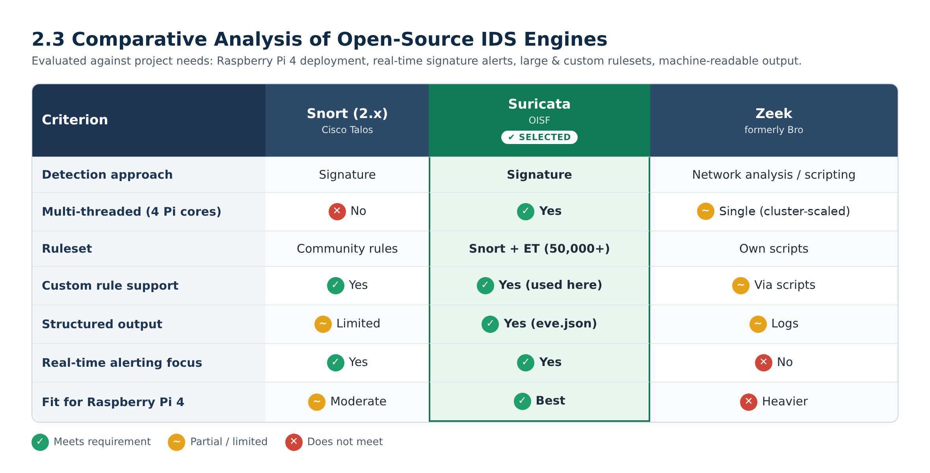
Table 2.5: Comparative analysis of open-source IDS engines against project needs
Conclusion: Suricata was selected. It is multi-threaded, so it uses all four cores of the Pi 4; it supports the large Emerging Threats ruleset plus the team's custom rules; and its eve.json output is easy for the alert collector to read for real-time notification.
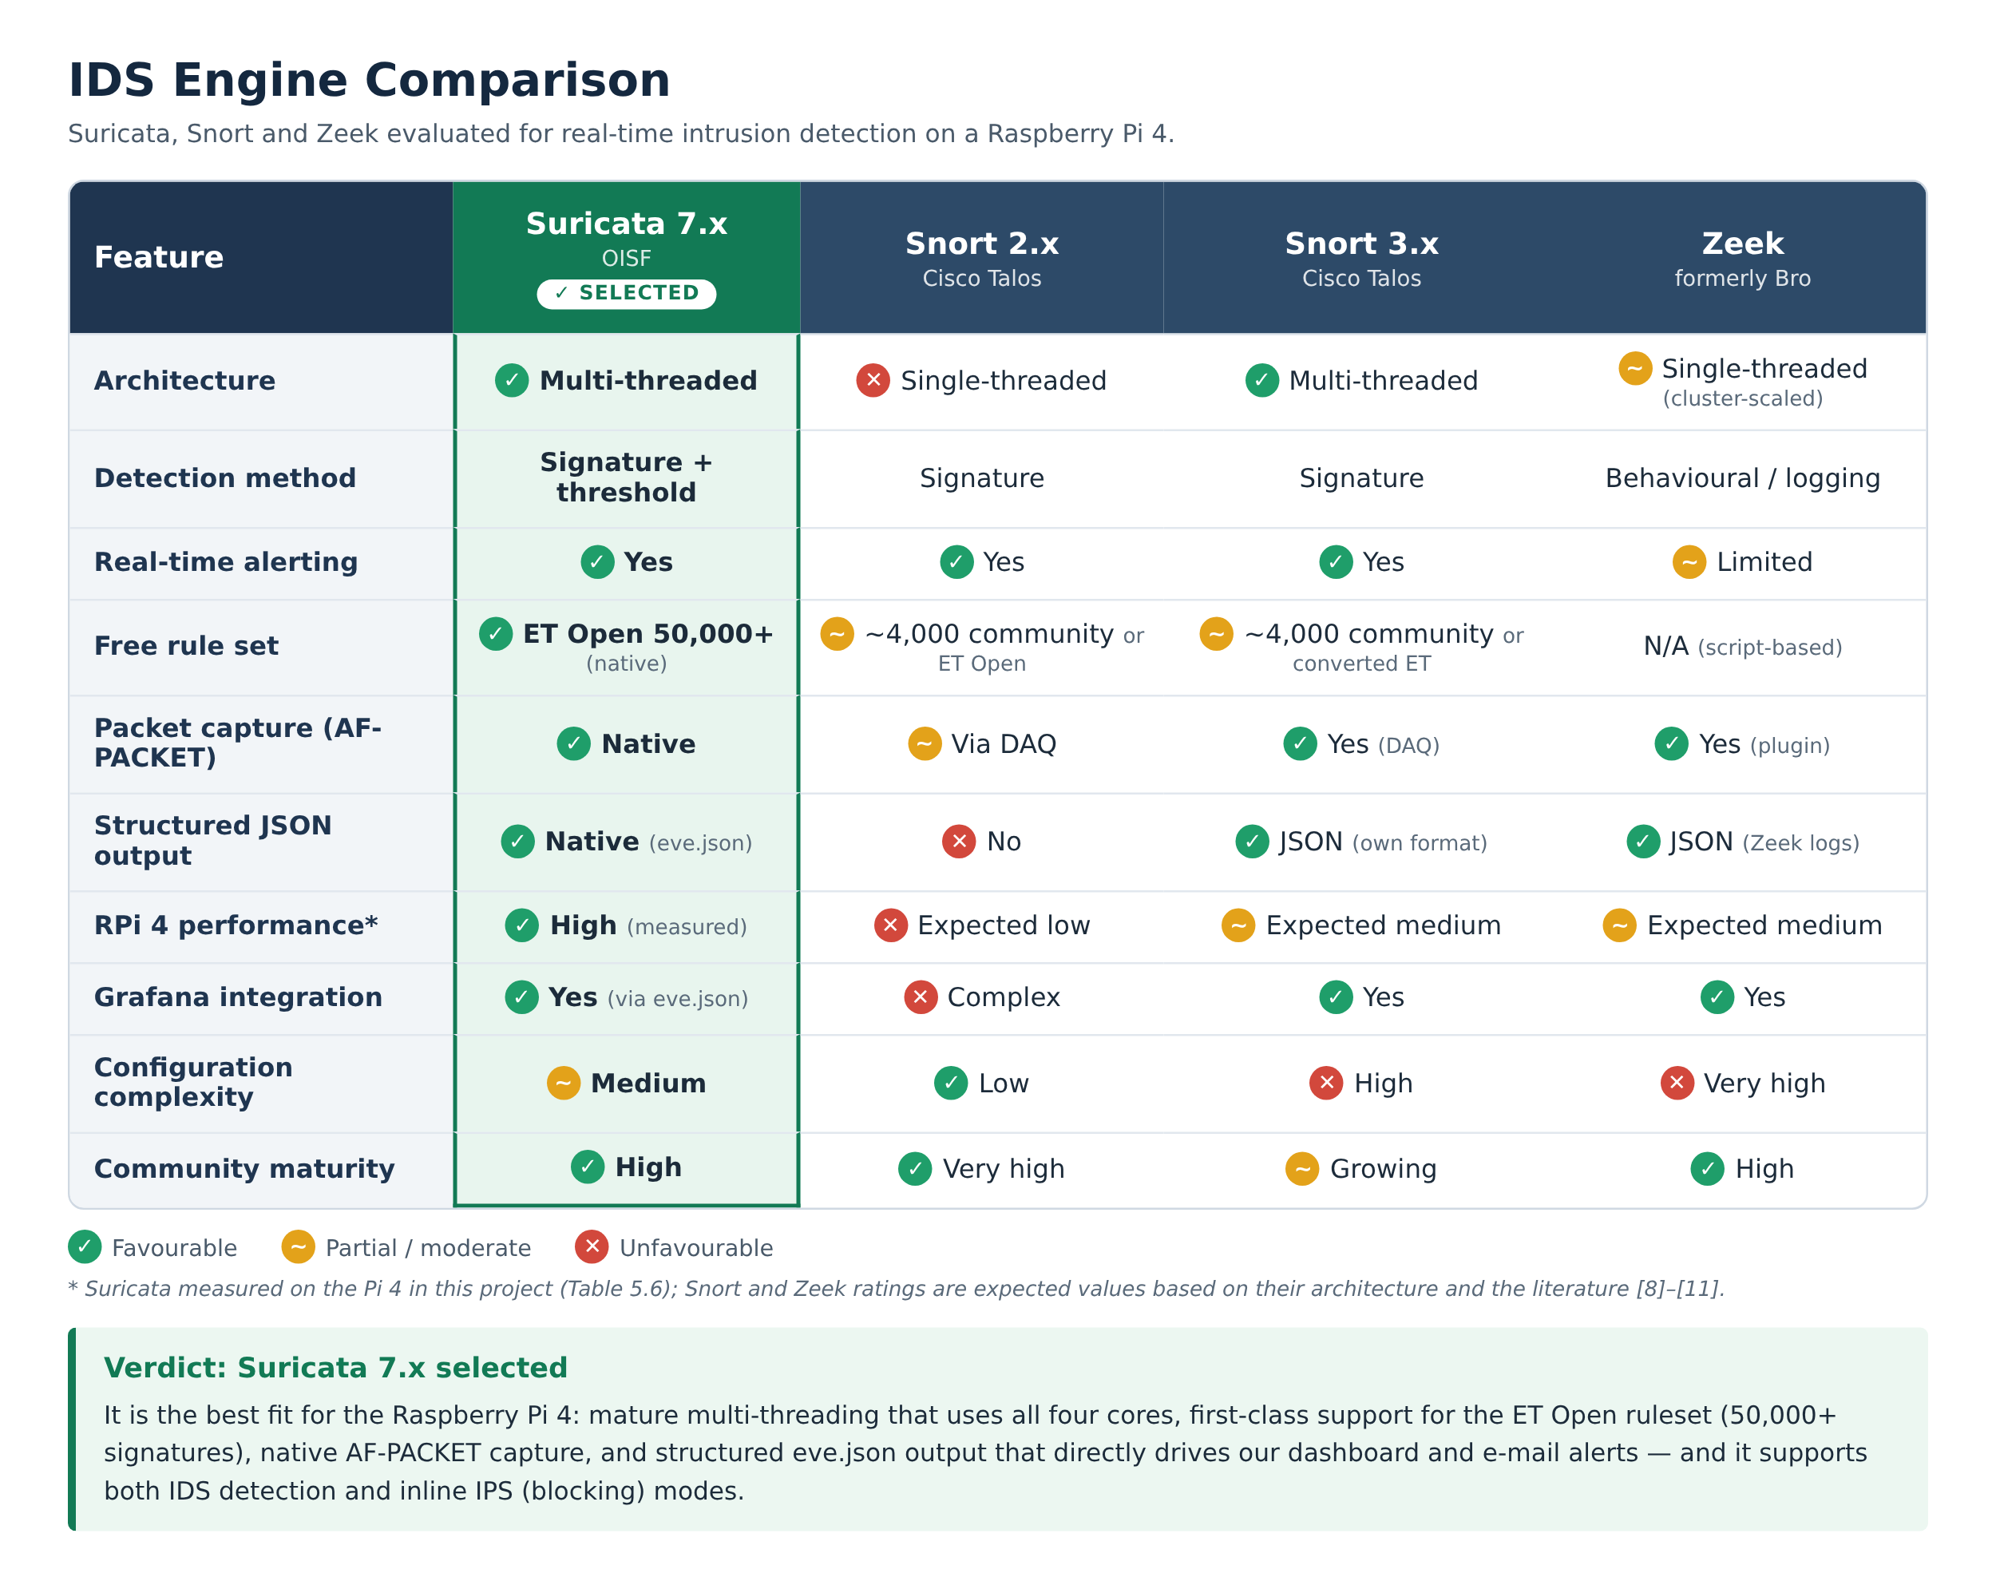

Table 2.6: Detailed feature comparison of Suricata, Snort and Zeek

2.4 Research Gaps
Based on the literature reviewed in Section 2.2.5 and the product survey in Section 2.2.4, the following research gaps were identified:
- Limited evaluation on current Raspberry Pi hardware with modern Suricata. Most Raspberry Pi IDS studies [11]–[15] used Raspberry Pi 2 or 3 class hardware and mostly Snort. There is little published evaluation of Suricata 7.x on the Raspberry Pi 4 (8 GB), whose quad-core CPU is well suited to Suricata's multi-threaded design [7]–[9].
- Lack of quantitative, end-to-end results. Existing Raspberry Pi deployments often report qualitative outcomes [15], offline accuracy [17], [19], or packet-capture comparisons [13]. Few studies measure detection rate across several attack types together with alert latency, resource usage and long-duration (multi-day) stability on the device itself.
- Detection without accessible alerting and response for non-experts. Most reviewed systems stop at writing IDS logs [11]–[14]. Few combine on-device detection with persistent alert storage, severity-coded email notification, a live web dashboard and automatic attacker blocking that a non-specialist administrator can use.
- No documented, threshold-calibrated custom rules for Raspberry Pi 4. Prior work relied on default Emerging Threats signatures for example the Nmap User-Agent rule in [15] and default rules are known to produce many false positives [9]. No published custom Suricata rule set has been calibrated specifically for detecting scans, floods and brute-force attacks on Raspberry Pi 4.
- No validated deployment in the Pakistani context. The reviewed deployments were tested in Malaysia [15], Turkey [13], Sri Lanka [19] and elsewhere. None document an IDS designed and validated for Pakistani university labs and SMEs, where budget constraints are especially strong.

2.5 Problem Statement
Network intrusion attacks including Denial of Service (DoS), Distributed Denial of Service (DDoS), port scanning, brute force, service enumeration, and protocol exploits are increasing in frequency and sophistication globally every year. These attacks target all classes of network environments, from large enterprises to home networks, university labs, and small businesses.
Commercial IDS appliances, which represent the primary tool for detecting such attacks, cost from about $2,000–$5,000 for an entry-level appliance to $30,000–$100,000 per year for enterprise deployments, which is unaffordable for home users, university labs, students, and SMEs. As a result, these environments operate with zero network visibility: attacks proceed, persist, and succeed entirely undetected.
Existing open-source IDS tools such as Suricata and Snort, while technically capable, present significant barriers to deployment for non-expert users: they require dedicated hardware, expert configuration, complex rule management, and ongoing maintenance. No single integrated, easy-to-deploy, truly affordable NIDS solution currently exists for educational and small-organization environments, particularly in resource-constrained markets like Pakistan.
This project directly addresses this problem by designing, implementing, and validating Low Cost Real-Time Network Intrusion Detection System Using Raspberry Pi a complete, real-time Network Intrusion Detection System built on Raspberry Pi 4 and Suricata 7.x, delivered at a total hardware cost of about $70, achieving 100% detection rate across tested attack types, real-time alerts within about 2–3 seconds, and 72+ hours of validated continuous operation. The system is specifically designed for deployment in Pakistani universities, university labs, home networks, and SMEs, filling an identified gap in both the commercial market and the academic literature.

2.6 Chapter Summary
This chapter provided a comprehensive survey of the literature and market relevant to Network Intrusion Detection Systems. The conceptual foundations of signature-based and anomaly-based IDS were reviewed. The three major open-source IDS tools Suricata, Snort and Zeek were evaluated in detail, and the commercial IDS market was surveyed, confirming the unaffordability of existing solutions for non-enterprise users. Nineteen peer-reviewed studies were then reviewed across five themes and summarised in Table 2.3, and their influence on each design decision was mapped in Table 2.4. A comparative analysis established Suricata as the most suitable engine for the Raspberry Pi 4. Five specific research gaps were identified, and the formal problem statement was articulated. The following chapter translates these findings into a concrete system design.

Chapter 3:
Requirements and System Design

Chapter 3: Requirements and System Design

3.1 Introduction
This chapter translates the problem statement and research findings from Chapter 2 into a concrete system design for NetGuard Pi. It covers the complete system architecture, functional and non-functional requirements, design diagrams (use case, data flow, sequence), hardware and software specifications, threat scenarios, threat modeling techniques, and the threat resistance model. Together, these elements constitute the complete technical blueprint for NetGuard Pi.

3.2 System Architecture
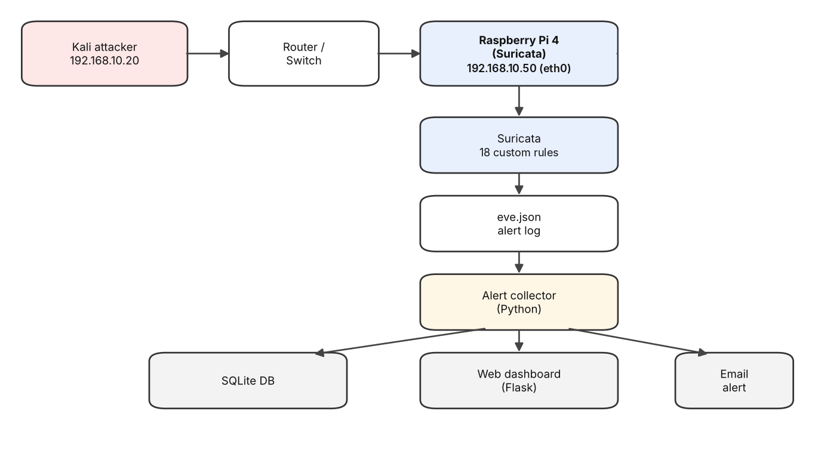
Figure 3.1: NetGuard Pi system architecture
NetGuard Pi is designed around a 4-layer architecture that separates concerns clearly: traffic capture, detection engine, alert processing, and output, response and remote management.
Layer 1 Network Traffic Capture
The Raspberry Pi 4 is physically connected to the target network via its Wired interface (eth0). The interface is placed in AF-PACKET promiscuous mode, which instructs the network card to capture all packets traversing the network segment not just those addressed to the Raspberry Pi's own IP address (192.168.10.50). This is essential for a NIDS, which must see all traffic on the monitored network, including traffic between other hosts.
The network environment is a lab subnet with CIDR notation 192.168.10.0/24, providing 254 usable host addresses. The Raspberry Pi sits passively on this network, collecting all frames received on its wired eth0 interface, and feeding them to the Suricata engine for analysis.
AF-PACKET mode was chosen over libpcap for its superior performance: AF-PACKET operates at the kernel level, bypassing some of the overhead of the standard libpcap socket layer, resulting in lower packet capture latency and reduced CPU load critical considerations on resource-constrained hardware.
Layer 2 IDS Detection Engine (Suricata 7.x)
Suricata 7.x is the core detection engine. It receives the raw packet stream from Layer 1 and processes each packet in real time against its rule set. Two rule sources were used during the project; the final configuration loads only the custom rules:
- Emerging Threats Open Rule Set (over 50,000 signatures; evaluated during development, disabled in the final configuration): This is a professionally maintained, continuously updated collection of signatures covering a wide range of attack types, including DoS attacks, TCP scanning behaviors, UDP anomalies, exploit attempts, malware communication patterns, protocol violations, and service-specific probes. Rules are organized by category and priority level (1–3, with 1 being highest priority).
- Custom local.rules (18 rules): Eighteen custom detection rules developed specifically for this project (13 local rules, SIDs 1000001–1000013, plus 5 team rules, SIDs 9000001–9000005), covering scans, stealth scans, ICMP/SYN floods, SSH/FTP brute force, SQL injection, XSS and malware downloads. These rules use Suricata's threshold mechanism to require a minimum number of matching packets within a defined time window before generating an alert, reducing false positives from legitimate traffic.
Suricata processes packets using multiple CPU threads, leveraging all four cores of the Raspberry Pi 4's ARM Cortex-A72 processor simultaneously. When a packet matches a rule, an alert is immediately written to the output logs.

Layer 3 - Alert Processing (Python alert collector)
Suricata writes alerts to two log files in /var/log/suricata/:
- fast.log: Human-readable one-line-per-alert format, including timestamp, alert priority, message, source IP:port, destination IP:port, and protocol.
- eve.json: Structured JSON format containing comprehensive event metadata including rule metadata, packet details, flow information, and community IDs. Designed for future integration with log shipping tools like Filebeat.
The Python alert collector runs as a background service, continuously reading eve.json. When Suricata writes a new alert, the collector parses the key fields, stores the alert in SQLite, sends an HTML email, and makes it available to the Flask dashboard in real time. This provides immediate notification of detected attacks on a web page and on the administrator's phone, without manually reading log files.
Layer 4 Output, Response and Remote Management
The system is designed for fully remote operation. Two remote access mechanisms are provided:
PuTTY (SSH): Enables encrypted command-line access to the Raspberry Pi from any machine on the network. Used for configuration management, log review, running Suricata commands, and executing the Python alerting script.
RealVNC Viewer (Remote Desktop): Enables full graphical desktop access to the Raspberry Pi, primarily used to access the Wireshark GUI for visual packet analysis during testing.
All alert data is permanently stored in /var/log/suricata/fast.log and eve.json, providing a persistent record for forensic analysis and future log pipeline integration (Filebeat → Loki → Grafana, planned future).
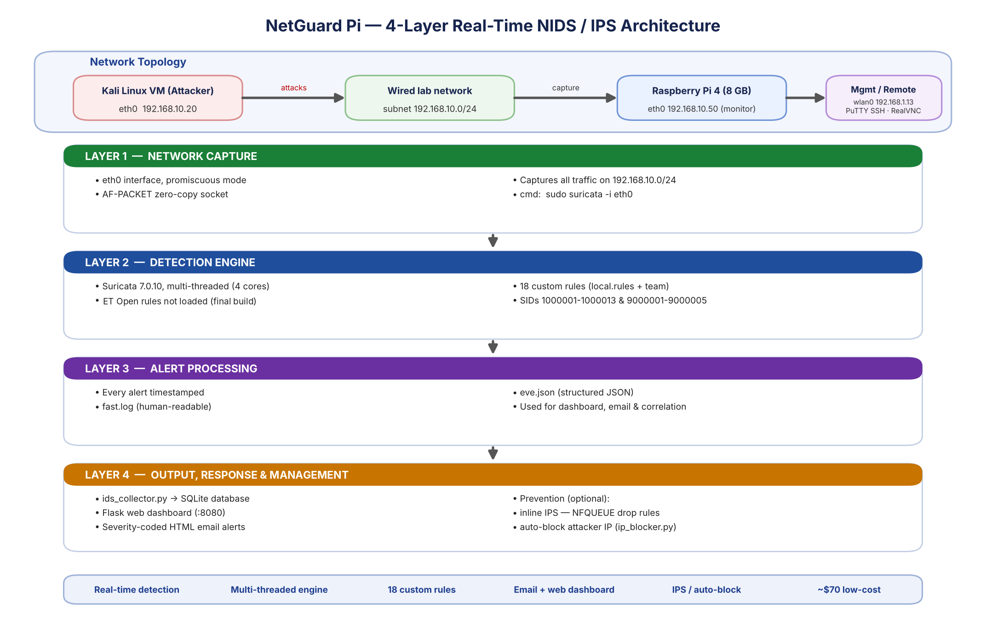
Figure 3.2: NetGuard Pi 4-layer real-time NIDS/IPS architecture

3.2.1 System Design Diagrams
The following design diagrams describe NetGuard Pi from four complementary viewpoints: who interacts with the system (use case), how data moves between the system and its environment (DFD Level 0), how data moves between the internal processes and data stores (DFD Level 1), and the time-ordered interaction between components when an attack occurs (sequence diagram).
Use case diagram. Two actors interact with the system. The attacker (simulated by the Kali Linux VM) performs scans, floods, brute-force, web and malware attacks, each of which triggers the detection chain: capture, signature matching, alert generation and, where configured, blocking. The network administrator views the live dashboard, receives email alerts, updates rules, reviews the alert history and manages the sensor remotely.
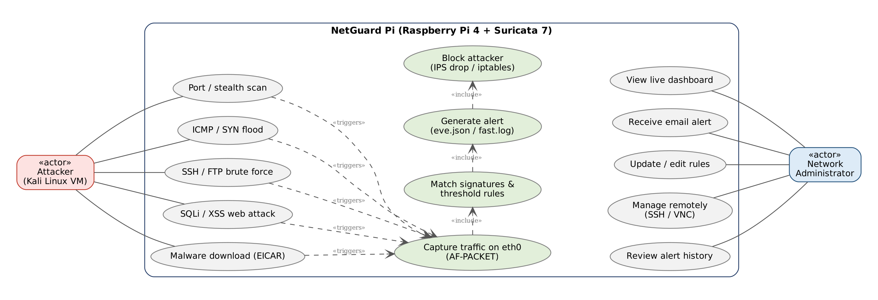
Figure 3.3: Use case diagram of NetGuard Pi
Data flow diagram – Level 0 (context diagram). At the highest level NetGuard Pi is a single process that receives network packets, returns drop/block decisions to attackers, sends severity-coded alerts through an email service, and exchanges rules, commands and dashboard views with the administrator.
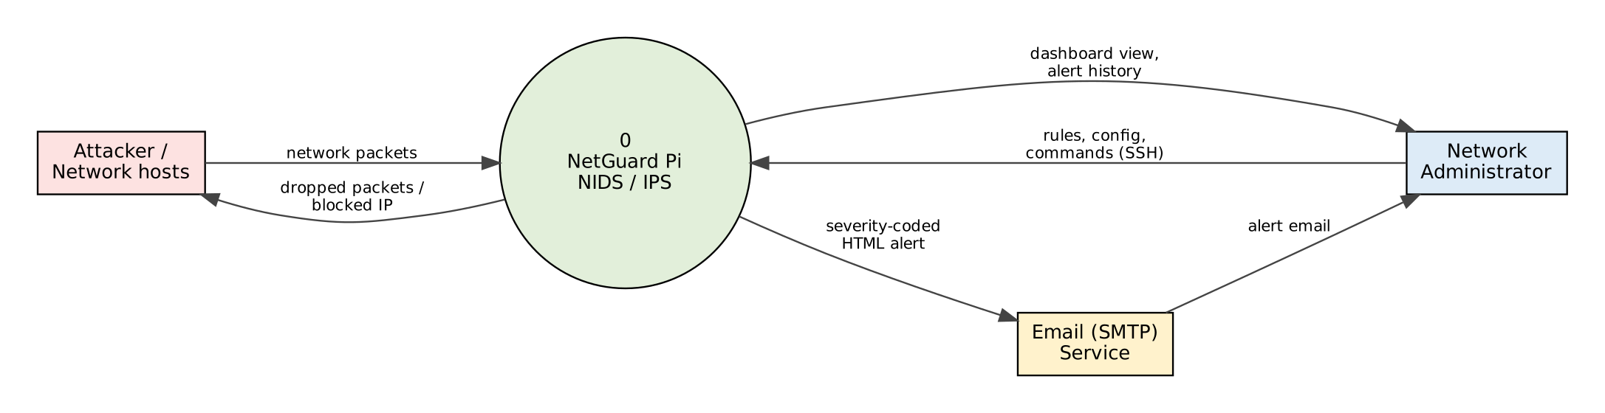
Figure 3.4: Data flow diagram – Level 0 (context diagram)
Data flow diagram – Level 1. The single process is decomposed into five sub-processes capture, detect, collect and store, notify, and respond — and three data stores: the rule sets (D1), the Suricata logs eve.json and fast.log (D2), and the SQLite alert database (D3).
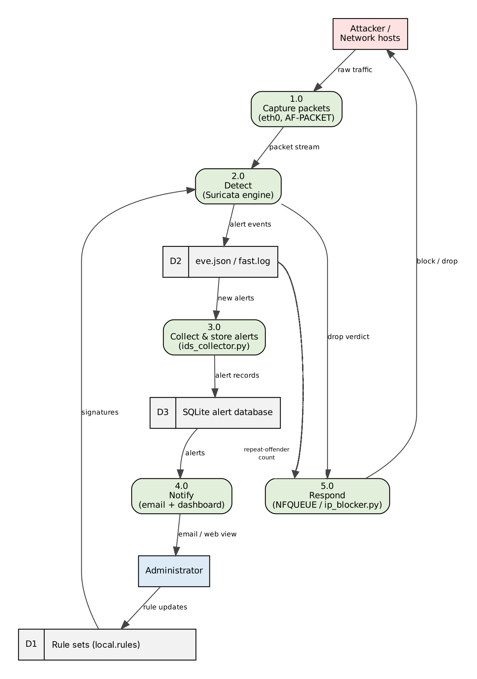
Figure 3.5: Data flow diagram – Level 1
Sequence diagram. Figure 3.6 shows the time-ordered flow for a detected attack: Suricata matches the traffic and writes an alert to eve.json within about 2–3 seconds; ids_collector.py stores it, updates the dashboard and sends an email that reaches the administrator within about 3–8 seconds; and, if the same source produces five alerts within 30 seconds, ip_blocker.py blocks it with iptables for ten minutes.
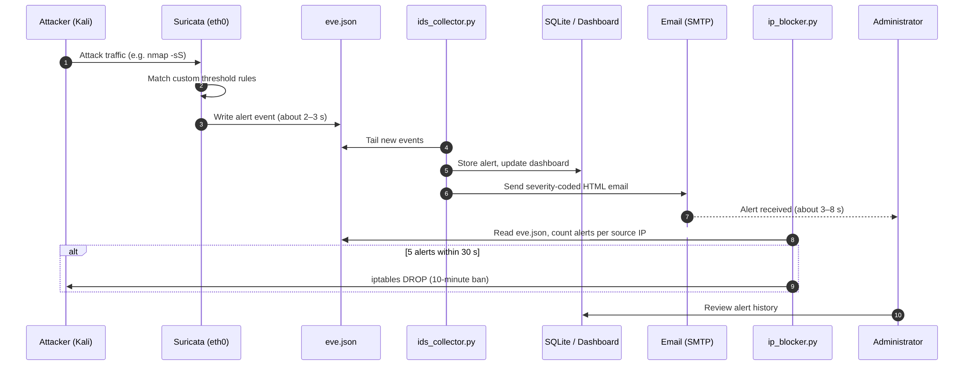
Figure 3.6: Sequence diagram for attack detection, alerting and automatic blocking

3.3 Functional Requirements
The system meets the following functional requirements:
Table 3.1: Functional requirements
ID | Functional requirement
FR-01 | Capture all traffic on 192.168.10.0/24 in real time via eth0 (AF-PACKET promiscuous mode).
FR-02 | Detect reconnaissance scans SYN, XMAS, NULL, FIN, port, service and UDP scans using custom rules.
FR-03 | Detect ICMP and TCP SYN floods using rate-threshold rules (SIDs 1000005 / 1000008).
FR-04 | Detect SSH and FTP brute-force attempts (SIDs 1000006 / 1000007).
FR-05 | Detect web attacks SQL injection and cross-site scripting (SIDs 1000010 / 1000013 / 1000011).
FR-06 | Detect malware download via the EICAR test file over HTTP (SID 1000009).
FR-07 | Match all captured packets against the 18 custom signatures in real time.
FR-08 | Generate an alert in real time (within about 2–3 seconds of the matching traffic).
FR-09 | Store all alerts persistently in fast.log (human-readable) and eve.json (structured JSON).
FR-10 | Deliver alerts to a Flask web dashboard and by severity-coded HTML email (ids_collector.py).
FR-11 | Optionally block confirmed attacks via inline IPS (NFQUEUE drop) or automatic IP blocking.
FR-12 | Support full remote management via SSH (PuTTY) and RealVNC without physical access.

3.4 Non-Functional Requirements
Table 3.2: Non-functional requirements
ID | Non-functional requirement | Target / achieved
NFR-01 | Cost of the complete hardware | ≤ $100 (achieved: ~$70)
NFR-02 | Power consumption for 24/7 use | ≤ 10 W (achieved: ~8 W)
NFR-03 | Continuous availability | ≥ 72 h (validated: 72+ h)
NFR-04 | Real-time alerting latency | alerts within ~2–3 seconds
NFR-05 | Rule-loading reliability | 18 rules load, 0 failures (50,193 with ET Open enabled)
NFR-06 | Ease of deployment | basic Linux skills; setup script provided
NFR-07 | Maintainability | rules updatable (suricata-update); documented config
NFR-08 | Scalability (future) | distributed-DDoS mitigation, ML anomaly detection, cloud dashboard
NFR-09 | Security of management channel | encrypted SSH (CLI) and VNC with authentication
NFR-10 | Log integrity | alert logs persist on disk and survive restart

3.5 Hardware and Software Requirements
Hardware:
- Raspberry Pi 4 Model B 8GB RAM [23]
- 32GB MicroSD Card (Raspberry Pi OS 64-bit)
- Wired interface (eth0) connected to 192.168.10.0/24 subnet
- Power supply (8W operation)
- Remote access: any machine with PuTTY and RealVNC Viewer installed
- Total cost: about $70 / PKR 21,000+
Software:
- Raspberry Pi OS 64-bit
- Suricata 7.x IDS Engine
- Wireshark (live packet capture and deep traffic analysis)
- PuTTY SSH client
- RealVNC Viewer remote desktop
- Python 3 alert collector (reads eve.json, stores to SQLite, emails alerts) and Flask web dashboard
- Kali Linux VM with Nmap 7.95 (attack simulation)
- tcpdump (packet capture verification)
- suricata-update (rule management and update tool)
Rule Sets:
- Emerging Threats Open: over 50,000 signatures (DoS, scan, exploit categories), evaluated during development and disabled in the final configuration
- Custom local.rules: 18 detection rules (SIDs 1000001–1000013 + team 9000001–9000005) The 13 detection rules reside in /etc/suricata/rules/local.rules and the 5 team rules in /var/lib/suricata/rules/local.rules; both are loaded via the rule-files list in suricata.yaml.

3.6 Threat Scenarios (Threat Handling)
The system is designed to detect the following threat scenarios, each of which was tested (see Section 5.5).
Table 3.3: Threat scenarios
# | Threat scenario | How the attacker acts | How the system detects it
TS1 | Port scan | Sends many connection requests to find open ports | Rule detects many SYN packets from one source in a short time
TS2 | Stealth scanning | Uses unusual TCP flags (XMAS, NULL, FIN) | Rules match these invalid flag combinations
TS3 | OS/service fingerprinting | Probes the host to identify OS and versions | Scan and probe rules fire
TS4 | ICMP flood (DoS) | Floods the host with ICMP echo requests | Rule detects a high rate of ICMP to one host
TS5 | SYN flood (DoS) | Floods a port with half-open TCP connections | Rule detects a high rate of SYN to one host
TS6 | SSH brute force | Repeatedly guesses SSH passwords | Rules detect many SSH connection attempts
TS7 | FTP brute force | Repeatedly guesses FTP passwords | Rule detects repeated failed-login (530) replies
TS8 | Web application attack | Sends SQL injection and XSS payloads | Rules match SQLi and XSS patterns in web requests
TS9 | Malware delivery | Downloads a malicious file over the network | Rule matches the malware signature in file content (EICAR test)
Figure 3.7 maps each threat scenario to the attack tool used to simulate it and to the rule(s) that detect it.
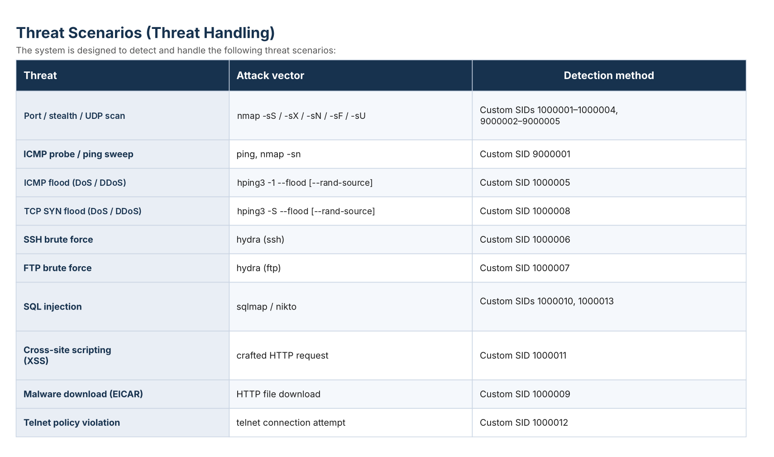
Figure 3.7: Threat scenarios mapped to attack vectors and detection rules

3.7 Threat Modeling (STRIDE) and Detection Techniques
Threat modelling was carried out using the STRIDE methodology, applied to NetGuard Pi itself. Because the sensor is a security device, an attacker who disables, deceives or takes over it removes the network's visibility. Table 3.4 lists each STRIDE category, the corresponding threat to NetGuard Pi, and the mitigation used in the system.
Table 3.4: STRIDE threat model for NetGuard Pi
STRIDE Category | Threat to NetGuard Pi | Mitigation in NetGuard Pi
Spoofing | Attacker forges source IP addresses to hide identity or to make a legitimate host look malicious and get it blocked | Automatic blocking needs repeated alerts (5 in 30 s), is scoped to eth0 and expires after 10 minutes; management uses a separate interface so the administrator is never locked out
Tampering | Attacker who gains access edits local.rules, suricata.yaml or deletes entries from eve.json/SQLite to hide activity | Rule and log files are root-owned; management only over encrypted SSH; alerts are also copied off-device by email (at most one per rule and attacker per minute)
Repudiation | Attacker denies having launched an attack | Each alert is timestamped with source/destination IP and port in eve.json, fast.log and SQLite, and can be cross-checked against Wireshark/tcpdump captures
Information Disclosure | Dashboard, alert emails or logs reveal internal IP addresses, services and topology | Encrypted SSH and authenticated VNC for management (NFR-09); the dashboard is intended for the internal lab network only
Denial of Service | Flooding the sensor to exhaust CPU or make it drop packets and miss attacks | Multi-threaded Suricata with AF-PACKET; measured 4.79% drop at ~57,000 pps while the flood was still detected (Table 5.6); flood rules and IP blocking
Elevation of Privilege | Brute-forcing SSH or exploiting a service on the Pi to gain root control of the sensor | SSH/FTP brute-force detection (T5, T6) and automatic IP blocking; unused services (e.g. rpcbind) disabled; remaining services are lab test targets and authenticated management
The detection side of the threat model uses a signature-based approach, augmented with threshold-based custom rules:
- Signature-based detection: Suricata matches each packet against the 18 custom signatures. Each rule specifies protocol, source/destination IPs and ports, payload patterns, and metadata.
- Threshold-based rules: Custom local.rules employ count-based thresholds over time windows to detect scanning behavior (e.g., 5 SYN packets in 3 seconds triggers SYN scan detection).
- AF-PACKET promiscuous mode: Ensures all traffic on the network segment is captured, not just traffic addressed to the Raspberry Pi.
- Validation methodology: Wireshark is used to independently verify captured packet timestamps and correlate them with Suricata alert logs.

3.8 Threat Resistance Model
The NetGuard Pi threat resistance model operates in three phases:
- Visibility Phase: All network traffic on eth0 is captured passively in promiscuous mode, ensuring no attack traffic is missed.
- Detection Phase: Suricata applies the 18 custom rules to every captured packet in real time (18 rules loaded, 0 failed). Matched packets generate alerts in fast.log and eve.json.
- Response Phase (Detection and Prevention): Alerts are surfaced to administrators via the Python alert collector (dashboard and email) and stored in persistent log files. Active blocking is implemented: inline IPS via NFQUEUE and automatic IP blocking via iptables (see Section 5.6).

3.9 Chapter Summary
This chapter provided the complete technical design specification for NetGuard Pi. The 4-layer system architecture traffic capture, IDS detection engine, alert processing, and output, response and remote management was described in detail, together with use case, data flow (Levels 0 and 1) and sequence diagrams. Twelve functional requirements and ten non-functional requirements were formally specified. Hardware and software requirements were documented with specific versions and configuration parameters. Nine threat scenarios were identified and mapped to detection rules, the sensor itself was analysed with the STRIDE threat model, and the signature-based and threshold-based detection techniques were described. The 3-phase threat resistance model (Visibility → Detection → Response) was defined. This chapter provides the complete technical blueprint from which the implementation in Chapter 5 was built.

Chapter 4:
Proposed Solution

Chapter 4: Proposed Solution

4.1 Introduction
This chapter presents the complete proposed solution for NetGuard Pi project. It describes the methodological approach, explains how data is collected and processed, details the complete tools and techniques stack, defines the evaluation metrics, and explains how each design decision maps to the problem identified in the previous chapters. The proposed solution is grounded in both practical engineering constraints (cost, power, performance) and academic rigor (validated measurement, reproducible results).

4.2 Proposed Model
The proposed solution employs a quantitative and experimental approach. NetGuard Pi is a hardware-software integrated system built around Raspberry Pi 4 and the Suricata IDS engine. The model is validated experimentally through live attack simulations using a Kali Linux VM on the same network subnet.
The system functions as follows:
- Captures all traffic on eth0 (192.168.10.50) via AF-PACKET in promiscuous mode.
- Suricata matches every packet against the 18 custom signatures in real time.
- Custom rules detect SYN scans, port scans, and service enumeration based on configurable thresholds.
- A Python alert-collector service reads Suricata's eve.json in real time, stores each alert in an SQLite database, and sends a severity-coded HTML email; a Flask web dashboard shows the alerts live.
- All alerts are saved permanently to /var/log/suricata/fast.log and eve.json.
End-to-end workflow. Figure 4.1 shows the complete closed-loop pipeline of the proposed model, from attack traffic to notification and automatic response:
1. The attacker (Kali Linux, 192.168.10.20) sends scan, flood, brute-force, web or malware traffic on the lab subnet.
2. The Raspberry Pi 4 captures every frame on eth0 using AF-PACKET in promiscuous mode.
3. Suricata 7 inspects each packet against the 18 custom threshold rules.
4. A matching packet produces an alert in eve.json and fast.log within about 2–3 seconds.
5. ids_collector.py reads the new alert, assigns severity and de-duplicates floods.
6. The alert is stored in the SQLite database.
7. The Flask dashboard displays the alert live.
8. A severity-coded HTML email reaches the administrator within about 3–8 seconds.
9. If the same source triggers 5 alerts within 30 seconds, ip_blocker.py blocks it with iptables for 10 minutes; in inline IPS mode, matching packets are dropped immediately via NFQUEUE.
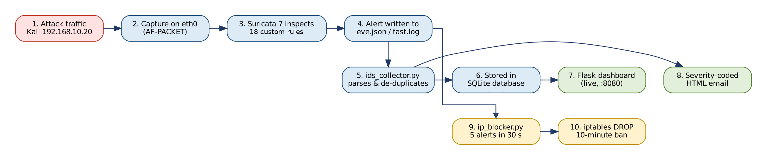
Figure 4.1: End-to-end detection, alerting and response pipeline of NetGuard Pi
Key contribution. Unlike the reviewed Raspberry Pi deployments, which stop at writing IDS logs or report offline accuracy (Section 2.2.5), NetGuard Pi combines multi-threaded signature detection, empirically tuned threshold rules, real-time email and dashboard alerting, and automatic prevention in a single ~$70 device and validates the whole pipeline with measured detection rate, latency, resource usage and uptime.

4.3 Data Collection
Network traffic data is gathered through the following methods:
- Live traffic capture: Raspberry Pi 4 passively monitors all traffic on the 192.168.10.0/24 lab subnet using AF-PACKET promiscuous mode on eth0.
- Attack simulation: Controlled attack traffic is generated using Kali Linux VM (IP: 192.168.10.20) running Nmap 7.95, hping3, Hydra, Nikto, sqlmap and curl, executing scans, floods, brute-force, web and malware-download attacks.
- Log collection: All Suricata alerts are logged in two formats fast.log (human-readable one-line alerts) and eve.json (structured JSON for future Filebeat/Grafana integration).
- Packet capture verification: tcpdump and Wireshark are used to independently capture and inspect raw packets on eth0, confirming that Suricata alerts correspond accurately to real attack traffic.

4.4 Data Pre-Processing
Data pre-processing in this system involves:
- Rule threshold tuning: Custom detection rules were iteratively tuned to balance sensitivity and false-positive rate. For example, SYN scan detection requires 5 SYN packets in 3 seconds to avoid false positives from legitimate traffic.
- Alert processing: the Python collector reads eve.json, stores each alert in SQLite, de-duplicates floods (at most one message per rule and attacker per minute), and formats a severity-coded HTML email; the dashboard reads the database and refreshes every few seconds.
- Log prioritization: Alerts are classified by Suricata priority level (1–3), allowing administrators to focus on high-priority detections first.
- Interface filtering: Configured to monitor only eth0, excluding loopback and irrelevant interfaces to reduce noise.

4.5 Tools and Techniques
Table 4.1: Tools and techniques
Tool | Version / type | Role in the project
Raspberry Pi OS | 64-bit | Operating system of the sensor
Suricata | 7.0.10 | Detection engine
Emerging Threats Open ruleset | 50,000+ signatures | Evaluated during development; disabled in the final system
Custom rules (local.rules) | 13 rules (1000001-1000013) + 5 team rules (9000001-9000005) | Project-specific detection
Python | 3 | Alert collector service
SQLite | - | Stores alerts for dashboard and analysis
Flask | - | Web dashboard
systemd | - | Runs services and starts them at boot
VirtualBox + Kali Linux | - | Attacker machine
nmap | 7.x | Port scans, stealth scans, OS detection (T1-T3)
hping3 | - | ICMP and SYN floods (T4, T7)
hydra | - | SSH and FTP brute force (T5, T6)
nikto, sqlmap | - | Web attacks (T8)
DVWA, vsftpd | - | Vulnerable web app and FTP server as targets (lab only)
Wireshark, tcpdump | - | Independent packet capture to verify detections
Git / GitHub | - | Version control for code, configs, results and progress log
Technique: the system uses signature-based detection. Suricata inspects each packet against the loaded rules, and the custom rules use count-based thresholds over time windows (for example, a set number of SYN packets within a few seconds) to detect scanning and flooding while limiting false positives.
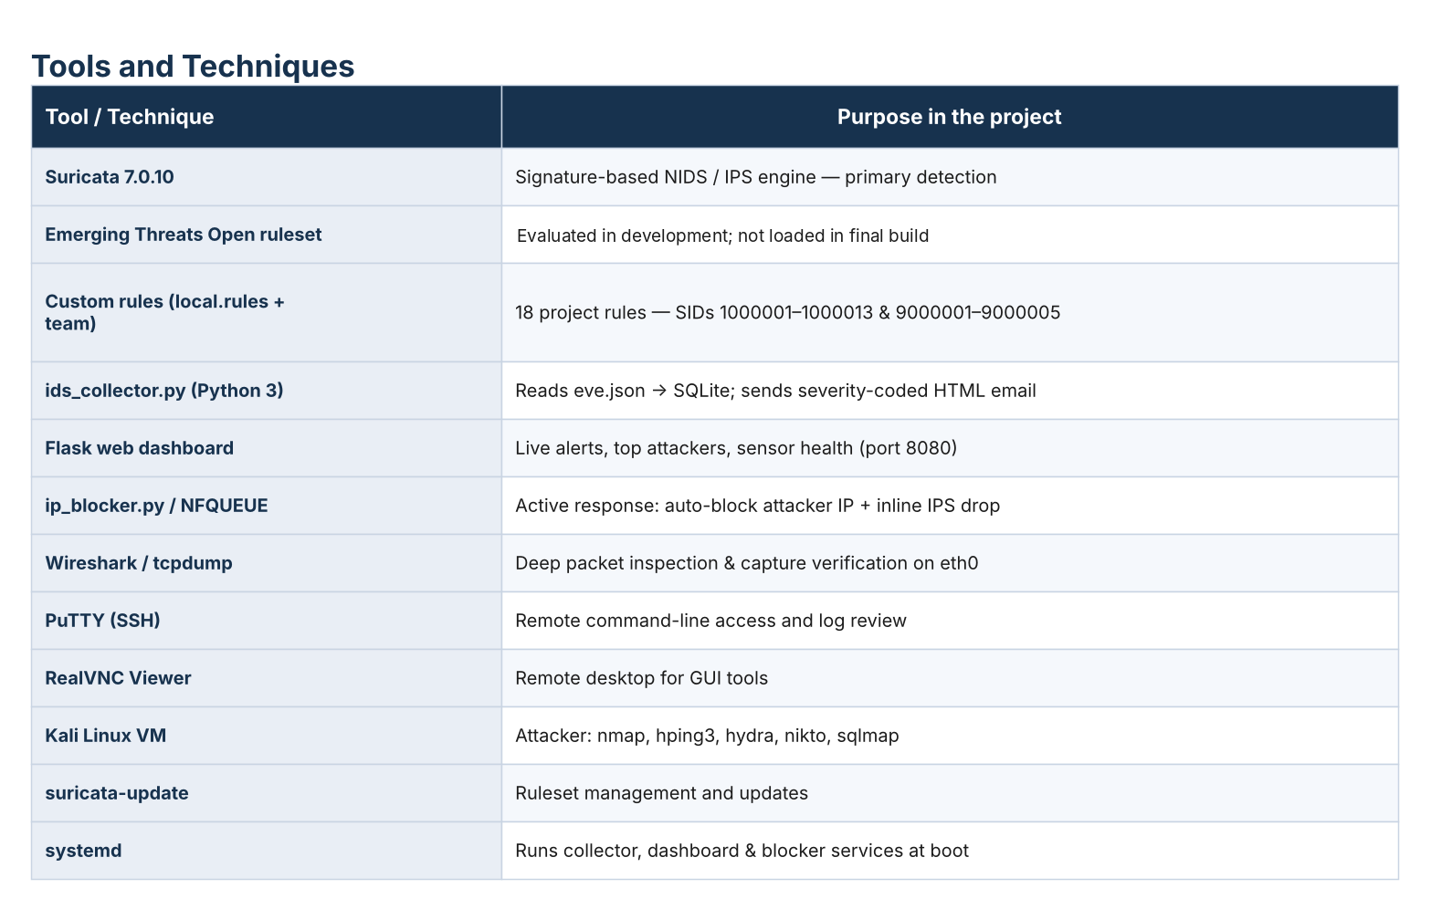
Figure 4.2: Tools and techniques stack and the purpose of each component

4.6 Evaluation Metrics
The performance of NetGuard Pi is evaluated with the eight metrics in Table 4.2. Targets were derived from the non-functional requirements (Table 3.2), and the achieved values were measured during the testing described in Chapter 5.
Table 4.2: Evaluation metrics, targets and achieved values
Metric | Definition / How Measured | Target | Achieved
1. Detection rate | Attack types detected ÷ attack types launched (T1–T9), checked against dashboard and email alerts | 100% of tested attack types | 9/9 = 100%
2. Alert latency | Time from attack traffic to the alert appearing in eve.json and on the dashboard | ≤ 3 s (NFR-04) | ≈ 2–3 s
3. Notification latency | Time from attack traffic to the email arriving in the administrator's inbox | ≤ 10 s | ≈ 3–8 s
4. Packet drop rate | Kernel/capture drops ÷ packets received, from Suricata statistics | < 1% under normal load | 0.70% at ~94 Mbit/s; 4.79% under a ~57,000 pps flood
5. Resource utilisation | CPU %, RAM and SoC temperature while Suricata runs | CPU < 50%; temperature below the 80 °C throttling point | CPU 21.6% (normal load); RAM ≈ 1.7–1.9 GB; max 48.5 °C
6. Availability | Continuous uninterrupted operation of all services | ≥ 72 h (NFR-03) | 72+ h
7. Prevention effectiveness | Whether attacks are stopped in IPS mode and attackers are automatically blocked | Matching attacks dropped; repeat offender blocked | SQLi and XSS dropped inline; attacker blocked after 5 alerts in 30 s for 10 min
8. Cost and power | Total hardware cost and measured power draw | ≤ $100; ≤ 10 W (NFR-01, NFR-02) | ≈ $70; ≈ 8 W
A formal false-positive rate over a sustained period of normal traffic has not yet been measured; it is identified as the next evaluation step in Section 6.3.

4.7 Chapter Summary
This chapter presented the complete proposed solution for NetGuard Pi in detail. The quantitative and experimental methodological approach was justified and explained. The 5-step operational model of the system was described in detail. The four-part data collection strategy (live promiscuous capture, controlled attack simulation, log collection and independent packet verification) was documented. Four data pre-processing steps were explained, including the critical iterative threshold tuning of custom detection rules. The complete tools and techniques stack was presented with specific versions and justifications. Eight evaluation metrics were formally defined with targets and achieved values. The proposed solution demonstrates that all primary project objectives are achievable within the defined constraints of cost, power, and performance.

Chapter 5:
Implementation and Testing

Chapter 5: Implementation and Testing

5.1 Security Properties Testing
The system was validated for the following security properties:
- Confidentiality: All remote access is encrypted via SSH (PuTTY); VNC access is protected by authentication.
- Integrity: Alert logs are written to persistent storage (fast.log and eve.json) and verified against Wireshark packet captures.
- Availability: System validated for 72+ continuous hours of uninterrupted operation at 8W power consumption.
- Detection coverage: 9 distinct attack types verified, 100% detection rate.

5.2 System Setup (Environment Configuration, Key Functions and Algorithms)
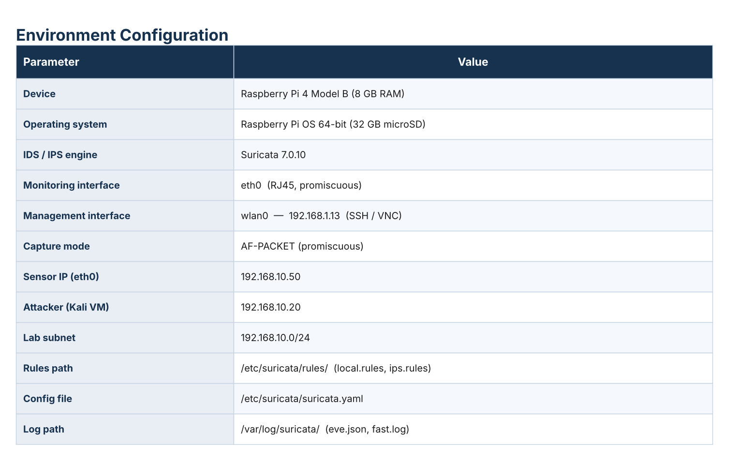
Table 5.1: Environment configuration of the NetGuard Pi test bed
Key Custom Rules (18 total local.rules SIDs 1000001–1000013 and team rules 9000001–9000005):
- Scans (SIDs 1000001–1000004, 9000001–9000005): TCP SYN, XMAS, NULL and FIN port scans, plus ICMP and UDP probes.
- Denial of service (SIDs 1000005, 1000008): ICMP flood and TCP SYN flood, detected by packet-rate thresholds.
- Brute force (SIDs 1000006, 1000007): SSH and FTP repeated failed-login attempts.
- Web attacks (SIDs 1000010, 1000013, 1000011): SQL injection (UNION SELECT and OR 1=1) and cross-site scripting (XSS).
- Malware and policy (SIDs 1000009, 1000012): EICAR malware download over HTTP and Telnet connection attempts.
Key component - alert collector: the Python service continuously reads /var/log/suricata/eve.json, parses each new alert, stores it in SQLite, sends an HTML email, and feeds the Flask dashboard, giving immediate administrator visibility on a web page and on the phone.

5.3 System Integration
Component Integration:
- Raspberry Pi OS provides the base operating system, networking stack, and process management for all other components.
- Suricata 7.x integrates directly with the eth0 interface via AF-PACKET socket, bypassing higher-level network stack layers for maximum capture performance [20], [21].
- The alert collector integrates with Suricata via the eve.json log, reading new events in real time and delivering them to the database, dashboard and email without modifying Suricata's core.
- Wireshark integrates with eth0 for independent packet capture, accessible remotely via RealVNC Viewer.
- PuTTY and RealVNC Viewer provide encrypted remote management channels for command-line and GUI access respectively.
Log Management Setup:
- Primary alert log: /var/log/suricata/fast.log (human-readable, one alert per line)
- Structured log: /var/log/suricata/eve.json (JSON format), read in real time by the alert collector that stores alerts in SQLite and drives the dashboard and email notifications.

5.4 Penetration Testing and Vulnerability Assessment
Penetration testing was conducted using a Kali Linux VM (192.168.10.20) as the attacker machine against the Raspberry Pi 4 (192.168.10.50) defender on a shared lab subnet (192.168.10.0/24). Remote access during testing was maintained via PuTTY and RealVNC Viewer.
Test Environment:
- Attacker: Kali Linux VM, IP 192.168.10.20, Nmap 7.95
- Defender: Raspberry Pi 4 (8GB), Suricata 7.x, IP 192.168.10.50
- Subnet: 192.168.10.0/24 (wired Ethernet)

5.4.1 Methodology
Penetration testing followed a structured four-phase methodology commonly used in cybersecurity assessments. The purpose was not to find vulnerabilities in the Raspberry Pi itself, but to verify that every attack phase is detected, alerted and — where enabled — blocked by NetGuard Pi.
Phase 1 – Reconnaissance. Discovering live hosts, open ports, services and operating systems with Nmap: TCP SYN scan (-sS), stealth XMAS/NULL/FIN scans (-sX, -sN, -sF) and aggressive service/OS detection (-A). Covered by tests T1–T3.
Phase 2 – Denial of service. Flooding the target to test detection under load and the sensor's own resilience, using hping3 ICMP floods (-1 --flood) and TCP SYN floods (-S --flood). Covered by tests T4 and T7.
Phase 3 – Exploitation attempts. Simulating credential and application attacks: SSH and FTP brute force with Hydra, SQL injection and cross-site scripting with sqlmap, Nikto and crafted curl requests, and a malware download using the EICAR test file over HTTP. Covered by tests T5, T6, T8 and T9.
Phase 4 – Monitoring and verification. For every test, confirming that (a) Suricata wrote the expected alert to eve.json and fast.log, (b) the alert was stored in SQLite and appeared on the dashboard, (c) an email was received, and (d) the alert timestamps matched the packets captured independently with tcpdump/Wireshark. In prevention tests, the attack was additionally confirmed to be dropped or the attacker blocked (Section 5.6).

5.5 Test Cases
Nine attack test cases were run from the Kali attacker (192.168.10.20) against the Raspberry Pi and its services (192.168.10.50). Each was checked against the alerts recorded by the IDS. Every attack was detected and produced both a dashboard alert and an email notification.
Table 5.2: Test cases and results
ID | Attack | Tool / command | Key rule(s) | Result
T1 | TCP SYN port scan | nmap -sS | 1000001, 9000002-9000004 | Detected 5/5 runs
T2 | Stealth scans (XMAS/NULL/FIN) | nmap -sX / -sN / -sF | 1000002, 1000003, 1000004 | Detected 15/15 runs
T3 | Aggressive scan + OS detection | nmap -A | 1000001, 9000002–9000004, 1000006 (SSH probes) | Detected
T4 | ICMP flood | hping3 -1 --flood | 1000005 | Detected
T5 | SSH brute force | hydra (ssh) | 1000006 (custom) | Detected
T6 | FTP brute force | hydra (ftp) | 1000007 (custom) | Detected
T7 | SYN flood | hping3 -S --flood | 1000008 | Detected
T8 | Web attacks (SQLi, XSS) | sqlmap, nikto, curl | 1000010, 1000011 (custom) | Detected
T9 | Malware download (EICAR) | HTTP download | 1000009 (custom) | Detected
Detection rate: 9/9 = 100%. Detection occurred within about 2-3 seconds of each attack, with email notifications within about 3-8 seconds.
During development the full Emerging Threats Open ruleset was loaded alongside the custom rules (50,193 rules in total). It added noise, for example alerts on the dashboard's own login page, so the final configuration loads only the 18 custom rules (18 loaded, 0 failed). Three further tests exercised the remaining rules: a UDP scan (nmap -sU) triggered SID 9000005, a real Telnet connection triggered SID 1000012, and a 10-second ICMP and SYN flood from thousands of spoofed sources (hping3 --rand-source) was detected by SIDs 1000005 and 1000008. All 18 custom rules were therefore triggered at least once.
The step-by-step flow of three representative test cases is shown in Tables 5.3–5.5, following the format Step → Action → Expected result → Observed result.
Test Case T1: TCP SYN port scan
Table 5.3: Test case T1 – TCP SYN port scan
Step | Action | Expected Result | Observed Result
1 | Run nmap -sS 192.168.10.50 from Kali | Burst of SYN packets on the subnet | SYN packets seen on eth0 (tcpdump)
2 | Suricata evaluates the threshold rule (SID 1000001) | ≥ 5 SYN packets in 3 s from one source triggers an alert | Alert written to eve.json and fast.log
3 | ids_collector.py reads the alert | Alert stored in SQLite and shown on the dashboard | Dashboard updated within ~2–3 s
4 | Email notification sent | Severity-coded HTML email received | Email received within ~3–8 s
5 | Repeat the scan 5 times | Detected on every run | Detected 5/5 runs
Test Case T6: FTP brute force
Table 5.4: Test case T6 – FTP brute force
Step | Action | Expected Result | Observed Result
1 | Run Hydra against the FTP service on 192.168.10.50 | Repeated login attempts with wrong passwords | Server returns repeated 530 (login failed) replies
2 | Suricata evaluates SID 1000007 | Repeated 530 replies to one source trigger an alert | Brute-force alert generated
3 | ids_collector.py stores and de-duplicates the alert | One dashboard entry per burst, no email flood | Alert visible on dashboard; at most one email per rule and attacker per minute
4 | Administrator notified | Email identifies attacker IP and rule | Email received with source 192.168.10.20
Test Case T8: SQL injection with prevention
Table 5.5: Test case T8 – SQL injection with IPS and automatic blocking
Step | Action | Expected Result | Observed Result
1 | Send UNION SELECT payload with curl (IDS mode) | Alert raised; request reaches the web server | SID 1000010 alert; HTTP 200 returned
2 | Switch Suricata to inline IPS mode (NFQUEUE) and repeat | Request dropped before reaching the server | curl timed out; event logged with action "blocked"
3 | Send repeated SQLi requests | ip_blocker.py blocks the source after 5 alerts in 30 s | iptables rule added for 192.168.10.20
4 | Send a normal web request from Kali | Request blocked while the ban is active | Request timed out; ban logged to database
5 | Wait for the ban window | Ban lifted automatically after 10 minutes | Access restored after 10 minutes
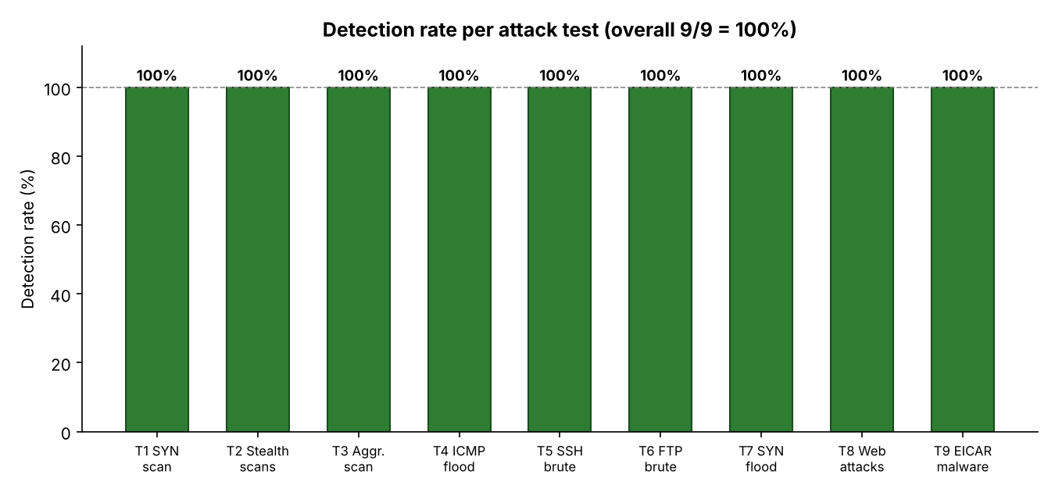
Figure 5.1: Detection rate per attack test (9/9 = 100%)
Table 5.6: System performance under three traffic conditions (measured on the Raspberry Pi 4)
Condition | CPU (%) | RAM used (MB) | Temp (°C) | Packet drop (%)
Idle (Suricata running) | 2.0 | 1878 | 41.6 | 0.00
Normal load (~94 Mbit/s, iperf3) | 21.6 | 1757 | 48.5 | 0.70
Under attack (ICMP flood, ~57k pps) | 17.8 | 1691 | 47.7 | 4.79
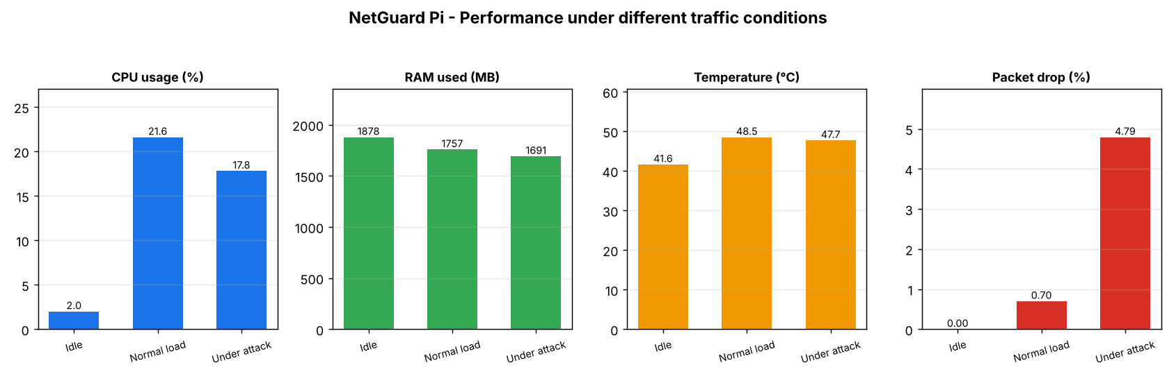
Figure 5.2: Performance under idle, normal load and attack conditions
The system was benchmarked under three traffic conditions with the full Emerging Threats ruleset loaded (50,193 rules), so the final 18-rule configuration places an even lower load on the sensor. At idle the sensor is almost free (2.0% CPU, 41.6 °C) with no packet loss. Under a sustained ~94 Mbit/s TCP load it used 21.6% CPU at 48.5 °C and dropped only 0.70% of packets, inspecting over 500,000 packets in 60 s. During an extreme ICMP flood (~57,000 packets/s, 3.45 million packets in 60 s) CPU stayed at 17.8% and the attack was still detected, with packet drop rising to 4.79%. RAM remained flat at about 1.7–1.9 GB and the temperature never approached the 80 °C throttling point, confirming the Raspberry Pi 4 is comfortably able to run the IDS in real time at low cost.

5.6 Prevention Testing (IPS Mode and Automatic Blocking)
Beyond detection, two prevention layers were implemented and tested so the system can also stop attacks, not only report them. In inline IPS mode Suricata runs on the monitoring interface via NFQUEUE and drops packets that match the prevention ruleset (rules/ips.rules); in reactive mode a watcher service (ip_blocker.py) automatically blocks an attacker's IP with iptables after repeated alerts. All blocking is scoped to the monitoring interface (eth0) so management access is never affected.
Inline IPS before vs after:
Table 5.7: Inline IPS before and after (IDS mode vs IPS mode)
Attack from Kali (192.168.10.20) | IDS mode (passive) | IPS mode (inline)
SQL injection (UNION SELECT) via HTTP | Request reaches the Pi (HTTP 200 returned) | Dropped curl times out; event logged action=blocked
Cross-site scripting (<script>) via HTTP | Request reaches the Pi (HTTP 200 returned) | Dropped curl times out; event logged action=blocked
In IDS mode both attacks returned the web server's page (reaching the target); after switching to IPS mode the identical requests timed out and Suricata logged them with action "blocked", confirming the attacks were prevented at the packet level.
Automatic IP blocking: when the Kali attacker sent repeated SQL-injection requests, the active-response service blocked the source after 5 alerts in 30 seconds. iptables then dropped all further traffic from 192.168.10.20 even a normal web request from Kali timed out and the ban was logged to the database and lifted automatically after the configured 10-minute window.

5.7 Best Practices / Coding Standards

5.7.1 Code Validation
- The alert collector was validated against live Suricata output to confirm correct parsing, storage, dashboard display and email delivery of all alert fields.
- Custom rules (SIDs 9000001-9000005 and 1000001-1000013) were tested against controlled attacks to verify accurate triggering with correctly tuned threshold values.
- tcpdump was used to verify that packets captured by Suricata matched expected attack patterns.

5.7.2 Development Practices & Standards
- Iterative incremental development: The project followed an install → test → fix → re-test cycle, resolving issues step-by-step (e.g., correcting the capture interface to eth0, rules path correction, threshold tuning).
- Issue-driven debugging: Each problem was diagnosed systematically using tcpdump, ping, and Nmap for validation at each stage.
- Validation-first: Every component (interface, rules, Python script) was independently confirmed before integration testing.
- Remote-first collaboration: Team used PuTTY (SSH) and RealVNC for consistent remote access, enabling collaboration without physical access to the hardware.
- Configuration documentation: All key configurations (suricata.yaml, local.rules, interface settings) were documented for reproducibility.

5.8 Chapter Summary
This chapter detailed the complete implementation and testing of the system. The system setup, component integration, four-phase penetration testing methodology, test cases (with step-by-step tables for representative tests), performance results and prevention testing were presented. The system achieved 100% detection across all 9 attack types tested, with alerts within about 2-3 seconds and a total hardware cost of about $70. Development followed iterative, validation-first practices with full remote collaboration.

Chapter 6:
Conclusion and Future Work

Chapter 6: Conclusion and Future Work

6.1 Introduction
This chapter summarizes the achievements of the project across its two phases — FYP-1, which delivered the detection system, and FYP-2, which added prevention, full attack validation and performance evaluation — provides a critical review of the work completed, and outlines future development directions.

6.2 Achievements and Improvements
FYP-1 — Detection system (completed):
Table 6.1: FYP-1 tasks and status
Task | Status
Studied IDS concepts and common network attacks | ✓ Completed
Reviewed tools, selected Suricata over Snort/Zeek for RPi 4 | ✓ Completed
Designed 4-layer architecture with network topology | ✓ Completed
Configured RPi 4 with Suricata, 50,193 rules, Wireshark, remote access | ✓ Completed
Live attack detection 3 attack types validated from Kali Linux VM | ✓ Completed
- Literature Review (19 peer-reviewed studies reviewed, five research gaps identified)
- System Design Document (4-layer architecture, network topology, hardware/software specs)
- Working detection prototype: Suricata 7.x deployed on Raspberry Pi 4 with over 50,000 Emerging Threats rules, Python alert collector, Flask dashboard and severity-coded email alerting
FYP-2 — Prevention, full validation and performance evaluation (completed):
- Expanded to 18 custom detection rules (13 local, SIDs 1000001–1000013, plus 5 team rules, SIDs 9000001–9000005) covering scans, floods, brute force, SQL injection, XSS, malware and Telnet policy violations; the final configuration loads only these 18 rules
- Full attack validation: 9 attack types (T1–T9) tested with a 100% detection rate and alerts within about 2–3 seconds; together with additional UDP scan, Telnet and spoofed-source DDoS tests, all 18 rules were triggered at least once
- Prevention added: inline IPS mode (NFQUEUE packet drop) and automatic IP blocking via iptables, both tested; the attacker was blocked after 5 alerts in 30 seconds and automatically unblocked after 10 minutes (see Section 5.6)
- Performance evaluation under idle, normal load and attack conditions: 0–0.7% packet drop in normal use, and attacks still detected under a ~57,000 packets/s flood (4.79% drop)
Key Achievements:
- 100% attack detection rate (9/9 attack types)
- Real-time alerts within about 2–3 seconds
- About $70 total hardware cost (roughly 30 times cheaper than the cheapest commercial appliance, and over 400 times cheaper than enterprise IDS at $30,000+ per year)
- 8W power consumption enabling 24/7 operation
- 72+ hours validated continuous uptime
- Prevention capable: inline IPS (packet drop) and automatic IP blocking implemented and tested
- Performance evaluated under idle, normal load and attack (0–0.7% packet drop in normal use; attack still detected under flood)

6.3 Critical Review
While the project successfully delivers a complete, working NIDS/IPS system across its two phases, several limitations are acknowledged:
- Inline protection scope: the inline IPS (NFQUEUE) and automatic IP blocking (iptables) were validated in the lab, but they currently protect the Raspberry Pi itself. Deploying the Pi as a transparent inline bridge to protect other hosts is future work.
- Alerting: alerts are delivered to a web dashboard and by HTML email. SMS notification and a cloud dashboard remain future work.
- Attack coverage: the system was tested against nine attack types — port and stealth scans, ICMP and SYN floods, SSH and FTP brute force, SQL injection, XSS and malware (EICAR), all detected. A distributed flood from thousands of spoofed sources was detected by the flood rules, but per-IP blocking cannot stop it, and being signature-based the system may miss novel attacks that have no signature.
- Single network interface: the system monitors one interface (eth0). Covering additional segments via a mirrored switch port or multiple capture interfaces is future work.
- False positive quantification: A formal, numeric false positive rate measurement over a sustained normal-traffic window has not yet been conducted and is recommended as the next step.
- Scalability not yet tested: Performance under high-traffic loads (e.g., campus-scale traffic) has not been evaluated.

6.4 Future Recommendations
The following developments are recommended for future work:
- Attack Detection Expansion:
  - DDoS mitigation (detection of spoofed-source floods is already demonstrated; blocking them needs upstream filtering such as the ISP or a scrubbing service)
  - Machine-learning anomaly detection to catch novel / zero-day attacks that signature rules miss
  - IPv6-specific detection rules and testing
  - Inspection of encrypted traffic metadata (e.g. TLS SNI and JA3/JA4 fingerprints) to detect threats inside HTTPS without decrypting it
- Inline Bridge Deployment:
  - Deploy the Pi as a transparent inline bridge so that the existing IPS and automatic blocking protect every host on the segment, and tune the drop policy to minimise impact on legitimate traffic
- Alerting System:
  - Add SMS and mobile push-notification alerts as extra channels alongside the existing e-mail alerts, so administrators are reached even without checking their inbox
- Centralised Dashboard (Grafana):
  - For multi-sensor deployments, ship eve.json with Filebeat to Loki and visualise it in Grafana, complementing the lightweight Flask/SQLite dashboard used on each single sensor.
  - Add capabilities the current dashboard lacks: long-term alert history and search, attack timelines and trend charts, geographic IP mapping, and one combined view of several NetGuard Pi sensors.
- Extended Performance Evaluation:
  - Formal false-positive rate measurement over a sustained window of normal traffic
  - Throughput testing above 100 Mbit/s (up to 1 Gbps) and campus-scale load testing
  - Multi-segment monitoring via a mirrored switch (SPAN) port or multiple capture interfaces

6.5 Chapter Summary
This chapter summarised the completion of the project tasks and deliverables. The system achieved a 100% detection rate across 9 attack types, alerts within a few seconds, and about $70 hardware cost. Limitations (signature-based only, no inspection of encrypted payloads, packet drop under extreme floods) were acknowledged, and a roadmap for distributed-DDoS mitigation, machine-learning anomaly detection and higher throughput was established.

REFERENCES
[1] D. E. Denning, "An intrusion-detection model," IEEE Transactions on Software Engineering, vol. SE-13, no. 2, pp. 222–232, 1987.
[2] M. Roesch, "Snort – Lightweight intrusion detection for networks," in Proc. 13th USENIX Conference on System Administration (LISA '99), Seattle, WA, USA, 1999, pp. 229–238.
[3] V. Paxson, "Bro: A system for detecting network intruders in real-time," Computer Networks, vol. 31, no. 23–24, pp. 2435–2463, 1999.
[4] A. Khraisat, I. Gondal, P. Vamplew, and J. Kamruzzaman, "Survey of intrusion detection systems: Techniques, datasets and challenges," Cybersecurity, vol. 2, art. no. 20, 2019, doi: 10.1186/s42400-019-0038-7.
[5] S. Axelsson, "The base-rate fallacy and the difficulty of intrusion detection," ACM Transactions on Information and System Security, vol. 3, no. 3, pp. 186–205, 2000.
[6] R. Sommer and V. Paxson, "Outside the closed world: On using machine learning for network intrusion detection," in Proc. IEEE Symposium on Security and Privacy, Oakland, CA, USA, 2010, pp. 305–316.
[7] D. Day and B. Burns, "A performance analysis of Snort and Suricata network intrusion detection and prevention engines," in Proc. 5th International Conference on Digital Society (ICDS), 2011, pp. 187–192.
[8] E. Albin and N. C. Rowe, "A realistic experimental comparison of the Suricata and Snort intrusion-detection systems," in Proc. 26th International Conference on Advanced Information Networking and Applications Workshops (WAINA), Fukuoka, Japan, 2012, pp. 122–127.
[9] S. A. R. Shah and B. Issac, "Performance comparison of intrusion detection systems and application of machine learning to Snort system," Future Generation Computer Systems, vol. 80, pp. 157–170, 2018, doi: 10.1016/j.future.2017.10.016.
[10] A. Waleed, A. F. Jamali, and A. Masood, "Which open-source IDS? Snort, Suricata or Zeek," Computer Networks, vol. 213, art. no. 109116, 2022, doi: 10.1016/j.comnet.2022.109116.
[11] A. K. Kyaw, Y. Chen, and J. Joseph, "Pi-IDS: Evaluation of open-source intrusion detection systems on Raspberry Pi 2," in Proc. 2nd International Conference on Information Security and Cyber Forensics (InfoSec), 2015, pp. 165–170, doi: 10.1109/InfoSec.2015.7435523.
[12] A. Sforzin, F. Gómez Mármol, M. Conti, and J.-M. Bohli, "RPiDS: Raspberry Pi IDS – A fruitful intrusion detection system for IoT," in Proc. IEEE UIC/ATC/ScalCom/CBDCom/IoP/SmartWorld, Toulouse, France, 2016, pp. 440–448, doi: 10.1109/UIC-ATC-ScalCom-CBDCom-IoP-SmartWorld.2016.0080.
[13] M. Coşar and H. E. Kıran, "Performance comparison of open source IDSs via Raspberry Pi," in Proc. International Conference on Artificial Intelligence and Data Processing (IDAP), Malatya, Turkey, 2018, doi: 10.1109/IDAP.2018.8620784.
[14] T. Garalov and M. El-hajj, "Enhancing IoT security: Design and evaluation of a Raspberry Pi-based intrusion detection system," in Proc. International Symposium on Networks, Computers and Communications (ISNCC), Doha, Qatar, 2023, pp. 1–7, doi: 10.1109/ISNCC58260.2023.10323656.
[15] P. Veerasingam, S. A. Razak, A. F. A. Abidin, M. A. Mohamed, and S. D. M. Satar, "Intrusion detection and prevention system in SME's local network by using Suricata," Malaysian Journal of Computing and Applied Mathematics, vol. 6, no. 1, pp. 21–30, 2023, doi: 10.37231/myjcam.2023.6.1.88.
[16] Y. Mirsky, T. Doitshman, Y. Elovici, and A. Shabtai, "Kitsune: An ensemble of autoencoders for online network intrusion detection," in Proc. Network and Distributed System Security Symposium (NDSS), San Diego, CA, USA, 2018.
[17] I. Syamsuddin and O. M. Barukab, "SUKRY: Suricata IDS with enhanced kNN algorithm on Raspberry Pi for classifying IoT botnet attacks," Electronics, vol. 11, no. 5, art. no. 737, 2022, doi: 10.3390/electronics11050737.
[18] S. S. Tirumala, N. Nepal, and S. K. Ray, "Raspberry Pi-based intelligent cyber defense systems for SMEs and smart-homes: An exploratory study," EAI Endorsed Transactions on Smart Cities, vol. 6, no. 18, art. no. e4, 2022, doi: 10.4108/eetsc.v6i18.2345.
[19] R. W. K. S. Wijethilaka, K. Yapa, and D. Siriwardena, "A cost effective machine learning based network intrusion detection system using Raspberry Pi for real time analysis," PLOS ONE, vol. 20, no. 12, art. no. e0331123, 2025, doi: 10.1371/journal.pone.0331123.
[20] J. Fajardini, "Suricata on your Raspberry Pi," 2021. [Online]. Available: https://jufajardini.wordpress.com/2021/02/15/suricata-on-your-raspberry-pi/
[21] Open Information Security Foundation, "AF_PACKET," Suricata Documentation. [Online]. Available: https://docs.suricata.io/en/latest/capture-hardware/af-packet.html
[22] Open Information Security Foundation, "Rule management with Suricata-Update," Suricata Documentation. [Online]. Available: https://docs.suricata.io/en/latest/rule-management/suricata-update.html
[23] Raspberry Pi Ltd., "Raspberry Pi 4 Model B specifications." [Online]. Available: https://www.raspberrypi.com/products/raspberry-pi-4-model-b/

