Corresponds to Kp = 0.26, Ki = 0.02.

General comments – MATLAB determined it was numerically within the constraints of < 4% overshoot & damping coefficient, 0.75 < Z < 1.In this case the damping coefficient is 0.9899 so it is barely within the range. Despite being so close to critical damping, the graph is not visually reflective of this which may indicate an issue with the method.

Through testing it was found that these settings were not suitable.

Bode Plot:

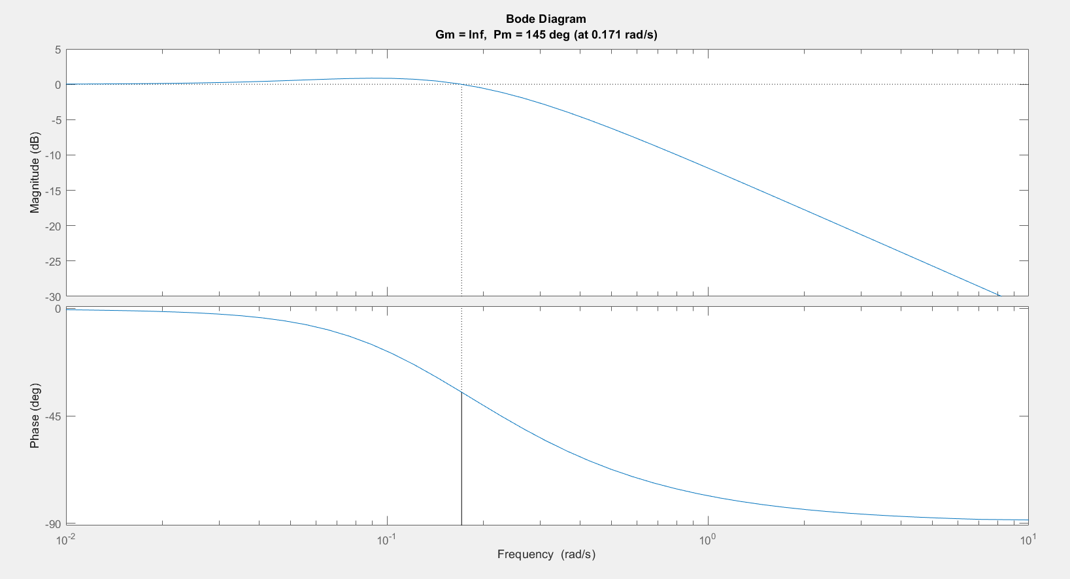

Root Locus:

Corresponds to Kp = 1.81, Ki = 1.47:

General comments: Output signal closely follows the input signal minimising error as input grows. When input ceases increasing, minimal overshoot occurs and takes very little time to return to the selected speed. System corresponds to a damping coefficient of 0.7547.

Corresponds to Kp = 2.38, Ki = 1.44:

General comments – almost the same as the previous example, the difference here is that MATLAB produces a damping coefficient of 1, meaning that this system is critically damped.

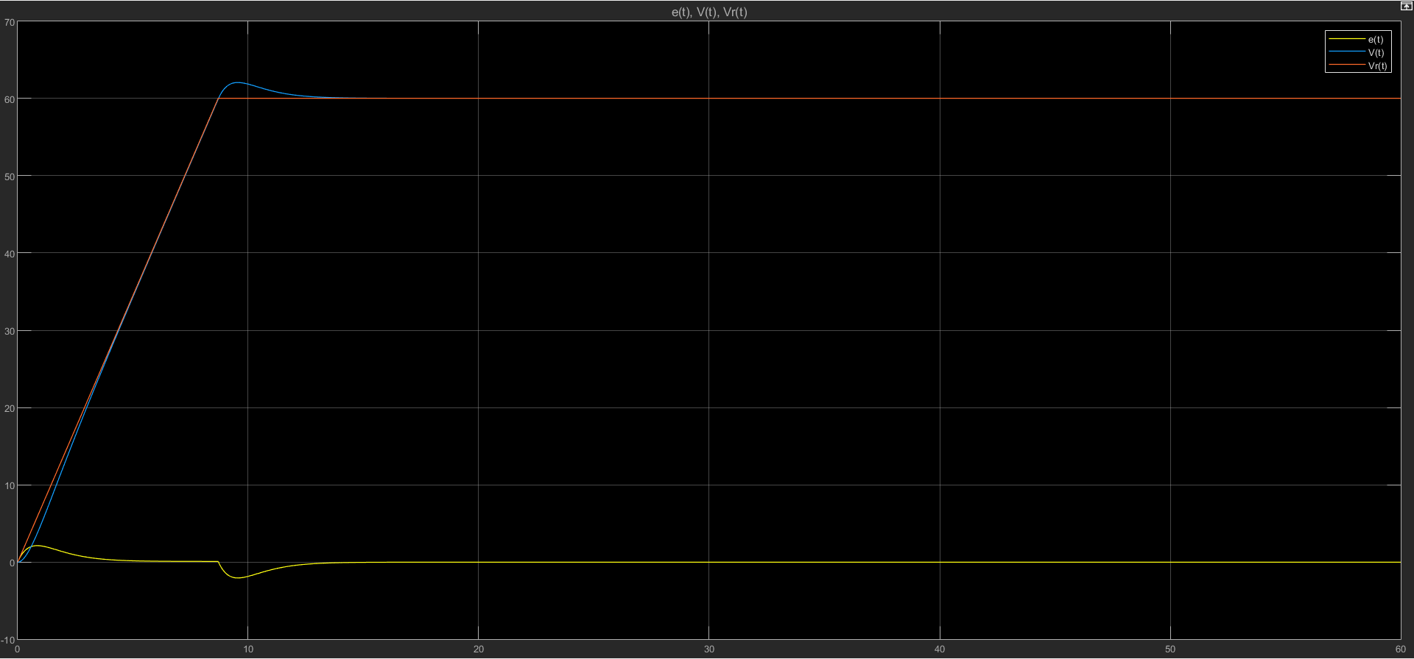

**Part 2 Stuff:**

Plot including torque along side controller input, error, and response.

