“A year later, after doing the self-healing project, I feel so much better all the time, stopped taking all prescription pain medications and eliminated the sharp pains in my back. This project has taught me that I have the skill set needed to be whole and healthy.” –J.C., 28-year-old college student

Comparison of benefits between in-person and online holistic health stress management classes
Nicholas Heinz, Erik Peper, PhD, Richard Harvey, PhD., and Monica Almendras
San Francisco State University

Each semesters students enroll in an undergraduate Holistic Health course that incorporates a ‘self- healing’ project to improve health outcomes. The class covers physiology of stress, concepts of holistic health and healing. The daily practices from the book, Make Health Happen (Peper,Gibney & Holt, 2003).

The students were assigned to practice these skills daily. In addition, they record their subjective experiences, meet weekly in a small group, and write up results in a paper. The sequence of practice assigned are shown in Figure 1.

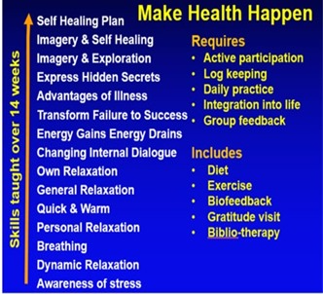

Figure 1. Sequence of Self-healing practices

Methods
The retrospective study compares summary data from ‘pre-pandemic’ 2012 and 2016 classes, to online and hybrid ‘pandemic’ 2021-2022 classes.

Participants: 184 undergraduate students (72 males
and 112 females) from the 2012 and 2016 in-person classes and 336 undergraduate students (97 males; 257 female) from the 2021 and 2022 online classes.

Procedure

After completing their self-healing project, students self-rated their success and benefits as well as reasons for their success and benefits

Results
There was no significant difference between the self-rating of success and benefits between in-person versus online classes (two-tail t-test; P= 0.90) as shown in Figure 2.

Figure 2. Comparison rating of success between 2012/2014 in-person classes and 2021/2022 online classes.

There were some changes in the self-healing categories. There appeared to be an increase in physical symptoms and mood changes (anxiety and depression) in the online classes as shown in Figure 3.

Figure 3. Average ratings of success/benefits.

In the detailed analysis of the 2021-2022 online classes, there was no meaningful difference in the topic of self-healing depending on teaching mode when it came to personal success outcomes.

Discussion
Student reported what interfered and what contributed to their success as described in tables 1 and 2.

Table 1: Factors that interfered with success
Interference of life stressors
• Lack of time
• Inconsistency
• Lack of motivation
• Lack of belief in project
• Having too many goals
• Absence of clear plan
• Lack of social support
• An inflexible plan
• Unrealistic expectations

Table 2: Factors that contributed to success
• Self-belief
• Motivation
• Realistic expectations
• A flexible/detailed plan
• Time invested into research
• Social support
• Having a reward system
Conclusion
Our findings confirm the importance of teaching undergraduates self-healing skills to mobilize their health. Online and in-person modes of instruction for the same classes with the same instructor appear to have the same success outcomes. We recommend that all undergraduate students be required to take similar holistic health stress management classes to optimize their health.
Correspondence should be addressed to:
Erik Peper, Ph.D., Institute for Holistic Health Studies, San Francisco State University Email:epeper@sfsu.edu blog: http://www.peperperspective.com

