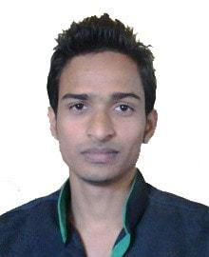







* **Databases:**
* MySQL
* SQL Server
* Oracle
* Firebase
* **Programming I Know**
* core JAVA(With Swing UI)
* PHP(PDO Object Oriented)
* JavaScript
* C
* C++
* **Expertise in:**
* Bootstrap Library
* AJAX
* JSON
* JQuery
* Laravel PHP
* PDO
* **CMS:**
* Wordpress,
* Drupal
* **Operating System:**
* Windows
* Linux OS(Ubuntu, Fedora)





* I have been working with Word Press, Drupal Content management system for 6 months.
* Developed an android based messenger application with android studio IDE with the help of firebase database.



* **April 2013 – 2014**  
  **Founder**  
  Muktangon, An assamese multi user blog

Lead developer and system architect design with high traffic dynamic blog via Drupal Content Management System.

* Structure several internal systems in order to manage and workflow tracking.
* Work with control panel.
* Designed and implemented a blank theme using Drupal.
* **August 2017 – December 2017  
  Mini Project (Attendance System)**  
  CCS, Dibrugarh

Developed and delivered high-end daily attendance system in JAVA (SWING) for CCS, Dibrugarh University.

* **Jan 2018 – June 2018  
  Internship (Parcel Management System)**  
  Indian Railway  
  Banipur, Dibrugarh

Developed and delivered high-end parcel revenue calculation portal of the Division office along with the 75 stations. Division is the main office where the information about all the parcel revenue is being recorded. P

* Successfully generated back-end programming utilizing WAMP; Windows, PHP 5, Bootstrap v3.3.7, JavaScript/JQuery, AJAX, and MySQL framework.
* Provided leadership as client and admin logins, and general upgrade/maintenance of servers.
* **Sept 2018 – Current**

**Web Developer at Nice Infotech, Shillong.**

* **Dec 05 2018 – Current**

**Web Developer(part time) at First Assamese Social media ‘PRABAH’.**



**Master in Computer Application** Graduated, July 2018Centre for computer studies Marks 6.6 (CGPA)  
Dibrugarh University 1st class

**Bachelor of Computer Application** Graduated, July 2014MC College, Barpeta Marks 56.7%  
Gauhati University 2nd division

**10+2** Graduated, July 2009MC College, Barpeta Marks 47%  
AHSEC ` 2nd Division



* MS Office
* Adobe Photoshop
* MS Visio



* Hindi
* English
* Assamese
* Bengali



|  |
| --- |
| * Singing |
| * Playing Instruments |
| * Cricket |  |



Father’s Name: Nurul Islam Marital Status: Single  
Birthday: February 21, 1991 Nationality: Indian  
Gender: Male

**Declaration**

I, Saddam Hussain, hereby declare that the information contained herein is true and correct to the best of my knowledge and belief.

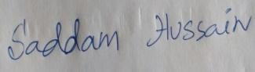

____________________________  
Saddam Hussain Barpeta  
 August 14, 2018