UOS SMART

ELECTRONIC WHEELCHAIR

A work submitted in partial fulfillment of the requirements for the degree of

Bachelor of Science in Computer Science

**By:**

**Asma Zafar**

BSCSF16E034

**Saddiqa Javiad**

BSCSF16E030

**Sabahat Sabir**

BSCSF16E052



**FACULTY OF COMPUTER SCIENCE & INFORMATION TECHNOLOGY**

**University of Sargodha**

UOS SMART

ELECTRONIC WHEELCHAIR

Supervisor: Mr. Abu-Bakar Ubaid

Project Manager: Mr. Fahad Maqbool

Project Team:

|  |  |  |
| --- | --- | --- |
| **Roll No** | **Student Name** | **Team Role** |
| BSCSF16E034 | Asma Zafar | Team Leader |
| BSCSF16E052 | Sabahat Sabir | Team Member |
| BSCSF16E030 | Saddiqa Javaid | Team Member |

Submission Date: 06 January, 2020

**Certificate of Approval**

It is certified that the work presented in this Project titled

UOS SMART

ELECTRONIC WHEELCHAIR

Was submitted by

*Asma Zafar(BSCSF16E034),*

*Sabahat Sabir (BSCSF16E052),*

*Saddiqa Javaid(BSCSF16E030)*

Under my supervision and that in my opinion, is fully adequate, in scope and quality, for the degree of BS in Computer Science.

Supervisor:

Mr. Abu-Bakar Ubaid

Android Developer

Current visiting at

Department of CS & IT

University of Sargodha

Project Manager:

Mr. Fahad Maqbool

Asst. Professor

Department of Computer Science & Information Technology

University of Sargodha

External Examiner:

Dr. / Mr.

Designation:

Department:

Internal Examiner:

Dr. / Mr.

Designation:

Department of Computer Science

University of Sargodha

**Acknowledgement**

We would initially like to thank our supervisor Mr. Abu-Bakar Ubaid, an Android Developer current visiting faculty member at Department of CS & IT in University of Sargodha.The door to Mr. Abu-Bakar Ubaid office was always open whenever we ran into a trouble spot or had a question about ourwork or writing. His immense hard work and professionalism inspired us to push our limits. He consistently allowed this work to be our own work, but steered us in the right direction whenever he thought we needed it.

We would also like to thank Dr. Fahad Maqbool whose moral and professional support has encouraged us to complete our BS degree. His recommendations and suggestions helped us throughout our stay at University of Sargodha.

Finally, I should convey my very thoughtful gratitude to my father and to my friends for providing me with reliable support and continuous encouragement throughout my years of study and through the process of researching and working. This accomplishment would not have been possible without them.

Asma Zafar

Sabahat Sabir

Saddiqa Javaid

# : Introduction

## Purpose of document

The aim of introducing Smart E-wheelchairs is to facilitate elderliesandphysicallydisabled people. PhysicallyDisable peopleface problems while going from one place to another place. Wheelchair is one of the most commonly used supporting devices to uphold mobility and enhance quality of life for people who have difficulties in walking. Wheelchair provides the user the freedom to move around, allowing the user to perform day to day physical activity. If a disabled person uses simple wheelchair than he/she needs an attendant who helps them to perform the activity. Smart E-wheelchairs is a ride solution to solve the problem faced by disable people. It allows the user to get around and undertake daily activities without assistance. It makes a disabledpeople independent. They will simply have to install an application on their cell phones and fill an application to get wheelchairs services. By using androidsmartphone, the user can select the specified direction displayed within the four quadrants on the screen of the android smartphone to controlthewheelchair.An Arduino Uno is basically used to execute all commands. Moreover, MD30C motor driver and HC05 Bluetooth module are used in this system. This system is mainly designed to save time and energy of the user.

## Problem Statement

Due to the increased percentage of elders and physically disabled people, wheelchairs are the best assistive devices to help them enhance their personal mobility. The conventional wheelchairs have some limitations such as flexibility, bulkiness and restricted functions. There are existing technologies which allow the users to use human gestures such as the movements of hands, movements of leg tongue and head and synchronize them with the movement of the wheelchair. Smartwheelchair App is a better wheelchair controller..A smart wheelchair is developed to help an elderly or physically disabled person (user) to move from one place to another independently. To control Smartwheelchair, you need to install the application in your smartphones.

By using smartphone, the user can determine the wheelchair’s movement by selecting the desired direction on the android smartphone phone screen. The command given by the user will be forwarded to the Arduino Uno via Bluetooth. The Bluetooth will convert the commands given by the user in a binary format and send them to the Arduino Uno. Arduino Uno used in wheelchair will read and execute the command and finally send the digital values to the motor driver device.The motor driver installed will direct the wheelchair according to the command given. When the user selects the “Go” arrow, the wheelchair will move in a forward direction, “Back” arrow prompts the wheelchair to move backward, and “Left” arrow causes the wheelchair to turn towards left,and“Right” arrow makes the wheelchair to turn right.An aged or physically challenged person can carry on the direction and movement of the wheelchair with the facility of android smartphone in the following four different directions namely, left, right, forward and reverse. There would also be a stop button to make the wheelchair’s movement stop at once. The wheelchair will move according to the command given by the user.

In this paper will discuss, a smart wheelchair is developed to help an elder person or someone who is physically disabled to move from one place to another independently. An elderly or physically challenged person can direct the direction and movement of the wheelchair with the help of the android smartphone in four different directions, left, right, forward, reverse and stop. The wheelchair will move according to the command given by the user.

## Scope and Objectives

The objective of Smart E-wheelchair System is to make physically disabled student independent.

Movement of wheelchair can be controlled by using android application. With the help of this functionality user don’t need any attendant. The electronics wheelchair presents in marketplace are too much costly. A common person cannot afford to buy that wheelchair. The electric wheelchair we are going to make is affordable by a common man.

The following six characteristics were considered in the choice of a design solution:

• Installation costs

• Time savings

• Reliability

• Power consumption

• Maintenance

• Expandability

A significant contemplation is the installation costs, since costs generally determine the feasibility and capability of a project.

# : Research and Requirements

## Functional requirement

* User will provide log in information.
* User must provide valid contact detail.
* User can use application to operate wheelchair.
* User can stop wheelchair by using stop button in application.
* User can move left wheelchair by using left button in application.
* User can move right wheelchair by using right button in application.
* User can move reverse wheelchair by using reverse button in application.
* User can move forward wheelchair by using forward button in application.

## Non-Functional requirement

### Performance Requirements

The E_Wheelchair application should have a very quick performance capability to make the system efficient enough to act upon the generated command. All devices connected to it will confirm their duties within Nano seconds or within no time after receiving a notification from it. Talking about performance concerns all devices connected to the system are nicely communicating to each other to send and receive information. All modules are well integrated and process is running in an adequate flow.

### Availability

The system will be available 24/7. By using androidsmartphone, the user can select the specified direction displayed within the four quadrants on the screen of the android smartphone to controlthewheelchair.

### Security

The application will provide database security. Only the registered person that has been installed E_Wheelchair would be able to log in and can operate wheelchair at any time. User would be able to set log in passwords of their suitable safety requirement.

### User Documentation

On first startup of website application. There will be a small description or a graphical slider will be shown in order to guide the particular customer so that he could easily navigate through the system and could make changes when or how he feels suitable or when required regarding field necessity. User will be guided through proper guideline. Step wise understanding would be tried to facilitate the users. Any complexity would be avoided that can be cause of worry for an E_Wheelchair user. Also a YouTube tutorial URL will be provided (if possible) that will teach how to use the Electronic Wheelchair.

## External Interface Requirement

### Hardware Requirement

Hardware requirement includes following:

|  |  |  |
| --- | --- | --- |
| Sr.No | Component | Description |
| 1 | Motor driver | L298N |
| 2 | DC motor | 350W,24V,2600rpm |
| 3 | Bluetooth module | HC-05 or HC-06 |
| 4 | Microcontroller | AVR(Arduino Uno) |
| 5 | Power supply | 24V/7.0Ah lead acid and 9V battery |
| 6 | Wheelchair | Used in project |
| 7 | Personal computer | Used for coding and testing. PC must have at least 8 GB RAM. Here we work on window operating system |
| 8 | Wire | Used in project |
| 9 | Button | Used in project |
| 10 | Capacitor | Used in project |
| 11 | LM7809 | Used in project |

**Table 2:** The Table of Components

### Software Requirement

|  |  |  |
| --- | --- | --- |
| Sr.No | component | Description |
| 1 | Software used in project | Arduino, Android studio |

**Table 3:** The Table of Components

## Assumptions and Dependencies

It is assumed that the user is familiar with the windows operating system. It is assumed that information collected through experiment will be used for providing the demo for the presentations. There is a need for the smartphone. It will be assumed that the users will a smartphone.

# : Detailed Design and System Architecture

## System Level Architecture

### System Block Diagram

Diagram shows separate control architecture for target wheelchair. The first one shows, controllingdata communication architecture from android towheelchair receiving unit over Bluetooth link.After that separate controllingdatawillcommunicatewiththedevice. TheconceptofAndroid controlarchitectureislikeanAndroidgamethatweplay on our Androidphone.

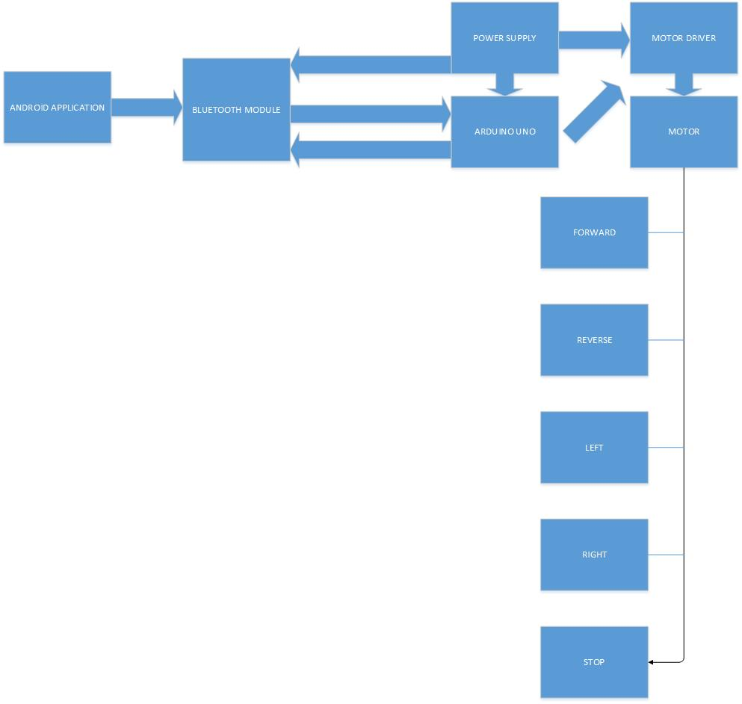

Figure 1: System Block Diagram

### Activity Diagram of System

Our product will consist of wheelchair infrastructure and an android application that work and communicate effectively with each other.

By using smartphone, the user can determine the wheelchair’s movement by selecting the desired direction on the android smartphone phone screen. The command given by the user will be forwarded to the Arduino Uno via Bluetooth. The Bluetooth will convertthecommandsgivenbytheuserinabinaryformatandsend them to the Arduino Uno. Arduino Uno will read and execute the command and lastly send the digital values to the motor driver device.Themotordriverwilldirectthewheelchairaccordingtothe command given. When the user selects the “Go” arrow, the wheelchair will move in a forward direction, “Back” arrow prompts the wheelchair to move backward, and “Left” arrow causes the wheelchairtoturnleft,and“Right”arrowmakesthewheelchairturnright. Figureshows activity diagram of system level architecture.

Figure 2: Activity Diagram of System

### Use Case Diagram of System

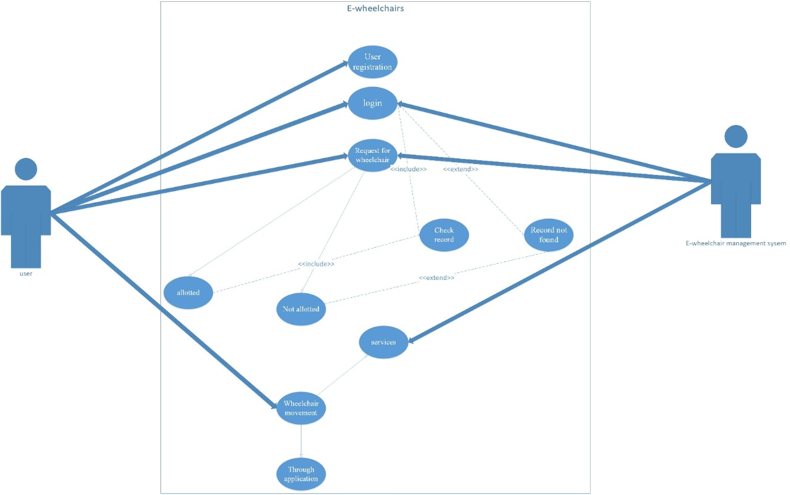In Figure-7shows Use Case diagram of system level architecture.

Figure 3:Use Case Diagram of System

### Entity Relationship Diagram of System

In Figure Entity Relationship diagram show the whole system working.

Figure 4:Entity Relationship Diagram of System



