Reg ID - GO_STP_6834

Day 12:



STEPS:

1. Take the no of clusters which is k
2. Based on k value take that many random points from the data set
3. Calculate distance centroid
4. Assign mini dist centroid
5. Recalculate the centroid
6. Do it till the new value is equal to the last centroid value.

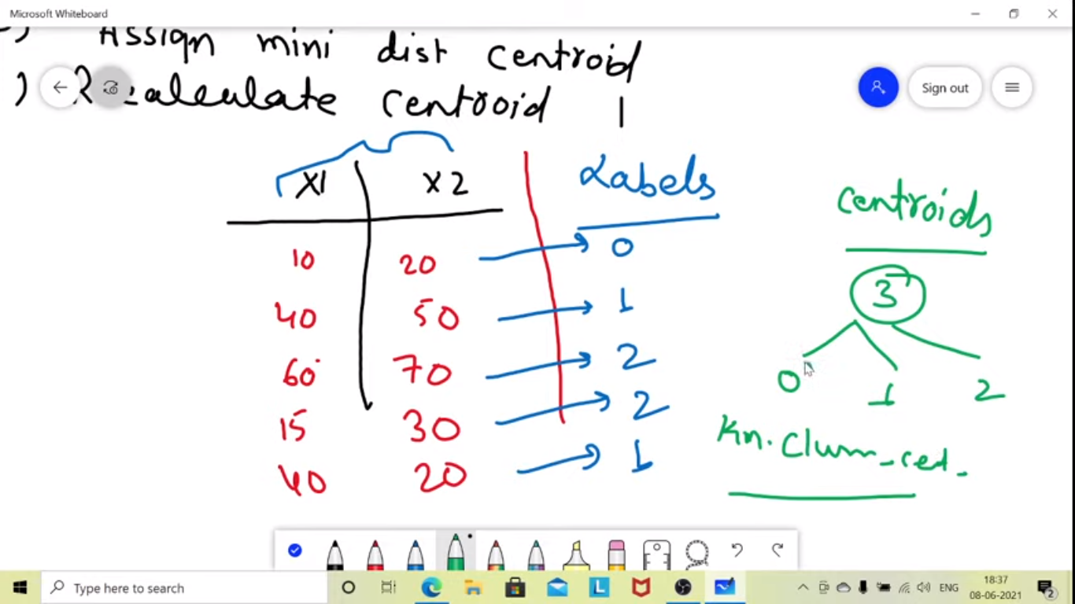

To select appropriate no of clusters

Done using elbow method- Determines the optimal no of clusters

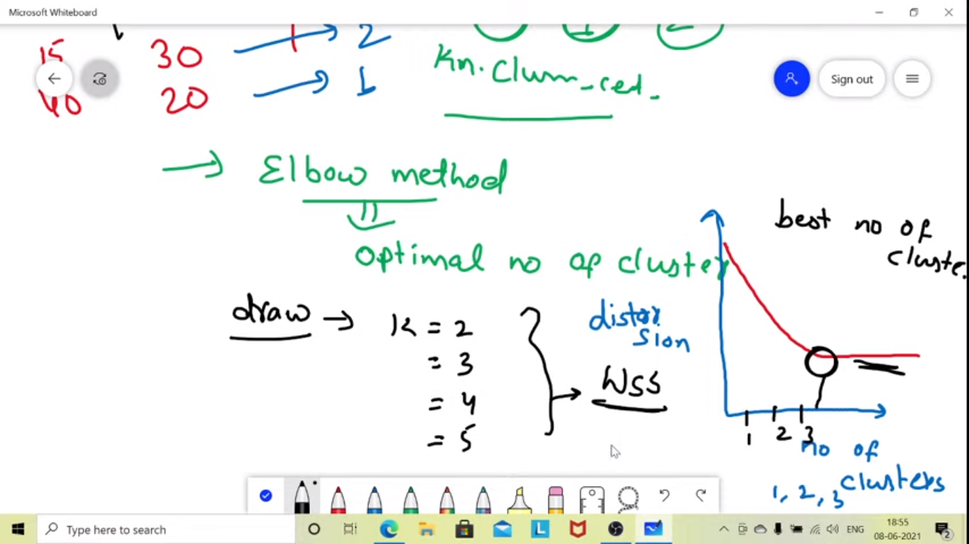

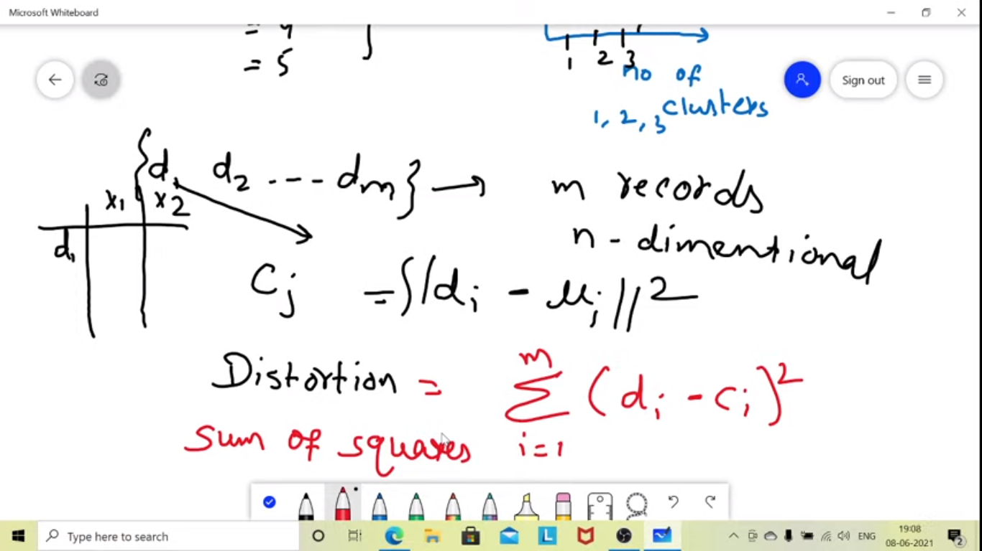

SEABORN

