Reg ID - GO_STP_6834

Day 16:

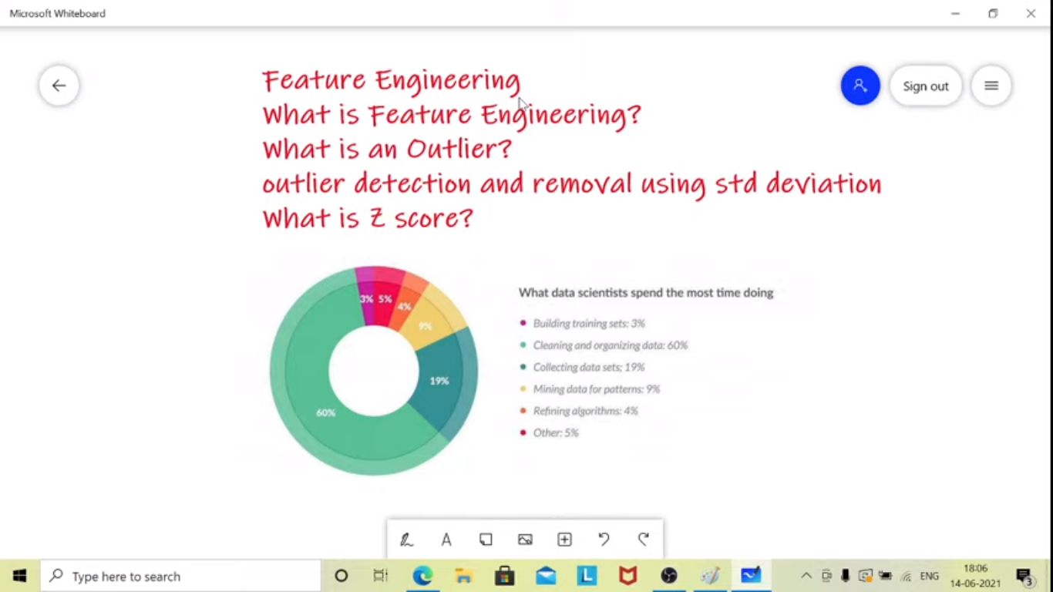

Feature Engineering:

* Preparing the data for the ML algorithm
* Improve the performance of models
* Can be used in predictions
* Each and every features will have some relation to the target

Feature- column in a dataset.

So we need to select the feature which highly affects the model.

Re 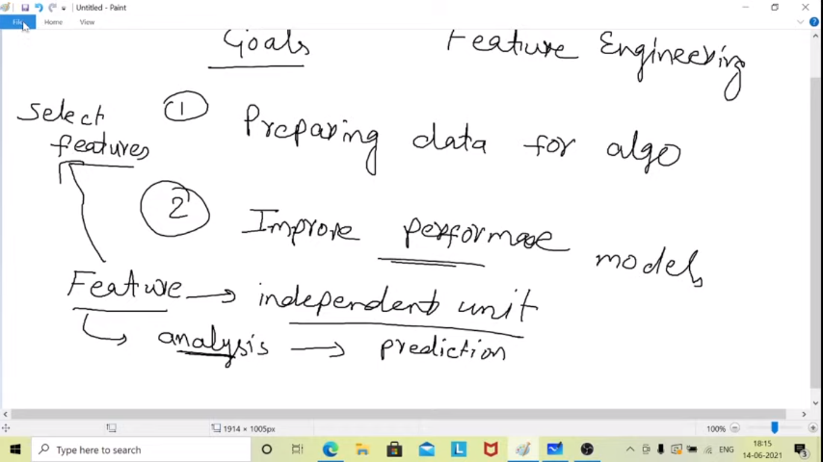

Feature Reengineering Techniques:

* Imputation: Removing Null Values, missing values
* Outliers- Using visualization or statistics(stnd deviation and percentiles)

