Reg ID - GO_STP_6834

Day 17:

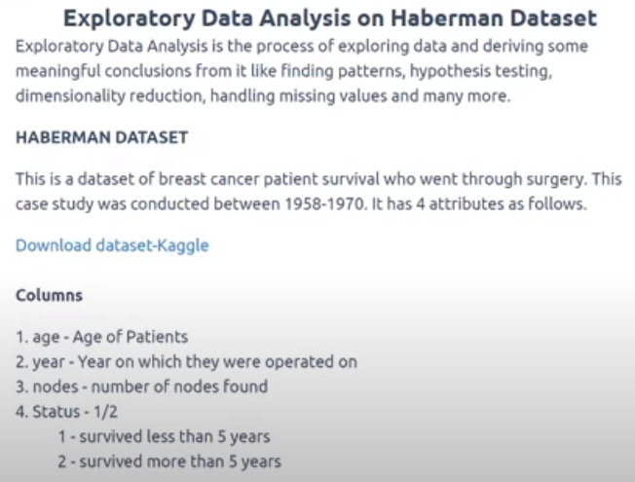

EDA:

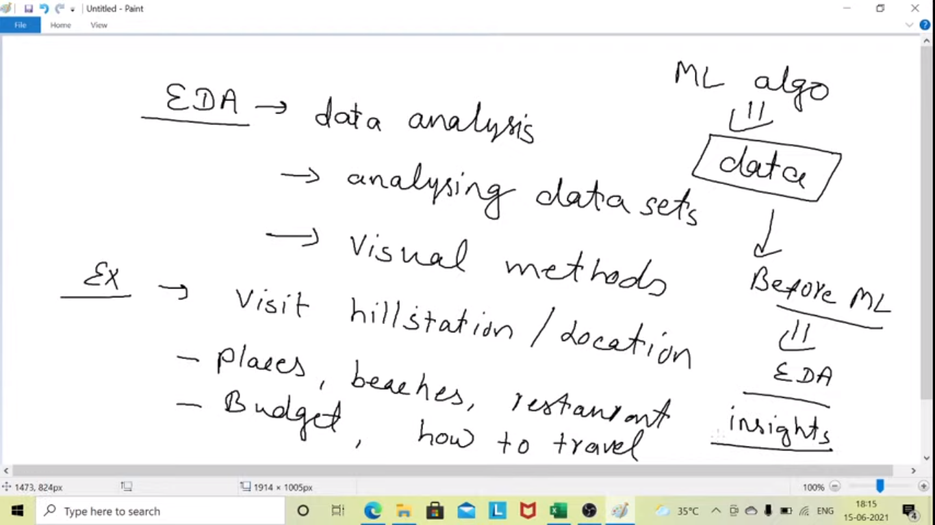

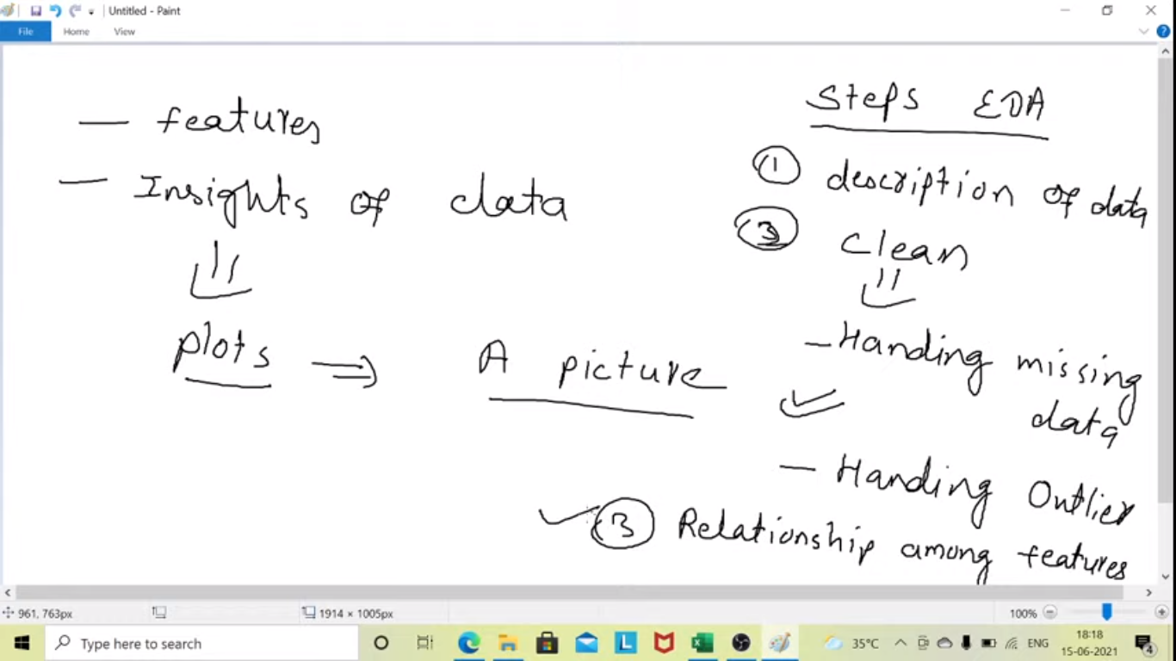

Steps EDA:

1. Description of data
2. Cleaning of Data
   1. Handling missing data
   2. Handling Outliers
3. Relationship among features

* Write about the dataset

Countplot- count of observation for each category for a feature