Reg ID - GO_STP_6834

Day 21:

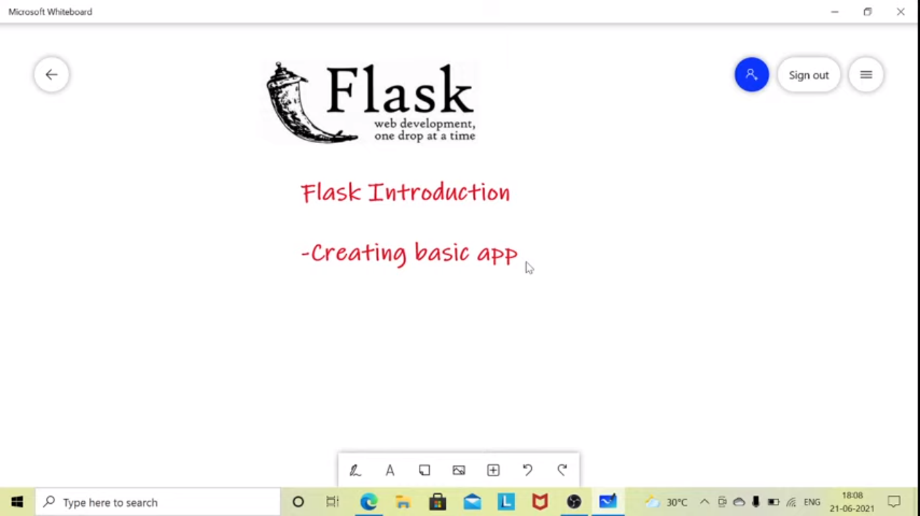

A we framework used for the web application development. A light weigt application can be built using this.

WSGI- A gateway between python and web server

Jinga2 – Template engine to comibine the data sources

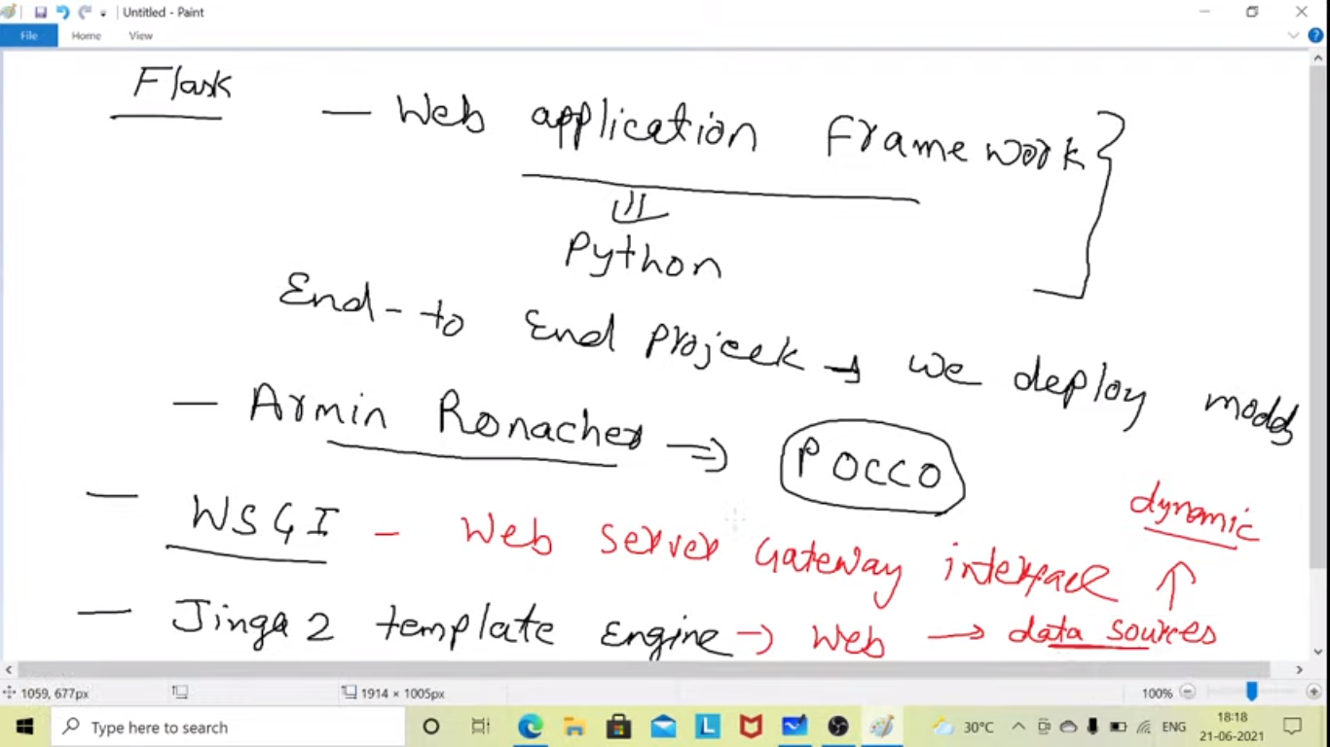

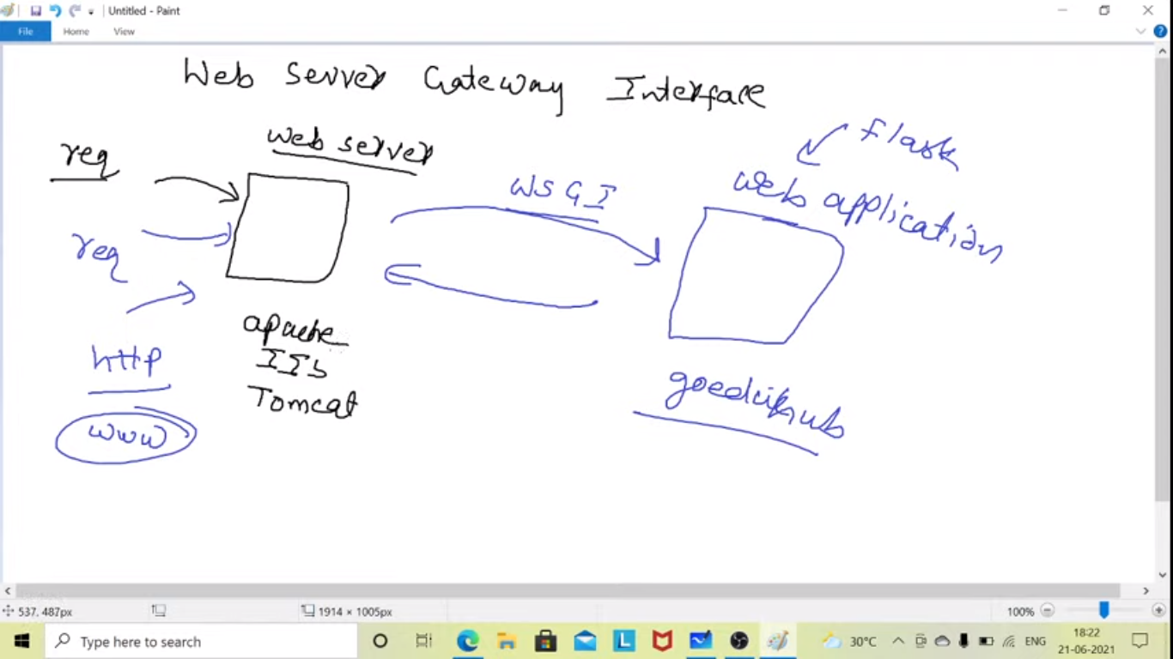

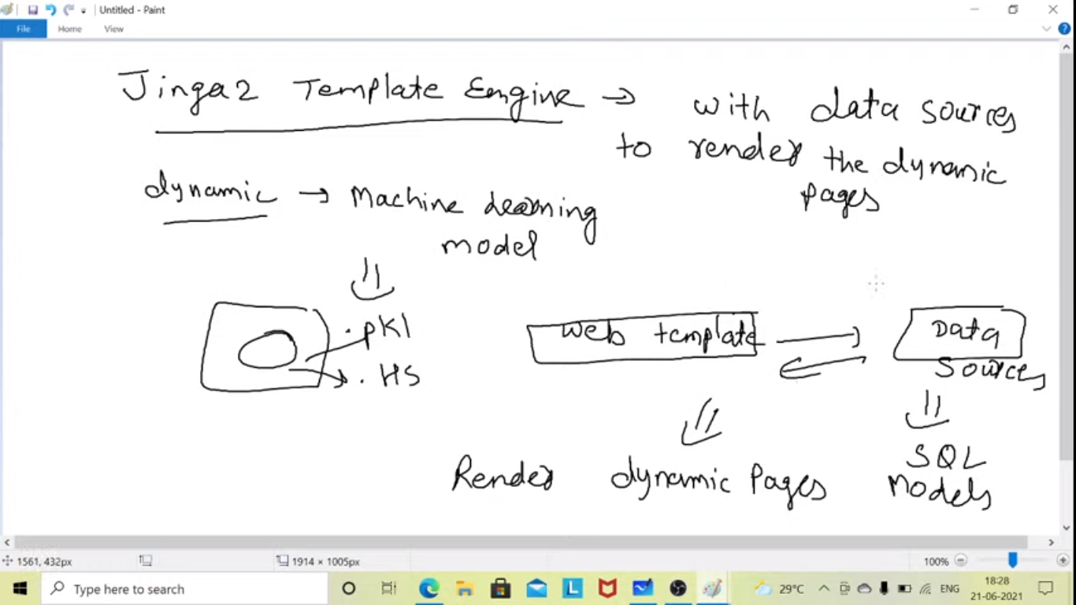

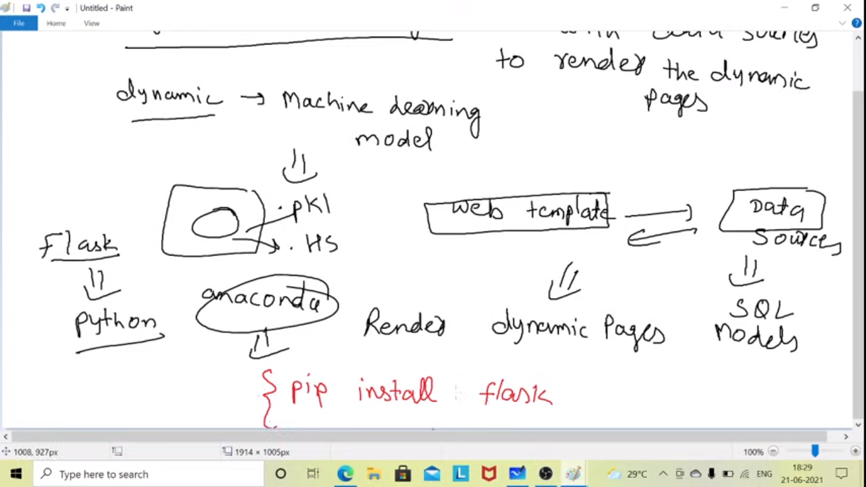

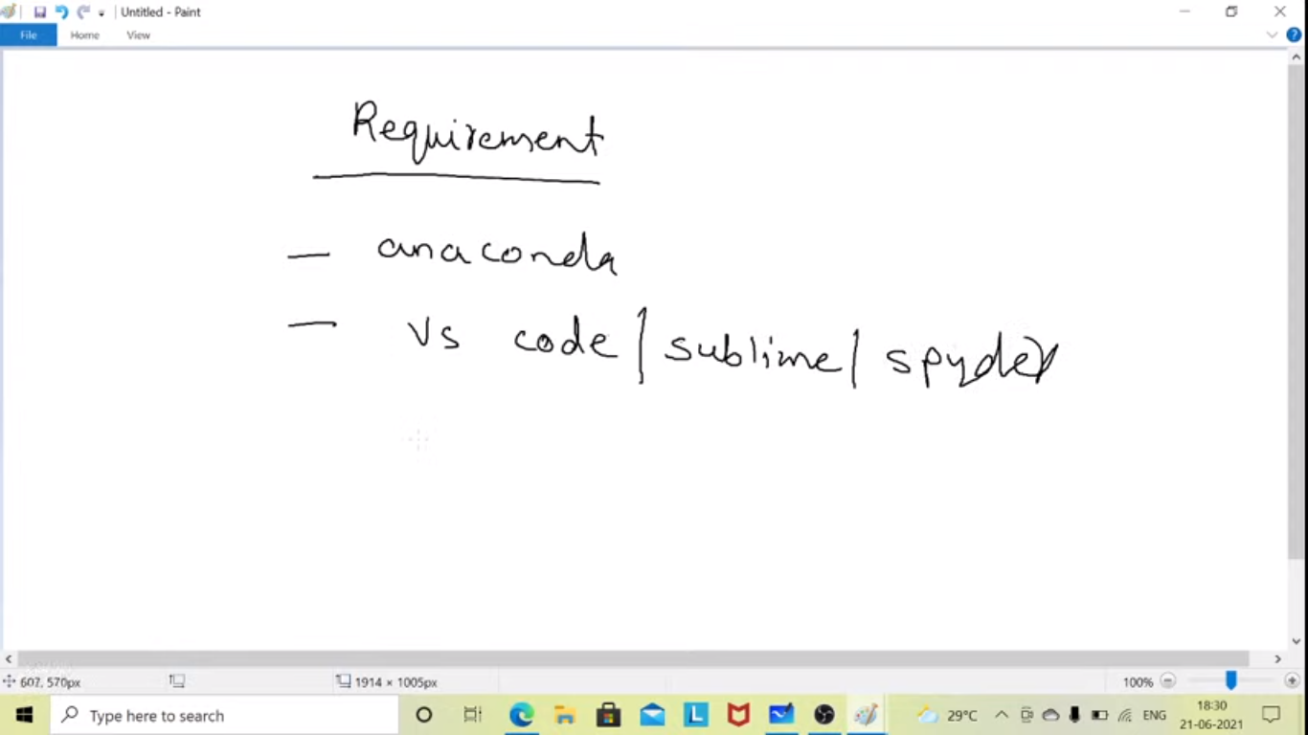

Flask is popular python web framework. 3rd party python library to develop the web application. Can also be interacted with models, databases, api can be created.

Flask is similar as compared to jango and Jango has lots of more functionality as compared to Flask. Flask is like a micro framework.