Reg ID - GO_STP_6834

Day 3:

List, Tuple, Dict

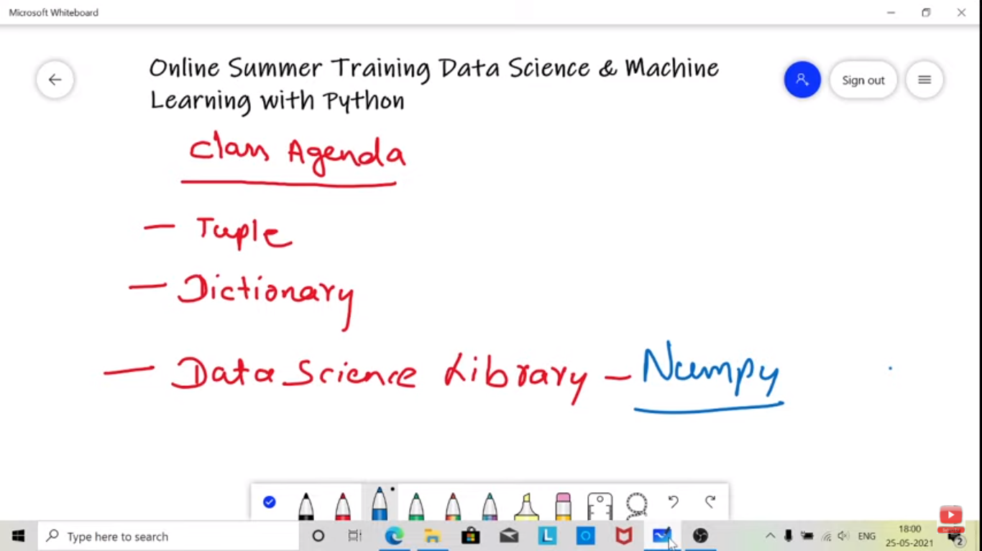

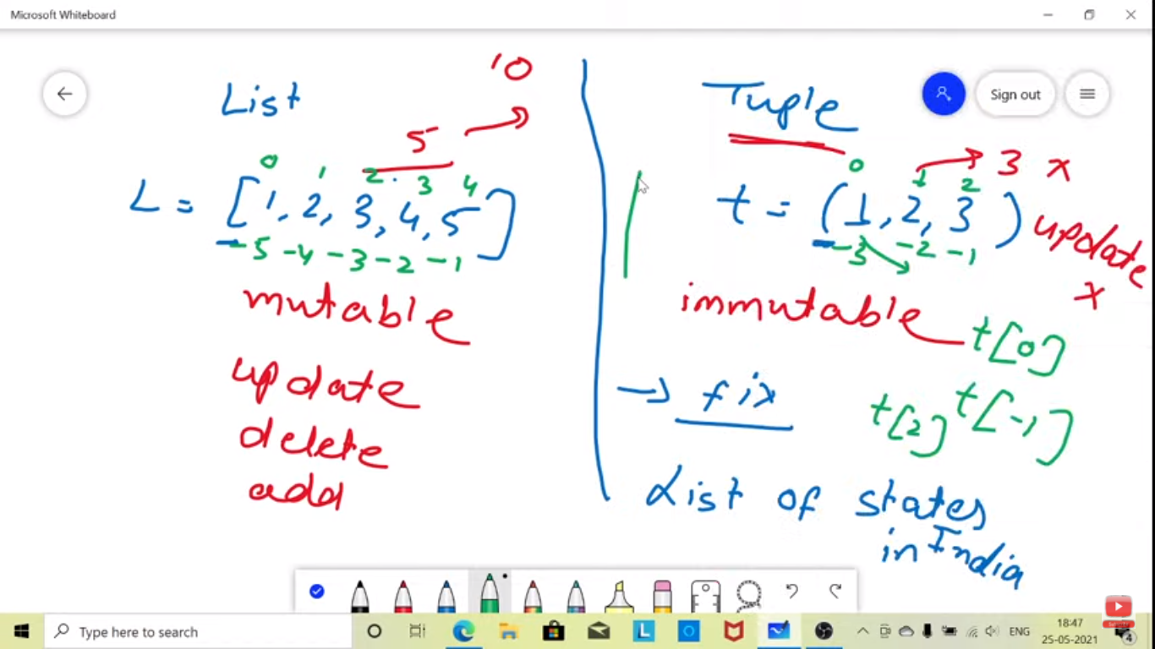

Fixing the value for the entire program can be done using tuple.

DICTIONARY

