Reg ID - GO_STP_6834

Day 6:

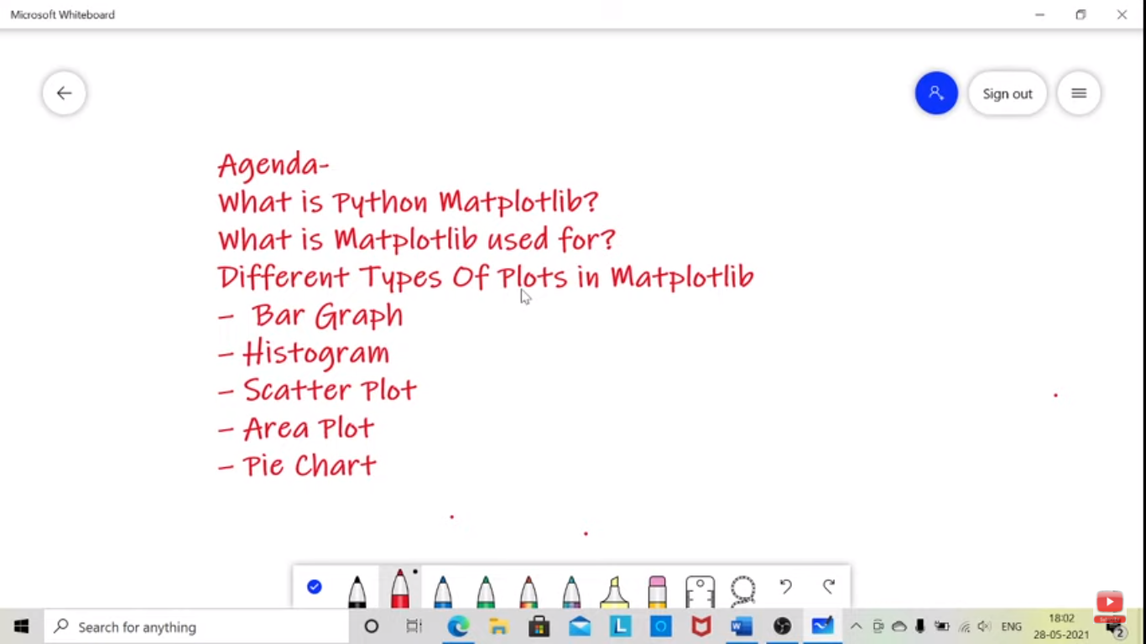

Library used for visualization through various plots under it. A plotting library used for 2d graphs.