ER DIAGRAM:

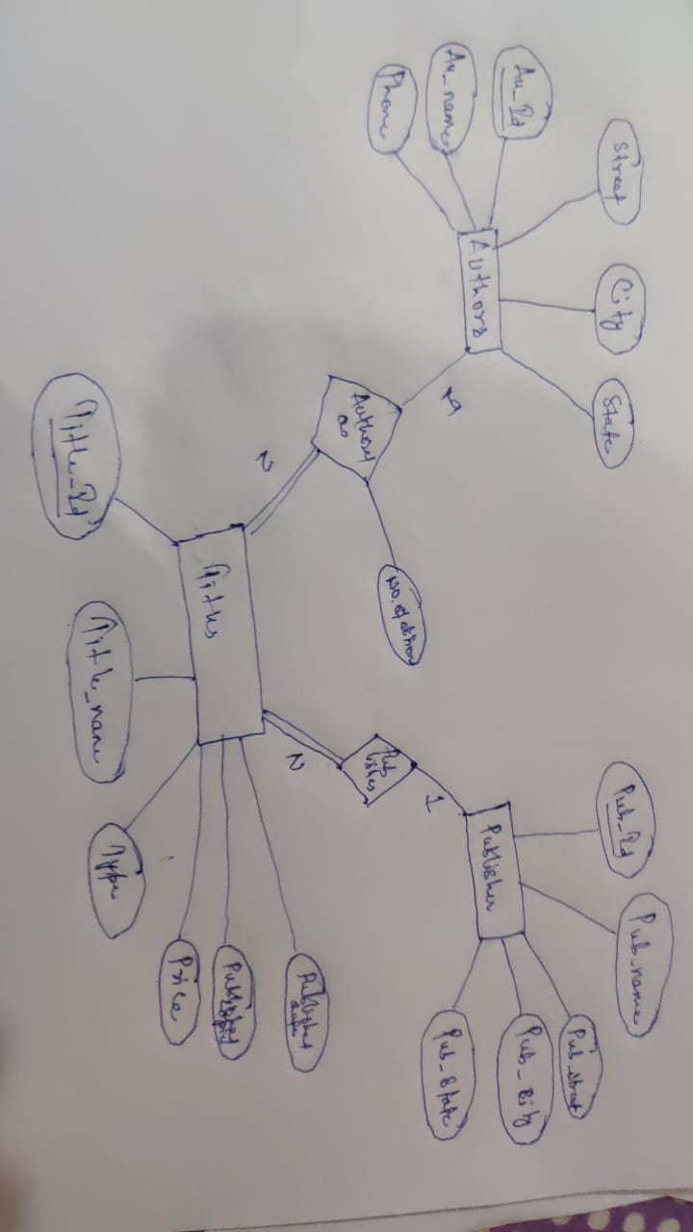

Authors and Titles will be having a M:N relationship named as Authored as or Title_Author

Also Publisher will have 1:N relationship

All the attributes has been shown in the diagram

1.

Ques:

Display the total No. of technical books published in the month of ‘may’ so far

Query:

select sum(published_copies) from titles where type in('Technical', 'technical');

select sum(published_copies) from titles where type in('Technical', 'technical') and to_char(pub_date,'Month') = 'May';

Output:

2.

Ques:List the authors who belong to particular state. Get the input of state from the user interactively. Allow the user to give state name in any case.

Query:

select au_name,state from authors where state = 'maharashtra';

select au_name,state from authors where state = '&state';

Output:

AU_NAME STATE

-------------------- ---------------

sahani maharashtra

sathe maharashtra

gppotdar maharashtra

3.

Ques:

Query:

a) sequence:

select count(id) from title_author;

create sequence TA_ID

start with 7

increment by 1;

insert into title_author values(TA_ID.NEXTVAL,'a5','t4',3);

b)

alter table title_author modify NO_OF_EDITIONS Number(5);

alter table title_author add constraint NOW_Greater_Cons check(NO_OF_EDITIONS > 0);

c)

select au_id, length(au_id) as len_auid from title_author;

Output:

Sequence created.

a)

ID AU_I TITL NO_OF_EDITIONS

---------- ---- ---- --------------

1 a1 t1 4

2 a2 t2 3

3 a2 t3 4

4 a3 t4 3

5 a4 t5 2

6 a3 t5 2

7 a5 t4 3

b)

Name Null? Type

----------------------------------------------------------------- -------- --------------------------------------------

ID NOT NULL NUMBER(2)

AU_ID CHAR(4)

TITLE_ID CHAR(4)

NO_OF_EDITIONS NUMBER(5)

c)

AU_I LEN_AUID

---- ----------

a1 4

a2 4

a2 4

a3 4

a4 4

a3 4

a5 4

4.

Ques:

Update the cities with the latest city names of all authors authors using one single SQL command [hint:banglalore is now bengaluru]

Query:

update authors set city = decode(city,'bangalore','bengaluru', 'pune', 'pune', 'bombay','mumbai','madras','chennai','culcatta','kolkata');

Output:

AU_I AU_NAME PHONE STREET CITY STATE

---- -------------------- ------------ -------------------- ---------- ---------------

a1 sahani 020-4214612 kr-road mumbai maharashtra

a2 sathe 020-4214613 karwe road pune maharashtra

a3 manjunath 080-6614614 richmond road bengaluru Karnataka

a4 mani 044-7715512 Anna salai chennai tamil nadu

a5 gppotdar 022-4414667 s-road mumbai maharashtra

a6 soma 040-8414667 Jessore Road kolkata Westbengal

6 rows selected.

5.

Ques:

List the author name who does not belong to Bombay and has published more than 3 editions on various titles

Query:

select * from authors where city <> 'bombay';

Output:

6.

Ques:

List the publisher from Maharashtra who has not published any titles

Query:

select pub_name,pub_state from publishers where pub_state = 'maharashtra';

Output:

7.

Ques:

Display state wise, city wise number of publishers in ascending order of state

Query:

select pub_state, pub_city, count(*) from publishers group by pub_state, pub_city order by pub_state asc;

Output:

PUB_STATE PUB_CITY COUNT(*)

-------------------- -------------------- ----------

madhya pradesh bhopal 1

maharashtra chennai 1

maharashtra mumbai 1

maharashtra pune 3